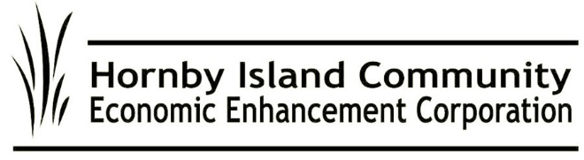  
**Summer ‘24, HICEEC First Edition**

**NEW: Scheduled Water Taxi to Comox, and Vis Versa**

Water taxi service from Shingle Spit to Comox Harbour, and back, every Friday, Saturday, and Sunday from June 28th – September 1st, 2024, plus July 1st (Canada Day) & August 5th (BC Day).

Contact **https://biganimalencounters.com/hornby-island-water-taxi/**

**Let It Guide You**

Your copy of the 2024/25 Hornby Denman Visitor Guide can be picked up on the brochure rack at the Coop front entrance. Some new information this year:

* Emergency Services messaging has been incorporated on the Hornby side
* Denman Island Parks committee have saved paper and submitted their trails information
* On the map, the Hornby bus route is shown. (note: there are some very minor changes that happened after production of the Guide. Check the website to print a copy of the schedule: **www.hornbybus.com**
* The ferry schedule may vary from what’s shown, depending on how the ferries operate. Tandem service during July and August will improve service on the Buckley Bay to Denman route.
* Welcome to the new businesses and organizations advertising this year!

**Food Sustainability and the Hornby Food Hub**

HICEEC is excited about the opportunities at the new Food Hub. Board members Marilyn Kopansky, John Grayson, Sheila McDonnell, and Katherine Ronan are all looking into ways to make the best use of this facility. This is a real boost for the Farmland Trust. If you’re looking for information on how to help, have ideas to submit, or have questions about how the Hub could serve your business needs, please contact Marilyn. She’s calling on the Community for input on the Food Hub's usage, sustainability, and potential tenants. Key questions on the development of the Hub’s business plan are, Who will be the “anchor tenant”? How will rents be determined? What will the focus of the building be? You can also contact the Farmland Trust Board.

**Thanks to our Visitors**

If they’re here and staying in a “fixed roof, transient accommodation” they are paying a 3% MRDT (Municipal Regional District Tax) on the amount of their rental. This includes guests in vacation rentals, B&B’s, lodges, and resorts. MRDT is the “pillow tax” and HICEEC was the entity on Hornby that was eligible to apply to manage the program. The program is under the auspices of the Ministry of Finance, so it is tightly regulated, with a lot of reporting and engagement required. That includes discussion with tourism stakeholders regarding how to apply the funds, within the uses allowed by the program. Hornby’s tourism stakeholders have identified the creation of affordable workforce housing as the top priority. Other projects include a Responsible Tourism Campaign, support for Festivals/Events, and the Farmers Market Welcome Centre.

**Internet Update**

To read the lastest updates on the high speed, fibre-optic internet project, please visit:

[**www.hornbydenmaninternet.com**](http://www.hornbydenmaninternet.com) and look under the **HORNBY CONNECT** tab.

**Ready, Set, Roll!**

The wheels on the Hornby bus will start to go round and round on June 27th.

A new service this year, on the website, will be the “bus finder”—an app that shows where on the route the bus is scheduled to be; very helpful for people not familiar with road names. **www.hornbybus.com**

We would like to offer our BIGGEST THANK YOU to retiring Bus Steering Committee members John Nemy, Alex Ortwein, Kate Ortwein, Sheila McDonnell, and Hilary Wood.

And an equally BIG HELLO to new Committee members Chris Allen and Steve MacDonald. They join our stalwart gang: Peter Mills, Garth Millan, Gary Law, Ray Therrien Scott Towson, Stu Brown, and John Heinegg. (with thanks to HICEEC staffers, Karen Ross and Cam Domay for administrative support).

Submitted on behalf of the volunteer Board: John Heinegg, John Grayson, Jack Hornstein, Katherine Ronan, Donna Tuele, Sheila McDonnell, Marilyn Kopansky, Stu Amos.