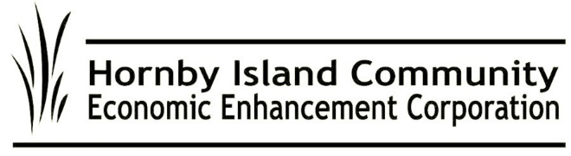
June 2022 First Edition
HICEEC REPORT

Ferry Talk at the Ministry

A delegation from Hornby traveled to Victoria May 11 to plead the case for improved capacity on the Hornby and Denman ferries. Daniel Arbour (Regional Director), Grant Scott (Island Trustee), Karen Ross (HICEEC) and Danyn Fine (observer, Sizzle) met with the Minister of Transportation, Rob Fleming; our MLA, Josie Osborne; and some of their staff.
The main points they highlighted were:
- The schedules for vessel replacements/upgrades and terminal redevelopments for both routes need to be advanced.
- These routes have some of the worst performance records in the fleet (summer overloads and utilization).
- The use of narrow 2-lane roads as parking for ferry line-ups raises grave concerns regarding safety and liability.
- The downgraded capacity of the Kahloke renders it non-serviceable on the Hornby route.
- We deeply appreciate our ferry crews and the jobs they do, and how their working conditions are impacted negatively when the ferries they work on are under-capacity.
- The Provincial government has actively invested in the Islands—with parks, new park acquisitions, etc.—and have been very supportive in providing grants for the coastal fibre optic project, the replacement Hornby school, the new Hornby Arts Centre, and the planned Food hub. However, these projects all put increased pressure on our ferries.
- The population on both islands rose approximately 20% from 2016 to 2021, and the higher population puts increased pressure on our ferries.

After listening, both Ministers said they clearly understand the issues and will encourage BC Ferries to make the needed changes to improve service and alleviate the wait times and congestion on both ferries. Minister Osborne will get back to us after she has had a chance to talk to senior Ferries personnel. The Hornby delegation felt it was a productive meeting.

From the Visitors, for the Island

The ‘‘pillow tax“ came into effect on June 1. Anyone doing short-term accommodation rentals in a building with a fixed roof (i.e, not a tent), whether they advertise or not, is now obligated to collect this tax from their guests. Remember that the funds collected will come back to Hornby, primarily to help with our affordable housing crunch. For more information, see https://hiceec.org/mrdt. Workforce housing is one of HICEEC’s priorities, which is why HICEEC is a founding member of the Hornby Housing Network.
We’ll Be There

HICEEC is once again hosting the Farmers Market Information Booth. On Wednesdays and Saturdays during July and August we will be answering questions, distributing Visitor Guides, displaying Community Fund pamphlets, handing out free water testing kits, providing bus schedules/routes, sharing information on local events, and generally being a friendly face to help with Island messaging.

Au Revoir, Alas

With heavy hearts we offer best wishes to retiring Board member Carlyn Bishop. Carlyn has become the General Manager of her family’s business, Sea Breeze Lodge, and that must be her priority. Carlyn is a graduate of Sauders School of Business at UBC and has served on the HICEEC Board for 6 years, guiding both the Marketing and Human Resources portfolios. We are deeply grateful to Carlyn for her contributions. Don’t be a stranger, now!

Driver Training – Skill Development Opportunity
Do you have family or friends who might like professional driver training? And you can house them? The Hornby Bus has a mentorship opportunity to train and license new drivers for the summer.
For more information: www.hiceec.org

Submitted on behalf of the volunteer HICEEC Board: Carlyn Bishop, Donna Tuele, Jack Hornstein, John Grayson, John Heinegg, Katherine Ronan, and Rudy Rogalsky

