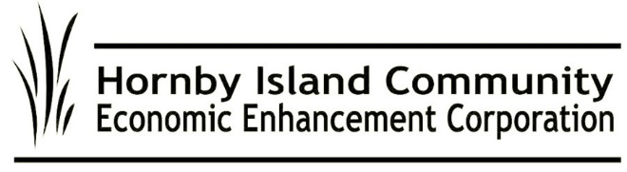  
**May ‘24, HICEEC First Edition**

**What Is that White Light?**

It’s the light at the end of the tunnel on the installation of the high speed, fibre optic infrastructure project on Hornby Island. In a Town Hall meeting on April 18th, representatives of City West answered questions and shared the great news that most of the island will be “live” by the summer. They also committed to having outstanding rocky spots done as soon as possible in the Fall. (no work takes place during the busier summer)

**Ship Ho!**

And it’s back: On April 15th, the mighty Quinitsa returned to ply the waters of Lambert Channel amidst cheering from the folks on shore……well, at least silent appreciation.

The Quinits. is deployed to Hornby (unless called into emergency service elsewhere) until next October. The humble Kahloke will be deployed, in tandem service with the “she’s high-maintenance” Baynes Sound Connector, during July and August.

Ferry Beefs and Bouquets: Send feedback to https://www.bcferries.com/contact-us

**Short-Term Vacation Rentals: Upended**

There’s no shortage of opinions on short-term vacation rentals on Hornby — Has there been a more controversial topic in our community? But with short-term rentals on the cusp of being limited, it’s worth noting that data on this are remarkably limited.

What are the facts of the matter?

How many are there? How many are too many? How to share the benefits among those needing the income? How to retain the residential character of our neighbourhoods? Would fewer home rentals provide significantly more long-term residential units? (currently available data: No). Do vacation rentals for 5 months stress the Island’s water and septic more than a family living in the home year-round? Would the proposed changes have negative, unintended consequences? What is the impact on the Hornby economy of restricting rentals? Would it benefit our Island infrastructure to have more rentals in the winter months? For example, would more businesses stay open?

In 2014, when Vacation Rental use was enshrined in the Official Community Plan and the Land Use Bylaw, the compromise was to limit the use to 5 of the 12 months, to limit capacity via bedrooms and number of beds, to the ensure accountability via signage, provision of off-street parking, etc. What challenges has Islands Trust Bylaw Enforcement experienced? How many “cases” have they had? How many “cases” are outstanding?

So many questions.

**Visitor Guide Messaging: The Fine Print is Just Fine**

Meaningful words from the Emergency Preparedness committee have been added to the welcome-with-caution section of the Discover Hornby Island feature box in the Visitor Guide. The final paragraph reads: *“We invite you to discover this wonderful but fragile place for yourself, and to steward it. Slow down, conserve water, limit waste, recycle, and practice safe fire behaviours. Bring a “grab n go” bag for unexpected emergencies. If together we walk lightly, the island can nourish us all for years to come.”*

**Food Hub – The Who and How Questions**

At the behest of the Farmland Trust, Marilyn Kopansky, a HICEEC Board member with experience in the food service industry, is seeking community input on the Food Hub's usage, sustainability, and potential tenants. Marilyn is likely spearheading the interior design phase and project logistics. She emphasizes that collaboration, community involvement, and stakeholder engagement are necessary, especially for seeking funding, financial planning, and project visioning. To get involved, contact Marilyn or the Farmland Trust Board.

**Affordable Workforce Housing Gets a Boost**

The Rural Economic Diversification and Infrastructure Program (REDIP) has announced the successful applicants for their 2023/2024 intake, and HICEEC received $100,000.00 for a Diversified Community Development project. More information can be found here: https://www2.gov.bc.ca/assets/gov/employment-business-and-economic-development/economic-development/find-support-organizations/rural-economic-development/redip_23-24_funded_vanislandcoastal.pdf.

Submitted on behalf of the volunteer Board: John Heinegg, John Grayson, Jack Hornstein, Katherine Ronan, Donna Tuele, Sheila McDonnell, Marilyn Kopansky, Stu Amos.