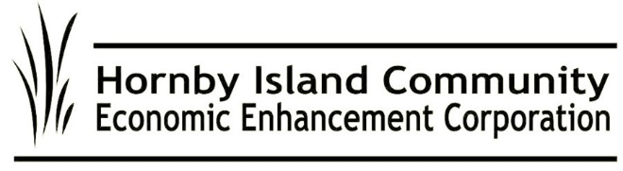
Nov. 2023, HICEEC First Edition

Cable ferry versus jellyfish—Guess who wins!
Add the inability to navigate through a jellyfish bloom to the deficiencies of the Baynes Sound Connector. Monday of Thanksgiving weekend, service was delayed due to the engine overheating when the fresh water intake for cooling became plugged with jellyfish.

Add that to all the time that the BS Con is out of service because it needs maintenance, how often it needs cable replacement—each one a quarter-million-dollar expense—and its inability to shuttle.

At the Sept. 29th Ferry Advisory Committee meeting, the members passed two unanimous motions:
- Year-round, serviceable vessels are needed on both routes immediately. Decommission the cable ferry. The solution proposed by retired Senior Master, Captain Pete Kimmerly: In the absence of any plans for new ferries on our routes, use the 80-car Quinsam on route 21 and the 44-car Quinitsa on route 22 to provide the level of service needed.
- Reservations are not supported

Residents are strongly encouraged to attend BC Ferries public engagements, date TBD, and support the call for serviceable vessels on both routes.

Economic Development Strategy
The Wellesley Consulting Group (WCG) has been hard at work, reviewing existing reports, conducting group engagements, listening in on community meetings, and digesting the online comments. If you haven’t shared your ideas, it’s not too late. Comments can be submitted online: https://www.wellesleyconsulting.ca/hornbyisland/
Scroll down to the input form.

Also on that webpage is the registration form for the next two engagements: Nov. 14 and 20th. Please, do join in!

MRDT, a.k.a. the pillow tax
The Municipal Regional District Tax— collected from visitors to short-term, fixed- roof accommodations, and intended to support projects that benefit the community, including affordable housing—is in place and funds are being collected (although for some reason the funds collected by Airbnb and Vrbo haven’t shown up yet). 4VI, an industry consultant, has been contracted with, to assist with crafting the 2024 tactical plan to work toward implementing the approved 5-year strategic plan.

The Internet team returns
After an unexpectedly prolonged break, Summit Earth is back on Hornby to install the infrastructure for high-speed, fibre optic internet. The source of the 6-week delay? The Ministry of Transportation and Infrastructure, which is clueless about the technique being used to bury the conduits; it’s a well-established technique, but new to MOTI, so they’ve balked at issuing permits. (MOTI would prefer that the lines go on poles—like the Hydro lines that get taken out by storms, cars skidding off the road, and wildfires.)
The installation crews have returned to finalize the currently permitted areas, referred to as Phases 1 and 2. With good timing, and MOTI cooperation in issuing permits, construction should move seamlessly into the final Phases 3 and 4.

Bus hibernation
Our new bus is a gem and we intend to take good care of it, including tucking it in snugly for the winter. It will sleep inside a galvanized steel frame structure with a commercial grade, triple-layer ripstop polyethylene (PE) tarpaulin cover. Thanks to Peter Mills and Al Dickie for erecting it. And Donna & Ron Tuele for donating some foundation materials. And thanks to Mainroad Contracting and Doug Nixon for making a site for the Bus’s Winter Vacation Home in the works yard.

Submitted on behalf of the volunteer Board: John Heinegg, John Grayson, Jack Hornstein, Katherine Ronan, Donna Tuele, Sheila McDonnell

