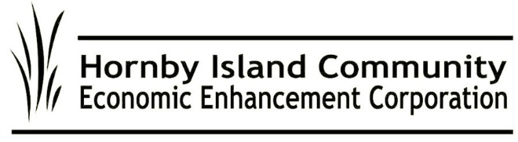

**Summer 2022, HICEEC First Edition**

**Who is HICEEC?**

**Introduction to the Volunteers on the HICEEC Board**

Chair John Heinegg works online as a medical editor. He is a Hornby First Responder and First Aid/CPR instructor.

Vice-Chair John Grayson owns H.I. Winery. He also serves on the Farmland Trust Board, and had a professional career in the telecommunications industry.

Board Secretary Katherine Ronan is an architect. Her passion is housing and she also served for years on the ISLA Housing Board.

Treasurer Jack Hornstein is part owner of the Thatch and is a practicing Chartered Accountant in Comox.

Marketing and Human Resources lead Carlyn Bishop is a graduate of the Sauders School of Business at U.B.C. and is currently General Manager of her family’s business, Sea Breeze Lodge.

Housing and Marketing Director Donna Tuele owns the LePage Realty business at Ringside with her daughter, Jenessa. Over the years, Donna has served on almost every Board on the Island.

HIRRA appointee Rudy Rogalsky worked in foreign community development prior to retiring to Hornby.

HIRRA appointee Sheila McDonnell is our current Area A School District 71 Trustee and lives part time in Courtenay. Sheila is a past manager at the Hornby Coop, and is fortunate to have both of her children, raised on Hornby, still living here.

The Board is supported by two part-time staff members:

Karen Ross moved to Hornby in 1984 as part owner of the Thatch. She has extensive business schooling and experience. She is Chair of the Hornby Community Fund and coordinator for the New Horizons Golf program.

Cam Domay, born and raised on Hornby, is the bookkeeper. Cam also works at First Credit Union and plays in a local band, Wailing Station.

**What has this team been working on during the past year?**

***Welcome to the 21st century***

HICEEC worked with the Denman Internet Committee to bring high-speed fibre-optic internet to both Islands. The November/21 tax referendum to support this project passed by a whopping 93%. (a record show of support in Island referendums). Construction on Denman is proceeding nicely, and Hornby is next in line.

***Education and our environment***

HICEEC and the Natural History Centre Society worked together to secure spaces for their organizations in the decommissioned school modular complex, at 2250 Sollans Road.

***Food sustainability***

The Farris Farmland Trust secured a $676,000 grant to build a food processing hub, with the grant writing support of members of the HICEEC Board and staff. Work on this collaboration continues through the planning and development stages.

***From the visitors, for the Island***

Funds collected from visitors staying on Hornby will come back to Hornby, primarily to help with our affordable housing crunch. The ‘‘pillow tax“ came into effect on June 1. For more information, see <https://hiceec.org/mrdt>. Workforce housing is one of HICEEC’s priorities, which is why we‘re a founding member of the Hornby Housing Network.

***Fixing the ferries***

Efforts continue toward improving serviceon the Buckley Bay/Denman/Hornby routes. CVRD Area A Director Daniel Arbour, Islands Trustee Grant Scott and HICEEC staffer Karen Ross went to Victoria to lobby. Keeping the pressure on, a core working group, including HIRRA reps Rob McCreary and Stephan Wehner, will be asking YOU to HELP. Write letters and sign the petition. Find info at the HICEEC Ambassador booth at the Farmers Market, or at https://hiceec.org/fac-reports

***See You There!***

At the Farmers Market Information Booth this summer. Ask your questions. Find out about local events. Pick up a Visitor Guide, bus schedule/routes map, other pamphlets, and free water testing kit.

***Moving People, Not Cars***

Think green and ride blue—the Hornby bus runs again, in July and August. [www.hornbybus.com](http://www.hornbybus.com)

**For more information on HICEEC programs:** [**www.hiceec.org**](http://www.hiceec.org)