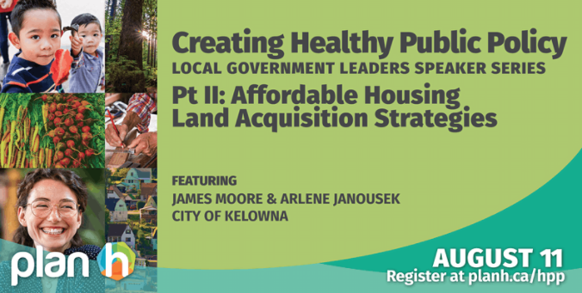

Creating Healthy Public Policy: Affordable Housing Land Acquisition Strategies
date-iconWed, Aug 11, 2021
time-icon11:00AM-12:00PM
Housing affordability is a key issue for many local governments across the province. Its effects can be felt across a community through secondary impacts such as homelessness, labour shortages, strained transportation networks, hampered local economic development and diminished participation in civic life.
Many communities in B.C. are exploring the use of land acquisition strategies to proactively respond to these challenges, guide decision-making and help create property portfolios that lend themselves to the community’s strategic priorities and goals.
As part of our Local Government Leaders Speaker Series, BC Healthy Communities is pleased to present Creating Healthy Public Policy: Affordable Housing Land Acquisition Strategies on August 11, 2021 at 11am Pacific. This session, featuring James Moore and Arlene Janousek from the City of Kelowna's planning department, looks at Kelowna's experience developing a strategy to support the acquisition of land that can be used for affordable housing.
Designed for elected officials and staff in decision-making roles, each event in the speaker series provides participants with the opportunity to explore whether a similar policy fits their community's needs, and to consider the next steps needed to advance action towards adopting such a policy. Following the presentation, attendees are invited to stay for an optional virtual networking session to meet with other local government leaders interested in adopting similar policies, using small group breakout rooms to explore specific topics.
The Creating Healthy Public Policy: Local Government Leaders Speaker Series is supported through PlanH, a partnership between BC Healthy Communities Society and the BC Ministry of Health and is informed by health authorities and other stakeholders. PlanH creates healthier communities by supporting partnerships across sectors, providing learning opportunities, resources, and consultation, and facilitating collaborative local action.
KAREN’S NOTES:
Jacob Cramer, B.C. Healthy Communities
Goal of B.C. Healthy Communities (BCHC) plan H
- Thriving, equitable communities
- Improve the lives of constituents
- Interplay between health and housing
- Social determinants of Health, with broad social economic & environmental factors that are beyond the individual’s control, that impact health.
Equity – Fair distribution of resources, power and opportunity
Negative consequences of poor, unsafe housing:
- Inadequate labour
- Isolation
- ?
Need new tools and collaborations.

City of Kelowna case study.
James Moore – policy planning manager , jmoore@kelowna.ca
Arlene Janousek – planner, works in housing and social development ajanousek@kelowna.ca

Completed a Affordable Housing Land Acquisition Strategy (AHLAS)
Kelowna has 150,000 residents. Solid growth between 2001 and 2020, 50,000 new residents.
Pressure for new development
As house prices go up, so does the cost of rentals.
Core housing need is identified when equal/greater than 30% of income goes towards rent.
Fixed land base, increasing population = increasing prices.
With people’s increased mobility & migration, prices in Kelowna for single family homes, rose year over year, June ’20 to ’21, by 30%.
Typical cost to people’s budgets:
# 1 is housing
#2 is transportation, related to geography
Acquire land to:
- Minimize transportation costs
- Increase access to amenities and services
Sources:
- Existing city owned land, opportunistic acquisition of land
- Infill & intensification are considered.
- Assemble existing lots
- Market available
- Change land use, with rezoning
Need for a strategy of affordable housing land acquisition, ongoing.
Shovel ready projects are more likely to attract grant money for construction
Cost of inaction is a worse outcome than the cost of action now.
Developed a tool, called a WHEELHOUSE:

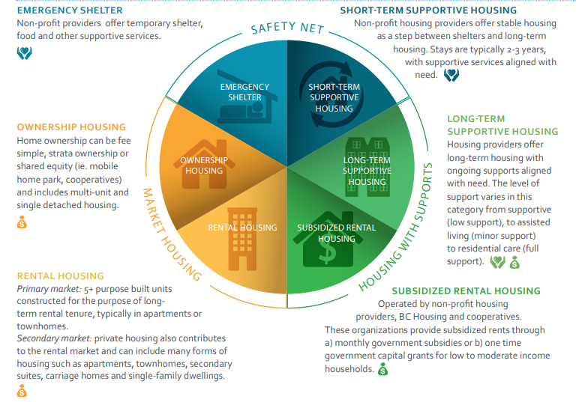
This depicts the different categories of housing, and the sectors within.
Currently Kelowna is working on subsidized rental housing, but also other sectors.
Where are the biggest priorities?
- Every section in the Wheelhouse
- Diversity of supply of houses & ownership housing
- Homelessness
- Subsidized rental housing (non market rates)
- Safety net housing
New development has a role to play. Ways they can do this:
  - Contribute a % of the project as affordable
  - Make a land donation for affordable housing
- Pay a density bonus, on rezoning
- Contribute cash, in lieu of other options
Leverage external partnerships
Normal scale of projects is 40 housing units
Full report: https://www.kelowna.ca/sites/files/1/docs/logos/healthy_housing_strategy_final_reduced_size.pdf
City of Kelowna, sources of funding, annually:
- Taxation – established a Housing Opportunities Reserve Fund
- Online Accommodation Platform (MRDT affordable housing component) 0AP

Reminders to the participants:
Housing Needs Reports, deadline April 2022
Legislation: https://www2.gov.bc.ca/gov/content/housing-tenancy/local-governments-and-housing/policy-and-planning-tools-for-housing/housing-needs-reports

An overview of Housing Need Reports
Legislative requirements took effect April 16, 2019 and require local governments to collect data, analyze trends and present reports that describe current and anticipated housing needs in B.C. communities. A three-year funding program, administered by the Union of B.C. Municipalities (UBCM), along with data and guidance provided by the B.C. government, will support communities to meet the new requirements.
Housing needs reports are a way for communities to better understand their current and future housing needs. These reports can help identify existing and projected gaps in housing supply by collecting and analyzing quantitative and qualitative information about local demographics, economics, housing stock, and other factors. A housing needs report is critical to developing a housing strategy or action plan.
Together, legislation and regulations specify requirements for local government related to housing needs reports. These requirements include:
- Collecting information to identify current and projected housing needs,
- Using that information to prepare and publish an online housing needs report which shows current and projected housing needs for at least the next five years, and
- Considering the most recently collected information and housing needs report when amending official community plans and regional growth strategies

Partners in providing affordable housing:
- Non profit housing providers
- B.C. Housing
- Private sector
Generally land is the stumbling block
CAPACITY AT THE CITY OF KELOWNA
- Much less than larger centres
- Equivalent to 3 to 4 full time staff working on all aspects of housing planning
Council reports:
  - Housing Needs Assessment
  - Housing Strategy

Partners:
- Regional housing provider to build and manage
- B.C. Housing to fund
- Ideal partner to provide land, do the build, manage the operation
- The provincial economic trusts (ICET, NDIT, etc.)

FAQ
Rural limitations – staff & financial constraints
First step – establish the need for affordable rental units
If using taxation for land acquisition
– establish the program with a small “ask” to start, move up from there
- Show what the total, 100% need is, the full scope, then retract to a modest start.
“missing middle” housing – Ownership model. Adv. Is that it doesn’t need a manager or operating component.
One government strategy can be that there are different approval dynamics for smaller projects, than larger.
Some ideas for participation:
- Hold an infill design competition
- Pre-zoning and getting land ready for the market
  - Allows smaller developers to act quickly and avoid costly approval process delays
- Have catalogues of pre-approved building designs
  - Avoid standard process for approvals
B.C. Province – study on housing supply & affordability
Costs of development a hinderance
Released June/21: https://engage.gov.bc.ca/app/uploads/sites/588/2021/06/Opening-Doors_BC-Expert-Panel_Final-Report_Jun16.pdf
Consultations for the Needs Assessment:
  - “Lived experience” people
  - First Nations
  - # of different voices
  - What housing and for whom?

Castlegar – donating land, offsetting approvals, etc. But the cost of construction is still too high to deliver affordable housing.
(note: Hornby – doesn’t have to build to mountain standards.........different?)
Municipal contributions can include:
- Land
- Financing
- Reducing construction costs
Not just limited to land acquisition.

NOTES SENT BY THE ORGANIZERS: Aug. 13/21
Johanna Henderson | BC Healthy Communities <johanna@bchealthycommunities.ca> | 8:31 AM (1 hour ago)
to bcc: karenross

Thanks so much for joining us yesterday for the second event in our Creating Healthy Public Policy speaker series! We hope that you left with a good sense of whether an affordable housing land acquisition strategy would be a good fit for your community, as well as more context around the concept of healthy public policy overall.

One of the main goals of this series is to reduce barriers to local and Indigenous governments implementing healthy public policies. We took a quick poll during the session to get a sense of how the session was working for folks, but if you’d like to offer additional feedback or ideas, we’d love to hear from you—just reply to this email to start a conversation.

Share the recording with your colleagues
As promised, we’ve published a recording of the presentation—please share it with your colleagues or anyone else you think may be interested in an affordable housing land acquisition strategy and other healthy public policies.
- See the recording
- Download the slides

Keep learning
Here are a few other links we shared in the chat during the presentation:
- Check out our PlanH Healthy Housing Action Guide full of examples from communities across B.C., information on legislation and funding, and more
- Learn more about the Social Determinants of Health on the Canadian Public Health Association’s website
- See Kelowna’s Journey Home Strategy and Healthy Housing Strategy

Take some next steps
- We outlined some potential action areas at the end of yesterday’s event. Here they are again, with links:
- Visit our Healthy Public Policy page, or read our blog article about the role of equity in Healthy Public Policy.
- Speak with our Healthy Communities staff about topics including land use and social planning, equitable community engagement design, local economic development and active transportation
- Take the National Collaborating Centre for Healthy Public Policy’s free Framework for Analyzing Public Policies course
- Tune in to the next 2 talks in this series—subscribe to our newsletter to be notified of upcoming events
- The deadline given in the provincial legislation mandating Housing Needs Reports is April 2022.

Keep the conversation going
Want to connect with one of our presenters? Their contact information is below:
- Jacob Cramer jacob@bchealthycommunities.ca
- James Moore jmoore@kelowna.ca
- Arlene Janousek ajanousek@victoria.ca

Thanks again for joining us. We hope to see you at another of our events in the future! As always, feel free to get in touch with any questions or feedback. You can email us at bchc@bchealthycommunities.ca

Johanna Henderson  Communications Manager  BC Healthy Communities  (she/her/they/them) | 778.404.7791  johanna@bchealthycommunities.ca  bchealthycommunities.ca  300 – 722 Cormorant St  Unceded Lkwungen Territories  Victoria BC V8W 1P8

