May 12/22
Quick report on the meeting May 11/22 regarding Island ferry service, with Minister of Transportation, Rob Fleming, and our MLA, Josie Osborne, and some of their staff.
Daniel Arbour (Regional Director), Grant Scott (Island Trustee), Karen Ross (HICEEC) and Danyn Fine (observer, Sizzle) met with the government in the Caucus meeting room at the Legislature to plead the cause for improved capacity on the Hornby and Denman ferries.
The main points we highlighted were:
- moving the schedule forward for short and long-term plans, for vessel replacements/upgrades and terminal redevelopments, for both routes
- emphasized that these routes have some of the worst performance records in the fleet (summer overloads and utilization)
- our dire concerns regarding safety and liability from using narrow 2 lane roads as parking for ferry line-ups
- that the downgraded capacity of the Kahloke renders it as non-serviceable
- how much we appreciate our ferry crews and the jobs they do, and how their working conditions are impacted negatively when the ferries they work on are under-capacity
- that the Provincial government is actively invested in the Islands with parks, new park acquisitions, etc. and have been very supportive in granting for the coastal fibre optic project, the replacement Hornby school, the new Hornby Arts Centre, the planned Food hub, etc. and that these projects all put increased pressure on our ferries.
- Population increases on both Islands, show approx. 20% increases, 2016 to 2021 and put increased pressure on our ferries.

In summary, both Ministers said they now clearly understand the problems and issues and will encourage BC Ferries to make the needed changes to improve service and alleviate the wait times and congestion on both ferries. Minister Osborne will get back to us after she has had a chance to talk to senior Ferries personnel. We felt it was a productive meeting.
- Karen, Daniel & Grant
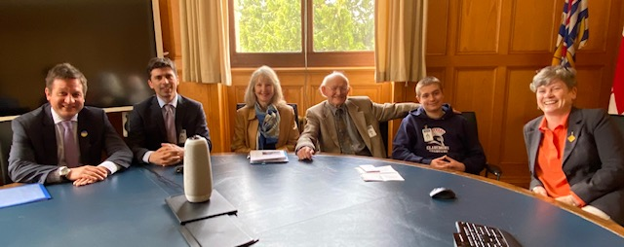
Minister of Transportation Rob Fleming, CVRD Regional Director Daniel Arbour, HICEEC Karen Ross, Hornby Island Trustee Grant Scott, observer (Grant’s grandson) Danyn Fine, Minister of Land, Water and Resource Stewardship and Minister Responsible for Fisheries, Josie Osborne (our M.L.A.)

