Hornby Island Community Economic Enhancement Corporation
A Canadian not for profit corporation

2022 Proposed Bylaw Amendments
To be presented at the 2022 AGM
To be held Sunday, May 29th at 3 p.m.,
New Horizons Centre,
Hornby Island, B.C.

- From:
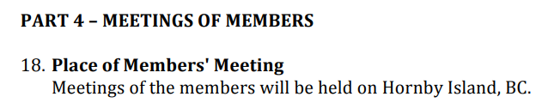
To:
18. Place of Members’ Meeting
In-person meetings of the members will be held on Hornby Island, B.C.

- From:
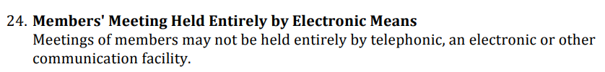
To:
24. Members’ Meeting Held Entirely by Electronic Means
Meetings of members may be held in part, or entirely, by telephonic, an electronic or other communication facility.

- From: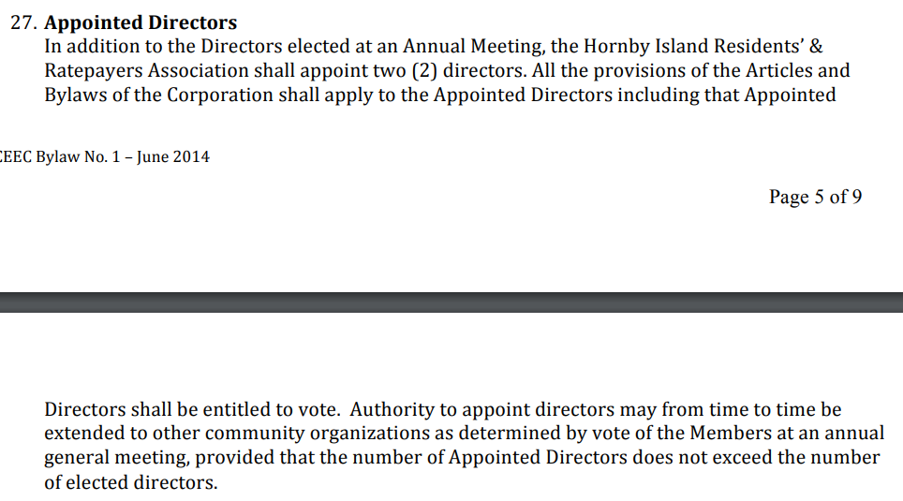
To:
27. Appointed Directors
In addition to the Directors elected at an Annual Meeting, the Hornby Island Residents' & Ratepayers Association may appoint up to two (2) directors, who will be subject to the same approval process as Members, under Section 9 of these Bylaws. All the provisions of the Articles and Bylaws of the Corporation shall apply to the Appointed Directors including that Appointed Directors shall be entitled to vote. Authority to appoint directors may from time to time be extended to other community organizations as determined by vote of the Members at an annual general meeting, provided that the number of Appointed Directors does not exceed the number of elected directors.
Directors does not exceed the number of elected directors.

