Hornby Island

Proposal: Future of Modular

Elementary School,

School District 71

Dec 21/20

HICEEC
Prepared for the Comox Valley Regional District
Authored by: Karen Ross

Hornby Elementary Temporary School
The new Hornby Elementary School is being built, and the current modular complex will be decommissioned.

Temporary Hornby Island Elementary School
Modular Complex – History
In August of 2018, there was a serious fire at the Hornby Elementary School.

Due to the severity of damage, and the condition of the school, the whole 165 student school was demolished. The school site is 2.56 hectare site.

In order to continue school services, School District 71 authorized the construction of a temporary school complex at 2100 Sollans Road, on a corner of the school property.
Modular units were built in Squamish and in Feb./19, barged to Hornby Island, where they were trucked to the current site, and located onto the waiting foundations, with giant cranes.

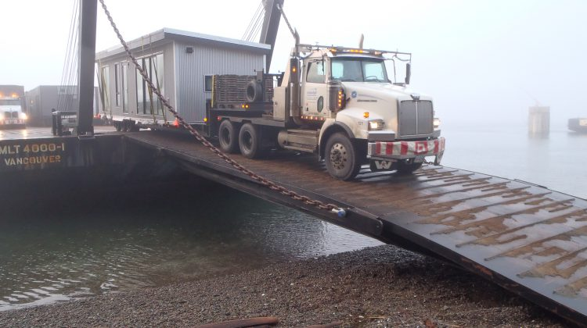

3 classrooms: 25’ x 40’ each (plumbed-washrooms & classroom sinks, and individual heat pumps)
Library: 25’ x 40’, no plumbing (individual heat pump)
Administration building: 12.5’ x 50’ (washroom & individual heat pump). This is also the location where the electric drop for the whole complex comes in.

The contract for a new 85 student, $10 million school, was awarded to AFC Construction. The work is progressing nicely, and the new school is currently scheduled for occupancy is Sept./21

The modular complex will be decommissioned when the new school opens.

Temporary Hornby Island Elementary School
Modular Complex Siting

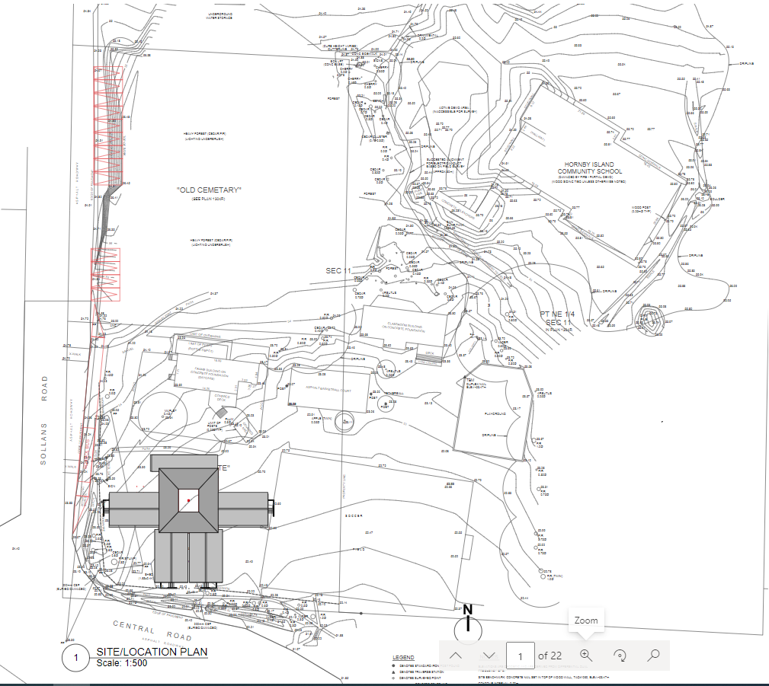

Temporary Hornby Island Elementary School
Modular Complex Layout

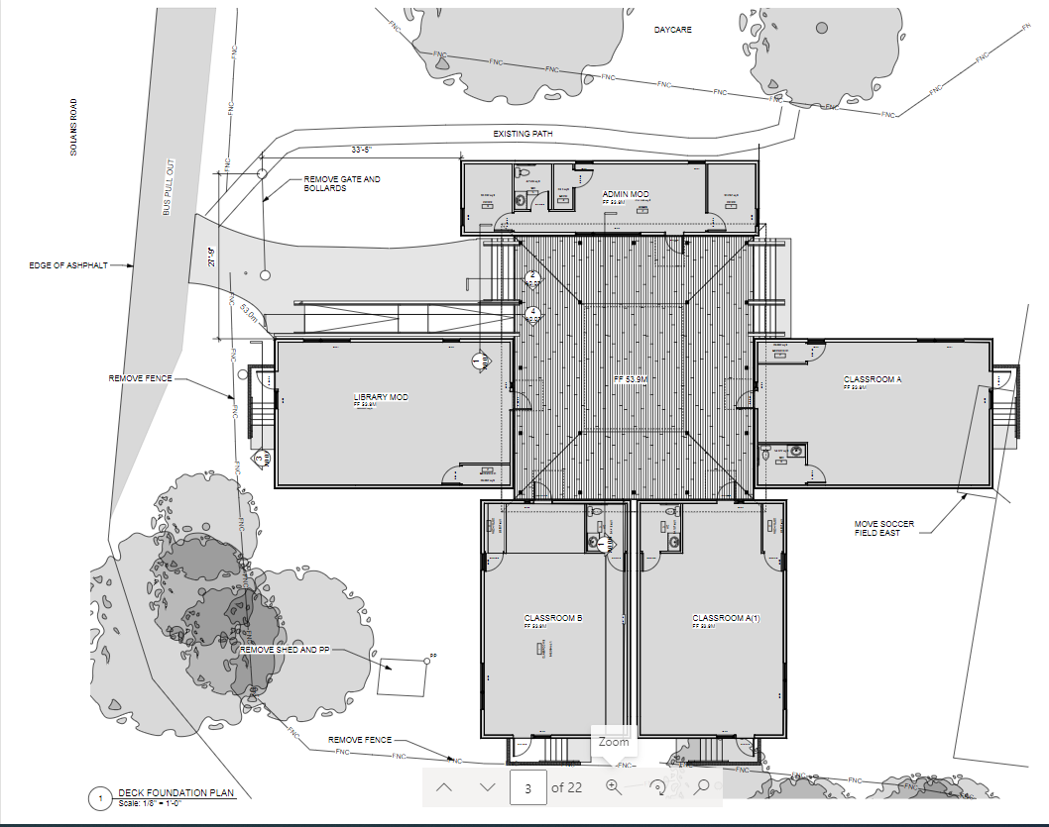

Temporary Hornby Island Elementary School
PICTURES – Administration Modular Building
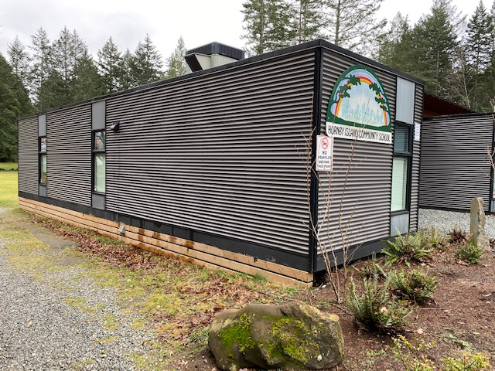

Temporary Hornby Island Elementary School
PICTURES – As seen from Sollans Road
Administration Building on the left
Library, new home for the Natural History Centre on the right

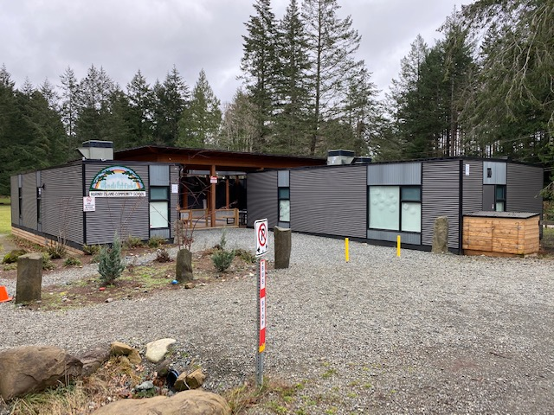

Temporary Hornby Island Elementary School
PICTURES – As seen looking towards Sollans Road
Community Hall viewed in between buildings

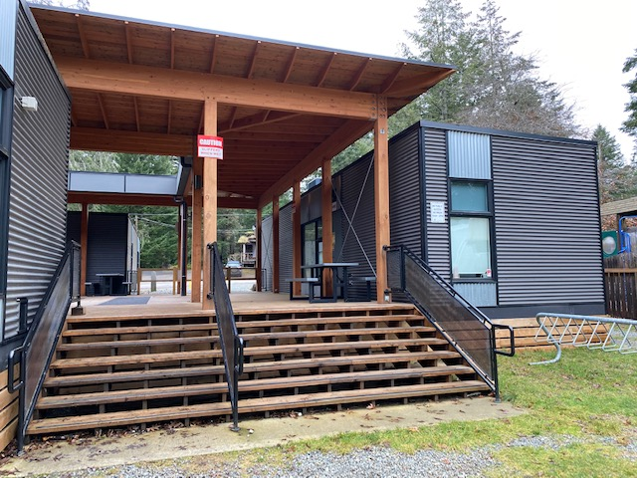

Temporary Hornby Island Elementary School
PICTURES – As seen from School Playing Field
Administration Building on the complex right
(the building on the right side is a covered sandbox
at the adjacent preschool)
One of 3 modular classrooms, on the left/front of the complex

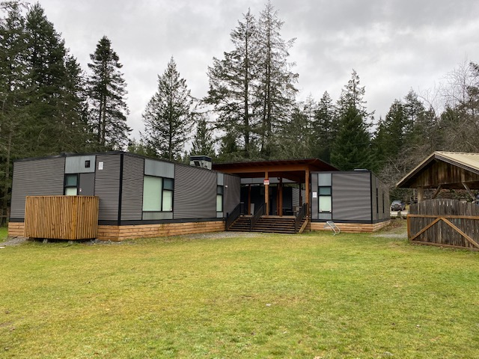

Temporary Hornby Island Elementary School
Modular Complex
Typical Classroom Plan (3 modulars), plumbed
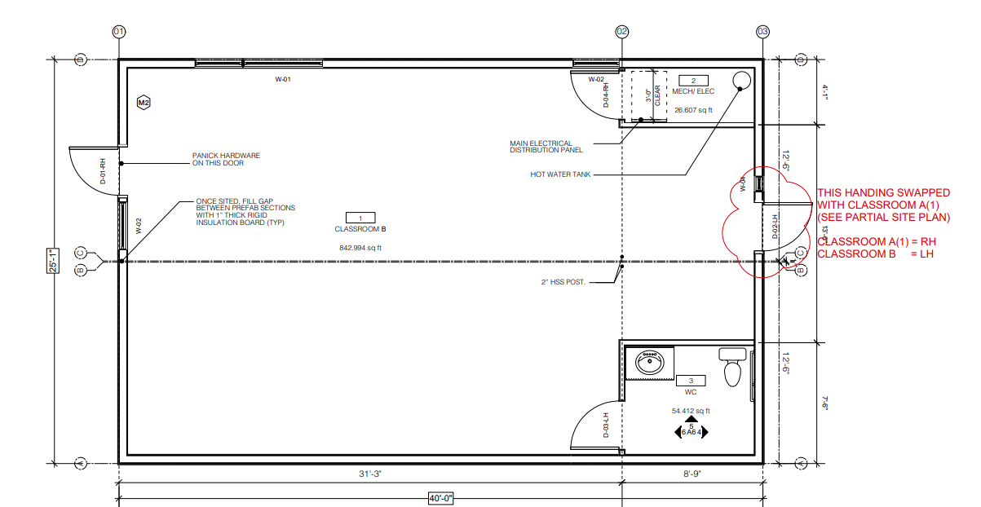
Library – no plumbing
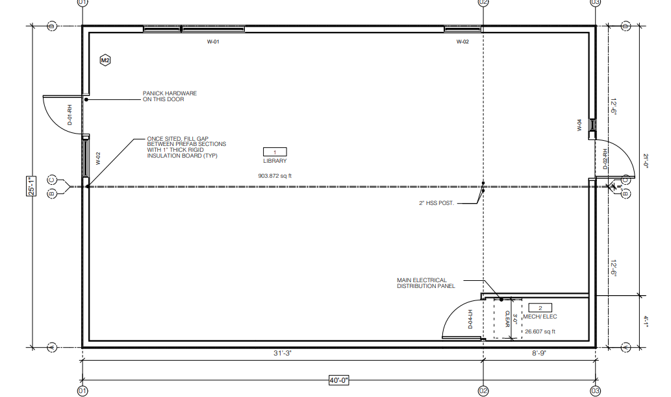

Temporary Hornby Island Elementary School
Modular Complex – Administration Building Description
Age: 2019

Size: 12.5’ x 50’

Floor plan: An office on either end, with a communal area and a washroom in the middle section

Heating: Roof mounted heat pump

Electrical: The main electrical drop for the whole complex. LED & advanced energy saving devices (Very in line with the HICEEC mandate to support green energy initiatives.)

Internet: There is currently fibre-optic internet to this location. If that could remain, as part of the School service package, it would save the Hornby taxpayers money.

Water: The entrance point, for the complex, for services. The complex has an adequate water supply, which is always important in a rural area served by individual wells.

Plumbing: The building has a washroom, and is believed to be connected to a current, approved septic system.
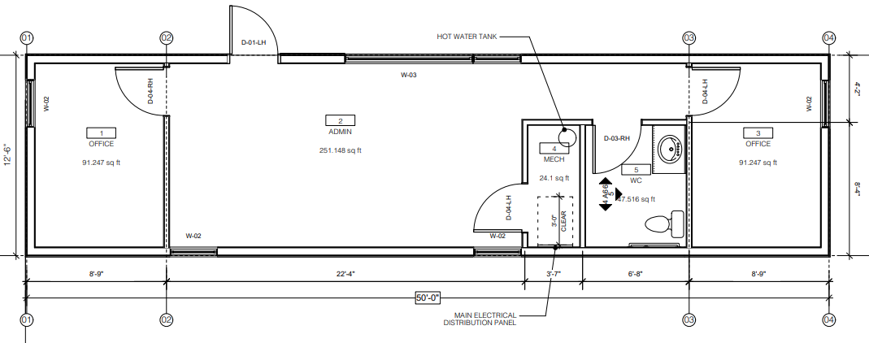

Temporary Hornby Island Elementary School
Modular Complex – Decommissioning

With the anticipated completion of the new Hornby Island Elementary School in 2021, with scheduled opening for September, 2021, the modular complex will cease to be needed as a temporary school.

Opportunities for having the modular remain, on the island, are now under discussion. What would the costs be of the School District removing the modular from the island, for use in other locations in the District?

Anticipated Costs of Decommissioning the Complex, for use off-island:

- Removal of the modulars – reversal of the set-up: crane, truck, barge, truck. Environmental process in building a landing site for the barge on Hornby.
- Modular complex site remediation
  - Removal of the seismetically engineered foundations
  - Restoration of vegetation
- Given that the Library modular will remain, as per the agreement for providing space for the Natural History Centre, the services will need to be extended to that building
- If the other buildings are removed, additional construction will be required to cover the exposed sides with new skirting, deck railings, and roadside wind screens.

If the modular were to be left on island, but moved, some of these costs would also have to be considered.

The cheapest cost of decommissioning would be to leave the whole complex, intact, for alternate community uses.

Temporary Hornby Island Elementary School
Modular Complex

We’d like to talk
The Hornby Island Community Economic Enhancement Corporation (HICEEC) is a tax funded organization, under contract to the Comox Valley Regional District (CVRD) to provide the Economic Development function. This is implemented in a holistic, Hornby style to include the impacts, and importance of decisions, on all sectors of the economy:

The work on Hornby Island to improve the economic reality is challenging. In the Comox Valley Community Foundation’s 2018 Vital Signs report, Hornby was identified as having the highest poverty rates in the valley.

During public consultations to develop the 2015-2020 Hornby island Economic Action Plan, lack of office & industrial space was identified as the Number One priority in the community. (http://www.hiceec.org/hornby-statistics.html)
That scarcity of commercial and industrial space still exists today.

In order to carry out it’s important work, HICEEC itself is in need of office space. Their current arrangement expires Feb/21. HICEEC has been looking for a suitable space since Feb./20. HICEEC has included securing office space in their 2021 budget, and Peter had spoken to Mark Jones, at the UBCU, regarding borrowing money to purchase a building. No business plan has been undertaken yet, but access to some capital money appears viable.

HICEEC would like to investigate acquiring the Administration Building, in place.

HICEEC believes that a viable collaboration between School District 71, the Comox Valley Regional District, the Natural History Centre, and HICEEC could address the lack of office space, in the best interest of all parties and the community.

Temporary Hornby Island Elementary School
Modular Complex

Community Opportunities
The Natural History Centre was previously housed in the Elementary School, the fire left them without a home. The collection has been rehabilitated, from the smoke damage, and is being temporarily housed in 2 storage containers on the school site.
During visioning for the new school, the need to house the exhibits was second only to the need for a gymn. Unfortunately, the new school facility will not have room for the Centre. However, the School District has not turned their back on them. They have given the Natural History Centre (NHC) a verbal agreement to lease the Library modular to repurpose for the Natural History Centre. (NHC is a sub committee of the Hornby Island Education Society)
The agreement is for the modular to remain in place, with a long-term lease to the NHC, for an annual rent of $1/year. The School District will retain ownership of the unit. The NHC will be responsible for the operational and maintenance costs during the lease period.
As well as providing the natural history exhibits, the Centre also focuses on education. Including tutelage on conservation, respect for the fragility of Hornby’s environment, the need to conserve water, and the importance of fire prevention. The centre’s presence benefits the visitor economy, local residents’ access to speakers and educational opportunities, and provides employment. These functions are all closely aligned with the work that HICEEC does. HICEEC has consistently supported the work done at the Centre, with grants totalling $8450., $2500. of which was given in 2020 to assist with re-establishment efforts for the Centre.

HICEEC and the Natural History Centre have been in discussions regarding collaborating at the Modular Complex.

On Dec. 20/20 a small group of HICEEC, NHC, and School District 71 Chair, Sheila McDonnell zoomed together in further discussions.

HICEEC is proposing a collaboration whereby they would buy the Administration building, for their own office use. This would also allow HICEEC to provide access to the washroom, electrical drop, water, sewer and internet for serving the Natural History Centre.

