February/22
Route 22: HORNBY FERRY – KAHLOKE
Hornby Island is a ferry dependent community and the ferry service is our life-line for moving of goods, services, and people.
Notes from a current crumbling situation:
The Ship: The Kahloke
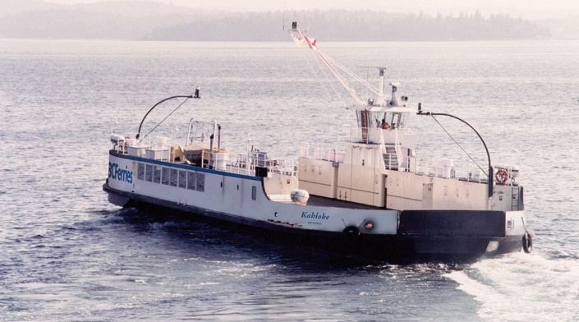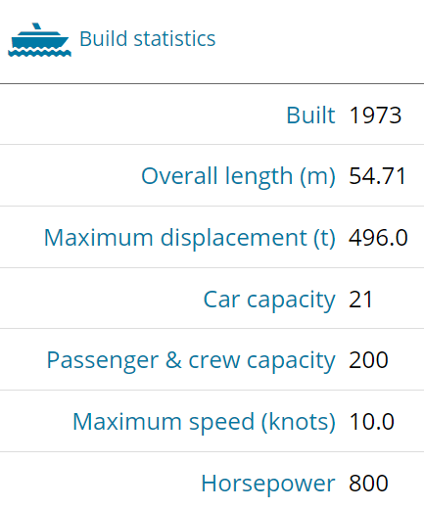
Source: https://www.bcferries.com/on-the-ferry/our-fleet/kahloke/KAHL
WHY HORNBY NEEDS A LARGER FERRY
New development:
In the Spring of 2021, Transport Canada requirements initiated a routine light ship survey on the Kahloke, the results were received in the Fall, November-ish/21. As a result of the survey, and the age of the ship, the carrying capacity of the Kahloke has been reduced by a significant amount.
NET RESULT: REDUCED SERVICE CAPACITY. Refer to the end of this report to put a human face to the stories coming in.
What’s on the horizon:
Commercial traffic is on the increase.
- With rising home prices, more and more commercial service providers are coming from off-island.
- With increasing population, more demands are being made on the supply chains serving the Island.
- Hornby is expanding. A new school was just completed. A new fire hall a few years ago. New hospitality developments are in the works at Ford Cove and The Thatch. The Arts Centre is scheduled to be built in 2022. A 26-unit housing complex is in the works. Old houses are coming down and new ones going up.
The numbers are in:
Population on Hornby has increased 20.3% in the past 5 years (2016 to 2021)

Source: Statistics Canada Census data
B.C. Ferries has been unable to respond to this increasing population with the current ferry. Despite Provincial Government COVID travel restrictions, in 2020 and 2021, demand for Hornby ferry service was barely affected by the pandemic.
Hornby is routinely operating at over 100% capacity all summer long.
Shuttling and crew overtime have routinely been implemented to try to address the situation.

B.C.Ferries rates the Kahloke with capacity for 21 vehicles (this would be the average from the mix of cars, trucks, recreational units and commercial vehicles)
Peak season there are 11 scheduled runs/day (except 14 on Fridays)
The math: pre-pandemic, August/19:
Capacity: 7476 vehicles
# vehicles moved: 10,102
(Source: https://www.bcferries.com/web_image/hea/h52/8798759649310.pdf)
Conclusion: During peak travel times ferry line-ups are already 4 or 5 ferry waits. Before the reduced capacity the Kahloke already couldn’t meet the demand.
Supply Chain Demand Increases, annually increasing pressure:

Public Services Demands Increasing:

Hornby Island Recycling Depot Trucking off Island
Breakdown to Landfill and Diverted from Landfill

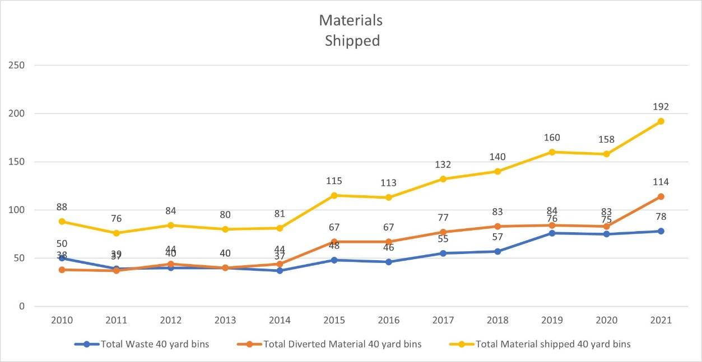

What happens to the service when capacity is reduced OR demand increases?
Facts:
- With enforcement of the new ship survey, the capacity of the vessel has been reduced

- New census numbers show a 20.2% increase in Hornby population, 2016 to 2021

- Graphical depictions prove an increase in commercial vehicle demand for the route. Commercial traffic will displace residential traffic, and ferries will be routinely running with empty deck space.

RESULT: A 49 year old, deteriorating vessel, is being asked to do the impossible.
THE KAHLOKE CANNOT PROPERLY SERVICE ROUTE 22

Suggested solution: Put the Quinitsa on the Hornby route.
The Quinitsa is rated for a load of something like 240 tons. And a 50 car capacity.
- Solve the current reduction in capacity from the load-line problem
- Cut down on the need for shuttling (and wear ‘n’ tear on the aging vessels)
- Fiscally responsible with less crew burnout, and overtime wages paid
- Only require one more staff per watch, so an economical solution
- Improved safety with a much better crew to client ratio
- Better public relations for BC Ferries
- Enhanced support for business and the Hornby economy as supply chain interruptions from missed ferries are eliminated
- Responsive access for the people of B.C. to access Helliwell Provincial Park, Tribune Bay Provincial Park, and the newly acquired Tribune Bay Campsite
Real Life Stories:
Only in the movies: The 2021 Netflix series “The Maid” was filmed using the Quinitsa for their shooting. i.e. It appears this was a private contract of a vessel needed to provide service to ferry dependent communities
Wait for me: On Friday, February 4^{th/22}, regular service deliveries/vehicles coming to Hornby caused an overload. Grant Morrison hauling gravel onto the Island (45 tons), CTS delivering to Island stores and restaurants (20 tons) and 8 cars comprised a full legal weight load. That load represented 1/2 of the total available deck space onboard the vessel. Other vehicles and people were left behind at Buckley Bay, watching a ½ empty ferry leave them behind.

Where did they go? Thursday, February 10th/22, FB: Michael Hamilton “As a result of the new system the trip across this afternoon took 3 1/2 hours. The 2 pm was at max weight capacity, so the kahloke shuttled the remaining cars at 2:35. But the bs con didn’t shuttle, thus leaving us in the denman west que for two hours. Qued up on hornby at 1:45, arrived in Buckley bay at 5:15.”
This is February! Can you imagine the summer?

THE solution is at hand:
Deploy the Quinitsa FULL TIME, YEAR ROUND on Route 22 until a new higher capacity ferry is designated.

Move up the schedule for a new ferry on the route (from the current suggested time frame of 2034).

