THE HOUSING CONTINUUM The Housing Continuum describes the range of housing in a community, both market and non-market housing. Non-market housing refers to housing below market rents or prices, ranging from emergency shelters through various forms of supportive housing and housing co-operatives. Moving across the continuum to the right is market rental housing and home ownership.The mix of market and non-market housing varies depending on community, as every community has a different socio-economic make-up and community-specific needs. However, residents should have the opportunity to move across the housing continuum and find housing that is most appropriate and best suited to their needs and circumstances, and housing that meets housing standards of adequacy, suitability, and affordability. To meet the needs of residents, communities strive to maintain housing across the continuum, identifying and filling gaps when needed.
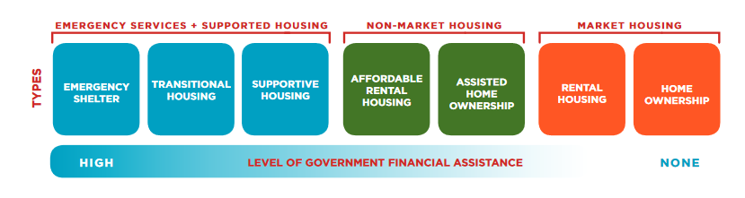
Source: City of Nanaimo Affordable Housing Discussion paper, April 2018
Prepared by: CitySpaces Consulting Ltd.

Hornby Island 2016 Census
Population and dwellings
Population, 2016^{Census data footnote 1} | 1,016
Population, 2011^{Census data footnote 1} | 958
Population percentage change, 2011 to 2016 | 6.1
Total private dwellings^{Census data footnote 2} | 1,104
Private dwellings occupied by usual residents^{Census data footnote 3} | 560

42% of the population is over 65 years old.
Average age 55, median age 61

The tourism economy is vital to Fernie’s overall economic sustainability and prosperity with over 307,000 visitors annually and over $100 million in visitor spending[1]. Over 42% of businesses in Fernie are directly impacted by tourism and 93% of businesses indicate that tourism is an economic driver with the greatest growth potential[2]. The future of tourism in Fernie is very optimistic with opportunities for further growth.

