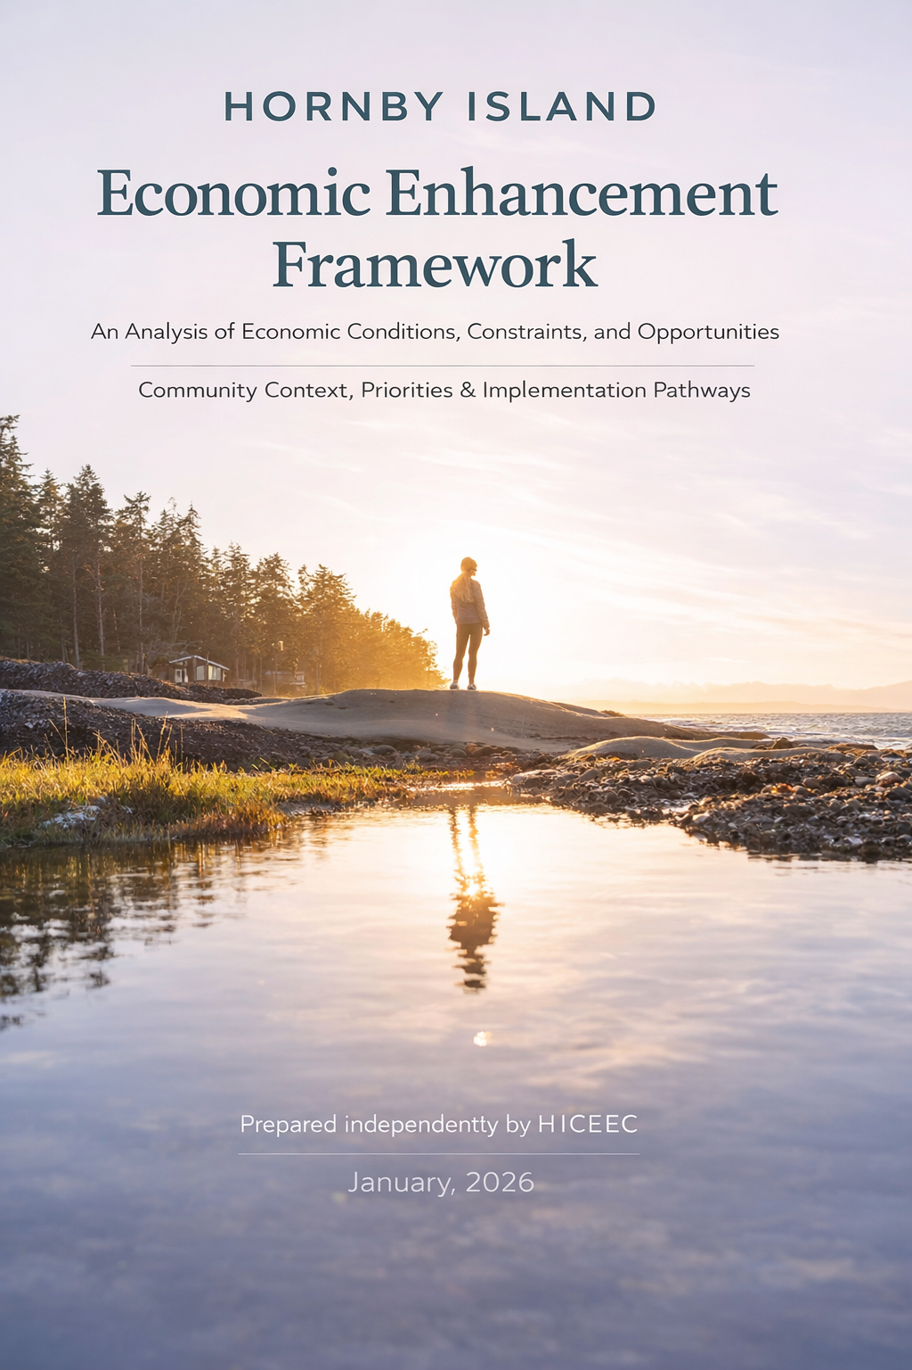

About This Report

Purpose and Scope of the Document
────────────────────────────────────
This document brings together available information on economic conditions, community priorities, and system-level factors influencing Hornby Island’s long-term resilience. It is based on a consolidation of community engagement records, background research, publicly available data, and independently maintained notes, informed by HICEEC’s ongoing work over the past several years.
The report is intended to provide context and continuity for ongoing community dialogue. Rather than presenting a formal economic strategy, it compiles information, identifies recurring themes, and documents observations about the conditions influencing Hornby Island’s local economy. These include housing availability, transportation and ferry access, visitor accommodation patterns, community collaboration, food sustainability, arts and culture, and the ability to attract and retain families and workforce.
Recent investments in community infrastructure—including the Hornby–Denman fibre broadband network, new housing developments, cultural facilities, and tourism infrastructure—are contributing to the long-term economic capacity and resilience of the island community.
The material presented reflects a combination of historical information, recent engagement, and contextual analysis. It is intended to support a shared understanding of the island’s economic system and the interconnected factors that influence community resilience.
The report does not prescribe policy actions or strategic direction. Implementation and decision-making remain the responsibility of individual organizations, governing bodies, and community initiatives operating within their respective mandates.
Instead, this document serves as a reference resource intended to support informed discussion, collaborative problem-solving, and future planning efforts affecting Hornby Island.
The sections that follow provide a structured overview of the context, evidence, and community perspectives informing this report.

TABLE OF CONTENTS

PART I — CONTEXT & PROCESS 5
1. Background & Approach
2. Summary of the Economic Enhancement Process
PART II — ECONOMIC CONTEXT & EVIDENCE 10
3. State of the Local Economy
4. Community SWOT Analysis
5. Big Wins: Community Investments & Outcomes
6. Digital Connectivity Infrastructure: The Hornby–Denman High-Speed Internet Initiative
PART III — ASSESSMENT & CONTEXT 25
7. Strategy Context and Community-Identified Priorities
PART IV — COMMUNITY PRIORITIES 27
8. Community Systems & Economic Resilience
8.1 Reconciliation & Environmental Stewardship
8.2 Housing Availability
8.3 Constraints of the Ferry Service
8.4 Local Mobility & Access
8.5 Visitor Accommodation Needs
8.6 Collaboration Between Businesses & Organizations
8.7 Food Sustainability
8.8 Arts and Culture
8.9 Attracting & Retaining Families and Workforce
PART V — IMPLEMENTATION OPTIONS 55
9. Implementation Options (Non-Prescriptive)
PART VI — SYNTHESIS & CLOSURE 61
10. Assessment & Evaluation
11. Summary & Closing Observations

APPENDICES & SUPPORTING INFORMATION…………………………66

Appendix A — Community Assets Inventory

Appendix B — Community Profile Highlights

Appendix C — Acknowledgements

PART I — CONTEXT & PROCESS
Purpose of This Document
This document provides a consolidated overview of economic conditions, community priorities, and system-level factors shaping Hornby Island’s long-term economic resilience. It is based on a consolidation of community engagement records, background research, publicly available information, and independently maintained notes, informed by HICEEC’s ongoing work.
This opening section provides background on the community context, governance structure, and engagement processes that inform the work summarized in this report.
1. Background & Approach
Hornby Island is a small rural island community with a year-round population of approximately 1,200 residents (2021 Census). More than 40% of the island’s housing stock is held by seasonal residents, resulting in significant population fluctuations throughout the year. These conditions contribute to a highly seasonal local economy shaped by tourism, recreation, remote work, and small-scale enterprise.
The island is widely known for its natural amenities, including extensive parklands, warm ocean waters, and accessible beaches that attract visitors seeking outdoor recreation and a low-impact coastal experience.
This report brings together recent engagement, background research, and contextual analysis to provide a consolidated overview of the economic conditions, community priorities, and systemic factors shaping Hornby Island’s long-term resilience.
Tourism has historically been a central component of the local economy, particularly during the summer months when the population increases substantially. Shoulder seasons also support economic activity through hiking, mountain biking, marine recreation, weddings, retreats, and cultural events.
At the same time, Hornby Island supports a diverse year-round population that includes artists, retirees, small business owners, remote workers, tradespeople, and young families who value its rural character and strong community networks.
Hornby Island encompasses approximately 29.9 square kilometres, of which roughly 40% is protected parkland. Key destinations include Tribune Bay Provincial Park, Helliwell Provincial Park, Ford Cove, Heron Rocks, Whaling Station Bay, and Shingle Spit. The island is also recognized as a mountain biking destination, with designated trails in Mount Geoffrey Regional Nature Park, Mount Geoffrey Escarpment Provincial Park, and adjacent Crown lands.

1.1 Governance and Service Context
Hornby Island lies within the Islands Trust area, a special-purpose local government created by the Province of British Columbia in 1974 to preserve and protect the ecological and cultural integrity of the Gulf Islands. The Islands Trust mandate is implemented through official community plans, land use bylaws, regional policy development, and land conservation initiatives.
Hornby Island is also part of the Comox Valley Regional District (CVRD), specifically Electoral Area A (Baynes Sound–Denman/Hornby Islands). The CVRD provides a range of regional, sub-regional, and local services, including parks, emergency communications, waste management, fire protection, and water services where applicable.
At the local level, many services typically associated with municipal governments are delivered through community organizations. The Hornby Island Residents and Ratepayers Association (HIRRA), founded in 1973, contracts with the CVRD to deliver services such as fire and emergency response, recycling and waste management, recreation, cemetery operations, and community facilities. The Hornby Island Community Economic Enhancement Corporation (HICEEC), founded in 1998, contracts with the CVRD to deliver economic development services and seasonal transit. Additional community functions are supported by non-profit organizations and volunteers, reflecting the island’s non-municipal governance structure.

1.2 Community Planning and Engagement History
Hornby Island has a long history of community-led planning and public consultation. Rather than relying on isolated planning events, community direction has evolved through ongoing engagement processes carried out over more than two decades. Together, these efforts demonstrate a sustained commitment to public participation, collaborative governance, and incremental decision-making.
2001–2003 — Vision 2020 Community Visioning
Facilitated by HICEEC, this broad community process engaged more than 500 participants through workshops and written questionnaires. The resulting Vision 2020 document articulated shared community values across sectors including environment, economy, transportation, housing, agriculture, arts, governance, and tourism.
2015 — Economic Action Plan (2015–2020)
Building on Vision 2020, HICEEC undertook engagement involving approximately 300 residents to identify practical economic actions aligned with local values.
2019–2021 (completion in 2026) Hornby–Denman High Speed Fibre Optic Internet Project
The Hornby–Denman high-speed internet initiative began in early 2019 and progressed through almost three years of community consultation, technical review, and stakeholder engagement. Hornby Island participated through representation by HICEEC, while Denman Island participation was organized through a committee of the Denman Island Ratepayers Association. A community tax-funding referendum held in November 2021 saw 1,192 voters participate across both islands, with 94% voting in favour, indicating strong community support for improved digital connectivity and related economic and social objectives.
MRDT Stakeholder Engagement (2019–Present)
As the eligible entity for MRDT administration on Hornby Island, HICEEC initiated stakeholder engagement in 2019. Initial work focused on distinguishing Hornby Island from CVRD Area A and securing support from primary accommodation stakeholders. Early decisions included engaging professional consultants to help guide program development and consultation. Following stakeholder engagement and implementation planning, MRDT came into effect on June 1, 2022. Ongoing stakeholder engagement continues in accordance with program requirements, including biannual stakeholder consultations.
2020–2021 — Vision 2020 Progress Review
HICEEC commissioned a review, to be done by the original Vision 2020 lead author, for assessing progress toward earlier goals. Interviews with sector leaders and organizations confirmed progress while identifying emerging pressures related to housing, labour availability, and infrastructure capacity.
June 2023 — Business Housing Needs Survey (Phase 1)
Targeted surveys of local businesses documented workforce housing pressures and operational impacts.
2023 — Economic Enhancement Engagement Process
Building on earlier planning work, a structured engagement process gathered updated community input regarding local economic well-being. Activities included in-person and virtual sessions, thematic round-table discussions, a community-wide survey, and targeted outreach to organizations, regional agencies, and Indigenous economic development representatives. Participation involved several hundred individuals.
June 2025 — Vision 2040 Release (HIRRA and HICEEC Joint Initiative)
Following approximately two years of collaborative discussion, HIRRA and HICEEC released Vision 2040, reaffirming long-standing community values while adding emphasis on reconciliation, climate change, and long-term resilience.
October 2025 — Business Housing Needs Survey (Phase 2)
A follow-up survey revisited workforce housing pressures and supported comparison over time.
Ongoing Engagement Mechanisms
In addition to formal planning processes, Hornby Island maintains several ongoing channels for public input and community dialogue:
- Monthly HIRRA public meetings
- MRDT annual spring stakeholder surveys and fall consultations
- Ferry Advisory Committee (approx. 1995–April 2025)
- Monthly publication of First Edition community newspaper
- Community social media discussion forums
Together, these mechanisms complement formal studies and planning initiatives, creating a layered engagement structure through which community input occurs both formally and informally.

Engagement Culture on Hornby Island
Community engagement on Hornby Island occurs through both formal planning processes and ongoing, relationship-based dialogue. In the absence of a municipal government, governance and community direction are shaped through non-profit organizations, volunteer-led committees, public meetings, surveys, local media, and informal discussion. This layered structure supports incremental decision-making and strong institutional memory while allowing priorities to adapt over time. Together, these processes reflect the island’s preference for gradual evolution grounded in community capacity and shared values.
The engagement history outlined above demonstrates that consultation on Hornby Island has occurred as an ongoing and cumulative process shaped by evolving conditions and recurring priorities. Each initiative has built upon previous work, contributing to a growing body of local knowledge and shared understanding.
The economic enhancement work summarized in the following section should therefore be understood as one stage within this broader continuum. Rather than introducing a new direction, it revisits established themes, updates community input, and clarifies priorities within changing economic and social conditions.



Photo courtesy of HICEEC media library

2. Community Engagement Summary (2023)

In Fall 2023, community engagement activities were undertaken on Hornby Island to gather input related to local economic well-being and priorities. Participation included residents, organizations, and stakeholders across a range of sectors.
Engagement took place over several months and included in-person and virtual sessions, a community survey, and direct outreach, with participation involving several hundred individuals and resulting in qualitative input and identified areas of priority.
This summary is based on records of community participation and contemporaneous notes maintained during that period, and forms part of the community’s planning record for background context.
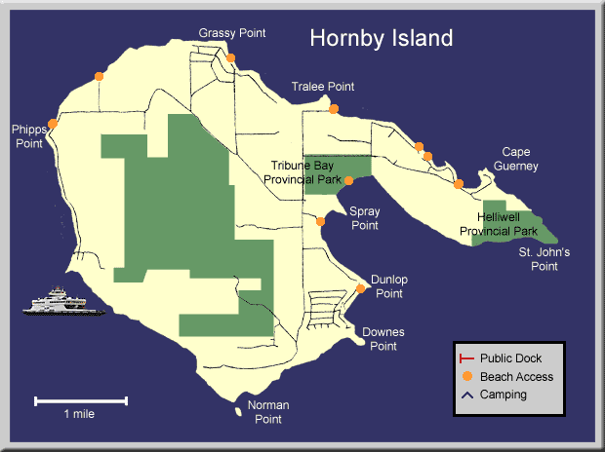

The following section provides background indicators and contextual evidence used to understand current economic conditions on Hornby Island.

PART II — ECONOMIC CONTEXT & EVIDENCE
The following sections summarize available economic indicators and contextual information used to understand current economic conditions on Hornby Island.
3. State of the Local Economy
(Winter 2026 | Independent HICEEC Analysis)
This section reflects independent, internally produced analysis undertaken by HICEEC staff to document current economic conditions on Hornby Island. This work was conducted separately from, and subsequent to, the Economic Development Strategy process initiated in 2023 and is not derived from, or reliant upon, that work. The indicators presented here are descriptive and observational in nature and are intended to provide current context rather than strategic direction. Where helpful, narrative context is included to interpret indicators and explain long-standing structural drivers.
The economic landscape of Hornby Island is shaped by a combination of interconnected factors including tourism, homesteading, arts and culture, seasonal migration, remote work, local businesses, and overall community well-being. The island’s long-standing reputation as an “Art Island” reflects a period when affordable land and the natural environment attracted artists seeking inspiration and connection to an established creative community. Over time, this concentration of artists and cultural activity has become an important component of Hornby Island’s identity, contributing to both cultural vitality and the local economy through visitor attraction, events, and creative enterprise.
Economic conditions continue to evolve as infrastructure and technology change. Improved digital connectivity is increasingly recognized as a critical component of the island’s economic infrastructure. The Hornby–Denman fibre broadband project, expected to be completed in 2026, will significantly improve internet reliability and capacity for residents and businesses, enabling expanded opportunities for remote work, digital entrepreneurship, and online services. These changes are expected to further diversify the local economic base beyond traditional seasonal and tourism-driven activity.
Together, these factors create a complex local economy shaped by environmental values, cultural richness, entrepreneurship, and changing patterns of work and residency. Several key indicators are tracked over time to provide insight into local economic conditions, including community demographics, ferry traffic statistics, school enrollment trends, and local business performance—particularly through the Hornby Island Co-op and Recycling Depot.
3.1 Community Profile Information
A comprehensive summary of Hornby Island’s community profile, covering a range of socio-economic factors such as health, education, and housing, is included in the appendices. For further detail, the full report is available through the Community Profiles website: www.communityprofiles.ca.
Hornby Island’s community profile illustrates key economic and social determinants of health. It identifies recurring challenges and emerging pressures for workers, families, and local businesses, alongside collaborative efforts by local organizations to improve quality of life.
Economic health for residents is commonly associated with stable employment, fair wages, job satisfaction, and safety—factors that contribute to community resilience. The island’s workforce is largely self-employed, with a self-employment rate of 51.55%. Median annual income, at approximately $27,600, remains about 30% lower than the provincial median. Despite these constraints, residents continue to support local businesses and services, helping to sustain local economic activity.
Hornby Island is home to 177 businesses, of which 155 are home-based businesses (HBBs). Of these, 76 identify as art-based businesses. The most common non-art HBBs operate in construction, machinery, and farming. In addition, approximately 131 home-accommodation providers—primarily vacation rental properties—contribute to the local economy.
Non-art HBBs, particularly those in construction and machinery, have benefited from recent economic activity, alongside traditional year-round employers such as the school, health clinic, home support services, B.C. Ferries service, the Coop Store, Gas Bar, and Ford Cove Store. Together, these provide a foundation of year-round employment.
Housing remains a persistent constraint for both year-round and seasonal workers, with limited affordable ownership and rental options. Hornby Island’s remoteness makes off-island employment difficult, and transportation costs—including ferry fares, limited public transit, and vehicle ownership—further affect affordability. Employers continue to report staffing shortages, particularly during the summer season, with notable challenges in attracting skilled workers in healthcare and building trades.
Challenges for Year-Round Workers include:
- Limited housing availability
- Seasonal income dependency
- Restricted year-round employment options
- Difficulty accessing off-island work due to ferry reliance
- Mental health pressures
- Limited access to health and support services, including the absence of full-time RCMP services
Challenges for Seasonal Workers include:
- Housing shortages, often with inadequate living conditions (e.g., lack of potable water or indoor plumbing)
- Limited or unreliable transportation to and from work
Challenges for Employers include:
- Persistent staffing shortages, particularly during peak season
- A limited pool of skilled workers, especially in healthcare, trades, and management
- High living costs and limited year-round housing options
Challenges for the Community include:
- The seasonal nature of many businesses
- Difficulty securing trades and maintenance services
- Transportation constraints, including ferry costs and limited public transit, affecting mobility and access
3.2 Ferry Traffic Statistics
Ferry traffic is one of the most significant indicators of Hornby Island’s economic conditions. Passenger volumes using BC Ferries service provide a direct reflection of the island’s reliance on seasonal tourism. Historical patterns in ferry traffic between 2011 and 2024 illustrate the cyclical nature of the local economy.


30,000
25,000
20,000
15,000
10,000
5,000
0
BCF Denman to Hornby,
by month, 2011 vs. 2024
2024
2024
2011







Tourism continues to play a central role, with peak ferry traffic occurring during the summer months. In 2024, approximately 57% of total annual ferry traffic occurred between June and September, underscoring the seasonal influx of visitors. A substantial portion of this activity—50,776 passengers—occurred during the two busiest summer months. These visitors, along with recreational boaters and seaplane passengers, contribute significantly to the local economy through retail, hospitality, and services.
BCF Passenger Count,
Denman to Hornby,
Calendar Year 2024
30,000
25,000
20,000
15,000
10,000
5,000
0
At the same time, ferry capacity functions as a limiting factor. Infrastructure constraints, including limited water and sewage capacity, have led some community members to express concerns regarding the island’s ability to accommodate peak-season volumes.
3.3 School Enrollment
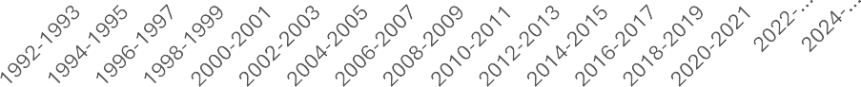
Hornby Elementary School Enrollment 1992 to Sept.24
140
120
100
80
60
40
20
0
Following years of declining enrollment at Hornby Island Elementary School, enrollment trends have shifted upward, particularly since the pandemic, as more households have sought smaller and more remote communities. The opening of the new school in Fall 2021 has also contributed to this change.
Accessible and comparatively affordable preschool services further support this trend, especially when contrasted with rising childcare costs elsewhere. The installation of high-speed fibre-optic internet has facilitated remote work and online learning, enhancing the island’s attractiveness to young families.
Increasing school enrollment and the presence of young families have broader economic implications. Younger households contribute to the local workforce both directly and indirectly, including through part-time and seasonal employment by teenagers. This demographic shift suggests greater population balance and supports longer-term community resilience.
3.4 Coop Store Sales
Hornby Island Coop, Annual Gross Sales Year end January 31st
10,000,000
8,000,000
6,000,000
4,000,000
2,000,000
0
25.00
20.00
15.00
10.00
5.00
0.00
-5.00
-10.00
-15.00
Gross Sales
Percent Change

The accompanying graph illustrates the Hornby Island Coop’s annual gross sales from 2009 through January 2025. Slate-coloured bars represent total annual sales, while the orange line tracks year-over-year percentage change. Notable distortions during pandemic years reflect COVID-related disruptions.
In recent years, sales have plateaued at approximately $9 million annually. A modest 2.5% decline from Fiscal 2024 to Fiscal 2025 may be attributed to reduced operating hours and staffing shortages during peak periods. Overall performance remains strong, underscoring the Coop’s role as a key economic indicator.
As the island’s largest retailer and a member-owned cooperative, the Coop functions as a barometer of both resident spending and visitor activity. Approximately 75% of annual sales occur between June and September, with roughly 70% of those sales attributed to visitor spending. This seasonal revenue surge supports product variety, pricing stability, and operational scale, benefiting both residents and visitors.
The Coop is also undertaking a facility replacement project in 2026. While the new building will maintain approximately the same overall footprint, the rebuild is expected to improve operational efficiency, modernize infrastructure, and enhance the working environment. In addition to supporting long-term business continuity, the construction phase will provide short-term economic activity within the local construction sector.
3.5 Recycling Depot Activity
The Hornby Island Recycling Depot has been a cornerstone of the island’s waste management since 1978, diverting more than 70% of its waste. Its success helps reduce operational costs while creating year-round jobs, supporting local employment, and fostering a culture of reuse and recycling. As the island's population grows, the graph shows increased use of the Depot, reflecting its growing importance to residents and visitors alike.

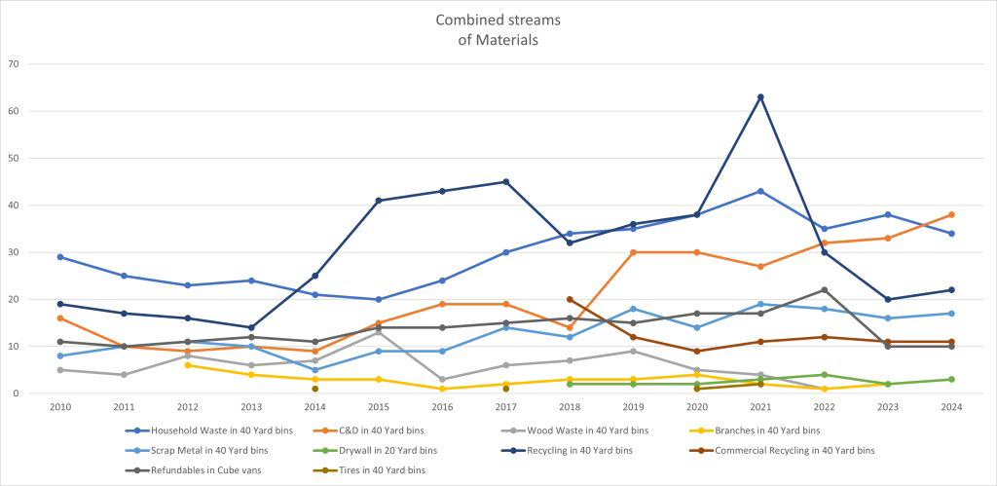
The Depot remains a vital economic and environmental asset, despite the logistical challenges of transporting all waste off island. It plays a key role in reducing local waste and supporting sustainable practices, benefiting both the island’s businesses and its residents. The "Free Store" at the Depot has become a unique tourist attraction, where “shoppers” often brag about their “scores,” further contributing to the Depot’s role as a community resource.
Through its focus on waste diversion and a thriving reuse culture, the Depot not only supports the island's environmental goals but also drives economic activity, making it a key contributor to the island’s sustainability and local economy.

4. Community SWOT Analysis
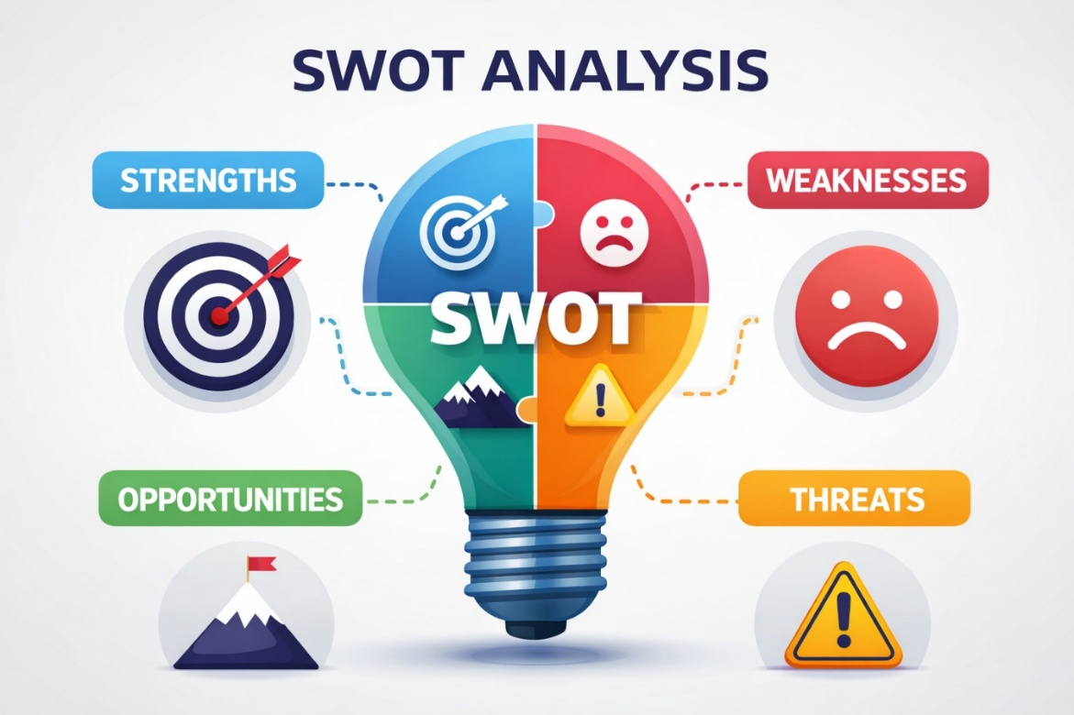

Community-Identified Strengths, Challenges, Opportunities, and Risks

Updated from 2015 with community input through 2025
The following S.W.O.T. analysis reflects community perspectives originally developed through engagement work undertaken in 2015 and updated with input received during consultations between 2023 and 2025. It represents a composite snapshot of recurring themes identified by local businesses, organizations, and residents over time.
This material is included as contextual reference, illustrating how community-identified strengths, weaknesses, opportunities, and threats have been understood across multiple planning cycles. It is not intended to function as a formal assessment or standalone strategic framework, but rather to document patterns of thinking and long-standing issues that have persisted, evolved, or re-emerged within community dialogue.
The following charts summarize community-identified strengths and challenges, followed by opportunities and external risks affecting Hornby Island’s long-term economic resilience.
First page, chart
Strengths | Weaknesses
Next page, chart
Opportunities | Threats

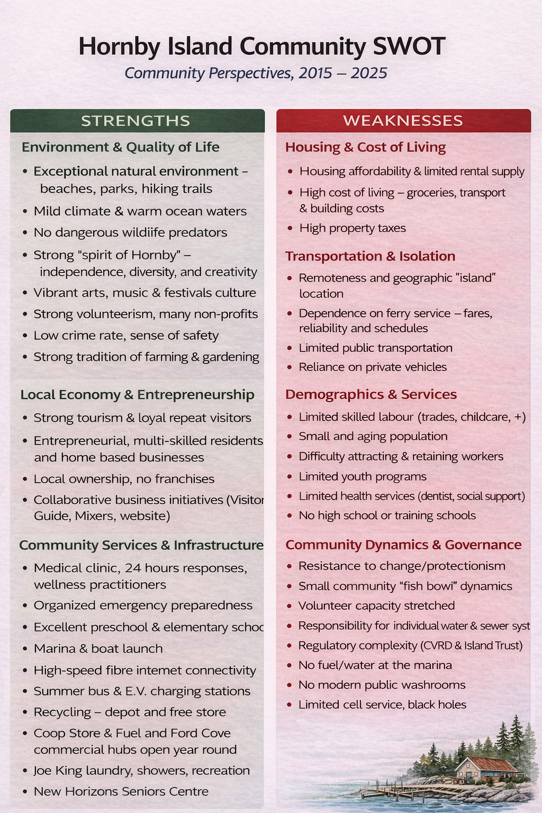
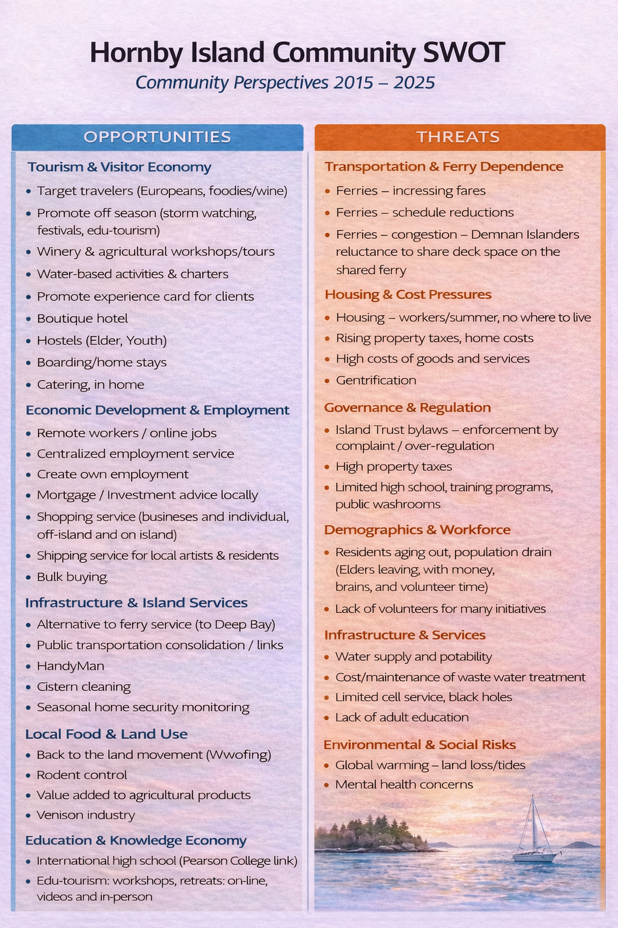
Recent Community Investments and Ongoing Initiatives
While the SWOT analysis reflects community perspectives on long-standing strengths, challenges, opportunities, and risks, it is also important to recognize the substantial public, private, and community-led investments that have taken place on Hornby Island in recent years. Together, these initiatives illustrate how the community continues to adapt, strengthen local systems, and respond to evolving economic and social conditions.
5. Big Wins: Community Investments & Outcomes
The following section summarizes major capital investments, infrastructure projects, and community facilities identified through the Vision 2040 update process undertaken by HIRRA and HICEEC, building on earlier Vision 2020 work. The information is presented as a record of completed, underway, or anticipated initiatives rather than as an evaluation of outcomes or economic performance.
Together, these projects reflect cumulative public, private, and community-led investment over time and illustrate the scale and diversity of changes that have occurred on Hornby Island since approximately 2015. Collectively, these initiatives represent tens of millions of dollars in capital investment relative to the island’s small population.
The table below highlights major projects undertaken between 2018 and 2026.

BIG WINS
Major Community Investments Since 2018
Recent Community Investments and Infrastructure Projects
────────────────────────────────────────────────────────────
Time Frame | Community Investment
2018 | New Fire Hall opened (Feb 2018)  • $1.9M construction investment
Fall 2021 | Hornby Island Elementary School rebuilt after the 2018 fire  • $10.4M construction investment
Nov 2021 | BC Parks purchased 23.7 acres to expand Tribune Bay Provincial Park  • $11.2M acquisition including former 135-site campground
2022–2025 | BC Parks continued operating the campground during redevelopment planning
Fall 2021 | Hornby Island Natural History Centre reopened  • Relocated to Sollans & Central
Fall 2021 | HICEEC secured commercial office space in former school administrative module
Est. 2022 | Ford Cove Store & Cabins opened licensed marina restaurant
Gradual | Agricultural diversification into glamping accommodations  • Fossil Beach Farm  • Heart Vineyard  • L’il Tribune Blueberry Farm
2023 + | Food Hub & Agricultural Processing Facility (REDIP)  • ~$2M project seeking funding
2019–2026 | Hornby & Denman Fibre Internet Project  • Initial investment: Province $5.64M + CityWest $1.203M + local tax funding  • Total project investment: $10.7M
2021–2026 | Thatch Pub & Townhomes redevelopment  • Pub reopened Sept 2025
2022–2025 | Hornby Arts Centre constructed  • $3.1M community arts facility
2025–2026 | BC Parks campground redevelopment – Phase 1  • $6.6M investment  • 69 campsites + 9 bunkies
2025 | Private Rugby Clubhouse and field development
2025 | CVRD Boat Launch rebuild  • $864K infrastructure investment
2026 | Hornby Community Hall accessibility upgrades
Early 2026 | Beulah Creek Village – Makola / BC Housing  • $18M construction investment (excluding land)  • 26 affordable housing units
2026–2027 | Hornby Island Co‑op redevelopment  • $10M construction budget  • New retail complex projected 2027  _____________________________________________________
Collectively, these initiatives represent more than $50 million in public, private, and community-led capital investment, a significant level of development relative to Hornby Island’s small population of approximately 1,200 residents. Together, these projects illustrate the scale and diversity of investments that have strengthened local infrastructure, services, and community capacity in recent years.
Among the most significant of these initiatives is the expansion of high-speed digital connectivity serving Hornby and Denman Islands. The following section outlines the development and broader significance of this infrastructure project.
6. Digital Connectivity Infrastructure: The Hornby–Denman High-Speed Internet Initiative
Reliable high-speed internet has become essential infrastructure for rural and remote economies. Broadband connectivity supports remote work, online commerce, tourism marketing, education, telehealth, and the ability for businesses and residents to participate fully in the digital economy. For geographically isolated communities such as Hornby and Denman Islands, digital connectivity also helps reduce the need for travel, lowering costs and improving access to services and opportunities.
For many years, internet service on Hornby and Denman Islands lagged behind national standards. Surveys of island households conducted during early project exploration indicated that few respondents were receiving internet speeds meeting Canada’s national broadband target of 50 Mbps download and 10 Mbps upload. Residents reported slow and unreliable connections affecting both personal and professional activities, including online education, remote work, business operations, and communication.
Recognizing the importance of reliable connectivity for economic resilience and quality of life, community leaders on both islands began exploring options for improved internet service in 2019. The effort was supported by the Denman Island Internet Committee (DIIC) and the Hornby Island Community Economic Enhancement Corporation (HICEEC), which worked collaboratively to research technical options, engage with potential service providers, and seek government support for improved infrastructure.
Technical feasibility work was undertaken with Baylink Networks Inc., the firm responsible for planning the broader Connected Coast subsea fibre network along the British Columbia coastline. Early engineering analysis demonstrated that a fibre-optic network capable of serving every household on Hornby and Denman Islands was technically achievable, subject to funding and partnerships with telecommunications providers.
Extensive community outreach followed in 2021, including public meetings, surveys, information sessions, and the production of educational materials to help residents understand available options and potential costs. This engagement culminated in an island-wide referendum seeking public authorization for the Comox Valley Regional District (CVRD) to establish a local service to support broadband infrastructure financing.
The referendum demonstrated strong community support for the initiative.
- 94% of voters supported the establishment of the service and associated borrowing authority.
- Voter turnout reached approximately 55% of eligible electors.
- A total of 1,192 valid ballots were cast across the two islands.
The referendum authorized the CVRD to:
- establish and operate a service for financing high-speed internet infrastructure;
- borrow approximately $767,677, repayable over a maximum 10-year period; and
- enter into a 20-year agreement with CityWest Cable and Telephone Corp. to support development of the network.
Project Development Timeline:
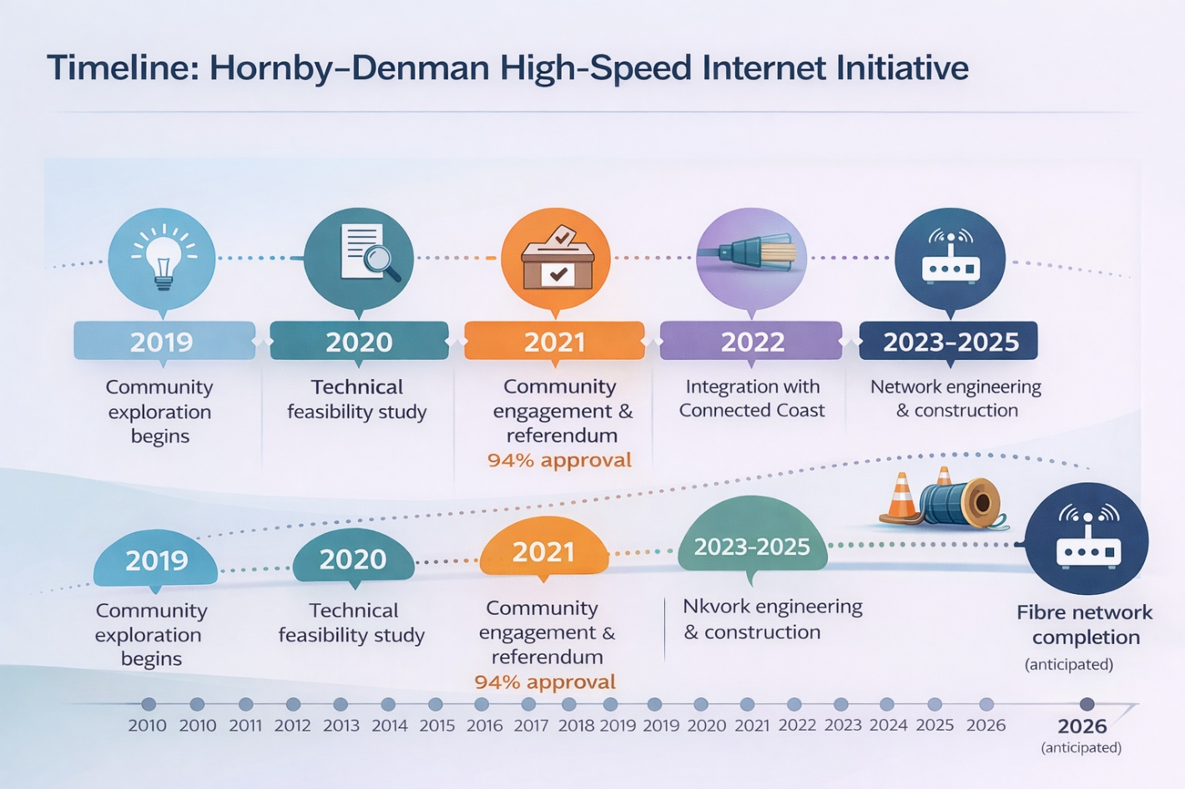
The Hornby–Denman project is part of the larger Connected Coast initiative, a major fibre infrastructure project extending subsea broadband capacity along the British Columbia coastline. Connected Coast will bring new or improved high-speed internet access to more than 130 rural and remote coastal communities, including 48 Indigenous communities representing 44 First Nations, from Prince Rupert and Haida Gwaii to Vancouver Island.
Funding for the Hornby–Denman fibre network reflects a partnership between local communities, telecommunications providers, and senior levels of government. Key contributors include:
- the Government of Canada’s Universal Broadband Fund
- the Province of British Columbia’s Connecting British Columbia program, administered by the Northern Development Initiative Trust
- CityWest Telecommunications
- local taxpayers through the Comox Valley Regional District broadband service
As engineering design and construction planning progressed, the scope of the project expanded beyond early estimates. The total investment in fibre infrastructure serving Hornby and Denman Islands is now estimated at approximately $10.7 million, representing one of the largest infrastructure investments made to support economic resilience and connectivity in the two island communities.
Construction and fibre deployment are currently underway, with completion anticipated in 2026. Once operational, the network will provide fibre-based high-speed internet service to homes and businesses on both islands, enabling significantly improved reliability and performance compared with previous services.
In addition to the infrastructure investment itself, the agreement negotiated with CityWest includes a long-term community benefit provision. Under the terms of the agreement, 20% of net profits generated by the network will be returned to the communities through the CVRD for a period of 20 years following substantial completion of the project. This revenue-sharing arrangement ensures that the long-term economic benefits of the network will support the communities that enabled its development.
The expansion of fibre connectivity represents a foundational investment in the economic future of Hornby and Denman Islands. Reliable broadband infrastructure will support local businesses, remote workers, entrepreneurs, artists, and organizations in participating more fully in regional, national, and global networks. It will also enhance the ability of residents to access education, healthcare, and other services without leaving the islands.
For rural communities increasingly connected through digital networks, broadband infrastructure is no longer a luxury but a critical component of economic resilience, sustainability, and community wellbeing. The Hornby–Denman High-Speed Internet Initiative demonstrates how locally driven leadership and collaboration, strong public engagement, and strategic partnerships can successfully deliver essential infrastructure to remote island communities.
The following section examines the strategic context and community-identified priorities that shape economic resilience on Hornby Island.
PART III — ASSESSMENT & CONTEXT
This section outlines the broader strategic context and recurring priorities identified through engagement, research, and community dialogue.
7. Strategy Context and Community-Identified Priorities
The Hornby Island Community Economic Enhancement Corporation (HICEEC) has undertaken ongoing work over the past three years to support community dialogue and better understand economic conditions and priorities affecting Hornby Island. As part of this broader effort, a $30,000 grant commitment was secured through the Island Coastal Economic Trust (ICET) to support the development of economic enhancement materials.
During this period, community members, businesses, and organizations participated in presentations, discussions, and feedback opportunities related to economic topics. HICEEC acknowledges and appreciates the time and perspectives shared by those who attended and contributed to these conversations.
The consultant work associated with the ICET grant did not result in completed strategy materials or written deliverables being provided to HICEEC. As a result, this document has been prepared independently by HICEEC and reflects work undertaken directly by the organization through ongoing research, submissions, engagement, and operational experience over the past three years.
HICEEC continues to play a central role in supporting economic enhancement on Hornby Island, operating with a CVRD-approved annual budget of approximately $100,000. This budget supports coordination, collaboration, advocacy, and demonstration-scale initiatives rather than direct economic control or program delivery. While modest in scale, these activities contribute to community capacity-building alongside the independent actions of residents, businesses, organizations, and visitors, which collectively shape the island’s economic conditions. In addition, HICEEC supports selected activities through social enterprise initiatives that extend the reach of its investments.
Across the engagement, research, and submissions undertaken during this period, a set of recurring themes emerged in relation to Hornby Island’s economic resilience.
I. Reconciliation & Environmental Stewardship
II. Housing Availability
III. Constraints of the Ferry Service
IV. Local Mobility & Access
V. Visitor Accommodation Needs
VI. Collaboration Between Businesses and Organizations
VII. Food Sustainability
VIII. Arts & Culture
IX. Attracting Families and Workforce
These themes are presented as observations arising from community dialogue and engagement. They are included to provide contextual understanding and should not be interpreted as adopted policy positions or validated strategic conclusions.

Photo courtesy of HICEEC media library
The following sections examine these themes in greater detail, drawing on community engagement, background research, and operational experience. While each topic is discussed individually for clarity, the issues are closely interconnected. Housing availability, transportation, workforce capacity, visitor activity, and community services all influence one another and collectively shape Hornby Island’s economic resilience and long-term sustainability.

PART IV — COMMUNITY PRIORITIES
The following sections examine key community systems and priorities that influence Hornby Island’s economic resilience and long-term sustainability. These themes reflect recurring observations identified through engagement, research, and community dialogue and are presented to provide context for ongoing discussion and future planning.
8. Community Systems & Economic Resilience
Community resilience depends on the strength of interconnected systems including housing, transportation, workforce capacity, environmental stewardship, and collaboration among local organizations.
Figure 8 — Digital Connectivity as a Foundation for Community Wellbeing and Economic Development
(Source: Connected Communities BC)
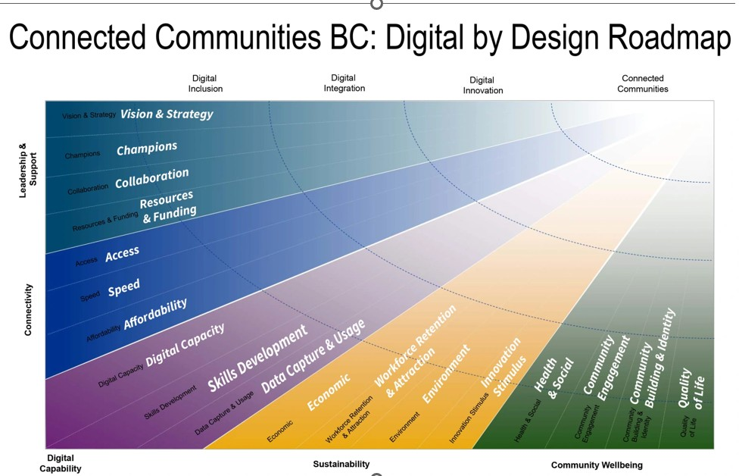
The graphic above illustrates how digital connectivity functions as a foundational component of modern community systems. Reliable broadband infrastructure supports economic participation, access to services, education, and collaboration, strengthening the overall resilience of rural communities.
Economic resilience on Hornby Island is shaped by a complex set of interconnected systems that influence the stability and adaptability of the local economy. Housing availability, transportation access, workforce capacity, environmental stewardship, and community collaboration all interact to affect the island’s ability to sustain year-round economic activity and maintain a balanced and vibrant community.
As a small island community with limited infrastructure and a strong reliance on volunteer organizations, Hornby Island’s economic resilience depends not only on market conditions but also on the strength of local relationships, shared values, and institutional capacity. The island’s social networks, community organizations, and collaborative initiatives play an important role in supporting services, cultural activities, food production, and local economic development.
Infrastructure investments also contribute to strengthening the resilience of community systems. Investments such as the Hornby–Denman fibre network will improve access to digital tools, communications, and remote services for local businesses and organizations. Enhanced digital connectivity is expected to expand opportunities for remote work, entrepreneurship, and access to professional services, while also helping residents and organizations maintain connections beyond the island.
At the same time, the island’s economic systems remain influenced by structural constraints, including limited housing supply, transportation dependence on ferry service, and the seasonal nature of tourism activity. These factors shape workforce stability, service delivery, and the capacity of organizations and businesses to operate year-round.
Community resilience therefore depends on the ability of local institutions, residents, businesses, and governing bodies to respond collaboratively to changing conditions. Many of the priorities identified through engagement reflect efforts to strengthen these interconnected systems while maintaining the environmental values and community character that define Hornby Island.
The subsections that follow explore several key areas identified through engagement and analysis as important contributors to the island’s long-term economic resilience.
8.1 Reconciliation & Environmental Stewardship
An Overarching Consideration
Reconciliation and environmental stewardship are widely understood on Hornby Island as foundational considerations that inform community discussion and decision-making. These principles are frequently referenced in conversations related to land use, community planning, and resource management.
Residents acknowledge that Hornby Island is situated within the traditional territories of the K’ómoks First Nation. While relationships continue to evolve, participants emphasized the importance of respecting the land, its history, and the presence and rights of Indigenous peoples when considering future activities. There is broad recognition of the value of fostering positive relationships with the K’ómoks First Nation and reflecting reconciliation principles in community dialogue.
At the same time, environmental sustainability is commonly cited as integral to the island’s long-term well-being. Practices such as waste reduction, renewable energy adoption, water stewardship, and consideration of ecological impacts associated with new development are frequently identified as important. Together, reconciliation and environmental responsibility are understood as guiding considerations that shape how economic and community activity is discussed on Hornby Island.
8.2 Housing Availability
Housing availability underpins workforce stability, business continuity, and long-term community resilience, making it a foundational component of Hornby Island’s economic system. Housing availability was consistently identified as a significant and recurring concern during engagement and review. Participants highlighted rising construction costs, increasing repair and renovation needs for existing housing stock, extended delivery timelines due to ferry reliance, and shortages of skilled labour as contributing factors affecting affordability and feasibility.
The information presented below reflects conditions, data sources, and community input available at the time of review and is intended to provide contextual understanding, rather than to prescribe outcomes.
Key facts from the Community Profile (communityprofiles.ca) for Hornby Island include:
- 117 vacant residential lots
- Total residential value of approximately $912 million (B.C. Assessment)
- 41.5% of homes identified as non-year-round residences
- 80% owner-occupied housing
- 43.5% one-person households

A. Ownership
The real estate market continues to reflect an imbalance between supply and demand, with limited listings and few options considered affordable. Participants identified several potential pathways that may contribute to housing supply over time:
- Development of existing vacant lots
- Creation of secondary suites or caregiver units, particularly in areas with a high proportion of one-person households
- Replacement or renovation of older seasonal cabins, often associated with long-term seasonal owners transitioning toward retirement. While this contributes to housing stock, it does not necessarily address workforce or affordability needs.
- Limited densification in half-acre subdivisions, constrained by individual water and septic servicing requirements

B. Rental
Prior to provincial restrictions on fixed-term tenancies, seasonal homeowners often rented properties during the school year while retaining personal use in summer months. Legislative changes and increased short-term rental income have reduced this practice.
According to a survey conducted by the Hornby Island Short-Term Rental Association (HISTRA), most owners prefer to retain personal use of their properties and are generally unwilling to consider year-round rentals. As a result, renters rely heavily on personal networks to locate housing, and formal matching efforts have had limited success.
Participants noted that the absence of rental housing limits the ability of potential new residents to relocate to the island, as there are no apartment buildings or transitional rental options that allow people to “test” living on Hornby before purchasing.
During Fall 2023 consultations with businesses and organizations:
- Eight businesses identified a need for seasonal housing to support approximately 21 workers
- Ten businesses identified a need for year-round housing to support approximately 45 employees
Building on the 2023 workforce housing survey, a follow-up poll was conducted in Fall 2025 to assess current employer needs and operational impacts. Responses across hospitality, retail, arts and culture, agriculture, and transportation sectors confirm that workforce housing continues to be a significant constraint affecting recruitment, retention, and business stability on Hornby Island.
Survey responses identified housing need for approximately 18–21 full-time workers and 51–67 seasonal workers, indicating that seasonal accommodation remains the most significant pressure point. Employers reported that hiring is often limited to individuals already housed on the island, restricting access to skilled, professional, and management-level candidates.
Workforce Housing Needs — Employer Survey Summary (Fall 2025)
 | Worker  Housing  Needed | Full-time | Summer/  Seasonal
Ford Cove Marina | Yes | 5 | 5 | * Ongoing difficulty recruiting enough staff.  * Limited accommodation reduces ability to attract skilled workers.
Hornby Island Winery | Yes | 1 | 3 | * Tasting Room closed for the summer two years in a row due to lack of staff.
Hornby Arts | Yes |  |  | * No current staff or seasonal housing need, but housing has previously limited recruitment of professional and management roles.  * Lack of short-term housing has been a barrier for project and summer positions.  * Workforce housing remains important for future expansion and youth employment opportunities.
Natural History  Centre | Potentially 1 | 0 | 1 | * We could attract more applicants if accommodation were provided.
Fossil Beach Farm  & Cidery | Yes | 3-4 | 15-20 | * Support for both seasonal and year-round workforce housing to strengthen community stability.  * Housing restrictions contribute to underutilized land, talent recruitment challenges, and limits on business growth and consistency.  * Suggestion to use MRDT funds to advocate with local and provincial governments for solutions.  * Existing zoning limits workforce housing despite an 80-acre fully serviced property.
Jeffrey Rubinoff  Sculpture Park | Yes | 1 | 9 | * Seasonal staff and visiting artists require accommodation; additional hiring is limited by housing availability.  * Lack of affordable housing restricts programming and year-round staffing stability.  * Planned artist programs have been cancelled due to high rental costs and housing shortages.  * Ongoing need for housing for artists, researchers, and visiting contributors.  * Interest in shared or employer-supported seasonal housing models.
Sea Breeze Lodge | Yes | 4 | 8-10 | * Staffing increases significantly in summer; housing is the primary constraint.  * Approximately 8–10 seasonal staff would benefit from dedicated accommodation.  * Limited housing affects hiring quality, recruitment, and retention.  * Some staff resort to camping or unstable housing due to lack of options.  * Dedicated seasonal housing would improve staffing stability and employee well-being.
Hornby Isl. Coop | Yes | 1 | 2 to 6 | * Hiring is largely limited to people already housed on Hornby; off-island recruitment is constrained by lack of local housing.  * Staffing shortages have reduced summer operating hours in recent years.  * Seasonal housing could support approximately 2–6 additional staff.  * Housing shortages affect recruitment, staff wellbeing, and retention, and create challenges at GM and management recruitment levels.  * Dedicated seasonal staff housing would improve operational stability and reduce staff burnout.  * Interest in exploring staff housing models used elsewhere.
Thatch Pub | Yes | 2 | 5-6 | * Lack of available housing has required the business to secure costly condo rentals for staff.  * Strong interest in progress and updates on workforce housing solutions.
BC Ferries | Yes |  |  | * Ferry workers are currently staying in B n B's, or personal trailers at Bradsdadsland Campsite (est. 6)
Forage Farm to Table Café | Yes | 1-3 | 3-7 | * Staff experienced significant housing challenges last summer, creating risk of management turnover.  * Tourism-driven housing pressures are contributing to affordability issues for local workers.  * Support expressed for workforce housing initiatives as part of the solution.
Total | 11 | 18 - 21 | 51-67
Many businesses noted that staffing shortages have resulted in reduced operating hours, cancelled programming, or limitations on service delivery. Over the years, employers have frequently relied on informal housing arrangements through family, friends, or community members to accommodate workers. Without these informal arrangements, some businesses indicated they would need to reduce hours or suspend operations.
Housing shortages were also reported to impact staff wellbeing, retention, and long-term operational consistency. Employers expressed strong support for dedicated seasonal and year-round workforce housing, noting that improved housing availability would strengthen recruitment, stabilize operations, and support long-term economic sustainability.
Overall, the 2025 findings reinforce the conclusions of the 2023 survey: workforce housing remains a critical factor in maintaining business continuity and supporting the local economy.

C. Current and Future Housing Initiatives
The Beulah Creek Village project is expected to deliver 26 rental units in late Spring of 2026. Initiated by the Hornby Island Housing Society, the project operates under a long-term lease and operating agreement with BC Housing and includes a Section 219 covenant. The project budget is approximately $18 million, excluding land, which was provided by a community member.
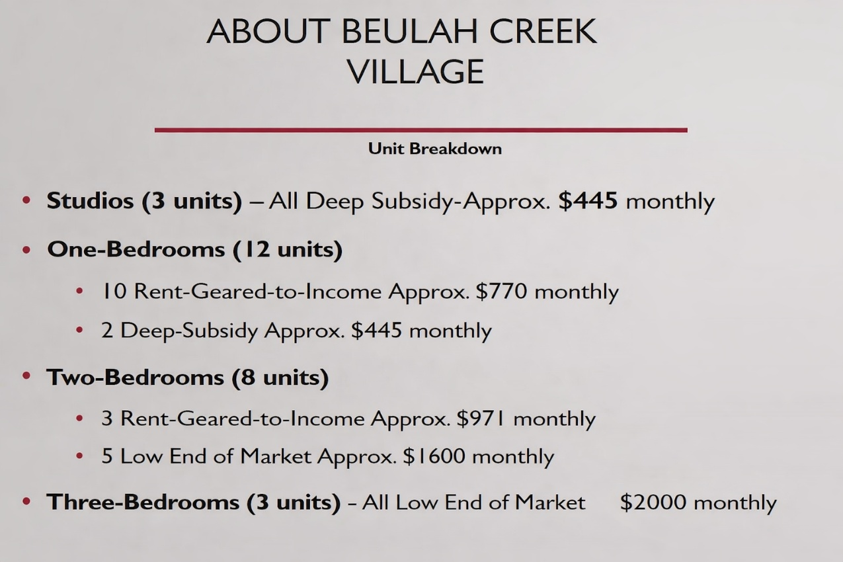

Additional housing supply will be required to address long-term needs:
HICEEC has also explored additional workforce housing models, including the concept of a Manufactured Home Park. While some infrastructure funding options exist, access to affordable and suitable land remains a primary constraint. In December 2024, an application was submitted to the Ministry of Lands, Water & Resource Stewardship for a centrally located 10-hectare Crown land parcel.
During consultations, participants also note the island’s demographic aging, consistent with a Naturally Occurring Retirement Community (NORC), and emphasized the importance of housing options for working-age residents who provide essential services.
The 2025 Island Trust Housing Needs Assessment prepared by Urbanics Consultants Ltd. identified ongoing housing shortfalls:
- 102 units required over five years
- 339 units required over twenty years
This includes needs related to affordability, homelessness, suppressed household formation, projected growth, and local context adjustments.

D. Observations and Areas Identified for Further Consideration
Housing availability on Hornby Island is widely identified as a multifaceted and pressing concern, with implications for workforce stability, service delivery, and community well-being.
Participants and organizations identified the following areas for further consideration:
- Supporting development of vacant lots where feasible
- Encouraging creation of rental units and secondary suites
- Recognizing the significance of Beulah Creek Village as a partial response to identified needs
- Continuing exploration of Crown land opportunities for affordable housing
- Ongoing advocacy related to housing policy, regulation, and funding
These observations are provided to inform understanding and future discussion. Any actions would depend on governance decisions, resources, partnerships, and further engagement.
8.3 Constraints of the Ferry Service
Transportation and ferry access shape both economic opportunity and daily life on Hornby Island, influencing how residents, workers, and visitors move through the local economy.
Ferry service is a critical lifeline for Hornby Island, supporting daily life, economic activity, emergency response, workforce mobility, and the movement of goods and services.
The information presented below summarizes conditions, historical developments, and community observations related to ferry service between 2015 and 2024. It is provided as contextual background rather than as an evaluation of operational decisions or policy outcomes.
A. Aging Ferry Infrastructure – Route #22 (Denman Island to Hornby Island)
Current vessel condition and capacity limitations
The primary vessel serving Route #22, the Kahloke, was built in 1973 and is the oldest vessel operating on BC Ferries’ minor routes. A mandatory Marine Lightship Survey in November 2021 identified structural limitations requiring a reduction in allowable weight to 80 tonnes, further reducing already limited vehicle capacity.
With an operating capacity of approximately 21 vehicle AEQs, the vessel is widely regarded by residents and businesses as insufficient to meet current demand, affecting accessibility, reliability, and economic participation.

B. Community Advocacy for Improved Ferry Service
Sustained community engagement
In response to service challenges, the Hornby and Denman communities undertook coordinated advocacy efforts. In summer 2022, HICEEC led a campaign gathering more than 2,500 signatures supporting improved ferry service, which were presented to elected officials including MLA Josie Osborne.
Advocacy efforts also included a documentary outlining impacts on residents, businesses, emergency response, and quality of life. The Hornby Ferry Advisory Committee (FAC), representing community organizations and local government, coordinated engagement with BC Ferries and the Ministry of Transportation, including meetings in Victoria in 2023.

C. Temporary Relief Measures – Quinitsa Deployment
Seasonal capacity relief
BC Ferries deployed the Quinitsa to Route #22 during summer 2023 and 2024, providing temporary peak-season relief with approximately 44 AEQ capacity. However, as a calm-water vessel, it is not designed for year-round operation in Lambert Channel, and community members have identified this as a short-term rather than long-term solution.

D. Route #21 and System-Wide Constraints
Interdependence of linked routes
Persistent congestion and capacity limitations on Route #21 (Denman Island–Buckley Bay) further affect Hornby Island, as this connection provides primary access to healthcare, education, supplies, and employment.
Reliance on the Baynes Sound Connector cable ferry creates an additional bottleneck. Because travel to Hornby depends on two linked services, disruptions or delays on either route create cascading system-wide impacts.

E. Equity, Cost, and Comparative Analysis
Comparative observations across minor routes
Community concerns regarding service equity prompted a review of vessel age, capacity, and financial reporting across selected minor routes.

Key Findings
- Reported route losses are significantly influenced by depreciation and financing allocations, which can obscure underlying operating performance.
- Older vessels continue to carry substantial depreciation charges despite advanced age, potentially overstating losses relative to cash-flow performance.
- Hornby Island is served by one of the oldest vessels in the minor-route fleet, creating combined challenges related to reliability, capacity, and service efficiency.
This table compares vessel age, capacity, and reported financial performance across selected minor routes:
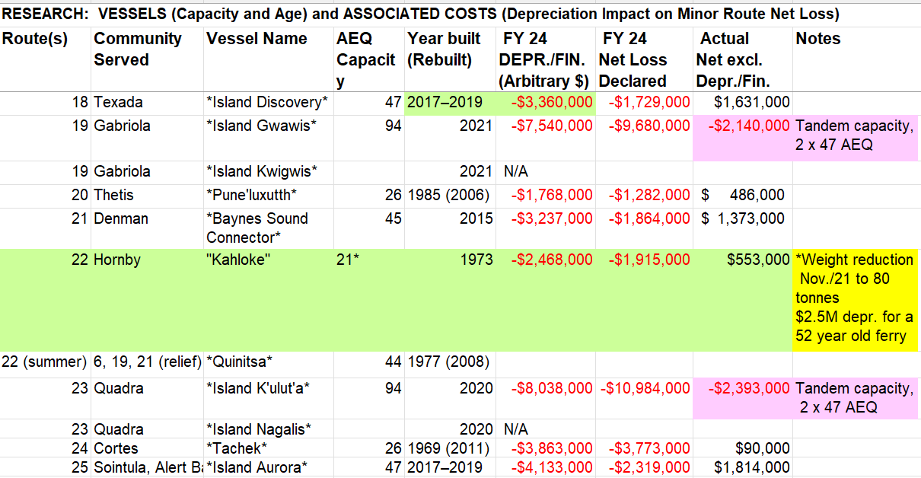
Figure Note: Values shown represent publicly available vessel capacity, age, depreciation/financing allocations, and reported net loss data for selected minor routes. Net loss excluding depreciation/financing is included to illustrate differences between accounting impacts and operating performance. Figures are presented for comparative context only.

Analysis
Accounting treatment significantly influences interpretation of route performance. While newer vessels appropriately carry higher depreciation reflecting recent investment, older vessels continue to carry depreciation charges that may not reflect remaining asset life. As a result, reported net losses may reflect accounting methodology as much as operational performance.
Vessel age and capacity also have direct operational impacts. Older vessels generally have lower vehicle capacity and reduced flexibility to meet current demand levels. On Routes #21 and #22, capacity constraints contribute to extended vehicle line-ups that can spill onto main island roads, affecting both efficiency and traffic safety.
Hornby Island faces a compounded challenge: service by one of the oldest vessels in the fleet combined with reliance on the Denman cable ferry, which functions as a system bottleneck. Together, these factors raise broader questions regarding vessel allocation, replacement priorities, and the interpretation of route performance metrics.
This analysis is intended to provide contextual comparison only and does not assess operational decision-making or corporate policy outcomes.

F. Affordability and Future Risk
Future fare pressures
Concerns regarding affordability increased following a November 27, 2024 statement by BC Ferries CEO Nicolas Jimenez indicating that fares may need to increase by approximately 30% by 2028 to address operating and capital costs.
Participants noted that potential future fare pressures would disproportionately affect island residents and businesses already facing high transportation costs, reinforcing the importance of considering affordability alongside reliability and capacity.

G. Observations
Taken together, aging vessels, constrained capacity, route interdependence, rising costs, and governance changes have contributed to sustained concern regarding ferry service equity and resilience. The extensive advocacy undertaken by Hornby and Denman communities reflects the central role ferry service plays in economic participation and quality of life.
In fall 2024, BC Ferries disbanded Ferry Advisory Committees across minor routes, shifting future advocacy to individual organizations, community groups, and direct engagement with decision-makers.

The information presented above is intended to support informed discussion by documenting observed conditions and community perspectives within their broader operational context. -Photo credit HICEEC media library
8.4 Local Mobility & Access
Local mobility systems support economic participation by connecting residents, workers, and visitors to services, employment, and community activities.
While ferry service remains the most significant transportation constraint affecting Hornby Island’s economy and daily life, local mobility and access also shape workforce participation, aging in place, volunteerism, and visitor experience. These factors are presented as context, not as a standalone transportation strategy.
Hornby Island has a small, dispersed population and a settlement pattern where services, employment, and amenities are spread across the island. As a result, the community is highly car reliant. Fixed-route public transit is inherently difficult to sustain and would likely be underutilized for much of the year, particularly during rainy weather when standing roadside to wait for service is impractical. These realities have consistently shaped transportation choices on the island.
Seasonal community bus service provides an important but limited mobility option, particularly in summer. However, ridership has been affected in recent years by the growing use of electric bicycles, which have become an increasingly popular and flexible transportation option for residents and workers. Informal practices such as hitchhiking continue to be used by some residents, reflecting both the island’s scale and long-standing social norms.

Walking, Trails, and Active Transportation
Hornby Island has a modest network of roadside trails and informal walking paths that allow pedestrians to travel away from main traffic corridors. While these routes are generally better suited for walking than cycling—due to uneven surfaces and exposed tree roots—they play a meaningful role in improving pedestrian safety and supporting daily movement.
There is ongoing community interest in expanding this trail network where feasible, particularly in ways that:
- Improve pedestrian safety by reducing interaction with vehicle traffic,
- Support seniors, youth, and families accessing services and gathering places,
- Encourage low-impact movement aligned with environmental and community values.

Contextual Summary
Local mobility on Hornby Island reflects practical constraints related to population size, geography, weather, and settlement patterns. While enhanced transit options are limited by these factors, a mix of private vehicles, seasonal bus service, walking paths, e-bikes, and informal transportation practices continues to support daily life.
Mobility realities intersect with broader priorities identified in this document—particularly housing, workforce attraction, aging in place, and volunteer participation—and should be considered as supporting context alongside the island’s most pressing transportation issue: reliable, affordable ferry service.
8.5 Visitor Accommodation Needs
Visitor accommodation represents both an economic driver and a point of community discussion, illustrating how tourism activity intersects with housing, infrastructure, and local capacity.
Tourism accommodation continues to be a significant component of Hornby Island’s economy. Community discussion reflects a longstanding preference for small-scale, locally owned accommodation consistent with Official Community Plan principles, alongside evolving pressures related to housing availability and visitor volumes. While visitor accommodation plays an important role in the local economy, participants consistently identified housing availability and transportation access as more fundamental constraints affecting community resilience and workforce stability.

A. Short-Term Vacation Rentals
According to the Hornby Community Profile (2023), there are approximately 131 vacation rentals, representing just over 10% of the island’s housing stock. Other estimates suggest higher numbers due to multiple units operated by individual owners. Average weekly rental rates of approximately $2,500 generate an estimated $3.3 million in direct annual spending, with additional indirect economic impacts across retail, hospitality, arts, and service sectors.
Participants acknowledged that vacation rentals contribute significantly to household incomes and local business activity. At the same time, increased visitor presence has led to differing views within the community regarding congestion, housing availability, and neighbourhood character.
Provincial legislative changes introduced in 2023 and 2024 have altered the regulatory environment for short-term rentals, including registration requirements, removal of legal non-conforming protections in some jurisdictions, and increased penalties for non-compliance. The implications of these changes for Hornby Island remain an area of active discussion.

B. Non-Fixed-Roof Accommodation
Campsites and glamping facilities represent the largest visitor accommodation category on Hornby Island. Approximately 280 non-fixed-roof units contribute an estimated $2 million annually in direct revenues, with broader economic benefits through visitor spending.
Changes in acquisition of a major private campground by BC Parks, have introduced uncertainty regarding future capacity and revenue impacts.

C. Resorts and Year-round Commercial Accommodation
Hornby Island’s small commercial accommodation sector includes Sea Breeze Lodge, Ford Cove Cabins, Hornby Island Resort units and a handful of Bed ‘n’ Breakfasts.

D. Marina and Boaters
Transient boaters contribute to the local economy primarily through moorage fees, fuel, food, and retail spending. While the economic impact is more modest than other tourism sectors, boating activity provides steady supplemental revenue. Concerns regarding anchoring congestion in Tribune Bay have also been raised.

E. MRDT Considerations
Municipal and Regional District Tax (MRDT) revenues on Hornby Island currently exceed $100,000 annually under the 3% program introduced in 2022.
Key MRDT Indicators (Approximate)
• Total annual MRDT revenue: $100,000+
• Estimated source: ~60% short-term vacation rentals / ~40% traditional commercial accommodation
• Current allocation through local MRDT planning process:
– ~60% directed toward affordable workforce housing initiatives (approximately $60,000 annually)
– ~40% supporting other uses – consultants, administration and visitor-oriented activities such as festivals, events, and initiatives benefiting both residents and visitors
Through the local MRDT planning and stakeholder consultation process required under the provincial MRDT framework, these allocations are reviewed annually. HICEEC serves as the local MRDT administering entity and works in collaboration with an industry consultant specializing in MRDT program administration and compliance.
A reduction in the number of legally operating vacation rentals would therefore result in a corresponding reduction in MRDT revenues, directly affecting the availability of funding for affordable workforce housing and other community-supported initiatives. The current 3% MRDT agreement term runs from June 1, 2022 to June 1, 2027, with continuation beyond this period subject to renewal based on local stakeholder engagement and support within the fixed-roof transient accommodation sector.
Potential future changes to the MRDT framework—including discussion regarding possible expansion to other accommodation types such as camping or glamping—remain under consideration and would require both stakeholder support and provincial approval.

F. Ongoing Discussion
Short-term vacation rentals remain one of the most debated topics within the Hornby Island community. Strongly held and often opposing views were expressed throughout engagement and discussion. Some residents advocate for reducing the number of vacation rentals in order to protect neighbourhood character, manage seasonal pressures, and improve long-term housing availability. Others emphasize that vacation rentals are a foundational component of the island’s economy, providing essential income for homeowners, sustaining local businesses, and supporting services that would otherwise be difficult to maintain in a small, remote community.
Participants across perspectives acknowledged that the issue involves complex trade-offs. Housing affordability, economic resilience, community character, tourism capacity, and individual property rights are all interconnected, and no single approach addresses all concerns simultaneously. As a result, proposals and recommendations from organizations such as HISTRA are included in this document as contributions to an ongoing community dialogue rather than adopted policy direction.

Summary Observations
Visitor accommodation remains an essential component of Hornby Island’s tourism economy and contributes significantly to local household income, business viability, and MRDT revenue. At the same time, engagement consistently identified housing availability and transportation access as broader structural constraints affecting community resilience and workforce stability.
Across all accommodation types, discussion reflected a shared desire to balance economic benefits with community capacity and long-term livability. While perspectives differ regarding appropriate scale and regulation, there was broad recognition that visitor accommodation decisions intersect with housing, infrastructure, environmental pressures, and local economic sustainability.
This section documents the range of perspectives, economic considerations, and ongoing discussions identified through engagement and review. It is intended to support understanding and future analysis rather than prescribe outcomes or policy direction.

Photo credit Julian Laffin

8.6 Collaboration Between Businesses & Organizations
Collaboration among businesses, organizations, and volunteers forms a key part of Hornby Island’s economic infrastructure, supporting coordination, innovation, and shared problem-solving.
Community Capacity and Collaboration Context
As highlighted in the Vision 2040 Community Vision, collaboration is widely understood as a defining characteristic of Hornby Island’s social and economic life. Participants consistently emphasized that economic activity on the island is shaped less by centralized direction and more by relationships, shared effort, and coordination across businesses, residents, and a large network of volunteer-driven organizations.
Economic awareness and resilience on Hornby Island are therefore closely linked to the quality of collaboration among local businesses, residents, non-profit organizations, and community committees.

A. Hornby Island Residents and Ratepayers Association (HIRRA)
The Hornby Island Residents and Ratepayers Association (HIRRA) is a central collaborative body within the community. Membership is open to all long-term residents and property owners, and the association’s purpose is to support the ongoing evolution of a vibrant, self-governing community that nurtures the well-being of island residents and the island itself.
HIRRA’s role is expressed through:
- Providing an open forum for democratic participation and respectful discussion of community issues
- Expressing community perspectives to governments and external agencies
- Providing information to the public
- Supporting coordination among volunteer groups
- Administering certain public services
In cooperation with the Comox Valley Regional District, HIRRA administers several tax-funded services, including Fire Rescue, Emergency Preparedness, Recycling and Waste Management, the Community Hall, Community Recreation, Comfort Stations, and Invasive Plant Control.
HIRRA also administers self-funded services, including Regional Parks and Trails Advisory functions, Cemetery Management, Boat Ramp Advisory, Water Stewardship initiatives, representation on ferry advisory bodies, and the annual Fall Fair.
HIRRA is the island’s largest landlord, owning the Community Hall and the Doris Savoie Centre, which houses the HIRRA administration office and First Credit Union. Additional community assets located on HIRRA-owned or leased lands include the RCMP office, electric vehicle charging infrastructure, healthcare offices, the Medical Clinic and Dental Bus, the Arts Centre, and the Copse community park, which hosts the Farmers’ Market.
HIRRA’s website (hirra.ca) serves as a centralized resource compiling information from its committees and volunteer networks.

B. The Co-op Store
The Hornby Island Co-operative Association is another cornerstone of the island’s collaborative economy. For more than 60 years, the Co-op has functioned as a geographic, social, and economic centre of the island, providing retail services, employment, and opportunities for small businesses to grow.
In addition to operating the General Store, Hardware and Liquor Store, Gas Bar, Convenience Store, and Post Office, the Co-op is also a major landlord and operator of the Ringside Market. This cluster includes a diverse range of independently owned shops, cafés, food services, and professional offices.
The Ringside Market operates as a mutually reinforcing ecosystem. The Co-op’s central role draws consistent foot traffic, benefiting surrounding businesses, while the diversity of offerings enhances the appeal of the site for both residents and visitors. Participants frequently cited this arrangement as an example of how collaboration and proximity strengthen local economic vitality.
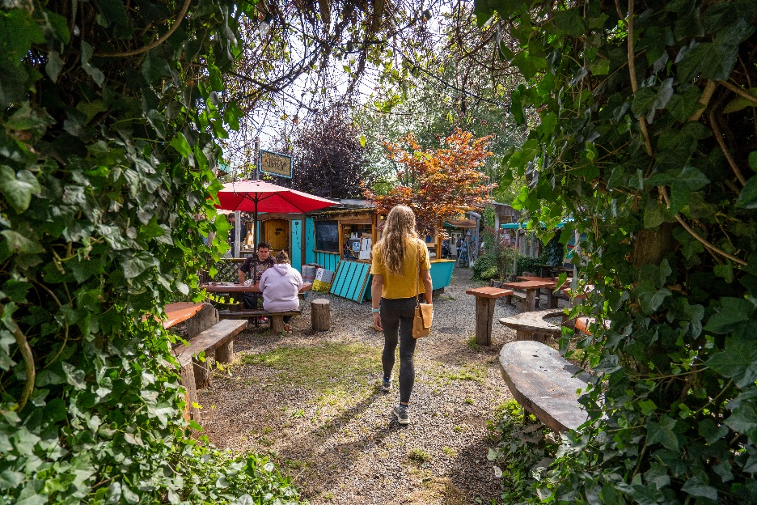
Photo courtesy of HICEEC

C. Contributions of the Non-Profit Sector
The non-profit sector plays a substantial role in Hornby Island’s economy, with cultural and arts organizations frequently identified as leading contributors. Organizations such as the Hornby Island Arts Council, Hornby Festival Society, and Hornby Island Blues Society, alongside a large community of artists and craftspeople, support local employment, attract visitors, and contribute to the island’s identity.
Other non-profits, including the Hornby Island Athletic Association, Hornby Island Education Society, Conservancy Hornby Island, and New Horizons Society, contribute through facility operation, programming, events, and rentals. These activities support both social well-being and economic activity, generating revenue while enhancing quality of life.
Participants consistently emphasized that the non-profit sector’s strength lies in its ability to combine volunteerism, creativity, and service delivery. Collectively, these organizations contribute to employment, visitor attraction, and community cohesion, reinforcing Hornby Island’s reputation as an engaged and culturally rich place to live and visit.

D. Entrepreneurship and the Spirit of Independence
Of the 177 businesses identified in the Hornby Community Profile, 155 are home-based enterprises. The Hornby Island Official Community Plan explicitly supports home occupations, recognizing their importance to economic self-sufficiency and local livelihoods.
Home-based businesses on Hornby Island span a wide range of activities, from food production and creative industries to industrial operations and service provision. Participants described this flexibility as essential in a remote, ferry-dependent context, allowing residents to generate income while maintaining close ties to home and community.
This entrepreneurial culture is widely viewed as both a necessity and a defining characteristic of the island, reinforcing independence, adaptability, and innovation.

E. Information Sharing and Communication
Effective information sharing was consistently identified as a foundational element of collaboration on Hornby Island. A wide range of platforms support communication among residents, businesses, and organizations, including print media, social media, websites, radio, and in-person meetings.
Key channels include First Edition, The Tribune, community Facebook groups, Instagram accounts, organizational websites, HIRRA meetings, CAST luncheons, and local radio programming. Each platform serves different audiences and purposes, contributing to a dense but sometimes fragmented communication environment.
HICEEC plays a coordinating role in this landscape by maintaining multiple high-traffic online platforms, producing regular public updates, hosting business mixers, and supporting networking and visibility for local enterprises. Programs such as the Eagles micro-loan initiative further support entrepreneurial activity through community-based financing.
Participants noted that while the number of communication channels is a strength, effective collaboration requires sustained effort. Many individuals participate in multiple organizations and roles, which supports shared understanding but can also stretch capacity and contribute to burnout if not managed carefully.

F. Observations
Participants emphasized that Hornby Island possesses strong collaborative assets, including engaged residents, active non-profit organizations, locally owned businesses, and shared community spaces. At the same time, collaboration was recognized as time-intensive and highly dependent on volunteer energy and organizational capacity.
Areas commonly identified for reflection and ongoing attention included:
- Creating intentional spaces for collaboration and relationship-building
- Supporting role clarity and shared responsibility within projects
- Recognizing capacity limits and avoiding over-reliance on the same individuals
These observations reflect lived experience and ongoing community dialogue. Together, they illustrate how collaboration functions as both a defining strength and an ongoing practice requiring care, renewal, and shared responsibility. This section is intended to provide context for understanding how economic and community activity is supported locally, rather than to prescribe specific actions or implementation strategies.

Photo credit John Cox
8.7 Food Sustainability
Food production and distribution contribute to economic resilience by supporting local livelihoods, food security, and community self-sufficiency.
Food sustainability is a long-standing and deeply rooted priority on Hornby Island, shaped by the island’s geographic isolation, ferry dependency, limited commercial infrastructure, and strong cultural emphasis on self-reliance. Community discussion consistently links food security with broader economic resilience, environmental stewardship, emergency preparedness, and quality of life.
Participants emphasized that food sustainability on Hornby Island extends beyond agricultural production alone. It encompasses access to affordable food, local processing capacity, distribution systems, land availability, labour, water security, and the ability to respond to supply disruptions.

A. Local Food Production and Agriculture
Hornby Island has a diverse but limited agricultural base, consisting primarily of small-scale farms, market gardens, and mixed-use agricultural properties. These operations contribute fresh produce, eggs, meat, and value-added products to the local economy, particularly during the growing season.
Community members identified several persistent constraints affecting local food production:
- Limited availability and high cost of agricultural land
- Aging farmers and challenges in succession planning
- Labour shortages, particularly during peak seasons
- Water availability and storage limitations
- Regulatory and infrastructure barriers to scaling production
Despite these constraints, local agriculture remains highly valued for its contributions to food security, environmental stewardship, and the island’s identity. Participants noted that local food production helps reduce reliance on ferry-dependent supply chains and strengthens community resilience during disruptions.

B. Food Access and Affordability
Access to affordable food is a concern for many residents, particularly given the high cost of transportation, seasonal supply variability, and limited retail competition. Ferry service disruptions, weather events, and global supply chain pressures were all cited as factors that can quickly affect food availability and pricing on the island.
Participants emphasized that food affordability is closely linked to housing costs, income levels, and employment stability. Lower-income households, seniors, and families with children were identified as being particularly vulnerable to food insecurity during periods of increased costs or reduced supply.

C. Food Processing, Storage, and Distribution
A recurring theme in community discussion is the lack of local food processing and storage infrastructure. While Hornby Island produces food, limited facilities for processing, preserving, and storing products constrain the ability to extend the availability of local food beyond the growing season.
Participants identified benefits associated with developing local processing and storage capacity, including:
- Reducing food waste
- Supporting local farmers and producers
- Creating value-added economic opportunities
- Increasing year-round food availability
- Strengthening emergency preparedness
The absence of centralized facilities has historically limited the island’s ability to fully capitalize on local agricultural production.

D. Emergency Preparedness and Food Security
Food sustainability was frequently discussed in the context of emergency preparedness. Hornby Island’s reliance on ferry service for most goods means that disruptions—whether due to mechanical failure, weather, labour action, or broader crises—can have immediate impacts on food availability.
Participants emphasized that local food systems, storage capacity, and coordinated planning are critical components of emergency readiness. Food security was described not only as an economic issue, but as a public safety and community resilience issue.

E. Workforce, Skills, and Knowledge Transfer
Food sustainability is also closely linked to workforce availability and skills. Participants noted challenges in recruiting and retaining agricultural workers, processors, and skilled trades needed to support infrastructure development.
Knowledge transfer was identified as an emerging concern, particularly as experienced farmers and food producers age. Without pathways for training, mentorship, and succession, there is a risk that local food knowledge and capacity could decline over time.

F. Observations
Participants consistently framed food sustainability as a foundational element of Hornby Island’s long-term resilience. Local food production, processing, and access were described as interconnected with housing availability, workforce stability, ferry reliability, and environmental stewardship.
This section documents community-identified conditions, challenges, and opportunities related to food sustainability. It does not prescribe specific actions, but highlights the importance of continued coordination among agricultural producers, community organizations, service providers, and government agencies to support a resilient and adaptable local food system.
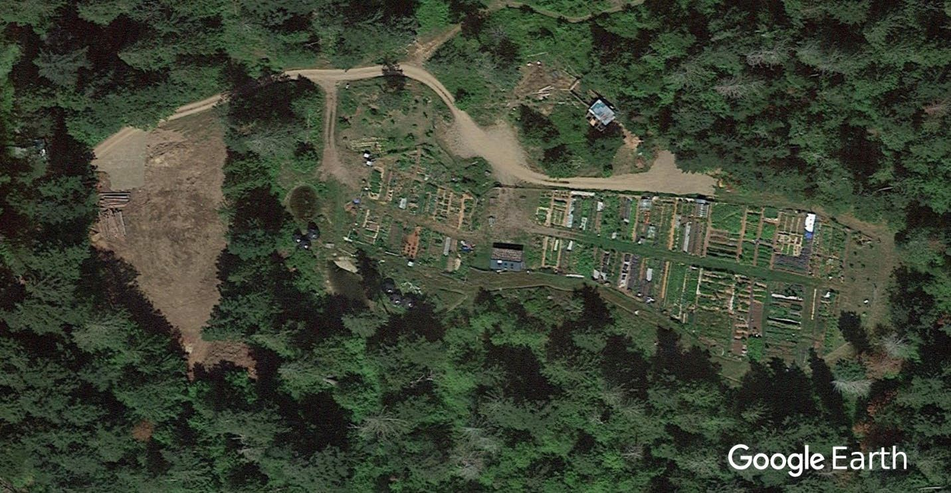

Hornby Island Farmland Trust: Donny Farris Community Garden

8.8 Arts & Culture
Arts and culture contribute to Hornby Island’s economic resilience by supporting local livelihoods, attracting visitors, and strengthening community identity and social cohesion.
Arts and culture form a longstanding and defining element of Hornby Island’s identity, social fabric, and local economy. Cultural activity on the island reflects both traditional creative practices and a strong contemporary arts community that includes visual arts, music, pottery, literature, sculpture, and multidisciplinary creative work. Community profile materials and planning documents consistently identify arts and culture as a core community strength contributing to quality of life, community cohesion, and economic diversity.
Hornby Island has long attracted artists, writers, and musicians, shaping a creative culture that is deeply integrated into daily life and the visitor experience. Artistic activity exists alongside the island’s natural environment and rural character, reinforcing a strong place-based identity that continues to influence community development.

A. Creative Community and Cultural Economy
Hornby Island is widely recognized as a creative community, with an unusually high concentration of practicing artists relative to its small population. Over the years, the island has attracted artists of national and international standing alongside a deep and enduring community of professional working artists whose careers span decades. The local arts community includes painters, potters, sculptors, photographers, weavers, fibre artists, writers, musicians, and craftspeople whose work enriches year-round community life while also contributing significantly to the island’s cultural identity and seasonal visitor experience.
In 2027, the Hornby Island Community Hall will mark its 100th anniversary. For nearly a century, the Hall has served as a cornerstone of island life and has historically been a central venue for art exhibitions, performances, and community gatherings. It continues to be highly valued as a shared cultural space where creativity and community connection intersect.
Beyond formal venues, many artists open their home studios, offering visitors a more personal experience and the rare opportunity to visit working creative spaces. These studio visits provide insight into the artistic process and reflect the island’s long-standing tradition of creativity embedded in everyday life.
Hornby’s cultural identity is also deeply connected to the natural world. The Natural History Centre and the annual Herring Fest highlight the ecological richness of the island and the importance of environmental stewardship, celebrating the relationship between nature, community, and culture that defines island life.

B. Pottery and Visual Arts Legacy
Hornby Island has developed a strong reputation for ceramics and pottery, with several well-known artists contributing to its artistic legacy. Their work has helped establish Hornby as a recognized centre for ceramics and craft, influencing both local artistic identity and visitor interest.
A new generation of emerging artists and potters continues to build on this foundation, reflecting ongoing renewal within the creative community and supporting the continuation of artistic traditions.

C. The Hornby Island Arts Centre
A major milestone in the island’s cultural infrastructure was the completion of the Hornby Island Arts Centre, a purpose-built community facility representing a long-term community vision. The approximately $3.1 million project opened in 2025 following many years of planning, fundraising, and volunteer effort.
The Arts Centre provides dedicated space for exhibitions, performances, workshops, literary events, and interdisciplinary programming, supporting both professional and community-based creative activity. The facility represents a significant investment in cultural infrastructure relative to community size and reflects the importance placed on arts and culture within Hornby’s long-term development.

D. Cultural Continuity and Community Identity
Arts and culture on Hornby Island extend beyond formal institutions. Informal gatherings, studio culture, music events, storytelling, and community-based creative practices contribute to intergenerational learning and shared identity. Creative activity also supports broader economic sectors, including tourism, hospitality, and small business development, reinforcing the role of arts and culture as both social infrastructure and economic asset.

E. Observations
The development of the Hornby Island Arts Centre marks a transition from primarily informal and dispersed cultural activity toward permanent cultural infrastructure. At the same time, the island’s artistic identity remains rooted in independent makers, performers, and community-led initiatives.
Arts and culture therefore function as both a social and economic asset, supporting community wellbeing, visitor experience, and economic diversification. As other sectors face pressures related to housing, transportation, and affordability, maintaining a vibrant creative community is increasingly recognized as part of sustaining Hornby Island’s overall resilience and quality of life.
The information presented above is intended to document the role of arts and culture as an established component of Hornby Island’s community identity and economic ecosystem.

8.9 Attracting & Retaining Families and Workforce
The ability to attract and retain young families is closely linked to long-term economic resilience, influencing workforce continuity, community services, and intergenerational sustainability. In small, rural communities, demographic balance is increasingly recognized as an economic factor, influencing labour availability, service viability, school enrollment, and the long-term sustainability of local businesses and organizations.
Participants emphasized that successful integration of new residents depends on a set of interconnected conditions, including housing availability, employment opportunities, access to education and services, community inclusion, and clear understanding of the island’s infrastructure and service limitations. Responsibility for these conditions is distributed across multiple organizations and sectors, requiring ongoing collaboration rather than reliance on any single initiative.

A. Workforce Skills and Recruitment Challenges
A recurring concern raised through engagement is the difficulty of attracting workers with specialized skills essential to the island’s functioning and quality of life. These include:
- Healthcare and wellness professionals
- Skilled tradespeople (electricians, plumbers, carpenters)
- Administrative and organizational staff
- Teachers and educational support workers
- Workers across hospitality, marine services, technology, arts, home support, agriculture, and related sectors
Limited housing availability, high living costs, and ferry dependency were consistently identified as barriers affecting recruitment and long-term workforce stability.

B. Community Identified Approaches Supporting Workforce Attraction
Participants identified several approaches considered relevant to workforce attraction and retention. These are presented as community observations rather than adopted strategies:
- Incentives or supports to offset higher living costs
- Workforce housing models and partnerships
- Increased rental housing availability
- Flexible and remote work opportunities
- Educational and apprenticeship partnerships
- Community integration supports and quality-of-life factors
Collectively, these themes reinforce the view that workforce attraction depends on coordinated action across housing, employment, services, and community life.

C. The Role of Volunteers in Community Sustainability

Volunteerism is a defining feature of Hornby Island’s social and economic structure. Beyond paid employment, residents contribute substantial time and expertise to sustaining essential services and programs.
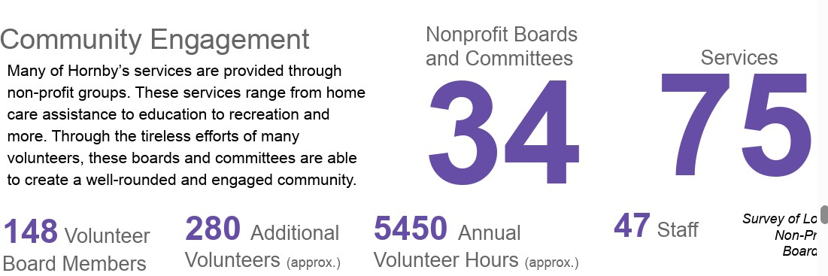
    - Chart from Community Profiles
Current data indicates:
- Approximately 34 non-profit boards and committees
- Around 75 services delivered through volunteer-supported organizations
- Approximately 280 volunteers contributing an estimated 5,450 hours annually
Volunteer contributions support emergency services, community facilities, cultural programming, waste management, and social supports. At the same time, concern was raised regarding an aging volunteer base, creating uncertainty about future capacity and long-term service sustainability.

D. Volunteer Renewal and Long-Term Sustainability
Participants identified several factors relevant to supporting volunteer renewal:
- Clear communication and awareness of opportunities
- Recognition and skill development
- Flexible participation models, including short-term roles
- Mentorship and leadership development pathways
Workforce attraction and volunteer sustainability were consistently described as interconnected. New residents often become volunteers once established, while volunteer engagement strengthens community attachment and long-term retention.

E. Observations
Participants consistently described workforce attraction, housing availability, and volunteer sustainability as interdependent challenges. Limited housing and services reduce the ability to attract skilled workers, while reduced workforce capacity places greater pressure on volunteers and community systems.
This section documents community-identified conditions and observations rather than prescribing specific actions. It highlights the importance of coordinated effort across housing, transportation, employment, and community services in supporting Hornby Island’s long-term resilience. Together, these themes reinforce how workforce stability and community participation remain central to sustaining both economic activity and quality of life on Hornby Island.
Section 8 Summary
Taken together, the topics discussed throughout this report illustrate that Hornby Island’s economy functions as an interconnected community system shaped by infrastructure, housing availability, transportation, environmental stewardship, and social capacity. The opportunities and pressures described are closely linked, reinforcing the importance of viewing economic activity not as isolated sectors, but as part of a shared community system that evolves over time.
The following section presents illustrative implementation pathways derived from these themes.

PART V — IMPLEMENTATION OPTIONS
This section presents illustrative implementation pathways derived from the themes and priorities identified throughout the report.

9. Implementation Options (Non-Prescriptive)
This section translates themes identified throughout the report into potential implementation pathways for future consideration. These options are derived from community engagement, observed conditions, and ongoing organizational work described in previous sections. They are presented as illustrative examples only and do not constitute adopted strategies, policy direction, or organizational mandates.
Implementation on Hornby Island typically occurs incrementally through collaboration among community organizations, residents, local businesses, and external partners. The options below are intended to support discussion, coordination, and future opportunity development.

9.1 Housing & Workforce Capacity
Illustrative implementation pathways may include:
- Continued support for workforce and affordable housing initiatives, including partnership-based models such as Beulah Creek Village and potential manufactured-home or land-lease approaches.
- Exploration of opportunities to activate existing vacant lots or secondary units where feasible.
- Ongoing advocacy with regional and provincial agencies regarding housing policy, infrastructure funding, and land availability.
- Encouraging housing models that support both year-round workforce stability and seasonal employment needs.
Implementation partners may include housing societies, local governments, provincial agencies, employers, and community organizations.

9.2 Transportation & Mobility
Potential implementation options include:
- Continued community advocacy regarding ferry service reliability, affordability, and capacity.
- Monitoring impacts of ferry system changes on economic activity and workforce mobility.
- Supporting incremental improvements to local mobility options, including seasonal transit, trail networks, and active transportation infrastructure.
- Encouraging coordination between transportation planning and housing/workforce initiatives.
Implementation would depend on collaboration with BC Ferries, CVRD, community organizations, and local advocacy groups.

9.3 Visitor Economy & Accommodation Balance
Possible pathways for consideration:
- Ongoing monitoring of provincial short-term rental regulations and local economic impacts.
- Continued stakeholder engagement through MRDT processes to align tourism support with community priorities.
- Exploration of ways to balance visitor accommodation with housing availability and infrastructure capacity.
- Supporting small-scale, locally owned accommodation consistent with community values.
Implementation would occur through existing MRDT governance structures and stakeholder consultation processes.

9.4 Collaboration & Community Capacity
Options emerging from engagement include:
- Creating intentional opportunities for inter-organizational dialogue and coordination.
- Supporting networking opportunities for businesses and non-profit organizations.
- Identifying ways to reduce volunteer burnout through shared roles and clearer coordination.
- Continuing communication and information-sharing initiatives across multiple platforms.
Implementation would rely on voluntary collaboration among organizations rather than centralized direction.

9.5 Food Sustainability
Potential implementation directions:
- Supporting development of local food processing, storage, and distribution infrastructure.
- Encouraging agricultural succession planning and knowledge transfer.
- Strengthening connections between food production, emergency preparedness, and local economic activity.
- Supporting partnerships among producers, community organizations, and funding agencies.

9.6 Arts, Culture, and Community Identity
Options identified through engagement include:
- Supporting programming and economic activity associated with the new Arts Centre.
- Encouraging visibility and promotion of home studios and cultural events.
- Recognizing arts and culture as contributors to both visitor economy and year-round community life.
- Exploring partnerships that strengthen cultural infrastructure and creative enterprise.

9.7 Workforce Attraction, Families, and Volunteer Renewal
Potential implementation pathways:
- Reliable high-speed internet is increasingly essential for attracting and retaining working-age residents and families, particularly those engaged in remote or hybrid employment.
- Supporting initiatives that improve workforce integration and community inclusion.
- Encouraging educational, apprenticeship, and mentorship opportunities.
- Promoting volunteer renewal through flexible participation models and leadership development.
- Aligning housing, employment, and community services to improve long-term retention.

9.8 Implementation Considerations
Across all themes, several cross-cutting considerations emerged:
- Implementation capacity is limited and dependent on volunteer energy and organizational resources.
- Many initiatives require partnership with external agencies and funding programs.
- Incremental progress is consistent with Hornby Island’s governance structure and community culture.
- Ongoing engagement and adaptive learning are essential as conditions evolve.

9.9 Implementation Pathways Overview
Illustrative pathways derived from community priorities to support future collaboration, planning, and opportunity development.
The following table summarizes illustrative implementation pathways emerging from community priorities identified throughout this report. It is intended to support coordination and discussion rather than prescribe specific actions.

9.9 Closing Note
These implementation options are provided to illustrate how community-identified priorities might translate into future action pathways. They are not intended as directives or commitments, but rather as a bridge between contextual understanding and potential future initiatives undertaken by organizations, partners, or community groups as opportunities arise.

PART VI — SYNTHESIS & CLOSURE
The final section summarizes key observations and provides closing reflections on the interconnected factors shaping Hornby Island’s economic resilience.
10. ASSESSMENT & EVALUATION
The assessment summarized in this document highlights the importance of cooperation among community organizations, local businesses, volunteers, and residents in addressing both challenges and opportunities facing Hornby Island.
The completion of the Hornby-Denman fibre network will create new opportunities for remote work, digital entrepreneurship, and improved access to services. Future economic initiatives may benefit from leveraging this improved digital infrastructure.
Sustaining the island’s economic health depends on continued attention to interconnected priorities identified through engagement, research, and observation. These include reconciliation and environmental stewardship, housing availability, ferry service reliability and affordability, local mobility, visitor accommodation, workforce and volunteer attraction, food sustainability, arts and culture, and collaboration among community partners.
Given Hornby Island’s small population, geographic isolation, and strong community values, progress is most likely to occur through incremental, locally informed actions supported by long-term partnerships. This document is intended to provide context, continuity, and shared understanding — drawing on both historical and recent work — to inform future analysis, decision-making, and collaboration as opportunities arise.
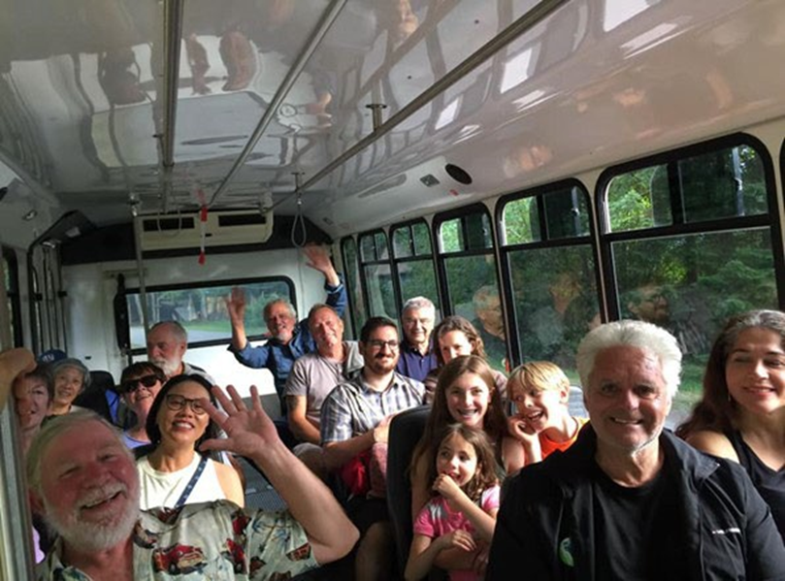
Photo credit: HICEEC – Summer Bus
11. SUMMARY & CLOSING OBSERVATIONS
Through public engagement, research, submissions, and review conducted over multiple years, a consistent set of priorities has emerged reflecting Hornby Island’s values, constraints, and aspirations. Together, these priorities provide a shared framework for understanding the island’s economic context and the factors influencing community well-being.
Recent investments across the community demonstrate the scale and diversity of efforts underway to strengthen local infrastructure and economic resilience. Investments in housing, cultural facilities, tourism infrastructure, and digital connectivity—including the Hornby–Denman fibre broadband project—are contributing to a more resilient and diversified island economy.
While individual organizations and governing bodies operate within different mandates, many of the underlying issues identified through this work are interconnected. Housing availability, transportation access, workforce stability, environmental stewardship, and community collaboration all influence the island’s long-term economic sustainability.
The purpose of this report has been to assemble available information, document recurring themes, and provide context for ongoing dialogue. It is intended to support informed discussion and future planning by organizations and institutions responsible for decision-making affecting Hornby Island.
The priorities described throughout this document reflect not only economic considerations but also broader community values. Maintaining environmental stewardship, supporting arts and culture, strengthening local food systems, and sustaining a vibrant year-round population all contribute to the island’s resilience.
As conditions continue to evolve, the observations and context presented here may assist future discussions, collaborations, and initiatives aimed at sustaining Hornby Island as a thriving and resilient community.

Key Community Priorities
Across the engagement, research, and submissions undertaken during this period, a set of recurring themes emerged in relation to Hornby Island’s economic resilience.
I. Reconciliation & Environmental Stewardship
II. Housing Availability
III. Constraints of the Ferry Service
IV. Local Mobility & Access
V. Visitor Accommodation Needs
VI. Collaboration Between Businesses and Organizations
VII. Food Sustainability
VIII. Arts & Culture
IX. Attracting Families and Workforce
These themes are presented as contextual priorities identified through engagement rather than directives, adopted policy positions, or validated strategic conclusions.

Overarching Observations
Reconciliation and environmental stewardship are foundational considerations for Hornby Island. The island is situated within the traditional territories of the K’ómoks First Nation, and respect for Indigenous presence, land, and history remains integral to future decision-making. Environmental responsibility similarly influences choices related to land use, tourism, housing, and infrastructure.
Housing availability remains a significant constraint affecting workforce attraction, service delivery, volunteer capacity, and long-term community sustainability. Ferry service reliability and affordability continue to shape access to employment, healthcare, education, goods, and visitors, reinforcing transportation as a defining factor in economic resilience.
Tourism and visitor accommodation contribute substantially to the local economy while also prompting ongoing discussion regarding balance, scale, housing impacts, and community character. Collaboration among residents, businesses, non-profit organizations, and institutions remains one of Hornby Island’s greatest strengths, although volunteer capacity and organizational resources continue to be stretched.
Food sustainability initiatives and the island’s strong arts and cultural sector contribute to local resilience by supporting small-scale economic activity, community identity, and social cohesion.

Closing Perspective
This document is intended to provide context, continuity, and shared understanding rather than prescribe specific actions or outcomes. It reflects both historical and recent work undertaken by the community and acknowledges the time, effort, and participation contributed by residents, organizations, and volunteers.
As Hornby Island moves forward, continued collaboration, incremental progress, and alignment with community values will remain essential. Grounded in reconciliation, environmental stewardship, and community well-being, the island is well positioned to navigate change while preserving what matters most— helping ensure Hornby Island remains a resilient, inclusive, and connected community for generations to come.
Implementation and decision-making will continue to be shaped by the mandates, governance structures, and capacities of individual organizations. Continued dialogue, updated information, and collaborative leadership will remain important as the community adapts to evolving economic, environmental, and demographic conditions.
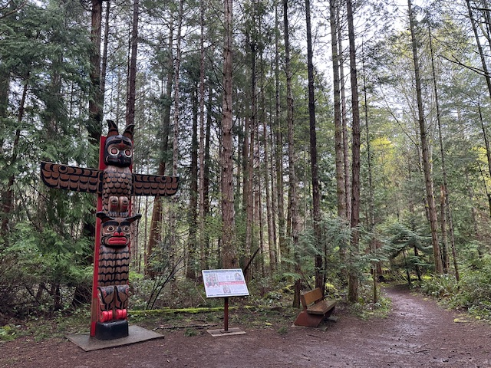
Photo credit Karen Ross
K’ómoks Guardian Pole Helliwell Park
Carver: Karver Everson: On this pole, the top crest depicts a Thunderbird (Suwa'lqum) and the bottom crest depicts a Double Headed Sea Serpent (Aihos). These two beings have great importance in the Pentlach and K'ómoks cultures.

APPENDICES
The appendices included in this document are provided for reference and contextual support. They contain background materials, publicly available data, and summary information that informed discussion and analysis within the report. These materials are not intended to function as standalone assessments, recommendations, or policy direction. Inclusion does not imply endorsement or prioritization, and the information should be read in conjunction with the main body of the report and any updated data available at the time of future analysis or decision-making.
Appendix A — Community Assets Inventory
Appendix B — Community Profile Highlights
(summary indicators used in analysis)
Appendix C — Acknowledgements

Appendix A — Community Assets Inventory
The development of a thriving community is built upon a strong foundation of both public and private assets. Hornby Island includes a range of infrastructure, public facilities, and private enterprises that support daily life and contribute to the island’s distinctive character.
A key constraint affecting future development is the absence of centralized water and sewer systems. While zoning bylaws currently allow for a minimum lot size of ½ acre, accommodating individual wells and septic systems on these lots can be challenging due to spatial requirements. These regulations apply not only to each individual lot but also to the required separation distances from neighbouring wells and septic fields. While these lot sizes may appear large by urban standards, they support privacy, self-sufficiency, and the rural character valued by residents.
Hornby Island does not have a municipal government or land dedicated to urban-style service infrastructure. As a result, strengthening community infrastructure in the future would likely require coordination among private landowners, community organizations, regional authorities, and external partners. These considerations highlight how existing assets contribute to Hornby Island’s resilience while also illustrating areas where future coordination may be required.
The following inventory summarizes key assets that contribute to Hornby Island’s economic, social, and institutional capacity.

COMMUNITY ASSETS
(Economic)
Asset Category | Description
Physical Infrastructure | B.C. Ferries Terminal & Dock
Boat ramp at Shingle Spit
Ford Cove Marina
City West high-speed internet
Telephone - multiple carriers
B.C. Hydro
MOTI compound
Joe King Ballpark, Recreational Facilities, and Kitchen
CHFR Local Radio Station
Economic Land Assets | Restricted zoning for Agricultural Land Reserve
Vacant residential lots
Limited Public Use zoned Crown Lands
Farmers Market on HIRRA land
Natural Assets | Helliwell Provincial Park
Tribune Bay Provincial Park
Mt. Geoffrey Regional Park
CVRD neighbourhood parks and accesses
Crown Lands
Local Institutions | Elementary School
Hornby Medical Clinic
Hornby Denman Health Care Centre
Hornby Archives
New Horizons Hall
Heron Rocks Friendship Centre
Hornby Firehall & First Responders Station
Spark Makers Space
Library
Room To Grow
Pre-school
Natural History Centre
RCMP station
Cemetery
Economic Drivers | Coop Store & Gas Bar
Estimated 157 Vacation Rental Homes on Hornby,
Legally limited to operated May through October (5 months)
Ford Cove Marina
B.C. Ferries Terminal & Vessel
Sea Breeze Lodge
Ford Cove Store, Cabins & Restaurant
Hornby Arts Centre
Heart Vineyard & Restaurant & Glamping
Bradsdadsland Campground
Tribune Bay Campsite
Heron Rocks Camping Coop
Thatch Pub & Town Homes
L'il Tribune Blueberry Farm & Glamping
Fossil Beach Farm & Cidery
Phrog Distillery
Middle Mountain Meadery
H.I. Winery
H.I. Brewing
Ringside Market Businesses
4 Corners Businesses
First Credit Union
Historical and Cultural  Features | Community Hall
Tribune Bay Outdoor Education Centre Lodge
Natural History Museum
Jeffrey Rubinoff Sculpture Park
KFN Friendship Totem at Helliwell Park
Leif House at Ford Cove/Park
Human Assets | Trained First Responders & Fire Department
Trained Ferry crews
Building Trades - Construction, Electrical, Plumbing, HVAC, Architects,
etc.
Hospitality - Chefs, cooks, servers, bartenders
Retail - all aspects
Horticulture & Agricultural knowledgeable people
Recreation & marine - skilled operators
Health & Wellness - full range of practitioners
Administrators, office workers, internet & web, bookkeepers.
Volunteers across the Board
Teachers & Educators
Creatives & Crafters, of all Art disciplines
Property management companies

Appendix B — Community Profile Highlights
The document is a community profile report for Hornby Island, focusing on housing, social determinants of health, and the creation of a comprehensive database to inform local planning and strategies.
Excerpts re ECONOMIC IMPACTS
- The website www.communityprofiles.ca hosts the FULL community profile reports and data, facilitating access for various organizations.

EXCERPTS FOR REFERENCE IN THIS REPORT:

ECONOMIC HEALTH
- Employment statistics show a labor force participation rate of 63.30% and a self-employment rate of 51.55%.
- Barriers include a reliance on seasonal income, lack of year-round employment, and mental health challenges affecting the workforce.
- There are 177 businesses in total, with 22 employers and 36 women-owned businesses contributing to the local economy.
- Economic health is when a person has a stable job where they work a suﬀicient number of hours, are respected, valued, engaged, paid a living wage, and are safe physically and mentally. When a person has a job that aﬀords them the necessities of life or more, they are able to participate in the local economy. They patronize the businesses and are able to spend money on entertainment and eating out occasionally. Their success helps others in their community achieve success as well.
- Hornby Island faces significant staﬀing shortages, particularly in summer, with 62 summer-only jobs and 25+ staﬀ needed. The limited worker pool is attributed to high living costs, lack of year-round housing, and under-the-table payment requests. There are 155 total home based businesses, plus 131 home based business accommodation providers.
Barriers:
  - Challenging for employers to find staﬀ, seasonally and year-round
  - High reliance on seasonal visitor-based income
  - Lack of

    - access to oﬀ-island jobs
    - businesses available year-round
    - full-time/full-year employment
    - living wage
    - qualified staﬀ
    - reliable transportation to/from work
  - Living below the poverty line
  - Mental Health Challenges
  - Oﬀ-island workers are costly
  - Tradespeople unavailable locally

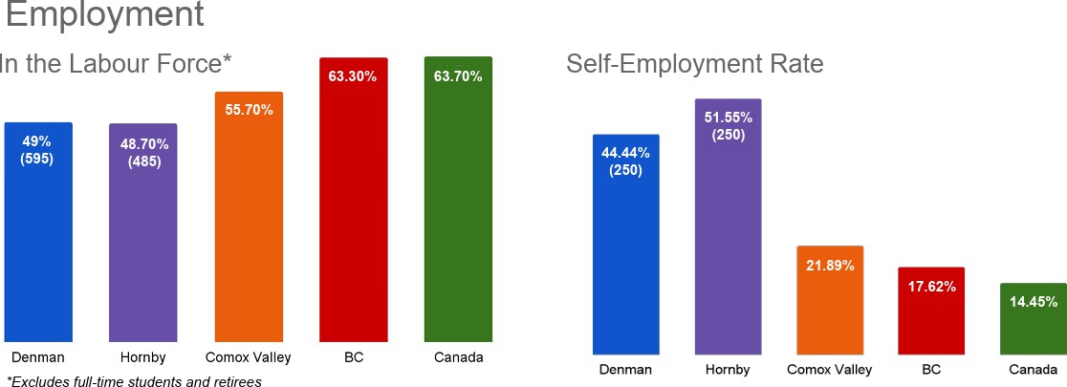
-Courtesy of Census 2021 and Community Profiles

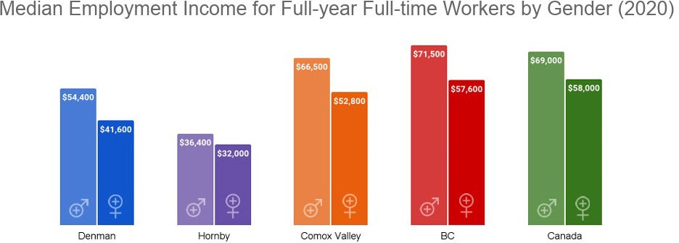
-Courtesy of Census 2021 and Community Profiles

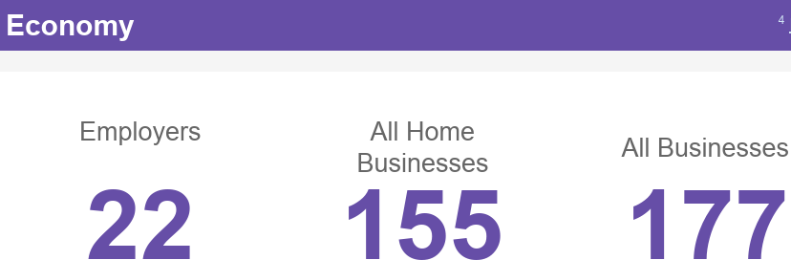

-Courtesy of Census 2021 and Community Profiles

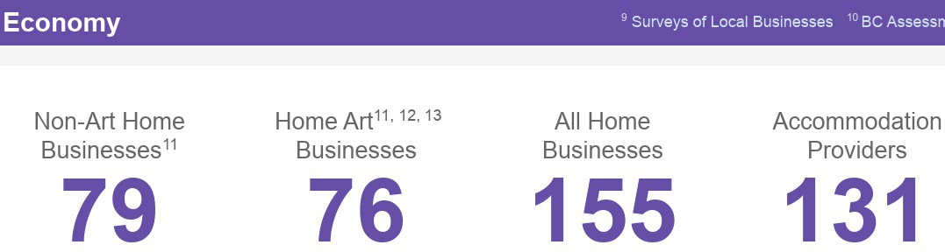

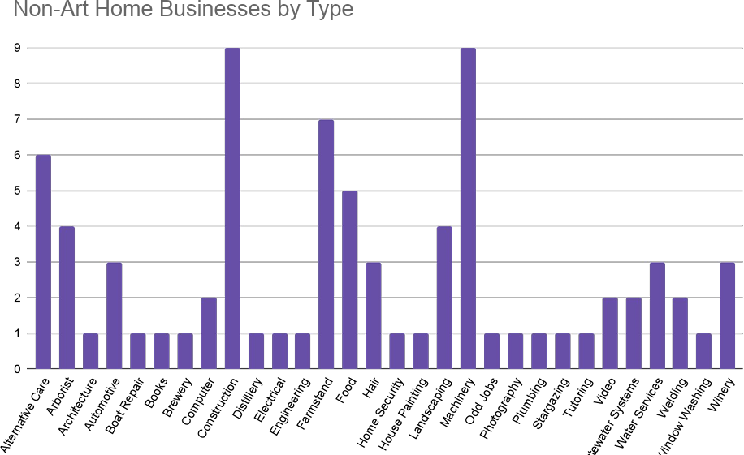
-Courtesy of Census 2021 and Community Profiles

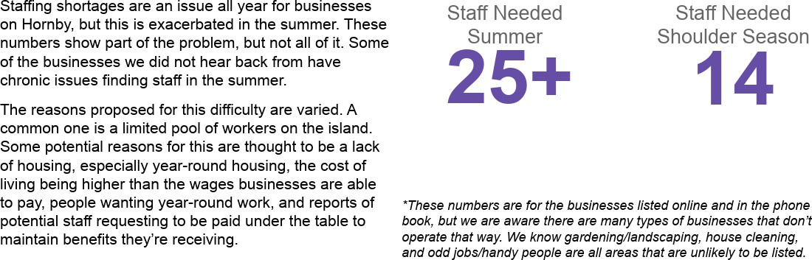

-Courtesy of Census 2021 and Community Profiles

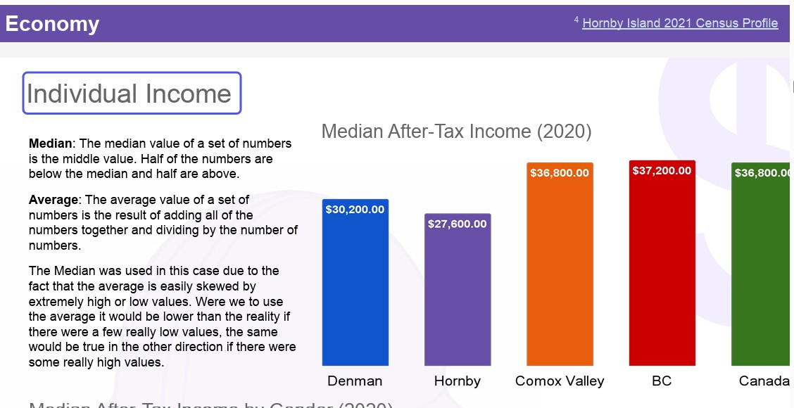
-Courtesy of Census 2021 and Community Profiles

HOUSING
Housing health means having a home to start with. Your home is clean and dry; pest and mould-free; it is an appropriate size for the number of people in your family; has access to adequate clean potable water; light after dark, heat in the winter, and it is aﬀordable.
Total Residential Value: $912,003,028. According to B.C. Assessment Records Barriers
    - Lack of aﬀordable housing for rent or purchase
    - Lack of housing stock
    - Many rentals oﬀered are unsuitable and/or unsafe
    - Challenging to age in place
    - Unfounded rumours/reputation can aﬀect housing opportunities

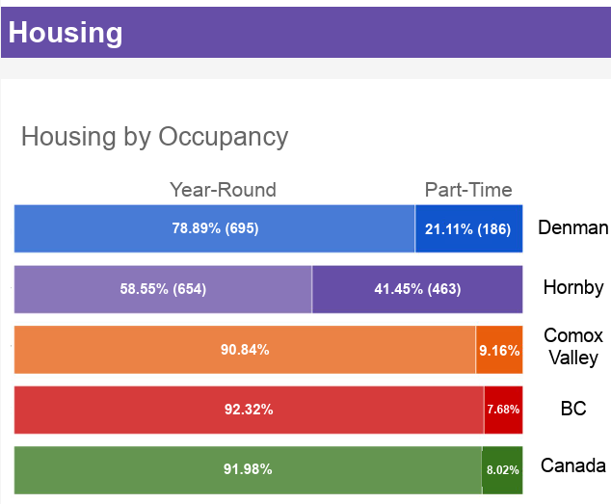
-Courtesy of Census 2021 and Community Profiles

VOLUNTEERS AS AN ECONOMIC FORCE
-Courtesy of Census 2021 and Community Profiles

Services at Risk of Volunteer Shortage:
The following services have been identified as particularly vulnerable to the loss of volunteers due to a maturing volunteer base:

Property Maintenance & Oversight:
  - Community Hall
  - Crown Land Lease Property
  - Arts Council Gallery
  - Copse Market Area
  - Provincial Parks Advisory
  - Beach Waste Pick-up
  - Free Store
  - Waste Transfer
  - Beach Clean-up
  - Forest Fest
  - Herring School

Healthcare & Wellness:
  - Water Testing for Public Buildings
  - Doris Savoie Centre
  - Sollans Rd Public Well
  - Fire Department Administration
  - Invasive Weed Control
  - Hot Meals: 3 days/week
  - Home Delivery: 3 days/week
  - Food Bank: 3 days/week
  - Food Hampers
  - Food Jar Program
  - Foodbank/Market Day for Families
  - Raise a Reader Story Time

Recreation & Community Engagement:
  - Family Recreation
  - Youth Recreation
  - Teen Night
  - Toddler Drop-In
  - Story Walks
  - Studio Tour
  - Summer Fire Patrol
  - Social/Emotional Workshops
  - Sign Language Lessons

Environmental & Educational Initiatives:
  - Regional Parks and Trails Advisory
  - Water Information/Education
  - Trail Maintenance
  - Summer Bus
  - Outdoor Education for Families
  - Outdoor Education for Youth

  - Drought Information/Education
  - Ecological Awareness
  - Environmental Education
  - Emergency Preparedness Education
  - Natural History Museum

Community Support Services:
  - Archives
  - Bursaries and Scholarships
  - Affordable Elder Housing
  - Affordable Rental Housing
  - Medical Equipment Loans
  - Community Garden
  - Community Radio Station
  - Community School
  - Facility and Hybrid Meeting Tech Rentals
  - Facility Rental
  - Fall and Winter Lecture Series
  - Fall Fair

Cultural & Arts Activities:
  - Art Shows
  - Blues Art Show
  - Blues Classes
  - Blues Concerts
  - Joint Theatre Project
  - Literacy Outreach for Adults
  - Literacy Outreach for Youth

Other Services:
  - Boat Ramp Oversight
  - Cemetery Maintenance and Information
  - Corporate Retreats
  - Conservation Efforts
  - Pen-pal Writing
  - Public Outhouses
  - Signage for Community Events

FOR A COMPLETE COPY OF THE PROFILE:
https://communityprofiles.ca/ Click on Hornby Profiles

Appendix C — Acknowledgements
This document reflects the cumulative efforts of many individuals and organizations who have contributed time, insight, and institutional knowledge toward understanding Hornby Island’s economic context over many years.
The Hornby Island Community Economic Enhancement Corporation (HICEEC) Board and staff are acknowledged for their role in facilitating engagement, assembling background information, and stewarding historical records and shared knowledge.
Appreciation is also extended to the many residents, volunteers, business owners, non-profit organizations, and community groups who participated through meetings, surveys, written submissions, and informal conversations. Their contributions—offered in good faith and grounded in lived experience—form an important part of the community record and continue to inform dialogue about Hornby Island’s future.
This work reflects the collective care people hold for Hornby Island and a shared commitment to sustaining the island’s social, economic, and environmental well-being. The perspectives and contributions shared through this work continue to support informed discussion and collaborative decision-making as the community considers future opportunities and challenges.

- photo credit HICEEC media library

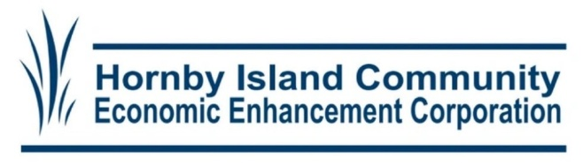
Hornby Island Economic Enhancement Framework
2026
www.hiceec.org

