https://www.cbc.ca/news/canada/british-columbia/ferry-frustrations-prompt-call-for-immediate-upgrade-on-hornby-island-1.6395575

British Columbia

Lineup frustrations prompt call for immediate upgrade to Denman-Hornby Island ferry

Locals say a drop in weight capacity on their ferry means lineups are even worse than usual
CBC News · Posted: Mar 24, 2022 4:00 AM PT | Last Updated: 3 hours ago
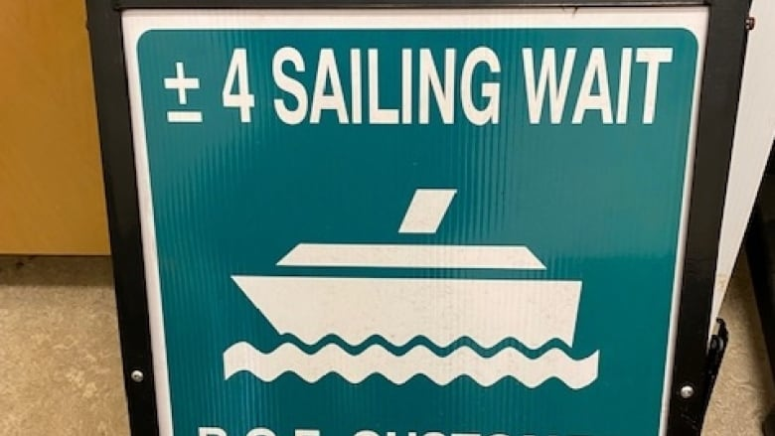
Signs made by the Hornby Island Community Economic Enhancement Corporation to inform ferry users how long they'll be waiting. (Submitted by Karen Ross)
77
comments
For the few thousand visitors who travel to Hornby Island each year, it's a trip worth taking⁠— but local leaders are worried that might change.
To get to Hornby, travellers take a short ferry trip from Vancouver Island to Denman Island, and then another from Denman to Hornby. The actual travel time is less than an hour, but with the wait for ferries, it can take more than three. Ferries generally sail every hour, and during busy times, there can be multiple-sailing waits.
Now, members of the local ferry advisory committee say a change to the capacity of the Kahloke ferry could make waits even longer.
They say a regular assessment from Transport Canada ruled that the ferry, which sails between Denman and Hornby, can no longer carry as much weight as it used to. That means when the 21-car vessel takes on heavier commercial vehicles, it cannot take as many cars as it normally would.
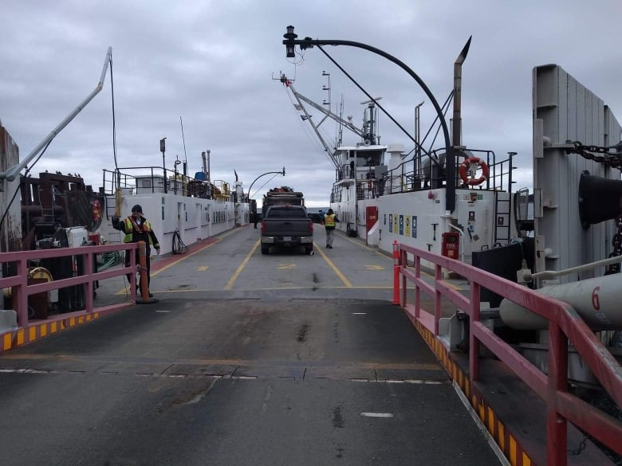
The Kahloke ferry, loaded to sail between Denman and Hornby in March 2022, is pictured with empty deck space — the result of having reached its maximum weight capacity. (Submitted by Karen Ross)
"And so the ferry sails, the deck's half empty," says Karen Ross of the Hornby Island Community Economic Enhancement Corporation.
"There's people waiting in line to get onto that ferry, the scheduled ferry that they thought they were going to catch just left, and they can see the empty space."
She says she's already getting calls from frustrated residents, who can't understand why ferries are sailing with room left on deck.
Some are seeing an increase in delivery fees from services on Vancouver Island, who are charging more because of the time it takes to deliver things like construction supplies.
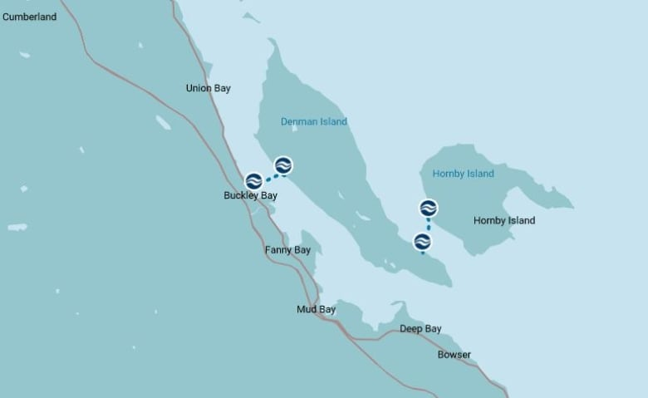
It takes two ferries to get to Hornby Island: one from Vancouver Island to Denman Island, and then another from Denman to Hornby. (B.C. Ferries)

A 'painful' situation for locals
Stephen Bishop has lived on Hornby Island for nearly 40 years. His family owns a resort and restaurant, and he says he makes weekly supply runs to Vancouver Island.
To make sure he gets on the first sailing of the day, he parks his car in the lineup the night before. To get home, a trip that should last one hour can take up to four.
Bishop says they give visitors to their resort ample warning, and people don't seem to mind⁠. But he says it's "painful" for locals. "If they are now in a situation where they can't even make a full capacity for that ferry, that's going to make it that much worse," he said.
- Washington ferry service slowly returning to Vancouver Island
Ross worries about what will happen this summer when tourists start to arrive. Even if they're willing to wait, there's no terminal with services to keep them occupied, although construction for one will begin late this year.
As lineups snake down island roads, waiting children have nowhere to play, and there are no washrooms nearby.
Ross says Hornby is in line to get an upgraded ship from B.C. Ferries, but not until 2026. She says they can't wait that long.
- B.C. Ferries advises passengers to check for cancellations due to staffing shortages, storms
She and two fellow members of the ferry advisory committee are calling on the corporation to swap in a new vessel now⁠ — and for the province to step in and help. They'd also like a bigger ferry between Denman and Hornby.
In a statement, the Ministry of Transportation and Infrastructure said it is "aware of the potential for sailing waits on B.C. Ferries' Denman-Hornby route this summer," and that it is in discussion with B.C. Ferries about "a long-term solution to the sailing wait times on the Denman-Hornby route, as well as other routes in the coastal ferry system."
It says the solutions will be submitted to the B.C. Ferry Commission this fall.
CBC's Journalistic Standards and Practices|About CBC News
Report Typo or Error|Corrections and Clarifications

