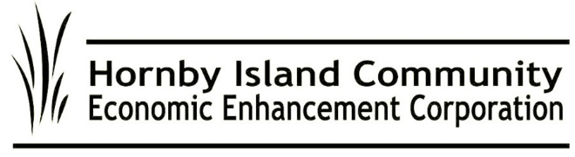

**HICEEC First Edition: November 2024**

**AGM Recap**  
A heartfelt thank you to everyone who joined us for this year’s Annual General Meeting on October 6th! Your participation and feedback are invaluable to our ongoing efforts.

**Community Grants**

HICEEC disburses on average $5,000 a year to qualified non-profit and business groups in support of economic activities. Applications can be considered at any time, The application for this program is on our website: https://hiceec.org/community-grants

**MRDT: Prioritizing Workforce Housing**  
The Municipal Regional District Tax (MRDT), affectionately dubbed “the pillow tax,” is up and running, with funds being collected to support community initiatives, especially workforce housing. We’re excited to partner with 4VI, an experienced industry consultant, to implement our 5-year strategic plan. Having previously guided our community consultations, Calum Matthews and his team will help steer the project moving forward. Public consultations held on October 18 at the Tribune Bay Lodge focused on solidifying housing as a top priority and establishing the groundwork for our Annual Tactical Plan to be submitted to the Province. The majority of funds collected to date are earmarked for a capital reserve fund dedicated to workforce housing initiatives. With the cost of land being challenging, we’re exploring creative partnerships and innovative solutions to ensure this project takes off. Other monies, are used as dictated under the program, and include marketing, tourism events/research/education, and program operations. FMI: <https://hiceec.org/mrdt>

**Make Your Voice Heard: Ferry Service Advocacy**

On October 16, the Kahloke returned to Hornby—meaning that for the next 6 months, our ferry service will once again be provided by an elderly, inadequate vessel (remember that in November 2021, Transport Canada enforced reduced weight capacity for the Kahloke, since the poor old thing is wearing out). What seemed like progress with the deployment of the 44-car Quinitsa to Hornby for most of last year has now been reversed. The Kahloke’s return, especially with the increased trades traffic due to ongoing construction projects, is raising serious concerns and causing significant disruptions for residents and our supply chains.

Additionally, the Buckley Bay to Denman route has its own set of challenges, with ongoing breakdowns affecting the Baynes Sound Connector. While the community appreciated the tandem service in July and August with the Quinitsa, the current situation represents a major setback for our ferry service. Community groups—including HIRRA, HICEEC, and the Ferry Advisory Committee—are urging everyone to share their “lived experiences.” Your feedback is vital, so please send your stories, along with your thoughts and suggestions, to BC Ferries at engagement@bcferries.com. Together, we can advocate for the improvements our community needs!

**Islanders Supporting Islanders**  
We’re proud to highlight the success of our local micro-loan program, the “Eagles,” which has been fostering small business growth on the island since 2016. With 16 loans totaling $67,025 distributed and a remarkable 100% repayment rate, our community-minded Eagles are making a significant impact. Thank you to everyone involved in this initiative! For more details, visit <https://hiceec.org/micro-loans-1>

**Celebrating Improved Internet Access**  
We appreciate the wonderful feedback regarding our new high-speed internet service! The journey began in 2017 with successful lobbying for small upgrades from Telus and progressed through a collaborative effort with Denman and the CVRD to join the major Provincial Connected Coast project. City West is diligently finalizing this initiative, so if you haven’t yet signed up, don’t miss out! Those of us with the new service are thrilled with the improved connectivity (that October 10 outage notwithstanding).

Thank you for staying engaged and supporting our community initiatives. Together, we’re making Hornby Island a better place for all!

Submitted on behalf of the volunteer Board: John Heinegg, John Grayson, Jack Hornstein, Katherine Ronan, Donna Tuele, Sheila McDonnell, Stu Amos and Marilyn Kopansky