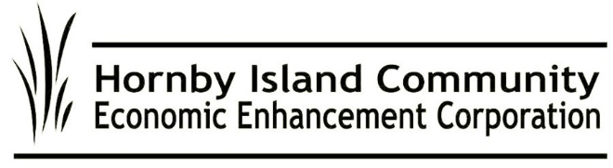

**HICEEC First Edition – July & August 2025**  
**Welcome to Summer on Hornby Island!**

**A Sunny Hello from the Welcome Centre**  
If you’ve been to the Farmers Market lately, you’ve likely seen Michele Papp’s friendly face at the HICEEC Welcome Centre. Located at the market entrance, the kiosk is your go-to for all things Hornby: visitor guides, Vision 2040 booklets, event tips, and answers to pressing questions like “Where’s the beach with the warmest water?” It also doubles as the Market Lost & Found. Misplaced a hat, sunglasses, or a lone sandal? Start at The Centre.

**Internet Upgrades Coming Online**  
City West is looking towards the finish line for construction on Hornby’s high-speed fibre optic project. This promises a major leap forward in internet quality for residents and visitors alike.

**Hornby Bus is Rolling Again**  
The Hornby Bus is back as of June 27, running 11 hours daily through Labour Day. With its green mission, the bus supports sustainable travel across the island. Pay what you can for your fare. This year’s stellar team includes driver-manager Jill Gathright, returning driver Dave Hayward, and newcomer Roman Hudson. Relief drivers from the Steering Committee—Garth Millan, Steve McDonald, and Ray Therrien—keep things moving smoothly. Behind the scenes are Gary Law (PR), Peter Mills (multi-talented wizard), and rookie (researcher Chris Allen).  
Find the schedule at:

* [hornbybus.com](http://www.hornbybus.com)
* Market boards
* Bus stops
* On the bus!

**What’s On?**  
From concerts and art exhibits to savouring the tasting rooms, the Hornby Events Calendar is your guide. Congratulations to Hornby Arts on the opening of the new Centre! Check out [hornbyisland.com/events](http://www.hornbyisland.com/events) for all the latest happenings.

**Where the Hornby “Pillow Tax” Goes**  
The Municipal and Regional District Tax (MRDT), or "pillow tax," collected from visitors to fixed-roof accommodations, is helping Hornby thrive. Most of the funds are reserved for affordable workforce housing, while the rest supports off-season events, sports, and community initiatives. A big thank you to our visitors for supporting Hornby’s future.

**Still Pushing for Land for Homes**  
While our proposal to secure 10 hectares of Crown Land near the Firehall was declined, we’re not giving up. With renewed support from the Regional District, HICEEC is still working on solutions—like tiny homes and staff housing—to meet urgent local needs.

**Vision 2040 – Our Community Roadmap**  
Vision 2040, created by HICEEC and HIRRA, is a bold, updated plan for Hornby’s future. It’s more than a report; it’s a shared vision for resilience. If you didn’t receive your copy by mail, grab one at the Welcome Centre and pass it along.

**Microloans Making a Difference**  
Hornby’s Microloan Program continues to support local entrepreneurs with small loans that pack a big punch. Backed by community investors and a strong pay-it-forward ethic, the program helps strengthen our economy from the ground up. Thank you to our silent “eagles”.

**Speak Up for Better Ferry Service**  
With BC Ferries ending local advisory committees, your voice matters more than ever. Share your ferry feedback with:

* BC Ferries: engagement@bcferries.com | 1-888-223-3779
* MLA Josie Osborne: Josie.Osborne.MLA@leg.bc.ca
* BC Ferry Authority: ClaireTrevena@bcferryauthority.com
* MOTI Marine Branch: [Francois.Bertrand@gov.bc.ca](mailto:Francois.Bertrand@gov.bc.ca)

**Thanks for Reading**  
Here’s to a sunny, sustainable, and community-minded summer!

**From your HICEEC Volunteer Board:**  
John Heinegg, John Grayson, Jack Hornstein, Katherine Ronan, Donna Tuele, Sheila McDonnell, Stu Amos, and Marilyn Kopansky

**See you at the Market – and on the Bus!**