CAGNOLATTI CAREFREE SOUTHERN AFRICA October 2026

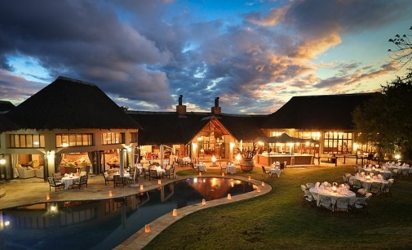 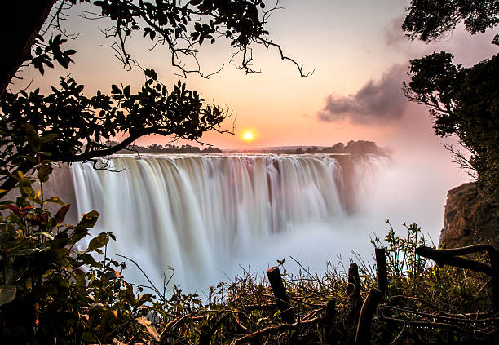 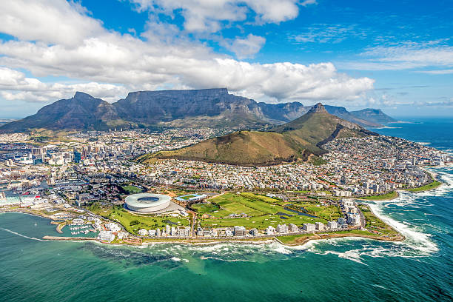

**DAY 0 OCT 9TH 2026            DEPART FOR JOHANNESBURG (INFLIGHT MEALS)**

**DAY 1 OCT 10TH 2026               ARRIVE JOHANNESBURG**

On arrival at Johannesburg airport you will be met and transferred to the Protea Balalaika Hotel for your overnight.

**Accommodation: Protea-Marriott Balalaika Hotel, guest room (2 Nights)**

**DAY 2 OCT 11TH 2026     JOHANNESBURG TOURING                                                      (BLD)**

After breakfast , your full day old and new Johannesburg touring begins.

Today you will be taken on a tour of Soweto.  You know the name. It's a legend. SOWETO, acronym for Southwestern Township, is home to over 2 million people, who, despite living in crowded and chaotic conditions, have a tangible sense of community, one which ironically, the ordered, walled, elitist northern suburbs lack. Inside Soweto, you will visit the Hector Pieterson Museum and discover the cause of the tragic riots which led to his death.  Entrance to Mandela House. Your journey continues to Regina Mundi Church, site of many secret underground meetings of the then banned political parties. Soweto is unlike a suburb you've ever seen or been to, yet the history of struggle encapsulated here is a cornerstone of the South African story. **Lunch** is included at Sakhumzi’s restaurant.  After lunch visit The Apartheid Museum (closed Monday and Tuesday), the first of its kind, illustrates the rise and fall of apartheid.  The museum is a superb example of design, space and landscape offering the international community a unique South African experience.  The exhibits have been assembled and organized by a multi-disciplinary team of curators, filmmakers, historians and designers. They include provocative film footage, photographs, text panels and artefacts illustrating the events and human stories that are part of the epic saga, known as apartheid.  A series of 22 individual exhibition areas takes the visitor through a dramatic emotional journey that tells a story of a state-sanctioned system based on racial discrimination and the struggle of the majority to overthrow this tyranny. For anyone wanting to understand and experience what apartheid South Africa was really like, a visit to the Apartheid Museum is fundamental. The museum is a beacon of hope showing the world how South Africa is coming to terms with its oppressive past and working towards a future that all South Africans can call their own. After you day out, back to hotel for welcome dinner at 7PM at the hotel restaurant, the Bull

Accommodation: Protea-Marriott Balalaika Hotel

**DAY 3 OCT 12TH 2026          DEPART JOHANNESBURG FOR ZIMBABWE                     (BD)**

After breakfast , transferred to the airport for a flight to Victoria Falls.

(flight to be quoted in due course and added to land total)

4Z 494  Y  OCT2026  JNB 1135A VFA 120P OR SIMILAR

No surprise why **Victoria Falls** is one of the seven Natural Wonders of the World. You'll understand it instantly as we tour the Zimbabwean side, for there are numerous spectacular vantage points along the width of the Falls, and the sight of this astounding gift of nature, simply takes your breath away. Walk through the permanent, beautifully misty rain forest which flanks the Falls, stopping to marvel at the principal sites as it cascades to the depths below the Main Falls, Horseshoe Falls, Rainbow Falls, the Boiling Pot, Cataract Island and Livingstone Island. We'll stand and watch, feel and listen to the spray and thunderous noise, as millions of litres of water tumble over the Falls into a series of narrow gorges below. The seventh Natural Wonder of the World puts on the most dramatic show for you, and you'll be privileged to have watched it.

Malachite Dinner Cruise: This afternoon you will enjoy a Scheduled Group - Sunset Cruise with others.

Put your feet up, sip a sundowner as the light gently fades, and let our tranquil wildlife cruise float you along the Zambezi River above the Falls.  You'll have the finest vantage point from which to watch hippo, crocodiles and other animals which come down to the river's edge in the early evening, to slake their thirst.  Enjoy your cocktail and snacks while captivated by the sun's dying rays as they cast a burnt orange glow which shimmers on the river. Take another sip in this golden setting.

**Accommodation: Ilala Hotel, classic room (2 nights)**

**DAY 4 OCT 13TH 2026               VICTORIA FALLS                                                           (BD)**

After breakfast , half day Victoria Falls tour and an evening Boma dinner

**Accommodation: Ilala Hotel, classic room**

**DAY 5 OCT 14TH 2026                           ABELANA RIVER LODGE                                   (BD)**

Breakfast at the hotel and transfer to Victoria Falls airport for flight to Kruger ( MQP)

(flight to be quoted in due course and added to land total) On arrival you will be met and transferred to the lodge

4Z 477  Y  OCT2026 VFA  200P  MQP  340P OR SIMILAR

**Abelana River Lodge:**Abelana Game Reserve is a 15,000ha (36,000 acre) Big Five game reserve adjacent to the Greater Kruger National Park and the Selati Game Reserve, close to the town of Phalaborwa in South Africa’s beautiful Lowveld – the country’s prime big game region. Owned by the Mashishimale community, the word “abelana” means “to share amongst each other” in the local Northern Sotho language. This spirit of sharing underpins the relationship between the Mashishimale and its lodge operations partner which leases the land for eco-tourism purposes. Characterized by breathtakingly beautiful landscapes, varied topography and a mixture of vegetation types, Abelana Game Reserve has a 10km stretch of the semi-perennial Selati River in its northern section, as well as numerous other seasonal water courses.

Abelana is home to a rich diversity of fauna and flora, from the hippos and crocodiles that make the Selati River their home and the famed Big Five – elephant, rhino, leopard, lion and buffalo – as well as cheetah and wild dog, which are occasional visitors, to an impressive number of endemic bird species including the African fish eagle, peregrine falcon, thick-billed cuckoo, and bat hawk. The main area and swimming pool overlook the river and include indoor and outdoor dining areas and a bar, as well as a lounge and fire pit for sharing safari experiences and sightings in the evenings.All rooms are under thatch with en-suite facilities, including an additional outside shower and spacious deck overlooking the river where guests can spend time relaxing between activities. The rooms are air-conditioned with ceiling fans and a mini fridge. Various dining experiences are offered overlooking the river. Dining options are dependent on weather and guest preferences. Activities included are guided morning and afternoon game drives, bush walks, birding, photography and stargazing

**Accommodation: Abelana River Lodge or similar (3 Nights)**

**DAY 6 OCT 15TH 2026                            ABELANA RIVER LODGE                         (BLD-2GD)**

Full day of game viewing activities with all meals and overnight at your lodge.

**Accommodation: Abelana River Lodge or similar**

**DAY 7 OCT 16TH 2026                            ABELANA RIVER LODGE                    (BLD-2GD)**

Full day of game viewing activities with all meals and overnight at your lodge.

**Accommodation: Abelana River Lodge or similar**

**DAY 8 OCT 17TH 2026                            ARRIVE CAPE TOWN                                        (B)**

This morning you will be met and transferred to Victoria Falls airport in time for flight to Cape Town

(flight to be quoted in due course and added to land total) On arrival at Cape Town airport, you will be met and transferred to the Southern Sun Waterfront Hotel for the next five nights overnight, with breakfast.

4Z 658 Y OCT2026 HDS 155P CPT 440P OR SIMILAR

**Cape Town:** With its majestic Table Mountain backdrop, Cape Town is one of the most beautiful and exciting cities in the world; an eclectic mix of architectural styles reflects the tastes and dictates of the past and the more functional demands of the 20th Century. Cobblestone streets, mosques and the flat roofed pastel homes of the Malay quarter enhance a cosmopolitan ambience and in a recent development, the restoration of the Victoria and Alfred Waterfront evokes images of the seafaring activities of the 19th century. At the end of the day, gourmets and lovers of sophisticated entertainment have a treat in store as the choice for your evening's repast is vast.

Lunch and dinner on own as a travel day.

**Accommodation: Southern Sun Waterfront Hotel standard room ( 5 nights)**

**DAY 9 OCT 18TH 2026  TABLE MOUNTAIN AND ROBBEN ISLAND                   (BD)**

Breakfast at the hotel, your full day Table Mountain and Robben Island Tour.

Guests will take a trip to the top of the world, high above the clouds on the famous Table Mountain. Table Mountain is an icon in Cape Town and is most likely the most photographed landmark in the country. Table Mountain has been named as of the seven wonders of nature and attracts millions of visitors from all across the globe, in fact, since the opening of the aerial cableway in 1929, more than 22 million people have taken the trip to the top. At the upper cable station, guests will find a restaurant and a curio shop as well as some footpaths for exploration.  After you have taken your photos, continue to Robben Island Museum - Robben Island Ferry Ticket - weather permitting.  Departure point - Nelson Mandela Gateway at V&A Waterfront

Robben Island requires guests to produce a form of identification when they purchase a ticket and board a ferry when visiting the island. All visitors are required to provide either an identification document, passport, birth certificate, or driver's license. Copies of these documents will be accepted.  Boats depart from the Nelson Mandela Gateway at the V&A Waterfront and head to one of the most famous prisons in the world. This is where South Africa's father of the nation spent 18 years, the legend of a man, Nelson Mandela. Guests will disembark at Murrays Harbour on the east coast of the island and take a short walk to buses that will transport them to all of the historically significant sites. The tour guides inside the prison today are former political prisoners and their knowledge of this island is unparalleled and adds a unique cultural layer to this experience. This tour culminates with a viewing of Nelson Mandela's cell. . Return to hotel for preparation for dinner.

**18:00 - GOLD Restaurant** - Interactive Djembe Drumming and 14 Dish African feast & Entertainment Including transfers. The group will be accompanied by an English speaking tour guide (Birthday Celebration) Gold Restaurant is often referred to as a taste safari and that is exactly what it is. This vibrant restaurant promises an evening of wining and dining in scintillating African style. The dinner begins with the drumbeat of the djembe drum and an interactive drum circle, and you will then be led into a courtyard where you will ceremoniously wash your hands before the feast begins. This 14-course set menu is authentically Cape Malay and African cuisine, while you are entertained by live performances near your table. Gold restaurant inspires and immerses you into the spirit of Africa while you savor delicious cuisine. Return to your hotel for your overnight.

**Accommodation: Southern Sun Waterfront Hotel**

**DAY 10 OCT 19TH 2026              WINELANDS                                                                 (BL)**

After breakfast, a full day Winelands Tour.  What is the best feature of the Cape Winelands? It’s true that it is renowned for its crisp white and classic French-style red wines, but it also has a stunning wealth of natural rustic beauty with vast estates shaded from the African sunshine by giant oak trees and towering mountains overlooking lush valleys. Lunch at a local restaurant

Franschhoek Cellar - Franschhoek Cellar List Tasting - 6 Wines

Huguenot Memorial Museum and Huguenot Memorial Monument

Lunch at a local winery in Stellenbosch and wine Tasting and Cellar Tour at a Local Estate

Orientation city tour of Stellenbosch. Return to Cape Town for dinner on own and with so many varieties available, ask the guide or hotel for their suggestions.

**Accommodation: Southern Sun Waterfront Hotel**

**DAY 11 OCT 20TH 2026        CAPE TOWN CULTURAL DAY                                           (BL)**

Breakfast at the hotel.  This morning you will be met for a Langa cultural experience tour.   Experience the rhythm and culture of Langa with a warm welcome and by participating in an array of traditional activities, such as:

**Gumboot Dancing**

Feel the beat of Africa as guests learn the famous African Gumboot Dance created by migrant labourers in the gold and diamond mines in the heyday of apartheid. The dance involves slapping, stamping and clapping to a set rhythm to create a chant and beat as only Africans can! This form of expression spread through the mines like wildfire and was not only used to express their ethnic identity by using traditional songs and rhythms during a time of heavy oppression, but also helped teams communicate in pitch dark tunnels deep underground.

**African Djembe Drumming**

The word Djembe means ‘Everyone gather together in peace', as such guests are invited to join in and master their skill to hold a beat with fellow players. The drumming troop will belead by authentic African drummers that will teach guests historical songs and beats that tell the stories that shaped Africa, these mesmerizing tunes will have guests humming along, long after they leave the Township!

**Traditional Head Carrying**

Guests get to try their hand or should we say head at Traditional Head Carrying that has been an art form practiced for hundreds of years in Africa. This skill was developed from necessity as women in Africa would need to transport great loads of food, wood or water and still have the use of their arms. This skill is practiced by Africans from childhood and enables them to carry up to 70% of their body weight over vast distances with minimum strain on the back, improving posture and minimizing energy loss.

**Diski Dancing**

Join in on the Diski revolution as guests learn famous moves named in Tswana Zulu Sotho , and English amongst others and include " Tsamaya ", "Heel Extension Mkhari " and "Chester" all mimicking famous soccer Diski ” is common South African slang for the game of football, and the Diski Dance is a uniform routine that showcases the country's passion for the sport. This dance was created for the 2010 soccer world cup in South Africa and will excite and unite any group as it captures the essence of Africa, and gets deep into its spirit and soul. Enjoy a walking tour followed by a 3 Course Traditional Meal (excludes Beverages and Gratuity)

**District Six Museum**

As a result of the Group Areas Act, 60 000 Capetonian families were forcibly removed from this once vibrant area between 1966 and 1982. The District Six issue remains crucial. You will examine the now desolate area, Zonnebloem, which was District Six and visit the living museum which attempts to represent and recapture District Six in various ways - as a finespun tapestry of communal life torn apart but not forgotten. Return to the hotel with the evening at leisure. Dinner on own.

**Accommodation: Southern Sun Waterfront Hotel**

**DAY 12 OCT 21ST 2026        CAPE TOWN PENINSULA TOUR                                      (BL)**

After breakfast, a beautiful tour of Cape Town awaits

**Nauticat Seal Island:** The Nauticat is a diesel powered catamaran which has glass viewing windows below deck. This feature adds enormously to the thrill of visiting seal island, allowing the spectator unbelievable views of the inhabitants of seal island and other marine wildlife in their natural habitat.

**Chapmans Peak Drive:** Chapmans Peak Drive on the Atlantic Coast between Hout Bay and Noordhoek in the Cape Peninsula is one of the most spectacular marine drives in the world. Chapmans Peak Drive is affectionately known as Chappies and is a must for anyone who is passionate about the majestic scenery of Cape Town. Initially constructed during the First World War, this 9km route with its 114 curves, skirts Chapmans Peak, the 593m high southerly extension of Constantia Berg, and follows the rocky coastline to unfold breath taking views in both directions.  The route starts at the picturesque fishing harbor of Hout Bay and the climb winds steeply up to Chapmans Point, revealing breath taking views of the sandy bays down below, until the road reaches lower levels again at Noordhoek.

**Cape of Good Hope (Cape Point) :** So, named by Portugal's King John II this area has captured the imagination of European sailors such as Dias who first named it the Cape of Storms in 1488 and later in 1580 Sir Francis Drake who called it the "The Fairest Cape in all the World". Rich in cultural and natural heritage this is one of the top tourist destinations in South Africa.

Due to the variety of wildlife that occurs here it is the only section that is fenced, and visitors should look out for Eland, Red Hartebeest, Be sure to visit the Buffelsfontein Visitor Centre that showcases all the plants and animals to look out for in a particular season and is full of informative signage. At the point, visitors are treated to excellent viewing opportunities from both lighthouses that adorn the most southwestern point in Africa, one still fully functional. The lighthouse is accessible by foot or one can catch the Flying Dutchman funicular to the top. Bontebok and Zebra.

**Cape Point - Funicular (Return):** Apart from offering visitors an exciting and novel method of travel, taking the Flying Dutchman funicular saves visitors an uphill walk from the car park to see the old lighthouse and enjoy the panoramic views. The Flying Dutchman Funicular, also known as the Cape Point Funicular, is a funicular railway located at Cape Point. Its the only commercial funicular of its type in Africa and takes its name from the local legend of the Flying Dutchman ghost ship. The line runs from a lower station at the Cape Point car park, up an incline through dense fynbos to the upper lighthouse. The funicular leaves from the lower station every three minutes, comfortably accommodates 40 passengers per car, and can transport 450 persons to the upper lighthouse per hour, making it the ideal way to whisk closer to the lighthouse even during peak times

**Lunch at Bertha’s Restaurant:**Lite luncheon fare, adult beverages excluded. (subject to change)

**Boulders Penguin Colony :**Located on the Cape Peninsula, in Simon's Town, a suburb of Cape Town in the Western Cape province of South Africa. It is also commonly known as Boulders Bay. It is a popular tourist spot because of a colony of African penguins which settled there in 1982.

Return to your Cape Town hotel and overnight. Dinner on own

**Accommodation: Southern Sun Waterfront Hotel**

**DAY 13 OCT 22ND 2026                      DEPARTURE CAPE TOWN                                  (B)**

This mid morning you will be transferred to Cape Town Airport in time for your flight home.

**End of Arrangements by GOWAY Travel**