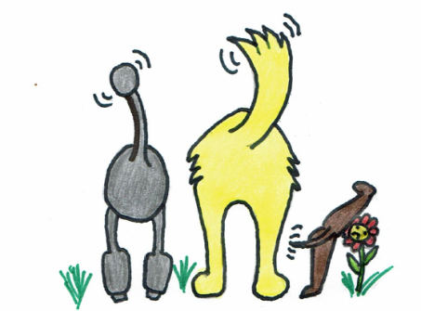
Waggy Trails
Phone Mobile 07977 178467
Website www.waggytrails.com
Email elaine450@hotmail.com
- New job with longer hours?
- Thinking or getting a dog but can’t always walk it?
- Going on holiday?
- Do you need emergency dog care, due to illness, hospitalisation, or last minute work commitments?
- Don’t like using kennels?
- Has your usual dog sitter let you down at the last minute?
Then don’t worry Waggy Trails is here to help take care of your dog. Whether you just need regular daily walks, day care in a home from home environment, overnight boarding, or just someone popping in to let your dog in the garden, feed and play. We offer a variety of services to suit your needs and were happy to tailor that service to ensure you and your beloved pet’s needs are met.
Why choose Waggy Trails?
- Unlike some of the larger dog walking services, here at Waggy Trails your dog gets the same walker every day.
- Fully qualified in dog first aid.
- We love all dogs big, small, young and old.
- Many years of experience with dog walking and care.
- Fully insured.
- Access to 24 hour vet care.
- Home from home boarding and day sitting in a dog friendly home.
- One to one attention and stimulating play.
- Secure safe transportation to and from home.
- Wash and brush up after muddle trails.
- Free treats and poo bags provided
- Basic training at no extra charge
- Varied walk locations.
- Free collection and drop off within a 5 mile radius of High Oaks St Albans
- Police DBS Checked April 2018 (certificate available on request).
Pop in service
This is one of our popular services which includes a 15 minute or half an hour visit, to provide the following care.
Open or close curtains
Water plants
Feed
Change litter trays
Provide garden relief for dogs
Wash bowls
Administer medicine
Put rubbish out for collection
Stack post and papers
Open close curtains
Turn on off lights and radio for added security
Check your pet’s general health and welfare.
Any additional requirements will be considered prices vary please ask for details.
Small pets
We visit your pet in your home; we can feed your pets, clean out cages, collect eggs from chicken coups and place them in your home. Feed fish in tanks or ponds, clean out small fish bowls, change littler trays or hay, give your pet fuss and attention if required. Boarding for hamsters, gerbils, or Guinea pigs is available on special request. Sorry no rats, birds, reptiles or arachnids.
Dog walking
- Reliable daily walks, dogs will generally be walked as a group of no more than 4 dogs at any time unless otherwise specified. Solo walks are charged at a higher rate (see price list for details) Dogs will be carefully selected to walk as a group to ensure that no dog or the walker is put at risk.
- Flexibility, we can walk your dog at times that suit your dog and you. Walks start from 8.00am, the last walk is a 6.00pm. If you require early or evening walks outside the walk times please speak to us, we can arrange special out of hours walks if required (see price list for details)
- Your dog will be treated with care and attention and given lots of love and affection.
- Every day is a different adventure with new smells, new trails, and new friends to meet along the way. Toy throwing, swims, walks in local woods and fields weather permitting.
- Permanent cover on standby in case of emergencies, help with your pet is just a phone call away.
- During winter months dogs will be street lead walked after 4.00pm due to lack of daylight.
Dogs will only be let off lead with owner’s permission, we can feed them when they are returned home if required. Walk times include collection and pick up within a 5 mile radius from High Oaks St Albans.
Poo bags and treats provided free.
Day care
We look after your dog in our home as if they were one of the family, the price includes a one or two half hour walk depending on duration of stay. They will be fed at regular intervals; we also have the facilities to store raw food for your dog. (see price list for details) we also provide lots of attention, cuddles, and play in a dog friendly secure garden.
Overnight boarding
You dog gets to stay in a clean safe environment, with two walks a day, included in the price. They will be given every attention. We do have a dog of our own, he is very friendly and accommodating and loves to have a new friend for a sleep over. No more than 3 dogs including our own are boarded in any 24 hour period.
If you have any concerns, queries or special requests please get in touch we will always endeavour to help.

