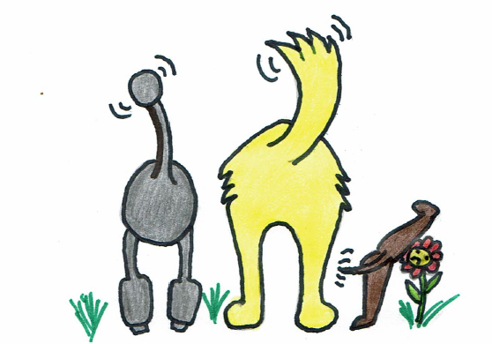
Waggy Trails

Application Form
Name
Address

Contact daytime phone number.
Mobile number
Email address.
Vets details
Name of Vet
Address
Contact phone number.
Is this vet 24hrs?
Is your dog insured?
(Please provide copy of certificate with this application)
Please note that if for any reason your dog should require veterinary assistance whilst in the care of Waggy Trails, this will be either sort from your dog’s usual vet, or if out of hours veterinary care is required, a 24 hour vet will be contacted to provide medical assistance. All costs associated with the vet will be met by the owners or their insurers.
By signing this form you are consenting to this agreement.
Dog/Dogs Names
Age of dog/dogs
Breed/breeds
Size of dog delate as appropriate Small Medium Large
Microchipped yes no
Address details on collar or harness.
Does your dog generally wear a muzzle on walks?
Does your dog need a coat in cold/wet weather conditions?
Which services do you require?
Option 1
Walking, please specify number of walks per day and duration of walk.
Walks per day 1 2 3 4
Duration of walks 30 mins 45 mins 60 mins
Solo walk or socialisation walks
Getting acquainted
The first walk will always be a solo walk. This will enable me to observe your dog’s habits, allow your dog to feel safe and comfortable with being walked by me.
Socialisation walks would be a group of no more than 4 dogs at any time. Dogs will be chosen for socialisation walks based on temperament and size. Socialisation walks are especially good for young dogs to get them used to other dogs and prevent problems with socialisation later on.
Option 3
Day care
(Includes free local collection and drop off and a 1 hour walk or two 30 minute walks)
Option 3
Boarding.
Please specify number of days/nights and provide dates. Please refer to the list of fees and charges as these may vary according to times and public holidays.
Option 4
Home visit Feed and garden relief.
Please specify type of walk. tick all that apply
- Lead walking only
- free to walk off lead
(Please note, dogs will not be walked off lead whilst near any roads).
- Street walks only
- parks and woods
- areas near water
Does your dog have any particular habits? This could be anything that might cause your dog to run off without warning, pull on the lead, jump up at strangers, chase cars, eat something unpalatable, or attack another dog? Please mention anything that you feel is important in the box below.

Your Dogs health.
Please answer all the questions below as thoroughly as possible.
- Has your dog been boarded in kennels within the last 3 weeks?

Yes no

- Has your dog been checked for kennel cough recently or do you suspect that they may have Kennel cough?

- Has your dog been (Male) neutered yes no (female) spayed yes no
Q.4 Female dogs only
- If your dog is still intact please specify the date when you’re dog last menstruated?
………………………………. Female dogs on heat will only be walked at low risk times to prevent the chances of male dog encounters, and well away from popular dog walking areas.

- Are your dog’s vaccinations up to date. Yes No
- Has your dog recently suffered from fleas or ticks? Yes no
- If yes when was it treated……………………………….. When was it last checked…………………………….
IMPORTANT NOTICE. For dog boarding and day care, If you answered no to question 7 and your dog is found to have fleas/ticks, your dog will be treated by me, there will be a charge for treatment and if required fumigation of my home. Please ensure you check your dog thoroughly for fleas before booking, and apply their regular treatment one week before boarding/day care commences.
Health continued
Please specify below any allergies you dog has.

Injuries or physical disabilities?

Fears nervousness or aggression issues? Please specify

Is your dog house trained?
Yes. No. Please state if you know that your dog is likely to urinate inside when entering a strange house.
Destructiveness, for day care and boarding, please state if your dog has a tendency to chew or be destructive in the home if left alone even for short periods of time?

Travel
Does your dog have any issues when being transported by car? Please include things like tendency to be sick, go to the toilet, trying to escape, or anything that you feel might be an issue if your dog is placed in a vehicle.

Any issues or special needs your dog may have are important for us to be aware of. At Waggy Trails we will do our utmost best to ensure that their needs are catered for and any issues that may arise from their doggy habits mitigated to the best of our ability.

Please check all your answers thoroughly and sign and date the declaration below.
Should it be found that you knowingly answered any of the questions falsely and an incident occurs whereby your dog causes, damage whether in the home or whilst outside on walks, injury to Waggy Trails staff, members of the public or another animal, or infestation to other dogs or to my home, a surcharge of £250 to cover the cost of insurance excess may be levied to cover the costs incurred as a result or your omissions.
By signing this you are agreeing to the terms and conditions above.
I confirm that all the answers I have given above are correct and accurate to the best of my knowledge at the time of signing.

Print Name Signature Date

