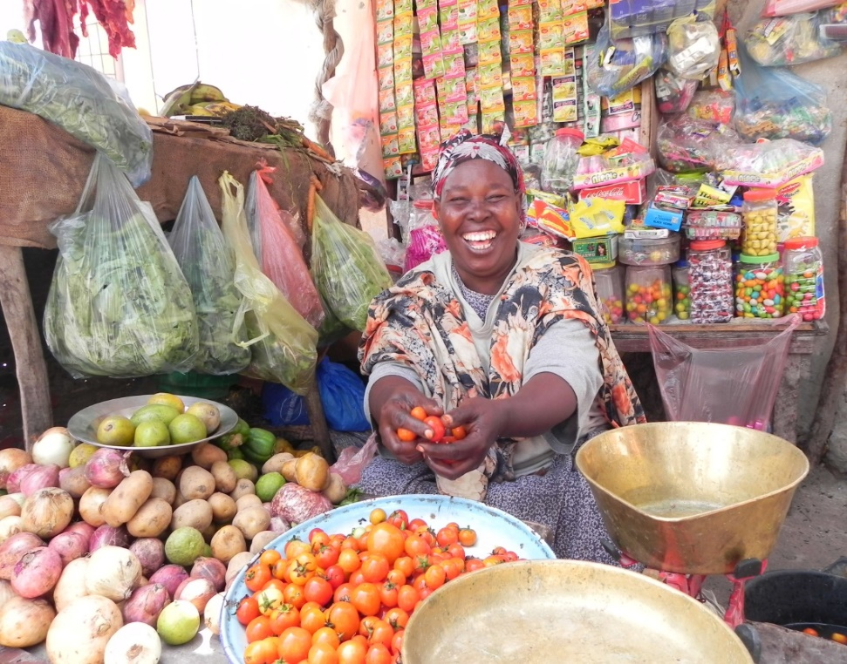

BY POVERTY ALLEVIATION COALITION: SOMALIA
September 2020
REFUGEE, RETURNEES, INTERNALLY DISPLACED AND HOST COMMUNITY EMPOWERMENT PROJECT: SOMALIA, URBAN AND PERI URBAN CONTEXT
Concept Note

PARTNERS

PARTNERS

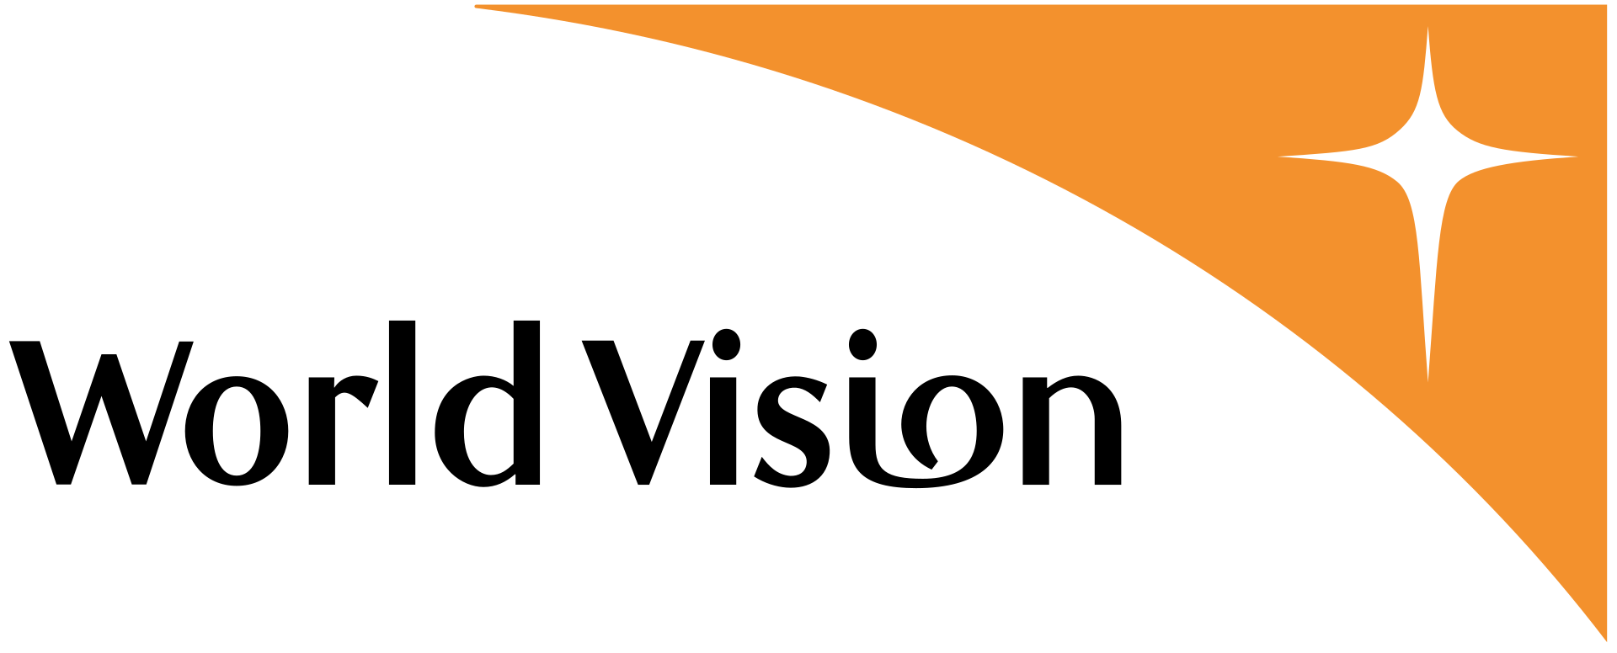
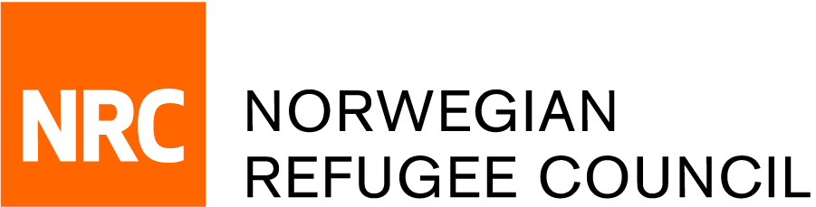
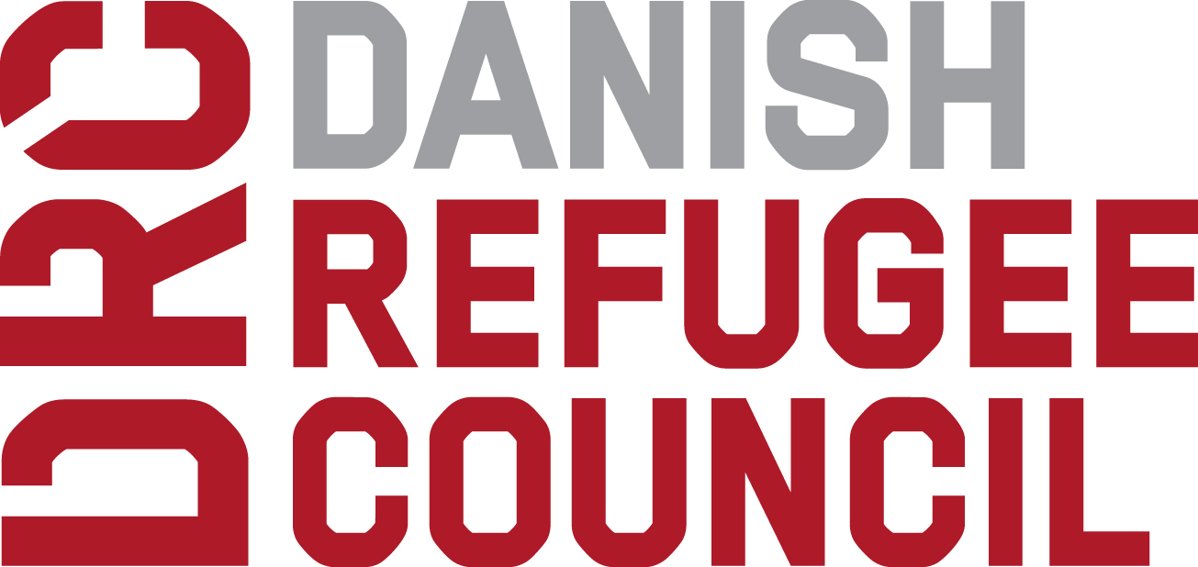
Project Summary
Concern Worldwide  Implementing  USD 3,375,000, 1,250 HH |  | World Vision  Implementing  USD 3,375,000 HH 1,250 | Norwegian Refugee Council  Implementing  USD 3,375,000 HH2,350
Danish Refugee Council
Implementing
USD 3,375,000 HH1,250

<Partner>  <Partner role>  USD 00,00, 000 HH- <location> |  | <Partner>  <Partner role>  USD 00,00, 000 HH- <location>
<Partner>  <Partner role>  USD 00,00  000 HH-  <location> | <Partner>  <Partner role>  USD 00,00  000 HH-  <location> |  | <Partner>  <Partner role>  USD 00,00  000 HH-  <location>

Target Beneficiaries
Households 6,100

Target Beneficiaries
Households 000
Methodology
The Graduation Approach

Methodology
The Graduation Approach

Country
Somalia

Country
<here>
Cost per household
USD 2,377

Cost per household
USD 00,00

Total Programme Value
USD 14.5 million

Total Programme Value
USD 00,00

Contents
District
Phase II: Expansion to more poverty-stricken regions and districts (to be decided)

District
Phase I: Hargeisa District, Waqooyi Galbeed Region, Bosasso District, Bari Region and Baidoa District, Bay Region.

Contents

Project Summary 5

Background 6
Problem analysis 6

Project Operating Model 10
Project Goal 10
PROJECT OUTCOMES 11
Implementation Phases Error! Bookmark not defined.

Project Impact and Sustainability 16
Intended IMPACT 16
Logical Framework Error! Bookmark not defined.

Project Management and Governance 17
Coalition Organisational capacity 17
Broader Project Stakeholders 19

Monitoring and Evaluation 20
LOGICAL FRAMEWORK 20
MONITORING 22
EVALUATION 22

Project Budget 23
Funding Request 23
Project Budget 23
Any In-Kind Contributions 23

Annex 1 – Risks and Assumptions 24

Annex 2 – Project Partner Credentials 28

ACRONYMS

BRCiS | Building Resilient Communities in Somalia
CBO’s | Community Based Organisations
CFW | Cash for Work
DIP | Detailed Implementation Plan
GDP | Gross Domestic Product
HDDS | Household Dietary Diversity Score
IASC | Inter-Agency Standing Committee
IDP | Internally Displaced Persons
INGO | International Non-government organisation
LNGO | Local Non-government organisation
MEAL | Monitoring, Evaluation and Learning
MEAL | Monitoring, Evaluation and Learning
MEB | Minimum Expenditure Basket
MEP | Monitoring and Evaluation Plan
MFI | Micro Finance Institutions
NGOs | Non-Governmental Organisations
rCSI | Reduced Coping Strategy Index
ReDSS | Regional Durable Solution Secretariat
SomRep | Somalia Resilience Program
TOC | Theory of Change
TVET | Technical and Vocational Education and Training
VSLA | Village Saving and Loan Association

Project Summary
Somalia suffers one of the most complex and protracted crises around the world. Conflict, weak governance and recurring climate shocks lead to a large number of Somali people struggling with extreme poverty. Insecurity and natural disasters have driven more than 2 million people into displacement. Together with refugees, asylum-seekers and returnees, this forms a highly vulnerable group with limited means to achieve economic self-sufficiency. While uprooted population are likely to be vulnerable, it is important to recognise a large number of host communities neighbouring displacement settlement are struggling - especially those who host the displaced in their home. Youths and women are particularly marginalised due to their low social status in the Somali communities. Extreme poverty traps households into a vicious circle of reliance on external assistance with limited means to build their ability to break out from it.
The rampant spread of COVID-19 across the world has led to infections and deaths; the measures taken to contain further spread of the virus by governments has threatened the ability of communities to access food, water and health care, and especially in the most fragile countries like Somalia. The extremely poor households such as displaced affected communities, are exposed to greater risk of infection as well as bearing the major brunt of the economic hardship caused by the pandemic. With their deep-rooted vulnerability they will find it difficult to bounce back even if they can survive the major outbreak.
The project, therefore, seeks to support the displacement affected communities - including refugees, returnees, internally displaced and vulnerable host communities, achieve graduation from extreme poverty to self-reliance by enabling sustainable livelihoods, wellbeing and dignity in Somalia. The immediate cash inject will protect the most vulnerable households from adopting negative coping strategies during the pandemic that will enable following livelihood measures to support the recovery of these households.
Four agencies active in Somalia, including World Vision Somalia (WV), Concern Worldwide (CWW), Norwegian Refugee Council (NRC) and Danish Refugee Council (DRC), intend to join hands to address the challenge of the extreme poor. The consortium of the four agencies propose a 3 year project, targeting 6,100 households who are the most destitute, chronically food insecure and malnourished families who are living well below the poverty line. The districts selected are Hargeisa District, Waqooyi Galbeed Region, Bosasso District, Bari Region and Baidoa District, Bay Region as a start but will expand to other locations throughout Somalia depending on funding availability. The project will support the targeted households with resource and capacity building that will bolster their income generating capacity and increase saving. The project focuses on empowering the extreme poor both economically and socially as these two elements are intertwined in contributing to self-reliance that can enable the households to be more resilient in the long run. Considering the cost of operation in Somalia is high, the project will seek USD 14.5 million for 36 months. A common monitoring and evaluation (M&E) framework alongside with detailed M&E plan will be developed to track progress and effectiveness of the project. The consortium will actively gather evidence over the course of the project to capture lessons and achievements to determine the effectiveness and efficiency of the graduation approach in the context of Somalia.
SUMMARY:
Funding Request and gaps
- USD 14.5 million
Implementing Locations and number of recipient households
- Phase I: Hargeisa District, Waqooyi Galbeed Region, Bosasso District, Bari Region and Baidoa District, Bay Region. Phase II: Expansion to more poverty-stricken regions and districts (to be decided)
- At least 6,100 households will receive assistance and expected to graduate from poverty.
Technical Assistance Partners
- BRAC (to be contacted)
Research Partners
- Academic institution (to be contacted)

Background

Problem analysis
The protracted humanitarian crisis in Somalia is among the most complicated around the globe. Somalia has plagued by violence and political turmoil for more than forty years. Ongoing armed conflict and insecurity, with recurring climate shocks, has resulted in protracted economic vulnerability across the country as well as fragmentation and weakening governance structure. Violence and limited access to humanitarian assistance in hard-to-reach areas propel large number of Somali moving toward urban and peri-urban areas, straining the limited resources of the host communities. Somalia has a large part of its population continuously relying on humanitarian assistance. According to the Humanitarian Need Overview of OCHA, the number of people in need was at about 4.9 to 5 million. In 2017, the people in need shot up to 6.2 million due to the protracted drought. On reaching 2019, a total of 4.2 million people, representing 30% of the total population in Somalia, are in need of humanitarian assistance. The heavy reliance of humanitarian assistance reflects a high level of vulnerability across the country which renders communities susceptible to shocks.
The absence of coherent government and security for over almost three decades has also meant that Somalia has not made the progress seen in its neighbours or in other countries that started from a similar baseline in human development terms. This has left the country at one extreme of the global rankings on many different indicators. It has, for example, exceptionally high rates of population growth, fertility rates, child mortality and maternal mortality. The high fertility rate also contributes to the exceptionally large youth bulge. Three-quarter of the population is under 30 years. Such a youth bulge can constitute a ‘demographic dividend’ in some countries but in Somalia the unfavourable context renders it more of a potential burden.
The Government of Somaliland and Somalia lacks government data and information on skills available and their distribution in the regions of the country. This makes it difficult for the government and development partners to have a firm basis of formulating, implementing, monitoring and evaluating socio-economic policies and strategies – and more so those related to the labour sector. A survey conducted in 2016 states that the proportions of those who have ever attended or completed school are 62% of males and 38% of females. The youth bulge in Somalia is more likely to result in: high levels of frustration over limited access to education, jobs and social mobility; easy recruitment of unemployed young men into armed groups of all types; acceleration of urban drift from the countryside, producing ever-growing urban slums; and, perhaps most significantly, increasing numbers of Somali youth seeking out-migration to the Gulf, Europe and North America in search of work and a new life. Surveys suggest that the last scenario is already playing out: a majority of young people surveyed identified out-migration as their preferred option for the future.
Poverty
Somalia’s economic development challenges are daunting with insufficient growth for reducing vulnerability for a large segment of the population. Between 2013 and 2017, Somali real gross domestic product (GDP) is estimated to have grown at an average of 2.5 percent per year while population grew by 2.9 percent per year. The result has been an annual contraction in per capita incomes of 0.4 percent during the same period, leaving GDP per capita at just over US$500. Growth is mainly consumption driven, enabled by large remittance and aid inflows (US$1.4 billion and US$1.75 billion respectively in 2017), while construction, telecommunications, and money transfer services have been the key growth sectors. The diaspora remittances enable household consumption at 132 percent of GDP and represent an important component of income for the bottom 40 percent of households. Half of Somalia’s estimated 12 million people live in rural areas, pursuing pastoralist and agro-pastoralist livelihoods. The agriculture sector remains the backbone of the economy and accounts for about 75 percent of GDP, among the highest in the world. Livestock alone accounts for about 40 percent of the sector’s 79 percent share of export earnings, bringing in over US$500 million a year. The incidence of poverty in Somalia remains high. In 2016, half of all Somalis lived in poverty, having a total daily per capital consumption expenditure lower than the international poverty line of USD1.9; while almost a third of them lived in extreme poverty, meaning this group of people living on less than USD 1.25 per day.
While the world average unemployment rate is at 4.936% in 2019, Somalia’s unemployment rate was at 13.955%, among the 25 countries with the highest unemployment rate around the world. From 2017 to 2019, the unemployment rate has been steady with less than 0.01% change. Youth employment rate is as high as 24.89%
Internally displaced, refugees, returnees and host communities
Widespread and protracted displacement is a major humanitarian challenge for Somalia. An estimated 2.6 million people are internally displaced, located in around 2,000 internally displaced people (IDP) settlements across Somalia. The majority of these are informal settlement on private land in urban areas, thus increasing their risk of being evicted. The major reasons of displacement include natural disasters such as flood and drought, fear of conflict/ insecurity, lack of livelihood opportunities and eviction.
The displacement is largely protracted with 3% of IDPs being displaced for 1 year, 42% between 1 to 3 years, 45% 3 years or above. Multiple displacement is also a concern. Data from the 2019 Aspiration Survey conducted by the Regional Durable Solution Secretary (ReDSS) in the three largest displacement hubs: Baidoa, Mogadishu and Kismayo finds that on average about 36% of the displaced households lived in at least one other location before reaching their current one. Multiple displacements render households more and more vulnerable given that they have no time to recover from their uprooting experience. These are likely the households which will continuously rely on humanitarian assistance.
Apart from the push factors, it is also important to examine the pull factors that draw IDPs to certain locations. In the ReDSS survey, IDPs reported absence of conflict, access to food aids and work opportunities as the major pull factors for them to come to the urban hubs. This echoes the general push factors as discussed above. With these pull factors, the vast majority of the respondents (from 90% to 100%) said they would like to stay in the current locations in the coming 6 months, which may help to explain the reason for protracted displacement in the country. If the security situation and poverty level do not improve significantly in Somalia, displacement will continue to be a humanitarian challenge to the country.
Somalia also has been receiving refugees, asylum-seekers and returnees over the years. As of October 31, 2019, there were 35,438 refugees and asylum seekers registered in Somalia mainly from Ethiopia, Yemen, Syria, Tanzania, Eritrea and others. The largest number of refugees and asylum seekers are in Woqooyi Galbeed region (19,395), followed by Bari Region (8,727) and Nugaal Region (1,866). Since December 2014, 91,101 Somali refugees have voluntarily returned to Somalia. The majority of them reside in Lower Juba Region (54,512), Banadir Region (19,925) and Bay Region (9,659).
Displaced affected population usually face more challenges than other groups in the communities in accessing economic opportunities. The Ground Truth Solutions, Somalia – ‘Strengthening accountability to affected people’ (September 2019) reported IDPs feel least able to access employment opportunity. Those who have moved to Somalia from their country of origin voluntarily reported to have the highest chance to access to employment (44%) closely followed by local residents affected by crisis (42%). Out of the IDPs, on the other hand, only 35% reported to have access.
Despite the fact that displaced populations are likely to be more vulnerable, it is important to note that their host communities are also largely living below the poverty line and probably affected by marginalization. According to OCHA’s Humanitarian Need Overview in 2019, about 35.7% of those who required humanitarian assistance are host communities. It is common among Somali to host the displaced through non-formal arrangements. The displaced will be hosted by family members, relatives, friends or even people previously unknown to those who have been displaced. The already poor host families will have to stretch their resources to cater to the new comers, whichwill tumble them into deeper poverty. It is therefore important to acknowledge non-formal host arrangements for displaced within/neighbouring existing communities who are already resource constrained.
Displaced affected population are also particularly vulnerable during the time of COVID-19. IDP settlements are potential hotbeds of COVID-19 transmission due to crowded and poor living condition. Even in the best of times, IDPs do not have adequate access to water and soap and will therefore be highly susceptible to the disease transmission. According to OCHA, about one third of the IDPs (0.8m) have insufficient access to WASH service. Due to their low economic status, the IDPs have limited access to health care services, if at all. Survey and research also constantly find IDPs are usually the most food insecure. The Gu’ 2019 IDP site assessments shows 3 out of 13 IDP sites reported to have GAM rates above the 15 per cent thresholds. High malnutrition can weaken the immune system and render IDPs more susceptible to COVID-19.
Gender Inequality
Somalia has a highly defined patriarchal clan based cultural system that defines the roles, responsibilities, and rights of women, men, boys, and girls. The Gender Inequality Index for Somalia is 0.776 (with a maximum of 1 denoting complete inequality), placing Somalia at the fourth highest position globally. Despite high labour force participation by men and women, women are disproportionately represented in unpaid subsistence and domestic work (reproductive gender roles), which is not accounted for in Labour Force Participation. Women occupy less technical and professional positions than men, thus are more likely to suffer from poverty.
Targeted locations and communities
The Woqooyi Galbeed, Bay and Bari regions are among the top 10 regions with the highest number of combined refugees, asylum seekers, returnees and IDPs. The total combined caseload as of 31 October of the three regions is more than 625,000, according to UNHCR. The programme will target the three major hubs of the three regions: Hargeisa district in Woqooyi Galbeed, Bosasso in Bari Region and Baidoa in Bay region. With the extreme poverty ratio at 31% across the country, the programme intends to target 50,000 extremely poor households; with the average size of household being about 6, the programme will aim to reach about 300,000 individuals. The programme will prioritise displacement settlement and its neighbouring communities, targeting households based on their level of poverty and vulnerability, which will include refugees, returnees, IDPs and host communities.
Hargeisa District
Hargeisa town is the biggest urban setting in the Somaliland. There are about 19 IDP settlements in Hargeisa. Over the years, it has become host to various population groups that have been displaced as a result of conflict, insecurity or drought, as well as those who migrated to the city for economic purposes. The last decades have seen IDPs, refugee returnees from Ethiopia and elsewhere, refugees and economic migrants moving to urban areas; the majority join communities residing in government-recognised settlements, while others mingle with the host populations across the city. Somaliland’s total population was estimated to be 3.8 million in 2016, with 53% living in urban areas, 11% in rural areas, and 34% described as the nomadic population. Somaliland’s population is young and increasingly urbanized. During the lean season (April to June) in 2019, the number of people reported to be highly food insecure (IPC 3 – Crisis & 4 Emergency) stood at more than 140,000.
In terms of the livelihood profile, both food and non-food imports are significant industries for Hargeisa, although the retail sector is undergoing a transformation as small shops are being replaced by supermarkets. Agriculture – especially livestock – has traditionally been the main source of livelihoods although it is susceptible to external shocks such as droughts, which have known to kill thousands of animals.
Bossaso District
Located on the northern coast of Somalia, Bossaso is the capital city of Bari region. It has been used as a transit point for mixed migratory movement coming from Southern and Central Somalia. According to CCCM cluster, there are about 45 IDP settlements in Bossaso. Bosasso observed to have more than 93,000 people reported to be highly food insecure (IPC 3 – Crisis & 4 Emergency) between April to June 2019. The labour market and service assessment done by IOM in 2019 showed that Bosasso has the least employment opportunities among seven other hubs across the country.
Agriculture and livestock are traditionally the main sources of livelihoods and are likely to remain important in Bossaso as Somalia seeks to meet domestic food needs, however, these sectors are susceptible to climate shocks. Fishing may become more important as the sector becomes more developed. The retail and services sectors are also booming as there is great demand for electronics and fast food.
Baidoa District
Baidoa is the capital of the Bay region; a strategic town in south-central Somalia situated approximately 250 kilometers west of Mogadishu and 240 km southeast of the Ethiopian border. It already hosts over 100 IDP settlements and of late there has been large influx of IDPs from the rural areas of Bay and Bakool Region. The absence of a functioning government, as well as continuing civil insecurity, has forced Baidoo’s population to develop strong social support systems, filling in the gap left by the lack of official political and social infrastructure. Almost over 50% of the host community especially in Baidoa are very vulnerable. This has been heightened by a number of factors. Most host communities located in the out skirts of urban centres have minimal access to basic social service as seen in the inadequacy of education facilities, limited access to clean and safe water plus poor health service delivery. Most of them (over 70%) are living by offering unskilled low paid manual labour or are involved in informal and small petty trading within the IDP camps. Levels of vulnerability are more pronounced among the youth and women in the host communities as they have limited access to resources, income earning opportunities and decision-making. The limited livelihood opportunities among host communities makes integration of IDPs even more challenging – as most of them have only background knowledge of agro-pastoralism as a means of livelihood; and are also threatened with the risk of forced evictions (50% of IDPs). Limited access to productive resources and low social capital has compounded the vulnerability situation of host communities and IDPs alike. Construction and agriculture are likely to remain key economic drivers with many people working in small businesses in Baidoa. Increased public spending could create employment opportunities.

Project Operating Model

Project Goal
The project strives to “achieve graduation from extreme poverty to self-reliance for displacement affected communities - including refugees, returnees, internally displaced and vulnerable host communities - by enabling sustainable livelihoods, wellbeing and dignity in Somalia.
‘Graduation’ in this context refers to participants moving out of safety net programmes, improving in nutritional status, and ‘graduating’ into income-earning activities that let them sustain themselves without external subsidies. The idea is to foster self-employment activities among the extreme poor, helping to shift them from insecure and fragile sources of income to more sustainable income-generating activities and engaging youth in productive labour.
The project will focus on the most destitute and chronically food insecure and malnourished families who are living well below the poverty line. While poverty is prevalent in Somalia, communities residing within or neighbouring displacement settlements are more likely to be food insecure, which include both the displaced and the host.
Economic self-reliance is defined as an individual’s and/ or household’s ability to garner and hold economic resources in order to access their basic needs. This is critical to allow individuals or households to adapt and adopt to different shocks such as conflict, droughts and flood, which are common in Somalia. The project aims to improve the overreliance on external aid of the extreme poor by strengthening two sources of economic self-reliance: 1) individuals’/ households’ effort and skills to acquire economic capital and 2) their relationships with families, communities and macrosocial system to acquire social and human capital. The project will address the root causes of extreme poverty in Somalia by minimising adoption of negative coping strategies, decreasing over-dependence on climate sensitive, single-sourced livelihood and lack of social support network due to displacement. The project will conduct careful assessment on livelihood options to ensure the livelihood options supported are appropriate to the specific context and environmentally friendly, thus sustainable for the households.
Social needs of refugees, while varied by nationality, are the most prohibitive most when it comes to achieving self-reliance. Language, literacy social network and capital are among the most important factors for refugees and displaced populations building sustainable livelihoods. Social connectedness is found to be a critical factor in Somali’s ability to cope with shocks and to be self-reliant, due to their clan system. The project therefore will seek to promote social cohesion among refugees, returnees, internally displaced and vulnerable host communities through livelihood interventions that will promote social and financial inclusion. This will be a critical element to enable graduation.
While this project focuses its effort on building economic capacity at a household level, it recognises that the overall well-being of the extreme poor will need to be achieved through multi-sectoral interventions that enable basic service provision and strengthen community mechanism and governance.
The project will engage multi stakeholders in the targeting process to ensure the appropriateness of the support. The project will coordinate with government and other agencies in the targeted areas to determine prioritised communities. The geographical targeting will ensure the targeted villages or districts are selected based on need alone with no political, ethnic, cultural or religious bias. The decision will be informed by need assessments conducted at the beginning of the project.
For households targeting, the project will adopt a community-based targeting approach. This approach recognises the fact that communities will be likely to have a better understanding of their contextual vulnerabilities than outsiders. With a participatory process lead by communities and facilitated by the project staff, the project means to reach those in greatest need, promote accountability to affected population and avoid risk of violence against and/ or further marginalization or stigmatisation of groups and individuals caused by lack of transparency.
Together with the communities, the project will develop a set of beneficiary selection criteria that considers various vulnerability factors (financial, physical, natural, human and political) in the Somalian context. The communities will then carry out a self-targeting process based on the agreed criteria through community meetings led by a community committee and village leaders with the participation of the project staff. The project will ensure the criteria development and beneficiary selection processes are transparent to all community members and make sure marginalised group such as women, minorities, physically challenged people are informed and included in the whole decision process. After the preliminary beneficiary list is produced, the project staff will verify the list proposed by the communities to minimise possible inclusion and/ or exclusion errors. The list will be read publicly, and each selected beneficiary will be appraised against the targeting criteria.

PROJECT OUTCOMES

Outcome 1: Enabled adoption and / or continuation of positive coping strategies of the extremely poor and displacement affected households by improving their immediate access to food and basic services and strengthening community productive assets
Output 1.1. Increased extremely poor households’ access to food and basic commodities through provision of conditional and unconditional assistance
Output 1.2. Improved community productive assets which will positively contribute to economic self-reliance
The project will seek to promote and enable positive coping strategies for the extremely poor households in the displacement affected communities through supporting their immediate consumption needs through cash transfers. The livelihood season and the food security situation will guide duration and timing of the cash transfer as the cash inject intends to cushion impact of lean season and the inflation caused by the movement restrictions due to COVID-19. This means to protect household’s basis for household engagement in subsequent project activities. Temporary cash transfer can allow recipients to adapt to changing circumstances and needs wherever the markets are functional. Allowing recipients’ freedom to decide how to spend the money is critical for their dignity especially when the extreme poor often face discrimination or marginalisation due to their lack of economic capacity. As the displaced population in Somalia usually reside in urban or semi-urban areas where the market is largely functional, cash transfers are deemed appropriate and effective to meet their most pushing need as well as to stimulate local economies. The programme will conduct detailed market assessments to determine the appropriateness of utilizing cash in targeted areas. In case the market situation is not conducive for cash distribution, the programme will also adjust the mechanism accordingly such as through voucher or in-kind distribution.
The project will adopt a mix of unconditional and conditional cash or food transfer for 4 to 6 months, depending on the level of vulnerability of targeted households, the seasonal livelihood situation and the COVID-19 situation at the time of implementation. Targeted households will be supported with unconditional cash for the initial 2 to 3 months then gradually transit into conditional cash transfer when the situation has improved. Work norms under the conditional transfer activity will be carefully assessed to ensure gender considerations, cultural sensitivity, safety considerations, and their applicability. The cash transfer value will be based on the Working Group recommendation on the minimum expenditure basket (MEB) that is intended for multi-purpose purchases of basic commodities such as food, water and other necessities for a family of six, an average family size in Somalia. Conditional cash transfer - in the form of cash for work (CFW) - aim to build, rehabilitate and/or improve community assets, including conserving natural resources on which lives and livelihoods depend, which can increase agricultural productivity and/ or minimise the risk of recurring natural disasters such as drought and flood in Somalia. Cash transfer will be done through mobile means to minimise physical interaction.

Outcome 2: Improved adaptive and absorptive capacity of the extremely poor and displacement affected households by promoting regular saving and access to formal and/ or informal financial services
Output 2.1. Strengthened or established village saving and loan association (VSLA) of which targeted households participated and started saving
Output 2.2. Increased knowledge on financial and business management of the targeted households
Community self-help mechanism builds on existing traditional social support mechanism that Somalis employ in the time of distress. Saving groups have seen a significant uptake and were widely welcomed by Somali communities. The Somalia Resilience Program (SomRep) conducted a Positive Deviance Study and found that the most important factor linked to the wellbeing of positive deviant households was being a member of a saving group. The programme will establish or strengthen self-help mechanisms in targeted communities by forming a network of saving groups or village saving and loan associations (VSLAs), particularly for women who generally have less control on economic capital. VSLAs will be networked for saving from members associations; VSLA operates on the principle that members of a self-selected group voluntarily form a VSLA and save money in the form of shares. The savings are invested in a Loan Fund from which members can borrow repaying with a service charge added. VSLAs provide a simple facility in a community that does not have access to formal financial services. It is common for group members to set aside an emergency/social fund which can be accessed at the discretion of the group members. The VSLA will include but not be limited to the extremely poor households targeted for the cash transfer. The whole community, especially women, will be encouraged to participate. When the saving group matures, the programme will explore linking saving groups with financial service providers such as Dahabshiil and/or other microfinance to enable access to formal financial services such as loan and credit. Participants will be trained with business development skills to help them manage the saving groups as well as to explore other business options.
The programme will seek to link the CFW activities to VSLAs to create synergistic effects on targeted households’ ability to reduce debt, save money, access credit in the dry season, and improve food consumption and access to basic services such as health and WASH. The program will further look at increasing access to formal financial services by linking saving groups with financial service providers whenever possible. When the VSLA matures, the programme will facilitate to move the individual groups into a cluster model wherein the mature group can support the newly formed groups. This model will reduce the dependency on agencies in the long run and create ownership of the groups. The VSLA will also be used as a delivery mechanism for food security and livelihoods as well as nutrition information, life skills, good hygiene practice and gender sensitization. The project will provide periodic coaching throughout the project life on social capital mobilisation, financial literacy and business facilitation.

Outcome 3: Increased livelihood and food security for extremely poor and displacement affected households to diversify and expand their livelihood opportunities
Output 3.1. Protected and restored livelihoods of the targeted households through provision of seasonally appropriate livelihood inputs and technical support
Output 3.2. Increased access in technical and vocational education and training of youth and adults from the targeted households
Following the initial cash inject through unconditional and conditional transfer, the programme will facilitate the identified extreme poor households to move out of poverty through providing knowledge, skill and assets to add value to their productions and enable diversification of livelihoods. The programme will conduct livelihood and labour market assessments in the targeted areas to establish knowledge and skills requires for the extremely poor households to generate better income.
Half of Somalis rely mostly on pastoralism and agro-pastoralism as their major livelihood. The agricultural sector is the backbone of the economy which accounts for 75% of Somalia’s GDP, among the highest around the world. This reliance on climate sensitive livelihood renders many Somalis highly vulnerable to natural disasters. For the targeted households who are pastoralists and agro-pastoralists, the programme seeks to boost agro-pastoral productivity through various measures considering the specific context and need. Interventions include but are not limited to - construction or rehabilitation of livelihoods and productive assets, provision of livelihood inputs such as seeds, livestock and tools, capacity building to households on management of livestock, crops and natural resource. The programme will also support Technical and Vocational Education and Training (TVET) by strengthening the institutions’ capacity to offer quality training for identified employable skills to ensure that graduates get job opportunities as well as to subsidise the training for the extremely poor households. The type of training provided will be based on gaps identified by the labour assessment. The face-to-face training will only be carried out when the movement and gathering restrictions are lifted. However, even if the situation improves, the programme will put measures in place to continue the effort in preventing the spread of COVID-19. The programme will equip the TVET centre with additional hygiene commodities and sufficient handwashing facilities to maintain a good sanitation standard. The programme will also collaborate with the local authorities to ensure guidance for training are in place to create a safe environment for both trainers and trainees.
Except for the training fee, the programme will support the households with additional cash inject to compensate the income loss caused by households attending training rather than engaging in income generation activities. While this amount is only to complement the major income of the households, the amount that households receive will be less than the minimum food basket to avoid creating over reliance on assistance. The subsidy will cover the training period which varies depending on the type of training that a household participates in. The programme will include a business coaching component to ensure targeted households who choose to be self-employed after vocational training are well prepared to run and manage their enterprise competitively.

Outcome 4: Improved social empowerment among refugees, returnees, displaced and host communities
Output 4.1: Increased the participation of the extreme poor and the displaced affected population in community decision making
Social and economic inclusion are important for extremely poor households, especially for those who are displaced, to achieve self-reliance in the long run. In the context such as Somalia where the displacement is largely protracted, social inclusion will be the key to enable economic inclusion thus achieving sustainable graduation from poverty of vulnerable households. The ultimate goal for social empowerment is to achieve social cohesion in the communities. Social cohesion, as mapped by Jane Jenson, has five dimensions: belonging, inclusion, participation, recognition and legitimacy. While the programme will not be able to address all aspects, it can promote inclusion and participation through its livelihood initiatives. The programme will target extremely poor households in the communities including refugees, displaced and the host communities. The beneficiary targeting and selection will be guided by Community Based Targeting Guidelines for Somalia to ensure inclusive decision making involving different members of the communities. Community assets identification will also be through community consultation to ensure the assets selected will be benefiting the communities as a whole. Although the programme will focus support at a household level, the VSLA will encourage participation of all members in the communities. The VSLAs are designed as a platform not only to promote saving and to advance financial skill, it will include life-skill training to promote social transformation. With continuous coaching on households’ self-reliance plans, financial education and other life skills, through dedicated staff regularly, the programme will facilitate the targeted households to actively engage with community initiatives, decision making and community action planning process through life skilling training. With the participation of different members in the communities, the VSLA can foster trust and solidarity among different groups. Due to the low social status of women in Somalia, their voice is rarely heard. They usually have little power in contributing to decisions at both household level and community level which will affect their well-being. The social empowerment activities will hence support in empowering women to take part in decision making that can contribute to better gender equality. This will lay a foundation to promote economic empowerment of women.

Figure 1: Theory of Change
The coalition partners envisage that ultra/extreme poor households that will go through this programme will undergo the transformation from dependence to self-reliance after the following sequential engagements and activities over the lifetime of the project. In summary:

If:
- comprehensive assessments are carried out on Livelihoods and Markets, Gender Equality, Social Protection/Empowerment and Financial Inclusion.
- thorough vulnerability assessments are carried out to enable ultra and extreme poor households to be selected into the graduation programme.
- ultra and extremely poor households are given consumption support to enable households meet their basic needs of food, healthcare, education, etc. over 4–6 months.
- ultra and extremely poor households are trained to build a culture of savings and financial management during the initial phases of the programme where households are receiving consumption support and throughout their lifetime.
- ultra and extremely poor households receive market-based skills training on viable traits as identified from the livelihoods and markets to enable gainful employment.
- ultra and extremely poor households that have been trained receive asset transfer or seed capital (to enable self-employment) or get wage employment opportunities after graduation.
- ultra and extremely poor households are linked to financial institutions to enable access to credit to boost business capital.
Then,
- ultra and extremely poor households will be able to save for business growth, create wealth and earn enough money from wage/self-employment to meet their basic needs
Then,
- Targeted households will be able to live sustainable livelihoods and have dignity.

These activities and expected changes and transformation within beneficiary households are pictorially summarised figures 1 and 2 (below).

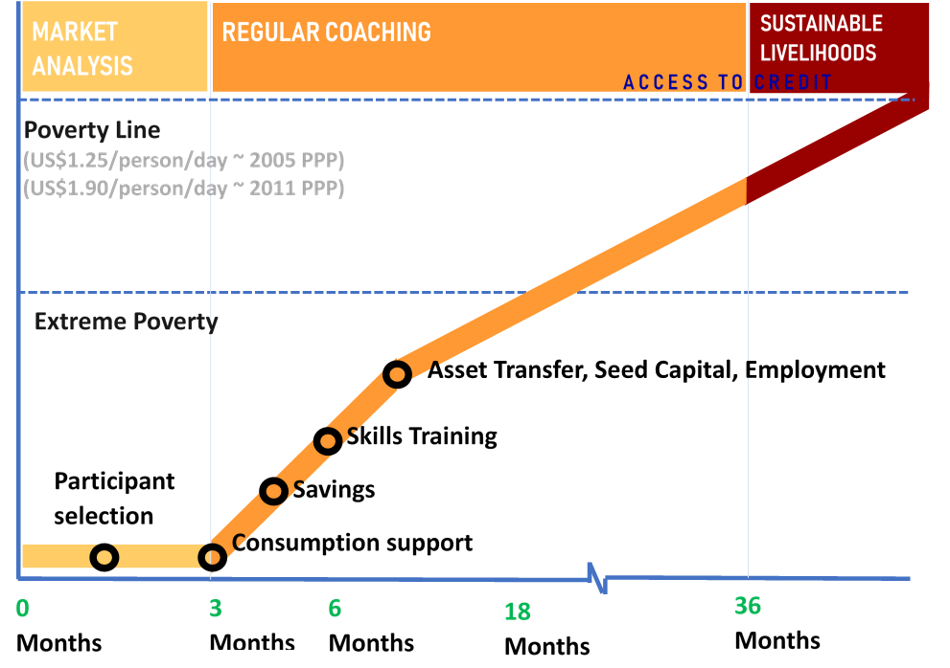
Figure 1: Expected Graduation pathway from of targeted households

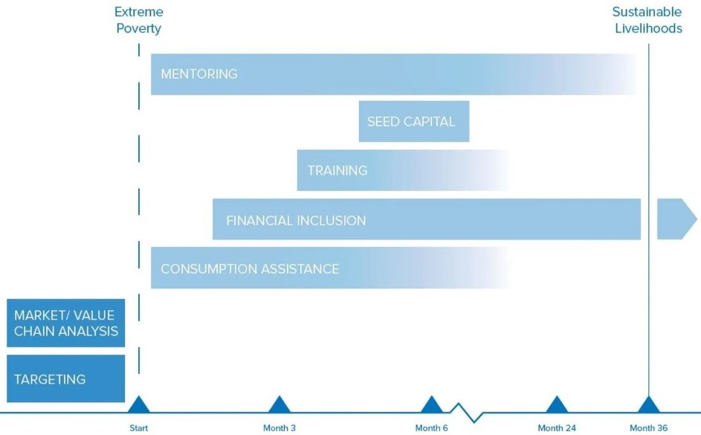
Figure 2: PAC Graduation Approach model that will be adopted.

Project Impact and Sustainability

Intended IMPACT
By facilitating the targeted households to graduate out of extreme poverty, the programme intends to enable the extreme poor to have improved well-being including having better food security and nutrition status, improved access to basic services, reduced reliance on humanitarian assistance and the minimised adaptation of a negative coping mechanism in the time of shock. Building from the learning generated through existing interventions, the programme will ensure that skills development and coaching is delivered simultaneously with cash transfers to support financial decision making from the onset. Building on the success of working with field extension workers in delivering training and monitoring, the number of community based staff will be increased, providing a more affordable alternative to the classic graduation model that uses internal staff, thus making replication/scale-up more likely.

Results from different approaches, particularly on food security and women’s empowerment are encouraging and validate graduation projects as a strategy for fighting extreme poverty. The project builds on both country experience and best practice on graduation programming specifically and will intend to continue this.

Through the social empowerment initiative, the programme intends to create or strengthen platforms for participation of different groups of stakeholders in the communities, specifically those marginalised and build their confidence to be active players in the communities. Through engagement with the larger communities in the process, the programme intends to promote transparency and foster a more inclusive environment for all.

While the well-being of targeted households will not be achieved only by improved economic capacity, the programme will leverage the existing footprint of the four consortium members in the targeted areas and intentionally create linkages to the on-going projects. This includes but is not limited to targeting locations where the agencies are providing other services such as water, health and education. This will help the programme to achieve its intended impact through comprehensive support.

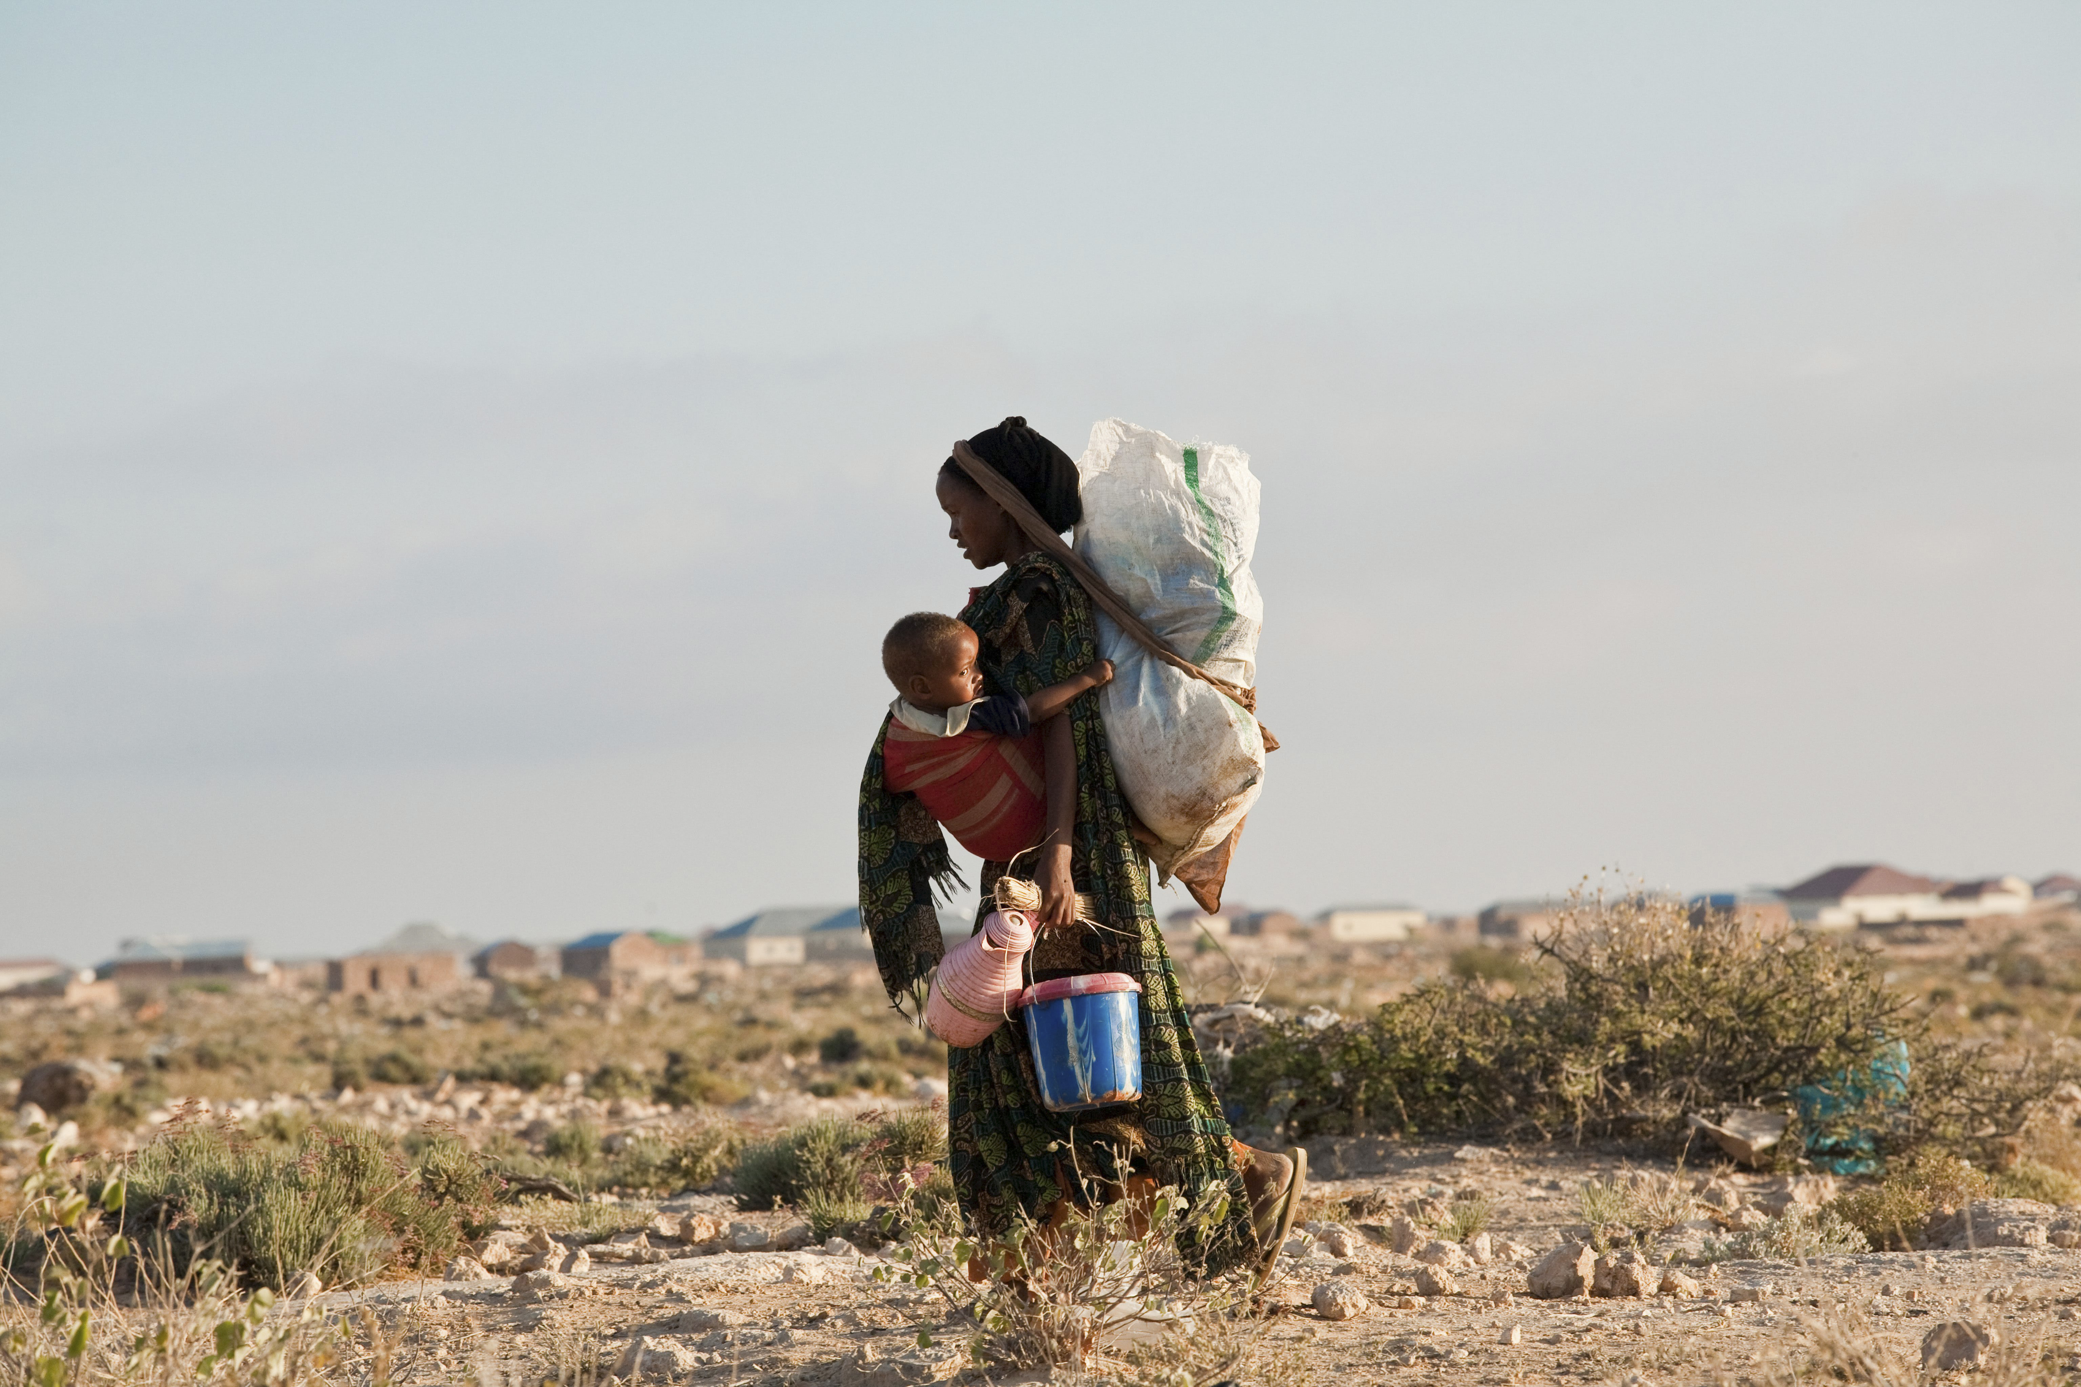

© UNHCR/Brendan Bannon

Project Management and Governance

Coalition Organisational capacity

World Vision
World Vision Somalia (WVS) has been in Somalia since 1992, with its footprint in most of the districts either through direct implementation or partners. Our goal is to achieve long-lasting benefits in the quality of life for vulnerable children and their families, displaced persons and communities through multi-sectoral intervention. WV has, over the years, implemented emergency, recovery and resilience building activities in collaboration with the government through the line ministries both at the state and federal levels, through over 40 local non-governmental and other partners.
As the lead of the Somalia Resilience Consortium, WVS has been the thought leaders on resilience building in Somalia focusing on supporting the chronically vulnerable communities in pastoral, agro-pastoral and peri-urban livelihood zones. The SomRep resilience model has a similar pathway of change as the ultra-poor graduation approach but with a larger vision to include early warning early action and governance components to build the transformative capacity of communities. Through the SomRep program, WV has built expertise and accumulated experience in leading and implementing long-term livelihood initiatives. WVS is also the lead agency of the Somaliland Durable Solution Consortium that focus on supporting displaced affected communities through multi-sectoral interventions, including livelihood support.
WV has been adapting the ultra-poor graduation (UPG) model for years across the globe. Currently, these models are fully implemented in Sri Lanka, India, Mongolia, Bangladesh and Armenia and partly adopted in many other countries whenever funding and context allowed, including the Somalia programme. World Vision Somalia has been implementing various components of the UPG model including conditional and unconditional cash / food transfer, saving for transformation, assets transfer, TVET support such as rehabilitation, training and curricular development, business facilitation and coaching as well as behaviour change and social empowerment in various locations of Somalia. There are subject matter specialists available to support with design and implementation at both field office and global level. The technical advisor of World Vision Somalia is trained on UPG model and can provide day-to-day technical support to partners and implementing staff.
Norwegian Refugee Council (NRC)
Norwegian Refugee Council (NRC) has been present in Somalia since 2004 with field offices in Puntland (Bossaso, Galkayo & Garowe), Somaliland (Hargeisa, Burco & Erigavo), South Central and Jubbaland (Mogadishu, Dhusamareeb, Luuq, Kismayo, Baidoa, Dollow & Dhobley). NRC Somalia has a staff capacity of over 250. NRC implements programming in WASH; Shelter; Information, Counselling & Legal Assistance (ICLA); FSL, Education, Durable Solutions and Resilience programming.
NRC’s strategic programmatic priority in 2019 is to ensure that the vulnerable displacement affected populations in Somalia including those in hard to reach areas have access to humanitarian assistance as well as durable solutions and resilience-based programming. NRC is the lead agency for implementation of BRCiS, a resilience building multiyear programme and is also part of several other consortia including ECHO cash consortium, DEVCO Funded RESTORE project and DFID funded Durable Solutions Project. To achieve a sustainable change, NRC Somalia continues to provide timely, effective, coordinated and adequate humanitarian assistance and protection services to the selected communities through five core competencies (Shelter, ICLA, WASH, Livelihoods and Food Security, and Education), while seeking to progressively introduce camp management. Over a period of time NRC has established strong relationship with key actors in the country and NRC Somalia is working to enhance area based integrated programming through the implementation of high quality programmes that focus on innovative emergency, recovery, resilience and durable solutions support. NRC will continue to remain responsive to changing contexts and the needs through adoptive management.
Concern
Concern Worldwide is a non-governmental, international, humanitarian organization dedicated to the reduction of suffering and working towards the ultimate elimination of extreme poverty in the world’s poorest countries. Concern engages in long-term development work, responds to emergencies, and seeks to address the root causes of poverty through development, education and advocacy work.
Concern’s Graduation Model has been tried and tested in several diverse countries including Burundi, Rwanda, Zambia, Haiti, Niger, Malawi and DRC, producing considerable successes in supporting targeted households to move out of the cycle of extreme poverty. Further, Concern’s Graduation work has been recognised and taken to scale by Governments, such as informing development of Burundi’s National Social Protection Strategy, and aligned with Ethiopia’s Productive Safety Net Programme. Concern’s country Graduation programmes all follow the same model and approach of layering and sequencing interventions, with adaptations to context e.g. a gender equality lens in Malawi. Going ahead Concern wants to ensure that the experience we have gained informs the policy debate on issues relating to the sustainable graduation from extreme poverty, social protection and resilience both nationally and globally.
Concern has had a continual presence since 1992 in south and central Somalia, moving into Somaliland in 2010. The project comprises of a cohesive complementary portfolio of emergency response interventions alongside longer-term multi-sector adaptive programming in community resilience to climate- and conflict-induced shocks and stresses, durable solutions (DS) for displacement-affected communities through enhancing sustainable integration of IDPs and host communities, and with parallel systems strengthening work in Health and Education sectors.
Concern is operational in Mogadishu (Banadir), Gedo (Jubaland), Bay and Lower Shabelle (South-West State), plus Awdal, Maroodi-Jeex/Gabiley and Togdheer in Somaliland. Programmes are a mix of direct implementation as well as partnerships with 5 local NGOs. Concern Somalia has considerable experience working in consortia, and is currently lead agency of the Somali Cash Consortium and EIDACS Durable Solutions Consortium.
Concern’s existing Resilience (BRCiS: Building Resilient Communities in Somalia) and Durable Solutions (especially EIDACS and Danwadaag in South-West State) programming have many similarities with the Graduation Model, with interventions ranging from livelihoods diversification and strengthening through women’s Self-Help Groups, youth TVET and Entrepreneurship training and training/inputs for agro-pastoral/pastoral livelihoods, alongside shock-responsive safety nets and complementary multi-sector community-level activities.
Danish Refugee Council
DRC possesses the technical capacity to carry out wide-range emergency, resilience/recovery and solutions work in Somalia, as proven by its experience and record of accomplishment. DRC has technical managers in its core programme areas of Protection, Shelter/NFI, Food Security and Livelihoods, WASH and CCCM, and has extensive experience implementing community development, resilience and durable solutions projects. DRC focuses on providing relief and solutions to populations in displacement including building the resilience and self-reliance of target populations. It coordinates closely with other actors including the government at all levels. DRC is actively involved in the coordination of humanitarian response and providing long-term solutions to displacement affected communities. DRC has a close relationship with UNHCR and is among UNCHRs biggest partners in advocating for self-resilience programmes in Somalia. DRC monitors its activities closely, involving a team of Monitoring and Evaluation specialists, Technical Managers and Project and Finance Managers, Close budget control and accountability to its beneficiaries through its feedback mechanism. Programme quality is a central pre-occupation of DRC’s work, which is entrenched through leadership in innovation in ground-breaking solutions and partnerships.
DRC has operations in both Somalia and Somaliland and has offices in Mogadishu, Hargeisa, Dollow, Baidoa, Kismayu, Beletweyne, Bosaso, Garowe, Galkayo, Abuduwak, Berbera and Garowe serving over 38 districts across the country. The head office is based in Mogadishu. Its presence in Somalia dates back to 1997.

Broader Project Stakeholders
Below is the background and involvement of other stakeholders that will be involved in the project. These could include:
Government agencies: The programme will closely collaborate with different relevant ministries at Federal, State and District levels to ensure the programme receives necessary support from the respective levels of government. Government stakeholders will be engaged from the beginning of the programme. In collaboration with the ministries, the programme will engage communities on planning, beneficiaries selection, implementation and monitoring. Whenever possible, joint monitoring and progress review meeting will be organised together with government officials. The Ministry of Planning will be the major coordination entity to engage. The exact ministries to be involved varies depending on the government structure in different states, but it is likely to include the Ministry of Labour, Ministry of Agriculture and Ministry of Livestock to name a few.
INGO and LNGO: Apart from the consortium members, the consortium will collaborate with other INGOs or LNGOs working in the same areas. The programme will seek synergy with other on-going projects rather than overlapping with them. The synergy can be created through geographical coverage and/or programming complementarity. The coordination will take place both through bilateral engagement and at clusters/ workgroups. The consortium will also explore cooperation opportunities with agencies, especially LNGOs, with expertise and experience which can complement the consortium, thus maximising the impact of the programme.
Learning Partners: The consortium will seek to engage learning partners such as academics or think tanks that can support in capturing learning and research that can build evidence of the graduation approach in the context of Somalia.

Monitoring and Evaluation

LOGICAL FRAMEWORK
Below is the logical framework for this programme showing the different outcomes, outputs, activities and indicators.

Table 1: Logical Framework

Outcome and Outputs | Activities | Indicative Indicators
Outcome 1: Enabled adoption and / or continuation of positive coping strategies of the extremely poor and displacement affected households by improving their immediate access to food and basic services and strengthening community productive assets  Output 1.1: Increased extremely poor households’ access to food and basic commodities through provision of conditional and unconditional assistance  Output 1.2. Improved community productive assets which will positively contribute to sustainable livelihood development | - Community engagement and planning  - Unconditional Cash Transfer  - Conditional Cash Transfer | Outcome level:  - Proportion of households consuming at least 3 meals  - Proportion of households attaining acceptable dietary diversity score (HDDS)  - Proportion of households reporting to have utilized/benefitted from community productive assets  - Proportion of households medium rCSI  Output level:  - Number of households received unconditional cash transfer  - Number of households received conditional cash transfer  - Number of communities’ productive assets rehabilitated
- Outcome 2: Improved adaptive and absorptive capacity of the extremely poor and displacement affected households by promoting regular saving and access to formal and/ or informal financial services  - Output 2.1. Strengthened or established village saving and loan association (VSLA) of which targeted households participated and started saving  Output 2.2. Increased knowledge on financial and business management of the targeted households | - Community mobilization and awareness rising  - Support formation of VSLA  - Conduct business development skills training  - Conduct life-skill training | - Outcome level:  - Proportion of households reporting increased household assets  - Proportions of households engaging in small scale businesses  - Proportion of household reporting increased savings  - Percentage increase/change in average saving per member  - Percentage of households started saving  - Percentage of participants in saving reported increased knowledge on business development  - Output level:  - Number of targeted households joined VSLAs disaggregated by gender  - Number of individual participated in trainings
Outcome 3: Increased absorptive and transformative capacity for extremely poor and displacement affected households targeted households to diversify and expand their livelihood opportunities  - Output 3.1. Protected and restored livelihoods of the targeted households through provision of seasonally appropriate livelihood inputs and technical support  Output 3.2. Increased access in technical and vocational education and training of youth and adults from the targeted households | - Conduct economic research assessment and labour market study  - Conduct Enterprise Based and/ or Institution Based Technical Vocational Education and Training (EBTVET and IBTVET)  - Support TVET centres with trainings and equipment  - Rehabilitate/ Revive public TVET centers  - Facilitate job placement  - Provide graduating trainees with basic package of start up | - Outcome Level:  - Proportion of agro- pastoralist or pastoralist households reported increase in production  - Proportion of Households reporting increased /doubled assets  - Proportion of households newly engaged in diversified livelihood strategies disaggregated by gender, livelihood groups and strategy employed  - Proportion of vocational training students who successfully completed their course implemented by the program  - Proportion of TVET graduates who are able to secure gainful employment after completing their course  - Proportion of targeted households reported increased income  - Proportion of targeted households who received production training reported increased knowledge on production  - Proportion of business training participant reported improved knowledge, values and ability of business development  - Output Level:  - Number of households received livelihood inputs  - Number of households received agricultural training  - Number of individuals joined TVET program disaggregated by gender  - Number of individuals graduated from TVET program
- Outcome 4: Improved social cohesion among refugees, returnees, displaced and host communities  Output 4.1: Increased the participation of the extreme poor and the displaced affected population in community decision making | - Community engagement meeting | - Outcome Level:  - Proportion increased in households with a bonding social capital index higher than 3  - Proportion of people/household in IDPs households who report to belong to at least one informal networks or groups in the decision making processes and community  - Output Level:  - Number of refugees, returnees and/or internal displaced people participated in community engagement meeting  - Number of refugees, returnees and/or internal displaced people participated in saving groups

MONITORING
The Monitoring, Evaluation and Learning (MEAL) component of the programme will ensure that continuous monitoring captures changes in the conditions of both displaced and host populations, capturing evolving levels of vulnerability within and between groups, and articulating how activities can be enhanced to address dynamic community and household’s needs. In particular, the MEAL component will measure the impact of the programme’s interventions on the circumstances of the displacement affected communities and the extreme poor. A common programme framework and indicators will be developed to measure the impact and monitor the progress of the programme which will be used by all agencies. The programme will develop a detailed monitoring plan (MEP) with a baseline and target for each indicator with timelines and status of implementation. Together with the detail implementation plan (DIP). The programme will apply standard approaches and tools across agencies to connect data, on a regular basis. The monitoring result will be shared with consortium members and discussed in joint review meetings among members to share learning and address challenge.
Local authorities cluster focal points, and other stakeholders will play an important role in the monitoring of the project progress. Data collection in this regard will use standard story collection templates to track community’s behaviour change and other social attributes, which the project contributed thus far. The programme will also seek to use different media to capture the result such as pictures and video clips as part of evidence based monitoring. Progress will be measured on a monthly basis, verification of the reported outputs will be done by field visit using random sampling. Monitoring and evaluation efforts will ensure it covers different stakeholders in the communities and is desegregated by gender and status.
The programme will take into consideration the Inter-Agency Standing Committee (IASC) and core humanitarian standards (CHS) commitment to the affected. The consortium will make efforts to ensure accountability to the project beneficiaries through open, transparent and inclusive project implementation and monitoring of all project activities.
Community feedback mechanisms will be established (where it is still missing) to improve the quality of programming and ensure that the project team is responsive to community needs and feedback is provided in a timely manner. This may include toll-free hotlines, suggestion boxes managed by community accountability committees and community meetings depending on the preference of the targeted communities/ households.
A trend report will be compiled on complaints registered and a response mechanism will be created to answer all concerns registered by beneficiaries in a timely manner. The feedback mechanism will allow the community to continuously monitor and provide information to improve the programme in good time.

EVALUATION
The consortium will coordinate baselining actions, progress monitoring, mid-term and end-line evaluations and learning events. The consortium is committed to learning, documenting, and disseminating best practices and lessons learned during the course of project implementation. A baseline assessment will establish the initial state for outcome-level and project goal-level results which will be monitored quarterly.
The monitoring and evaluation (M&E) component of the project will be based around the use of an enhanced impact monitoring process such as a 3-year longitudinal study to assess the impact of different interventions on disaggregated displacement affected population groups within the specific context of Somalia. The primary objective of this M&E will be to note displacement specific vulnerabilities in Somalia’s fragile economy and society, how they can be best addressed and the effectiveness of adopting the gradation approach to support the self-reliance of the extreme poor. Mid-term and end-line evaluations will be conducted to confirm impact and make recommendations for future programming.
The consortium will be deliberate in sharing learning among and beyond members. Bi-annual review meetings will be held to share and reflect on the monitoring and evaluation findings and project progress. Learnings and achievements will be documented as case studies which will be shared with stakeholders such as food security clusters and resilience working groups.

Project Budget

Funding Request
The program will target 6,100 households in the three targeted locations. Considering the cost of operation in Somalia is high due to the challenge of access and insecurity, the estimated cost for each household for a 36 months project will be at USD 2,377. This brings the total funding request up to USD 14.5 million.
The average financial structure of the project will be such that more than 70 percent of the assistance will go directly to beneficiaries.

Project Budget
This estimation has taken all the implementation, support, monitoring, evaluation and learning cost into account. Since the four consortium members have existing footprint in the targeted areas, the programme will seek to leverage on the existing footprint and structure to maximise cost effectiveness as well as program impact.

Table 2: Financial structure of the project
Description | Proportion (%) | Year 1 | Year 2 | Year 3 | Total
Programme or Activity costs | 70.0% | 7.0% | 28.0% | 35.0% | 70.0%
Programme Monitoring (MEAL) | 2.0% | 0.2% | 0.8% | 1.0% | 2.0%
Equipment and supplies | 1.2% | 0.1% | 0.5% | 0.6% | 1.2%
Staff and operational costs | 19.8% | 2.0% | 7.9% | 9.9% | 19.8%
Indirect costs | 7.0% | 0.7% | 2.8% | 3.5% | 7.0%
Project Total | 100.0% | 10.0% | 40.0% | 50.0% | 100.0%

Any In-Kind Contributions
There are no in-kind contributions made at this point. Nonetheless, the program will seek in-kind contributions from communities.

Annex 1 – Risks and Assumptions

Table 3: Internal and external risks
 | Assumption | Risk | Likelihood | Impact | Mitigation
Internal | Community members trained on VSLA and other financial management skills will apply the skills during the project and beyond. | Communities member do not see the value of applying saving and financial management skill which hamper their ability to acquire or sustain the intended income. There may also cause loss of saving in the VSLA due to poor financial management. | Unlikely | Major | - The training will not just focus on knowledge and skill transfer but also awareness raising of the importance of finance management  Regular monitoring that monitor both the knowledge increase and adaptation of skill of beneficiaries will provide timely information to allow programme adjustment if needed to reach the intended outcome.
 | Project implementation sensitive to child protection. | Project implementation sensitive to child protection. | Unlikely | Major | Selection criteria explicitly prohibits person under 18 year of age from participating in Cash for Work projects.  - BOQs for asset rehabilitation, construction, upgrading bares in mind issues affecting child safety.  - Members have Child Protection policies and mechanism in place which are at par with or exceed donor regulations  Accountability to Affected Populations (AAP) and Complaints Response Mechanism (CRM) should be widely available in appropriate mediums enable timely reporting of any protection related issue to the consortium so that action can be taken.
 | Community members trained on VSLA and other financial management skills will apply the skills during the project and beyond. | Communities member do not see the value of applying saving and financial management skill which hamper their ability to acquire or sustain the intended income. There may also cause loss of saving in the VSLA due to poor financial management. | Unlikely | Major | - The training will not just focus on knowledge and skill transfer but also awareness raising of the importance of finance management  Regular monitoring that monitor both the knowledge increase and adaptation of skill of beneficiaries will provide timely information to allow programme adjustment if needed to reach the intended outcome.
 | Project implementation sensitive to child protection. | Project activities pose risk to children such as increased. child labour or construction of assets pose risk to children’s physical safety | Unlikely | Major | Selection criteria explicitly prohibits person under 18 year of age from participating in Cash for Work projects.  - BOQs for asset rehabilitation, construction, upgrading bares in mind issues affecting child safety.  - Members have Child Protection policies and mechanism in place which are at par with or exceed donor regulations  Accountability to Affected Populations (AAP) and Complaints Response Mechanism (CRM) should be widely available in appropriate mediums enable timely reporting of any protection related issue to the consortium so that action can be taken.
 | The project targets the most vulnerable groups in the community. Programme resources bridge the gap in socio-economic inequalities and marginalization | Program fails to identify and reach the most vulnerable persons. | Moderate | Moderate | - Comprehensive participatory assessment will be conducted at the onset of the program, involving extensive actor-mapping and analysis of barriers for specific groups to participate in project activities.  - Project team will facilitate dialogue, planning and undertakes affirmative actions to include most vulnerable in decision-making bodies.  - Market assessment and research should further explore mechanisms of marginalization and barriers to inclusion in specific project activities (Savings Groups, decision-making body involvement, etc.).  - Project monitoring, evaluation and learning to include sessions of inclusivity.  Accountability to Affected Populations (AAP) and Complaints Response Mechanism (CRM) should be widely available in appropriate mediums to support marginalized to make their needs known.
External | Periods of drought, COVID-19 and stress do not overwhelm project implementation. In particular no mass movement of beneficiaries out from the targeted locations in search of resource or assistance | Adverse climatic conditions affecting implementation plan.  Prolonged drought conditions increase vulnerability-affecting targeting.  Changing climatic conditions may affect population movement leading to loss of beneficiary follow up. | Likely | Moderate | - * The cash component of the project intends to cushion the negative impact of the time of stress for the targeted beneficiary so that they can continuously engage in the livelihood enhancement process.  - Include a proportion of funding as crisis modifier to respond to the most urgent need of the households in case of disaster. Continue fundraising efforts to layer other resources in the locations in order to meet the changing needs on the population.
 | Sufficient sustained demand in the district and beyond for the products prepared by community groups |  | Moderate | Moderate | Conduct comprehensive community dialogue sessions about the products.
 | Security conditions do not significantly affect project implementation | Inaccessibility due to insecurity by armed groups, clan related conflicts, assassinations, kidnapping etc. | Moderate | Moderate | - Consortium organizations have security advisors who continuously monitor the security situation and advise preventive and responding measures for security risk  - Risk management policy and standard operating procedures (SOPs) are in place to guide staff to operate in times of insecurity  - Close collaboration with local government to allow safe access to the targeted locations.  Contingency plans will be in place and are regularly updated.
 | Government will actively participate and engage in the project implementation for sustainability. | Limited government capacity and willingness to engage in the project implementation. This affects sustainability of the gains made by the project. | Moderate | Moderate | Continue working with existing government structures building their capacity.  Engaging closely with line ministries.
 | The situation of COVID-19 will stabilize in the coming 4 to 6 months that will allow government to loosen some of the movement and gathering restrictions | Total ban of gathering will make it challenging to carry out some of the elements in the program, such as VSLA establishment and skill training | Moderate | Major | - The programme will continuously monitor the development of the COVID-19 and seek to adapt the activities accordingly.  - The program will seek alternative means to engage targeted beneficiaries such as through mobile phone

Annex 2 – Project Partner Credentials

World Vision Somalia (WVS) has been in Somalia since 1992, with its footprint in most of the districts either through direct implementation or partners. Our goal is to achieve long-lasting benefits in the quality of life for vulnerable children and their families, displaced persons and communities through multi-sectoral intervention. WV has, over the years, implemented emergency, recovery and resilience building activities in collaboration with the government through the line ministries both at the state and federal levels, through over 40 local non-governmental and other partners.

Norwegian Refugee Council (NRC) has been present in Somalia since 2004 with field offices across Puntland (Bossaso, Galkayo & Garowe), Somaliland (Hargeisa, Burco & Erigavo), South Central and Jubbaland (Mogadishu, Dhusamareeb, Luuq, Kismayo, Baidoa, Dollow & Dhobley). NRC Somalia has a staff capacity of over 250. NRC implements programming in WASH; Shelter; Information, Counselling & Legal Assistance (ICLA); FSL, Education, Durable Solutions and Resilience programming both directly and through local non-governmental organisations.
Concern Worldwide is a non-governmental, international, humanitarian organization dedicated to the reduction of suffering and working towards the ultimate elimination of extreme poverty in the world’s poorest countries. Concern engages in long-term development work, responds to emergencies, and seeks to address the root causes of poverty through development, education and advocacy work. Amongst other sectors that concern delivers on is Nutrition, livelihoods and cash transfers. Programmes are a mix of direct implementation as well as partnership with 5 local NGOs. Concern Worldwide have been present in Somalia for over 3 decades.

Danish Refugee Council (DRC) possesses the technical capacity to carry out wide-range emergency, resilience/recovery and solutions work in Somalia, as proven by its experience and record of accomplishment. With operational presence in all federal members states as well as Somaliland serving over 38 districts across the country. The head office is based in Mogadishu. DRC have had presence in Somalia for over 2 decades while implementing (both directly and through local implementing partners) programmes in the sectors of: WASH, Shelter and Non-Food Items (NFIs), Protection, Food Security and Livelihoods (FSL), Mine Action and Armed Violence Reduction (AVR).

WV, CWW, DRC and NRC have operations in all regions in Somalia including Somaliland.
OCHA, Humanitarian Need Overview – Somalia, 2016
OCHA, Humanitarian Need Overview – Somalia, 2019
UNICEF Situational analysis of Children -2016
UNDP Somalia Humanitarian Development Report, Somalia, 2012
World Bank Group, Federal Republic of Somalia, Somalia Economic Update, August 2018, Edition No. 3 http://documents.worldbank.org/curated/en/975231536256355812/pdf/REPLACEMENT-PUBLIC-Somalia-Economic-Update-3-FINAL.pdf
Ibis
World Bank Group, Unemployment, https://data.worldbank.org/indicator/SL.UEM.TOTL.ZS
OCHA, Humanitarian Need Overview, 2019
Information Management Working Group, 2018.
OCHA, Humanitarian Need Overview 2019
ReDSS, Annual Aspiration survey October 2019, https://regionaldss.org/wp-content/uploads/2019/11/ReDSS-aspirations-survey-Key-findings-baselines-Baidoa-Mogadishu-Kismayo.pdf
UNHCR, Operation Portal Refugee Situations, https://data2.unhcr.org/en/situations/horn
OCHA, Humanitarian Need Overview 2020, November 2019
Define as a total daily per capital consumption expenditure of less than USD 1.25
Poverty & Equity Global Practise, Africa, Somali Poverty Profile 2016, June 2017
Detailed Site Assessment (DSA), CCCM Cluster Somalia https://cccm-cluster-somalia.github.io/OPSMAP/
Figures provided in the NDP-II: Ministry of National Planning and Development estimates for 2016 based on UNFPA, Population Estimation Survey2014
FSNAU http://www.fsnau.org/ipc/ipc-map
IOM, Labour market and service assessment in selected locations – Somalia Report, January 2019
Ibid
UNICEF Situational analysis of Children -2016
Godfrey, P.C. “What is economic self-reliance? BYU Scholars Archive https://scholarsarchive.byu.edu/cgi/viewcontent.cgi?article=1152&context=esr
Ibis
IRC (2018) ‘From Response to Resilience – Working with Cities and City Plans to Address Urban Displacement: Lessons from Amman and Kampala
Understanding and measuring social capital to bridge humanitarian support, urban development and resilience https://resilientcities2018.iclei.org/wp-content/uploads/B4_Presentation_Beyer_Griffiths.pdf
SomRep is a consortium of 7 humanitarian agencies, including Action Against Hunger, ADRA, CARE, COOPI, DRC, Oxfam, leads by World Vision. The consortium is a joint effort to build and field best a resilience model based on the latest global resilience thinking, innovative livelihood approaches for the Somalia context.
Jenson, J. Mapping Social cohesion: The State of Canadian Research. Canadian Policy Research Network Inc. CPRN Study No F/02,1998
The Somalia Food Security Cluster Community Based Targeting Guideline was developed in 2018 by the FSC to assist FS cluster members to identify the most vulnerable communities, groups and individuals.
Medium coping score is suggested as this is a graduation model. There are 3 categories of Coping strategy Index (CSI) Score No or low coping (CSI) = 0-3), medium (CSI = 4-9, high coping (CSI ≥10) goal is to move cascade from High to “No or Low” score

