**I M B O L C**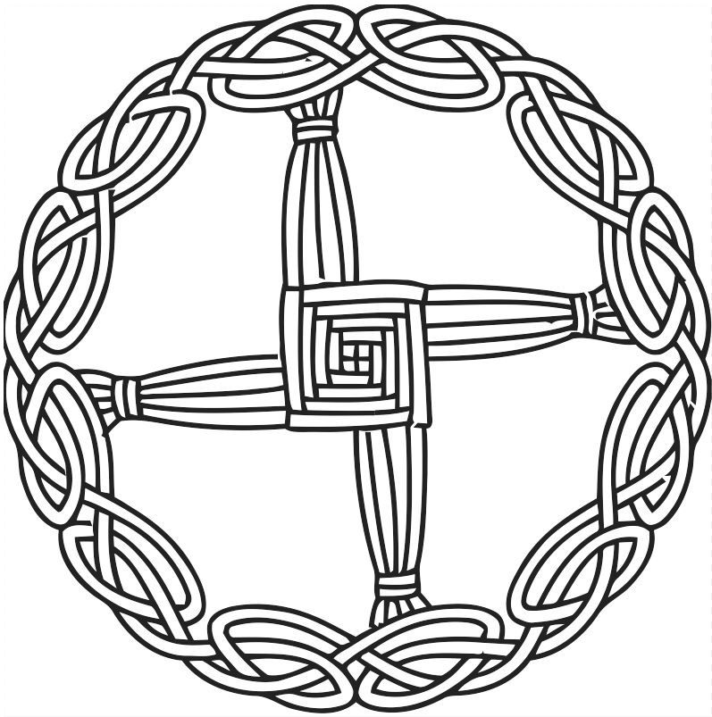

(EE-molc) *February 2 OR August 1*  
Imbolg - Oimelc - Candlemas - Brighid’s Day - Feast of Nut - Groundhog Day

Imbolc is a fire festival halfway between Winter Solstice and Spring Equinox, celebrating the changing of the Goddess from Crone to Maiden. The first signs of spring are around us as the Goddess is pregnant with hope and light. We know winter is coming to an end. It is a time of new beginnings.   
  
**Goddesses:** Aradia, Athena, Brigid/Brighid, St. Brigid, Cerridwen, Demeter, Gaia, Persephone, Proserpina, Venus, Vesta, Maiden Aspect  
  
**Gods:** Eros, Osiris, Pan, Cernunos, Herne, Aengus Og  
  
**Symbols & Decorations:** White Flowers (esp. Snowdrop), Seeds, Candles/Lights, Bonfires, Brighid’s Crosses, Brooms/Besoms, Flame, Swan Feathers, Eggs, Cauldron

**Colors:** Light Green, White, Silver, Yellow, Pink, Orange & Red (Fire), Brown  
  
**Crystals:** Amethyst, Aquamarine, Bloodstone, Garnet, Ruby, Turquoise, Onyx  
  
**Herbs & Plants:** Cinnamon, Frankincense, Rowan, Angelica, Bay, Basil, Celadine, Blackberry, Chamomile, Violets, All White Flowers, Willow, Ginger, Rosemary, Acorns, Lavender  
  
**Animals:** Wolf, Snake, Swan, Vulture, White Cow, Awakening Bear, Deer, Groundhog, Lamb, Phoenix, Sheep  
  
**Activities:** Spring cleaning your home, placing offerings of milk, planting seeds or planning your garden, lighting a red candle, make a Brighid’s Cross, make a Brighid’s doll & bed for her to lay in

**Spellworking:** Home Purification, Broom Blessings, Brighid’s Mantle, Cinnamon Kitchen Witchery, Love Spells, Fertility, Cleansing & Self Purification, Initiations & Dedications, Protection, Truth, Wand Consecration, Wish Spells

**Food & Drink:** Milk & Dairy, Hot Dishes, Anything with Seeds, Chamomile Tea, Breads & Cakes, Spiced Wines, Sheep’s Cheese, Omelette w/ Fresh Herbs, Roasted root vegetables, Yogurt, Honey Cakes, Lavender Cookies

| **Imbolc Oil** 8 drops Frankincense 6 drops Rosemary 2 drops Cinnamon ½ cup Base Oil | **Imbolc Incense** 6 parts Frankincense 4 parts Dragon’s Blood 2 parts Red Sandalwood 1 part Cinnamon |
| --- | --- |

| **Brigid Meal Blessing** *learnreligions.com*  This is the season of Brigid, She who protects our hearth and home. We honor her and thank her,  For keeping us as we eat this meal. Great Lady, bless us and this food, And protect us in your name. | **Imbolc Prayer to Brighid** *learnreligions.com*  Bride of the earth, sister of the faeries,  daughter of the Tuatha de Dannan, keeper of the eternal flame.  In autumn, the nights began to lengthen,  and the days grew shorter,  as the earth went to sleep.  Now, Brighid stokes her fire,  burning flames in the hearth,  bringing light back to us once more.  Winter is brief, but life is forever.  Brighid makes it so. |
| --- | --- |

**Brighid's Mantle**

One commonly found symbol of Brighid is her green mantle, or cloak. The legend has it that Brighid was the daughter of a Pictish chieftain who went to Ireland to learn from St. Patrick. In one story, the girl who later became St. Brighid went to the King of Leinster, and petitioned him for land so she could build an abbey. The King, who still held to the old Pagan practices of Ireland, told her he'd be happy to give her as much land as she could cover with her cloak. Naturally, her cloak grew and grew until it covered as much property as Brighid needed, and she got her abbey. Thanks to her roles as both a Pagan goddess and a Christian saint, Brighid is often seen as being of both worlds; a bridge between the old ways and the new. Some say Ireland is her green mantle.

In Celtic Pagan stories, Brighid's mantle carries with it blessings and powers of healing. Many people believe that if you place a piece of cloth out upon your hearth at Imbolc, Brighid will bless it in the night. Use the same cloth as your mantle each year, and it will gain strength and power each time Brighid passes by. The mantle can be used to comfort and heal a sick person, and to provide protection for women in labor. A newborn baby can be wrapped in the mantle to help them sleep through the night without fussing.

To make a Brighid's mantle of your own, find a piece of green cloth long enough to comfortably wrap around your shoulders. Leave it on your doorstep on the night of Imbolc, and Brighid will bless it for you. In the morning, wrap yourself in her healing energy.

**BRIGID’S WELL SPELL***To heal or bring general good health. From The Spells Bible, by Ann-Marie Gallagher*  
**Need:**6 white candles  
One stone or pottery cup or bowl  
Three small pebbles  
One small cup of salt  
Spring water  
Matches or a lighter  
  
**Timing:** Best cast on or near Imbolc.  
  
**Casting The Spell:**1. Place candles around the cup.  
2. Name each stone as an ailment you wish healed, and sprinkle a bit of salt over each.   
3. Breathe onto the stones, saying *“By my breath”*4. Cover them with your hands, saying *“By my flesh”*5. Place them in the cup and over them with water, saying:  
*“By the living waters of Brigid may health prevail and good reside.”*6. Light each candle, saying, *“Hail lady of fire.”*  
7. Hold your palms toward the flames and close your eyes, then visualize dark stains on the stones dissolving in the water, rising to the surface to be burned away in the candle flames.  
8. Chant the following until you feel the energy in your circle rise:  
*“Earth, water, flame,  
Work in her name  
Earth, water, fire,  
Work my desire.”*9. Discharge the energy by raising your hands into the air and mentally releasing it.  
10. Return the stones to the beach, river, stream, etc as soon as possible after Imbolc.

**O S T A R A**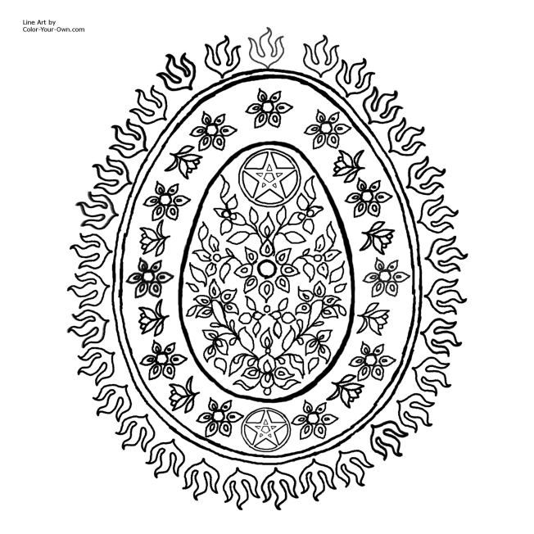

[Os-TAH-rah] *March 21/22 OR Sept 21/22*Spring Equinox - Vernal Equinox - Alban Eiler - Festival of Summer Finding - Easter - Passover

Ostara celebrates the Spring Equinox, when there is a balance of night and day, and the promise of the new life of growth begins to show around us. It’s name comes from the Germanic goddess, Eostre/Ostara, honored for fertility and rebirth.   
  
**Goddesses:** Amalthea, Aphrodite, Blodeuwedd, Eos, Eostre, Epona, Flora, Freya, Gaia, Guinevere, Persephone, Rati, Vila, Persephone, Goddess as Maiden  
  
**Gods:** Aengus MacOg, Cernunnos, Herne, the Dagda, Eros/Cupid, the Green Man, Kama, Mabon, Osiris, Pan, Thor, Dionysus  
  
**Symbols & Decorations:** Egg, Feathers, Baskets, Seeds,

**Colors:** Green, Yellow, Purple, Light Blue, Pink, Silver, Violet, White  
  
**Crystals:** Agate, Aquamarine, Bloodstone  
  
**Herbs & Plants:** Birch, Ash, Alder, Broom, High John Root, Irish Moss, Lemongrass, Apple, Hawthorn, Daffodils, Crocuses, Catkins, Honeysuckle, Apple Blossom, Tulip, Violets  
  
**Scents & Oils:** Apple Blossom, Clean Crisp Air, Columbine, Daffodil, Honey, Jasmine, Lilac, Orange Blossoms, Rose, Spring Florals, Rain  
  
**Animals:** Hare, Bees, Boar, Butterflies, Chicks, Hedgehog, Horse, Phoenix, Rabbit, Ram, Robin  
  
**Activities:** Coloring Eggs, Egg Hunts, Preparing a Garden, Spring Cleaning, Start Seedlings, Assist Homeless, Pick Up Litter, Community Gardening, Painting Garden Stones

**Spellworking:** Seed Blessing, Home Blessing, Creating & Blessing Outdoor Sacred Space, Divinations on Upcoming Year, Purifying & Protecting the Home, Abundance, Balance, Fertility, Lust, New Beginnings, Passion, Prosperity, Purification

**Food & Drink:** Hot Cross Buns, Mead, Asparagus, Eggs, Honey, Lamb, Lettuce, Radishes, Seafood, Spring Onions

| **Brief Invocation for Working with the Goddess on Ostara**  Maiden Goddess, soon to be Mother,  known by many names, I invoke your presence today, on this day of balance, Of equal day and equal night, On this day of beginnings, To join with me (us) in celebration. Goddess of the Earth, Goddess of all Living Things, Goddess of the Spring, Join with me (us) now. | **Brief Invocation for Working with the God on Ostara**  Robust Lord, soon to be Father, Known by many names, I invoke your presence today,  on this day of balance, Of equal day and equal night, On this day of beginnings, To join with me (us) in celebration. God of the Earth, God of all Living Things, God of Spring, Join with me (us) now. |
| --- | --- |

| **28 Adorations to Eostre** *By Galina Krasskova*  I adore You, Goddess of spring.  I adore You, Goddess of the wet and fertile field.  I adore You, Ever-brightening Dawn.  I adore You, Who hides Your mysteries in liminal places.  I adore You, Rebirth.  I adore You, Renewal.  I adore You, aching tug of awakening hungers.  I adore You, Goddess of adolescence.  I adore You, Goddess of bursting bloom.  I adore You, Goddess of the new season.  I adore You, Goddess of New Growth.  I adore You, Who awakens the womb of the earth.  I adore You, Who brings fertility.  I adore You, laughing dawnlight.  I adore You, who looses the hare.  I adore You, Who quickens the belly.  I adore you. Who fills the egg with life.  I adore You, Holder of all potentiality.  I adore You, Opening passage from winter to summer.  I adore You, Whose caress causes winter to yield its sway.  I adore You, Who sweeps away cold with a kiss of light.  I adore You, Alluring One.  I adore You, Who delights in the rising cock.  I adore You, Who delights in the wet cunt.  I adore You, Goddess of playful delight.  I adore You, friend of Mani.  I adore You, friend of Sunna.  I adore You, Eostre. | **Prayer for Waking the Earth** *From greenwillowwitch*  The death sleep of winter has slowly faded,  the rigor of the ground loosens,  and the earth is once more reborn.  Like Mithras and Osiris,  reborn from death,  life returns again to the land,  springing up as the snow melts away.  As the soil warms and the days grow longer,  dew forms along new sprouts of grass,  bringing life back.  Awaken! Awaken! Awaken!  And rise!  Let the earth come to life again,  and welcome the light of spring!  **Garden Blessing**  The earth is cool and dark,  and far below, new life begins.  May the soil be blessed with fertility and abundance,  with rains of life-giving water,  with the heat of the sun,  with the energy of the raw earth.  May the soil be blessed  as the womb of the land becomes full and fruitful  to bring forth the garden anew. |
| --- | --- |

**B E L T A N E** 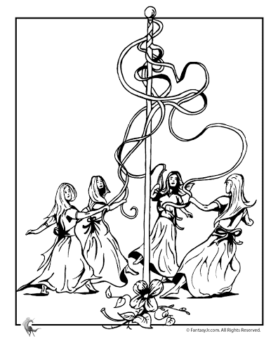

*(Bel-TAIN) May 1 OR Oct 31*Bealtaine - Whitsun - May Eve - Walpurgisnacht - May Day - Roodmas - Floralia

Beltane is a fire festival that celebrates fertility and summer’s rebirth. It begins on May Day Eve (April 30), and celebrates the union of masculine and feminine creative energies.  
  
**Goddesses:** Flower Goddesses, Aphrodite, Diana, Venus, Flora, Isis, Persephone, Demeter, Artemis, Bast, Maia, Arianrhod, Astarte, Ariel, Var, Skadi, Hera, Sheila-na-gig, Freya, Xochiquetzal, Rhiannon, Shakti,  
  
**Gods:** Bel/Belanos, Jack in the Green, Pan, Horned God, Cernunnos, Apollo, Bacchus, Herne, Faunus, Odin, Orion, Frey, Robin Goodfellow, Puck  
  
**Symbols & Decorations:** Maypole, Flower Crowns, Ribbons, Acorns, Seeds, Antlers, Baskets, Cauldron, Wreaths, Phallic shaped candle, Daisy Chains

**Colors:** Green, White, Silver, Red, Brown, Pink, Yellow, Purple  
  
**Crystals:** Emerald, Sapphire, Rose Quartz, Rhodonite, Selenite, Serpentine, Sunstone, Moss Agate, Aventurine, Malachite, Amber, Carnelian, Tourmaline, Beryl  
  
**Herbs & Plants:** Woodruff, Birch, Oak, Rowan, Willow, Mint, Mugwort, Daisy, Ivy, Marigold, Thyme, Yarrow, Rose, Fireweed, Fern, Rue, Tansy, Violets, Rosemary, Bluebells, Primroses  
  
**Scents & Oils:** Floral or Woodsy scents; Lilac, Frankincense, Jasmine, Musk, Peach, Rose, Vanilla, Ylang-Ylang, Passion Flower, Vanilla  
  
**Animals:** Alpaca, Swallow, Bees, Bluebird, Cattle, Swan, Cat, Dove, Frog, Horse, Rabbit, Sheep, Unicorn, Leopard, Lynx, Goat  
  
**Activities:** Light bonfires, dancing the maypole, mock battle between winter and summer, washing your face in May Day dew, sex with a willing partner, handfasting ceremonies, planting a tree, leaping bonfires, blessing animals, making garlands, feasts, creating an outdoor altar  
  
**Spellworking:** Fertility spells & rituals, love magick, abundance, safety & protection spells, boosting goals you’ve set, giving offerings to land spirits, sex magick  
  
**Food & Drink:** Breads, Cakes, Fruit, Vegetables, Dairy, Oatmeal, Wine, Salads, Lemonade, Honey, Eggs, Pork, Beef, Red Fruits, Barley Cakes

| **Prayer to Mother Earth** *From Patti Wigington at learnreligions.com*  Great earth mother!  We give you praise today  and ask for your blessing upon us.  As seeds spring forth  and grass grows green  and winds blow gently  and the rivers flow  and the sun shines down  upon our land,  we offer thanks to you for your blessings  and your gifts of life each spring. | **Prayer to the Gods of the Forest** *From Patti Wigington at learnreligions.com*  Spring has come to the earth.  the land is fertile and ready at Beltane,  seeds will be sown, and  new life will begin once more.  Hail, great gods of the land!  Hail, gods of resurrected life!  Hail, Cernunnos, Osiris, Herne, and Bacchus!  Let the soil open up  and mother earth's fertile womb  receive the seeds of life  as we welcome the spring. |
| --- | --- |

| **Invoking the Goddess** *By Syma Kharal @ Flourishing Goddess*  *Syma recommends creating a goddess altar, making an offering, and using this prayer to honor the sacred feminine gifts of Beltane.*  Dear Artemis, make my aim clear and true, let me run free and wild like you. Dear Isis, help me heal my deepest wounds and create my life anew. Dear Aphrodite, let me embrace my body as my temple, and enjoy life’s sweetest pleasures. Dear Rhiannon, let me awaken my magic and wisdom, that I may be the queen of my kingdom. Dear Shakti, awaken your primal power within me, and rise in bliss within and through me. Dear Hera, bless me in sacred union with my beloved, on earth as we dwell already in heaven. Dear Flora, crown me with a garland of flowers, and bless me with beauty in all hours. Dear Freya, help me know that it is safe and right for me to be lavished and ravished. Dear Xochiquetzal, help me conceive, nurture and birth every dream within my heart. | **Beltane Bannocks (Oatcakes)** *From Patti Wigington at learnreligions.com  It’s believed that eating a bannock on Beltane morning guarantees abundance for your crops and livestock.*  **Ingredients**   * 1 1/2 cup oatmeal * 1/8 tsp. salt * 1/4 tsp. baking soda * 1 Tbs. butter * 1/2 cup hot water   **Directions**  Combine oatmeal, salt and baking soda in a bowl. Melt the butter, and drizzle it over the oats. Add the water, and stir the mix until it forms a stiff dough. Turn the dough out on a sheet of wax paper and knead thoroughly.  Separate the dough into two equal portions, and roll each one into a ball. Use a rolling pin to make a flat pancake that is about ¼" thick. Cook your oatcakes on a griddle over medium heat until they are golden brown. Cut each round into quarters to serve.   Traditionally, the Beltane bannock would have been made with meat fat, such as bacon grease, instead of butter. You can use this if you prefer. |
| --- | --- |

**L I T H A**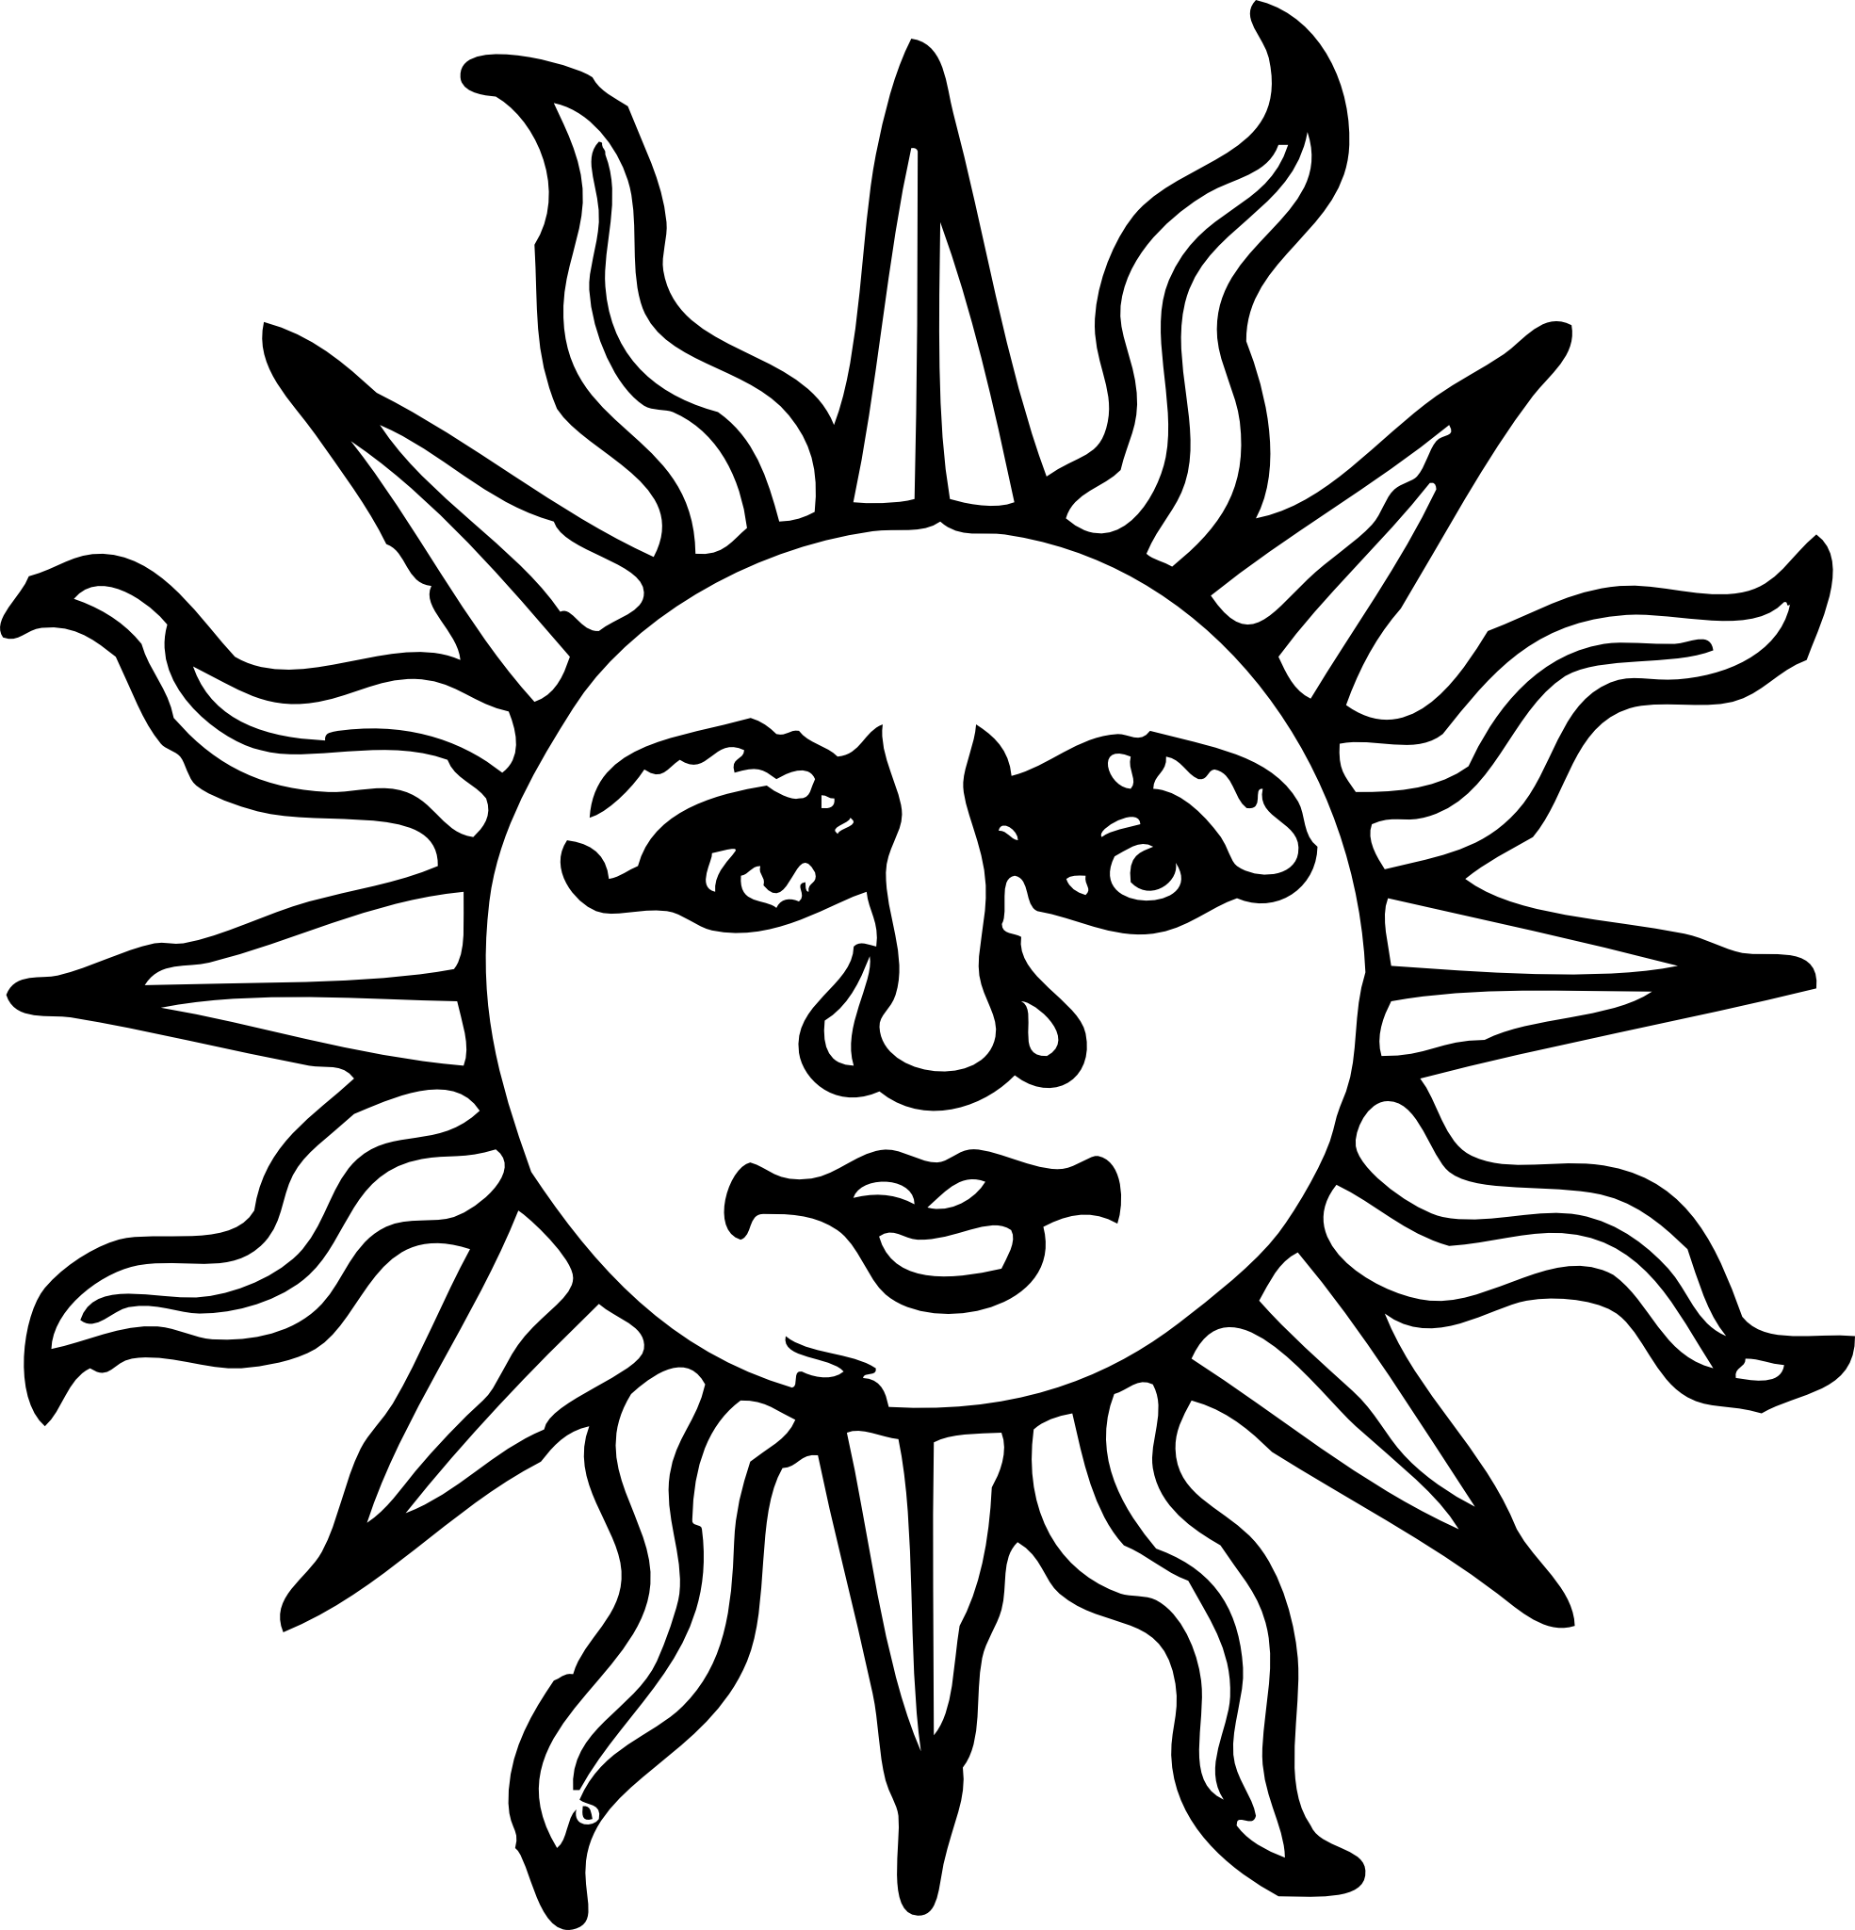

(LEE-tha) *June 21 OR Dec 21*  
Summer Solstice - Alban Heflen - Midsummer - Gathering Day

The Summer Solstice brings us the longest day and shortest night of the year. This holiday is all about life, power, abundance, warmth, protection and transformation. Fire is very prominent, as we celebrate the peak of the sun.

**Goddesses:** Gaia;/Mother Earth, Astarte, Freya, Hathor, Ishtar, Athena, Artemis, Dana, Kali, Isis, Juno, Aine, Briantia, Venus, Aphrodite, Bast, Yemaya, Vesta, Any Sun Goddesses

**Gods:** Ra, Apollo, Baldur, Horus, Helios, Zeus, Lugh, Prometheus, Thor, the Dagda, Gwydion, Green Man, Oak King, Holly King, Any Sun Gods  
  
**Symbols & Decorations:** Sun, Solar Wheel, Fire, Sunflower, Phoenix, Fae, Summer Flowers, Spirals, Mirrors, Suncatchers, Lights, Water, Stone Circles, Witches Ladder, Seashells

**Colors:** Green, Gold, Light Blue, Yellow, Red, Orange, White  
  
**Crystals:** Emerald, Jade, Sunstone, Orange or Green Calcite, Carnelian, Citrine, Amber, Tiger’s Eye, Diamond, Pearl, Quartz, Ruby, Garnet  
  
**Herbs & Plants:** Basil, Bay Leaves, Fennel, Lavender, Mint, Rosemary, Thyme, Chamomile, Mugwort, Vervain, Rose, Honeysuckle, St. John’s Wort, Yarrow, Calendula, Sunflower, Marigold, Oak, Elder, Cinnamon, Chickweed, Hemp, Wisteria, Daisy  
  
**Animals:** Bees, Cow, Butterfly, Dragonfly, Horse, Wren, Robin, Hawks, Eagles, Swallows, Dragons, Fairies

**Incense:** Lavender, Sage, Lemon, Rose, Mint, Jasmine, Rosemary, Coconut, Orange/Citrus, Florals, Verbena

**Activities:** Divination, making flower crowns, visiting a local well and leaving an offering, looking for messages in the clouds, greeting the sunrise, drying flowers or herbs, bonfire, making a suncatcher, baking summer treats, making a fairy garden or altar, craft a god’s eye  
 **Spellworking:** Love, Light, Passion, Creativity, Healing, Growth, Empowerment, Fertility, Prosperity & Abundance, Purity, Warmth  
  
**Foods:** Honey, Berries, Dairy (Cheese), Lemonade, Oranges, Sun Tea, Honey Cakes, Mead, Ale, Wine, Whipped Cream, Ice Cream, Summer Fruits & Vegetables, Chicken, Pork

**Moon Bowl Charm**

*A full moon charm to enhance your natural radiance to celebrate the beauty of Midsummer.*

You will need: A glass or china bowl, a glass or china jug and a small white candle. Remember the candle needs to burn away completely so choose a small one.

Draw your water into the jug - rainwater is best, but fresh water from the tap is fine. Take the jug of water, the bowl and the small white candle outside and place them on the ground. Light the candle in a suitable holder and place it at the top of the bowl - at the midnight/noon point of a clock face. Pour the water into the centre of the bowl and say:

***"Renewing water shining bright***

***Weave your charm in my bowl of Light"***

Place your Moon Bowl in the moonlight so the light of the full moon is reflected in the water and leave the candle to burn down.

When this is complete take your bowl and dip your hands into the water and as you gently splash the moon water onto your face say

***"By Full Moon charm,***

***By Full Moon light,***

***May inner beauty shine through tonight.***

***Brightest Blessings of the Goddess shine through me."***

When you have finished, return the water to the Earth. I always pour it on my favourite Holly Tree.  
  
*-From goddessandgreenman.co.uk/litha/*

**Litha Incense**3 Parts Myrhh  
1 Part Apple Blossoms  
½ Part Bay Leaves  
½ Part Cinnamon Bark  
1 Part Chamomile Flowers  
1 Part Lavender Flowers  
2 Parts Mugwort  
½ Part Rosemary

*-From sacredwicca.com*

**L U G H N A S A D H**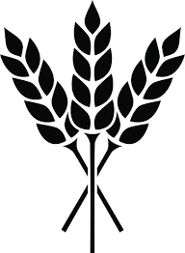

(LOO-nah-sah) *Aug 1 OR* Feb 1  
First Harvest - Lammas - Lunasa

Lughnasadh, or Lammas, is the first harvest festival of the season. This holiday celebrates the harvest of grain, and can honor the god Lugh as well. The harvesting of grain and baking of the first loaf of bread can be seen as a symbol of life, death and rebirth.

**Goddesses:** Tailtiu, Ishtar, Goddess as Mother, Demeter, Ceres, Isis, Dana, Lakshmi, , Blodeuwedd, Cerridwen, all Agriculture/Harvest goddesses

**Gods:** Lugh, Tammuz, Adonis, John Barleycorn, Green Man, Dagon, Taranis, Dionysis, Odin, all Agriculture/Harvest gods  
  
**Symbols & Decorations:** Sickles, Scythes, Grapevines, Dried Grains, Corn Dolly, Bread Loaf, Cornucopia, Gourds, Sun Wheels, Baskets

**Colors:** Green, Gold, Yellow, Orange, Brown, Bronze  
  
**Crystals:** Citrine, Cats Eye, Golden Topaz, Obsidian, Carnelian, Aventurine, Lodestone, Peridot, Tiger’s Eye, Moss Agate  
  
**Herbs & Plants:** Meadowsweet, Mint, Sunflower, Calendula, Mugwort, Basil, Milkweed, Acacia, Apple Leaf, Blackthorn, Clover, Goldenrod, Heather, Ivy, Rose, Rosemary, Vervain, Yarrow, Oak  
  
**Animals:** Rooster, Cow & Calves, Sheep, Crow, Pigs, Salmon, Stags, Griffins, Centaurs, Eagle

**Incense:** Basil, Frankincense, Rose, Rosemary, Sandalwood, Chamomile, Eucalyptus  
 **Activities:** Bake Bread, Learn a new skill, craft a corn dolly, make jams or jellies, community service  
 **Spellworking:** Cleansing, Protection, Gratitude, Abundance & Prosperity, Blessings, Growth, Honoring Ancestors, Making Offerings, Strength  
  
**Foods:** Bread, anything with Grains, Oatcakes, Ale, Apples, Pears, Berries, Lamb, Cornbread, Barley Cakes, Rice, Elderberry Wine, Cider, Local Produce, Summer Squash

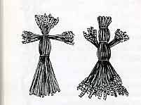

**Make A Grain Mother**

Make your own Grain Mother or Corn Dolly. Go for a walk and see what you can find - stalks of wheat, oats, barley, rye often left growing on the edges of fields after harvesting, failing that any grasses and/or reeds you can find. Let your creativity out - if you feel confident, weave your Grain Mother into being, but equally you can just lace and tie her into being with Lammas coloured ribbons. As you do so, give thanks for the gifts of Harvest. Place your Grain Mother on your altar or at the centre of celebrations. At Samhain, return the grain stalks to the earth, they contain the seeds of future harvest...

*-From goddessandgreenman.co.uk/lammas/*

**Prayer for Lughnasadh**Now is the time of the First Harvest,

when the bounties of nature give of themselves so that we may survive.

O God of the ripening fields,   
Lord of the Grain,

grant me the understanding of sacrifice as You prepare to deliver Yourself   
under the sickle of the Goddess and journey to the lands of eternal summer.

O Goddess of the Dark Moon,

teach me the secrets of rebirth as the Sun loses its strength and the nights grow cold.  
  
*-From belief.net/prayers/pagan/holidays/prayer-for-lughnasadh*

**Prayer to the Harvest Deities**The fields are full, the orchards blooming,  
and the harvest has arrived.  
Hail to the gods who watch over the land!  
Hail to [Ceres](https://www.learnreligions.com/resources-for-roman-pagans-2562633), goddess of the wheat!  
Hail Mercury, fleet of foot!  
Hail [Pomona](https://www.learnreligions.com/pomona-goddess-of-apples-2562306), and fruitful apples!  
Hail Attis, who dies and is reborn!  
Hail Demeter, bringing the dark of the year!  
Hail [Bacchus](https://www.learnreligions.com/bacchus-roman-god-2562627), who fills the goblets with wine!  
We honor you all, in this time of harvest,  
and set our tables with your bounty.

*-From “Lammas Prayers” by Patti Wigington - Learn Religions*

**M A B O N**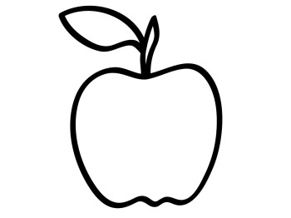

(MAY-bon) Sept 21 *OR* March 21  
Second Harvest - Michaelmas - Harvest Home - Alban Elfed - Winter Finding - Autumn Equinox

The Autumn Equinox, known to pagans in modern times as Mabon, celebrates the harvest of fruits. It is known as the Witches Thanksgiving.

**Goddesses:** Demeter, Ceres, Persephone, Pomona, Inanna, Epona, The Muses, Modron, Bona Dea, Morgan, Snake Woman

**Gods:** Mabon, Green Man, Thoth, Thor, Wicker Man, Bacchus, Dionysus, Hermes, Hotei  
  
**Symbols & Decorations:** Cornucopia (horn of plenty), Pinecones, Seeds, Pumpkins & Gourds, Scarecrows, Acorns, Vines, Autumn Flowers, Wreaths

**Colors:** Dark Green, Orange, Red, Yellow, Brown, Copper, Blue, Violet, Indigo  
  
**Crystals:** Amber, Citrine, Cat’s Eye, Aventurine, Sapphire, Jasper, Lapis Lazuli, Clear Quartz  
  
**Herbs & Plants:** Yarrow, Rosemary, Sage, Mugwort, Rosehips, Thistle, Marigolds, Ferns, Honeysuckle, Myrrh, Pine, Tobacco, Wheat, Aster, Mums, Oak, Hops, Cedar, Rue, Chamomile  
  
**Animals:** Owl, Stag, Blackbird, Salmon, Dogs, Wolves, Goat, Birds of Prey, Gnomes, Sphinx  
 **Incense:** Myrrh, Rosemary, Pine, Cedar, Sweetgrass, Apple Blossom, Benzoin, Jasmine, Black Pepper, Patchouli, Cinnamon, Clove, Oak Moss  
 **Activities:** Decorate home for autumn, gratitude exercises, go apple picking, have a picnic, offerings made to land spirits, canning or putting away food for winter, feasting, crafting apple head dolls, crafting a new besom, bake pumpkin pie, house cleaning, leaf rubbings  
 **Spellworking:** Gratitude, Prosperity & Abundance, Protection, Harmony, Balance, anything Hearth & Home, Security, Self-Confidence, Releasing Negativity, Shadow Work  
  
**Foods:** Corn, Beans, Squash, Apples, Pumpkins, Cider, Root Vegetables, Pomegranate, Wine, Dried Fruits, Nuts, Potatoes, Carrots, Onions, Cornbread, Ale, Seeds, Roast Goose or Mutton

| **Mabon Apple Dapple Cake  Ingredients**   * 3 cups flour * 1 tsp. salt * 1 tsp. baking soda * 2 cups sugar * 1 cup vegetable oil * ¼ cup orange juice * 3 eggs, beaten * 2 tsp. vanilla * 1½ cups chopped nuts * 3 cups peeled, chopped apples (3 medium-large apples) * Frosting (optional):1 cup brown sugar * ½ cup butter or margarine * ¼ cup milk, apple juice or orange juice   *-From readthespirit.com/feed-the-spirit/apple-cake-for-mabon* | **Instructions**   1. Preheat oven to 350 degrees. 2. Grease and flour two 9 x 5-inch loaf pans or a bundt pan. 3. Sift together the flour, salt and baking soda. 4. In a large bowl, mix the sugar, eggs, oil and juice. 5. Add the flour mixture in thirds until combined. 6. Stir in vanilla, then fold in nuts and apples. 7. Bake 45 minutes for the loaf pans or 1 hour for the bundt pan, until a toothpick inserted in the center comes out clean. 8. If you frost the cake, start the frosting (it’s more like a glaze) in the last 5 minutes of baking. 9. In a small saucepan, combine the brown sugar, butter or margarine and milk or juice and bring to a boil over medium-high heat, stirring constantly. 10. Cook 2½ minutes, stirring constantly. Pour the hot frosting over the hot cake. |
| --- | --- |

**S A M H A I N**

**(SOW-in, SAH-vin) *October 31 OR May 1*  
Halloween - All Hallow’s Eve - Day of the Dead / Dia de los Muertos - Celtic New Year - Hallowtide - Shadowfest - Feast of the Dead - Spirit Night - Nutcrack Night - Apple Fest - Witches’ New Year**

**The third harvest festival of the year and a fire festival, Samhain honors the approach of the darkest time of the year and death as part of the cycle of life. It is a liminal time when the veil is at its thinnest, so it is a good time to honor your ancestors. Samhain is thought to mean “end of summer”.**

**Goddesses: All Crone Goddesses, Hecate, Frigga, Persephone, the Morrigan, Cerridwen, Hel, Oya, Lilith, Kali, Ishtar, Arianrhod, Rhiannon, Tlazoteotl, Nephthys, Inanna, Baba Yaga, Isia, Pomona, Badh, Frau Holde, Macha**

**Gods: Osiris, the Horned God, Herne the Hunter, Cernunnos, Anubis, Odin, Bran, Any Death Gods, Arawn, Dagda, Hades, Loki, Pluto, Woden, Xocatl, Heimdall  
  
Symbols & Decorations: Jack-o-Lantern, Black Candles, Cauldrons, Autumn Leaves, Skulls, Gourds, Acorns, Besom, Mask, Oak Leaves, Ears of Corn, Waning Moon, Scarecrow, Corn Dollies**

**Colors: Black, Brown, Gray, Orange, Dark Purples, Yellow, White, Gold, Silver, Apple Red  
  
Crystals: Obsidian, Bloodstone, Smoky Quartz, Black Onyx, Jet, Ruby, Amber, Pyrite, Garnet, Brass, Marble, Sandstone, Amethyst, Carnelian  
  
Herbs & Plants: Mugwort, Allspice, Cinnamon, Rosemary, Mullein, Rue, Calendula, Sunflower, Apple Leaves, Sage, Wild Ginseng, Wormwood , Garlic, Myrrh, Yarrow, Cedar  
  
Animals: Bat, Black Cats, Coyote, Crows, Heron, Magpies, Moth, Owls, Ravens, Scorpion, Spiders**

**Incense: Sandalwood, Sage, Patchouli, Rosemary, Sweetgrass, Dragonsblood, Copal**

**Activities: Bonfires, carving pumpkins, hosting a dumb supper, creating an ancestor altar, divination, recreating old family recipes, giving your home a deep cleansing, drum circle, sweeping negativity out of your home, trick or treating, harvest feasts, bury apples for spirits**

**Spellworking: A time of setting spiritual intentions for the new year. Ancestor rituals. Protective magick. A good time to release anything you don’t wish to carry forward. Banishing, past lives, getting rid of bad habits, clarity. Road opening, confrontation, candle magick, sex magick.**

**Samhain Foods: Apples, Cider, Pumpkin, Squash, Grains, Turnips, Thick Stews, Root Veggies, Pears, Hazelnuts, Corn, Ale, Herbal Teas, Bacon, Pork, Poultry, Pomegranates, Nuts, Gingerbread, Soul Cakes**

**Samhain Money Drawing Charm Bag  
7 Pumpkin Seeds  
¼ tsp dried, ground pumpkin rind  
¼ tsp dried mint  
¼ tsp cinnamon**

**1 silver coin  
1 small pouch, preferably orange with red ribbon  
  
Make this before Samhain, preferably on the new moon. Mix herbal ingredients. Draw a dollar sign on each pumpkin seed with a black pen. Add to mix, then put mix into your pouch. Hold coin in your hand to get warm, and send intention into it, then put coin in pouch and tie it up. Add seven knots to the ribbon tying up the bag; one for beginnings, two for money, three for abundance, four for stability, five for protection from blocks, six for luck, and seventh to seal the spell. On Samhain, hold bag over your bonfire in your hands and send your intention into the bag as it warms. Keep it with you for the next year. Refresh every new moon. Great gift for a friend.  *- from Silver Ravenwolf’s book Halloween***

**Samhain Divination Spell:**

**Let the sacred fires burn bright.  
Let the spirits rise and the moon make her magick.  
Behold the shadows as they dance, while the cold wind whispers its ancient incantations.**

**Cast the circle and read the signs.**

**Magick is afoot in the witching hour.  
Let the love of the Old Ones light the way.  
May the wisdom of the ages through candle-glow and magick-mirror be revealed.  
And as it is willed, so shall it be.  
*- from Gerina Dunwich’s book A Witch’s Halloween***

**Y U L E**

[Yool] *December 21/22 OR June 21/22*Winter Solstice - Feast of Juul - Midwinter - Yuletide - Kwanzaa   
Hanukkah - Christmas

Yule or Winter Solstice is when we celebrate the return of light. The Holly King is defeated by the youthful Oak King, and after the darkest night of the year on Solstice, the days begin to grow longer. It is a celebration of rebirth.  
  
**Goddesses:** Amaterasu, Babouschka, Bona Dea, Cailleach Bheur, Demeter, Frigg, Hecate, Freya, Holle, Isis, La Befana, Mary, Pallas Athena, Rhea, Sankrat, Skadi, Spider Woman, Tonatzin, Unchi-Ahchi, Xi Hou  
  
**Gods:** Apollo, Babbo Natale, Balder, Cronos, Dionysus, Father Winter, Holly King, Horus, Jesus, Saturn, Shengdan Laoren, Jupiter, Marduk, Mithra, Oak King, Odin, Ra, Woden, Thor, Zeus  
  
**Symbols & Decorations:** Holly, Mistletoe, Deer/Stag/Reindeer, Poinsettias, Yule Log, Light/Flame, Yule Trees, Sun, Candles, Snowflakes, Cauldron, Mother & Child, Bells

**Colors:** Green, Red, Silver, Gold, White, Blue  
  
**Crystals:** Diamond, Emerald, Ruby, Snowflake Obsidian, Bloodstone, Clear Quartz, Peridot, Topaz, Goldstone, Onyx, Turquoise  
  
**Herbs & Plants:** Holly, Evergreens, Mistletoe, Frankincense, Myrrh, Rosemary, Sage, Laurel, Bayberry, Ivy, Valerian  
  
**Scents & Oils:** Frankincense, Myrrh, Cinnamon, Clove, Mint, Pine, Wintergreen, Ginger  
  
**Animals:** Goats, Deer, Dove, Wolf, Squirrels, Horse, Pigs, Raven  
  
**Activities:** Watching the sun rise, lighting Yule Log, creating a gratitude list, gift giving, community service, crafting magickal tools, divination, feasting, baking, caroling

**Spellworking:** Release ceremonies, house blessings, embracing your inner light, happiness, hope, peace, prosperity, world peace, healing

**Food & Drink:** Mulled wine, roasted meats, roasted root vegetables, cakes, cookies, fruitcakes, wassail, nuts, apples, oranges & other citrus fruits, squash, eggnog

| **Invocation to the Old Woman of Winter** *From tesswhitehurst.com*  Ancient mother of Midwinter  watcher over life and death,  the one who rebirths the world,  be with us on this longest night!  See us through the dark hours  and stand with us  as dawn births the promise of new life.  So mote it be! | **Invocation to Father Yule** *From tesswhitehurst.com*  Heroic father, giver of life,  one who stands with sword in hand  to fight against the dangers of the wild,  bring that sword into our circle  and stand with us against this night’s darkness.  For the night is long,  and you will keep us safe. |
| --- | --- |

| **Yule Prayer to the Sun Gods** *By Patti Wigington “12 Pagan Prayers for Yule”*  Great sun, wheel of fire,  sun god in your glory,  hear me as I honor you  on this, the shortest day of the year.  Summer has gone, passed us by,  the fields are dead and cold,  all of earth sleeps in your absence.  Even in the darkest times,  you light the way for those who need a beacon,  of hope, of brightness,  shining in the night.  Winter is here, and colder days coming,  the fields are bare and the livestock thin.  We light these candles in your honor,  that you might gather your strength  and bring life back to the world.  O mighty sun above us,  we ask you to return, to bring back to us  the light and the warmth of your fire.  Bring life back to earth.  Bring light back to earth.  Hail the sun! | **Blessing the Yule Tree** *From teriannestarot/blessing-yule-tree/*  *Needed: Salt, Incense or Herbs, Candle, Water  As you say this blessing, sprinkle salt around the tree in a circle (avoid the tree itself, just around it), use herb or incense smoke, pass the candle over it, and finally add water to the tray at the bottom.  Once you’ve blessed your tree, it is ready to decorate!*  By the powers of earth, I bless this tree, That it shall remain sacred, a symbol of life, Stable and strong in our home throughout the Yule season.  By the powers of air, I bless this tree, As the cool winter winds blow away the baggage of the old year, and we welcome the brightness of the new into our hearts and home.  By the powers of fire, I bless this tree, As the days have gotten shorter, and the nights grown dark, yet the warmth of the sun is returning, bringing with it life.  By the powers of water, I bless this tree, A gift I give, that it may stay bright and green for us a bit longer, so that we can enjoy the harmony and peace of Yule. |
| --- | --- |