How Progressive Language Was Hijacked Into Anti-Israel Orthodoxy
A grassroots organizer argues that terms such as progressive, liberal and woke have increasingly been recast to require hostility toward Israel, with growing political consequences across the West.
 | 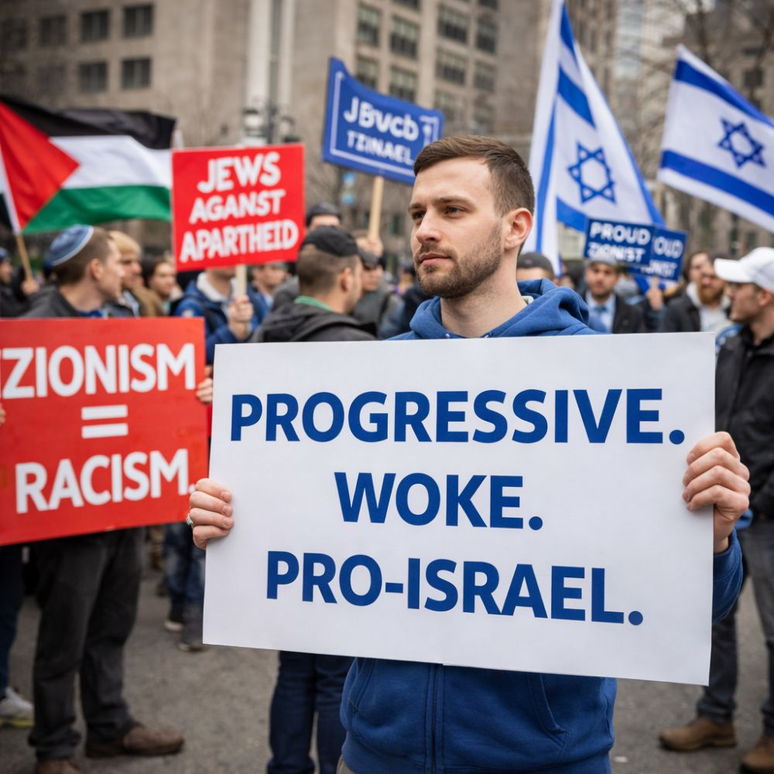

Mitch Mallett, Suncoast Jewish Alliance
Published in the J.CA International News, April 19, 2026
A demonstrator holds a pro-Israel sign during a public rally, symbolizing the argument that support for Israel, Zionism and Jewish self-determination can coexist with progressive and liberal values. (Image: TheJ.Ca.)
NEW YORK — Weeks after the October 7 attacks, I saw a vacuum for a place where people could unapologetically be progressive, liberal, woke and pro-Israel. So I started a Facebook group called We Are Progressive, Liberal, Woke and Pro Israel. It is now approaching 7,000 members.
I chose those words carefully because even then, I could see those terms beginning to be hijacked. Over the last two and a half years, that hijacking has become more deeply entrenched in society.
The discussions inside this group are not isolated. They are a microcosm of conversations now happening by the millions throughout Western society.
Recent examples include the April 9, 2026 fight over anti-Israel resolutions inside the Democratic National Committee in New Orleans and the April 15 U.S. Senate votes on resolutions to block certain arms sales to Israel.

A Familiar Script
Recently, a prospective member declared that no true progressive could support Israel. He then repeated familiar accusations of colonialism, apartheid, genocide, fascism, foreign control and the claim that Zionism itself is morally illegitimate.
What struck me was not simply that one person said it. It was how familiar the script has become.
Variations of these same accusations are now repeated daily across social media, activist spaces, campuses and political conversations throughout the Western world.
If these accusations are going to be repeated endlessly, they need to be answered clearly.
What Progressive Once Meant
A few years ago, being progressive did not mean being anti-Israel. In many circles, the opposite was often true.
Progressive values were understood to include democracy, civil rights, women’s rights, labor rights, LGBTQ rights, religious freedom, minority protections and open debate.
Israel, with all its flaws and internal political struggles, was widely understood to be the most liberal, democratic and pluralistic society in the Middle East.
Israel has competitive elections, opposition parties and an independent judiciary. Arab citizens vote, and in 2021 an Arab party joined the governing coalition for the first time.
Israel also made peace with Egypt in 1979 and Jordan in 1994. More recently, the Abraham Accords formalized normalization with the United Arab Emirates and Bahrain, followed by arrangements involving Morocco and Sudan.
None of this means Israel is perfect. It does mean that caricaturing Israel as uniquely evil collapses once real complexity enters the room.
The Hijacking of Language
That is why the word progressive itself has been hijacked. In some circles, it now seems to require hostility toward Israel as a condition of moral membership.
I reject that distortion.
The same is true of the word woke when it is twisted from awareness of injustice into blindness toward Jewish history, Jewish vulnerability and Jewish self-determination.
The same goes for Zionism, which is often turned into a slur by people who do not understand it or deliberately misdefine it.
At its core, Zionism is the Jewish national movement and the belief that Jews, like other peoples, have the right to self-determination in their ancestral homeland.
You can oppose a particular Israeli government, criticize settlement policy, dislike Netanyahu or disagree with military decisions without redefining Zionism itself as inherently evil.
That redefinition is not analysis. It is propaganda.
Slogans Versus Substance
The apartheid accusation is false. It is used as a slogan designed to end debate before it begins.
Whatever one’s criticisms of Israel, that framework does not map neatly onto the reality inside Israel proper, where Arab citizens have citizenship, voting rights, political representation and legal standing.
The genocide accusation is also used casually and repeatedly. Genocide is a grave legal and moral charge, not a slogan for every brutal war or civilian tragedy.
The claim that Israel is simply subsidized by American taxpayers is similarly misleading. U.S. aid is substantial, but it is primarily military assistance, not a blank check funding Israeli civil society.
The claim that Israel or the Mossad is the greatest threat to American national security ignores more serious threats including Iran, terror networks, cyber warfare and nuclear proliferation.
Political Consequences
This concern is no longer theoretical.
At the DNC meeting in New Orleans on April 9, one anti-AIPAC resolution was voted down in committee, while two other Israel-related resolutions were tabled for further review.
Only days later, on April 15, the United States Senate voted on two Sanders-led resolutions to block arms sales to Israel.
One failed 59 to 40. The other failed 63 to 36.
Those numbers suggest that rhetoric saturating social media, activist spaces and campuses is no longer fringe. It is increasingly shaping mainstream political behavior.
Iran’s Messaging Success
What concerns me most is that these arguments do not exist in a vacuum.
Iran and its regional proxies have been extraordinarily effective in the propaganda sphere. They have shaped language, framing and moral assumptions through which millions now view Israel, Zionism and Jews who defend Israel.
Many people now repeat this rhetoric without understanding where it originated or whose agenda it serves.
They believe they are speaking for justice, but often they are echoing narratives designed to weaken Israel, isolate Jews and erode confidence in democratic societies.
What Must Be Done
That is why friends of Israel cannot remain passive.
This is no longer just a debate for television panels, scholars or politicians in Washington. It has become a grassroots battle and must be answered at the grassroots level.
That means one person at a time. Conversation by conversation.
It means speaking in our communities, showing up in our organizations and refusing to let falsehoods go unanswered simply because they are loud or emotional.
It means participating in local politics, county politics and party structures where these ideas are increasingly being normalized.
Elected officials notice activism, demonstrations and pressure campaigns. If friends of Israel do not answer with equal or greater civic engagement, many politicians will read the imbalance as public consensus.
We cannot let that happen.
Without Apology
We need elected officials to see not only noise from the anti-Israel side, but organized, informed and morally confident pushback from people who understand what is at stake.
They need to see that support for Israel, Jewish legitimacy and democratic values still has real force.
That is exactly why I still say, without apology, that one can be progressive, liberal, woke and pro-Israel.
And that is why I am calling on all friends of Israel to recognize the reality of this assault and push back with visible, organized grassroots action before propaganda hardens into political power.

