V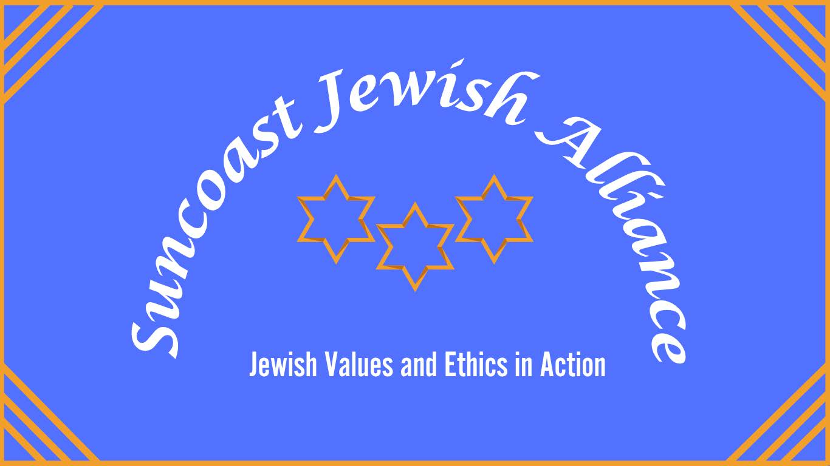
Sarasota’s School Board needs History Lesson | Opinion
Norman Olshansky, Guest Columnist
Sarasota Herald-Tribune, Dec. 28, 2025
- The Sarasota County School Board has implemented a new policy to begin its meetings with a prayer.
- The policy states there will be no guidelines or limitations on the content of the invocation.
- The article’s author questions the policy’s motivation and its potential conflict with the separation of church and state.
- Concerns are raised about the possibility of proselytizing or offensive language during the invocations.
A new Sarasota County School Board policy calls for a prayer at the start of board meetings.
The policy’s opening paragraph states that the purpose of the invocation is “to assist Board Members in setting their minds to a higher purpose and to ease their task of governing the school district.”
The policy also states that “no guidelines or limitations shall be issued regarding the invocation’s content…”
In addition, it states that neither the board nor its employees will interrupt the invocation or dismiss the Speaker based on the content of the invocation
What if the speaker goes into a racist, Islamophobic, anti-Catholic or antisemitic rant?
What if the speaker starts to proselytize to make believers who are not of their faith?
Are prayers that are particular to one religious group appropriate for a diverse audience?
Private and personal prayer is the right of everyone under the First Amendment.
However, bringing prayer into public meetings, which are attended or viewed by people of many faiths, can be problematic, especially when they are not ecumenical in nature.
The very first invocation under the Sarasota County School Board’s new policy was a prayer that only specific denominations of Christianity would find appropriate.
We would ask this: What is the real motivation behind this new policy?
Members of the Sarasota County School Board have been promoting efforts to bring their own faith into the schools in various ways.
What will be next?
Will Bibles be distributed?
Will prayers be conducted at the beginning of classes?
Will clergy chaplains that the state has authorized be used as
counselors in the schools?
Will public support be given to parochial schools?
Our Bill or Rights, which is part of the U.S. Constitution, starts with the First Amendment.
Our Founding Fathers made it clear that there should be a separation of church and state.
Indeed, Thomas Jefferson coined the phrase “separation of Church and State.”
James Madison went further and warned that “government involvement with religion could lead to the corruption of religion, threatening of liberty, coercion and favoritism.
Maybe the Sarasota County School Board needs to go back to school and take a civics history lesson.
Sarasota Herald-Tribune, Dec. 28, 2025

