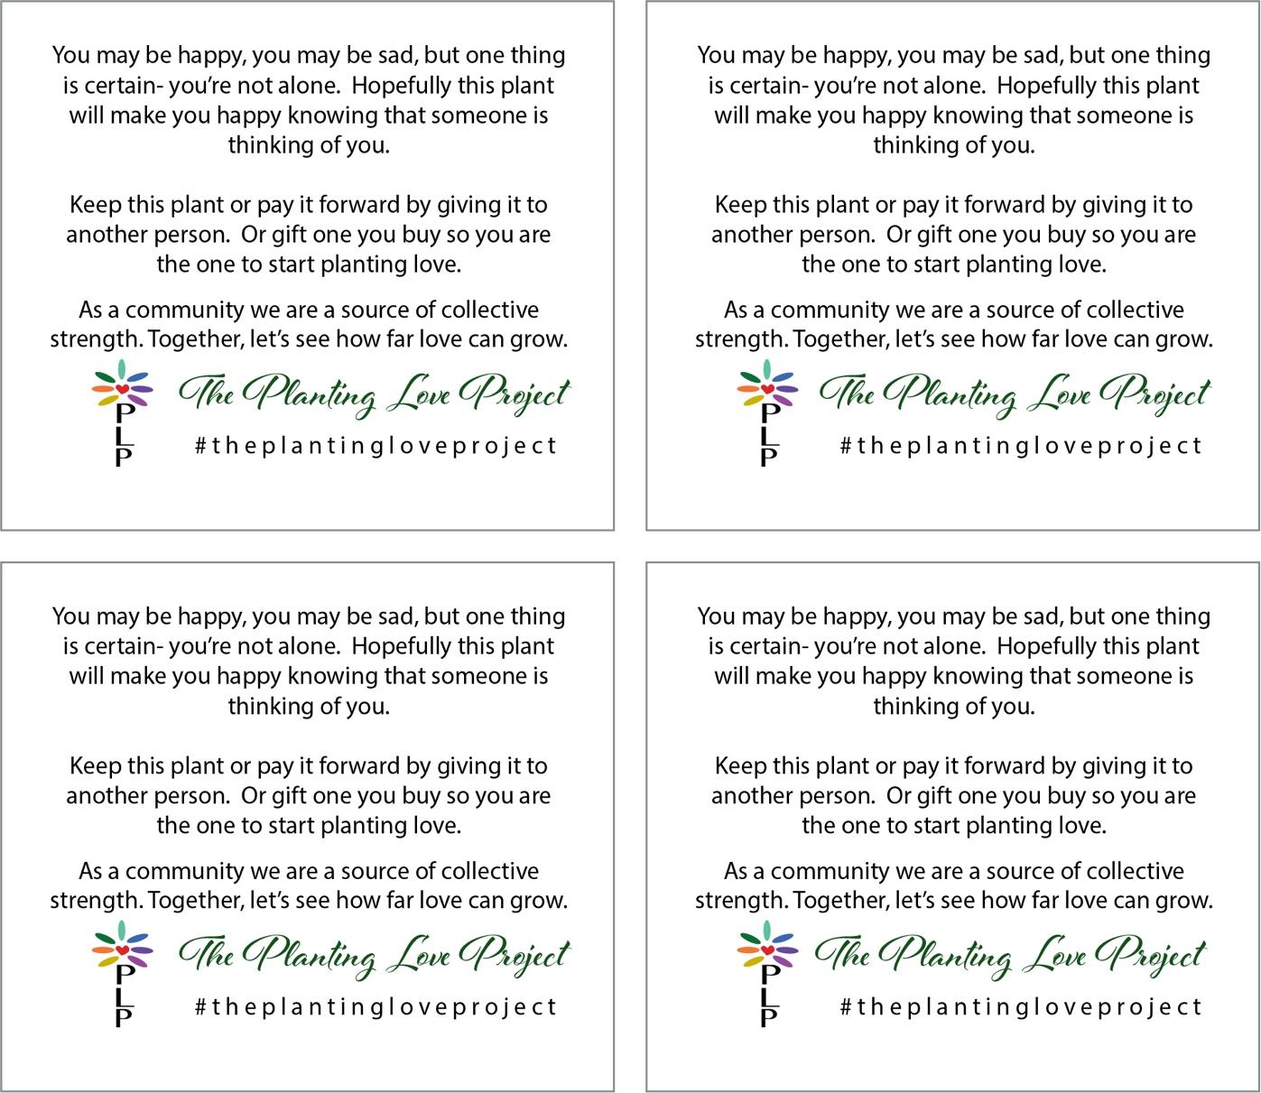

How To Start Your Own Planting Love Project:

- Select plants that you wish to anonymously gift.
- Print this page and cut out one tag for each plant.
- Tape the tag to a wooden skewer or the plant container.
- Deliver your plant and make someone’s day!

Thank you for taking the time to make this world a better place for someone else.

