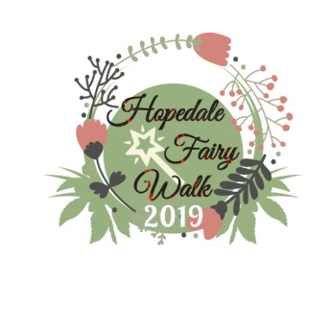

FoHH Hopedale Fairy Walk 2019

Date: | Saturday, June 8, 2019 10am – 4pm
House Drop Off is Friday, June 7th at the Bath House.
House Pick Up is Sunday, June 9th at the Bath House
Location: | Hopedale Parklands, Hopedale, MA.
Regis- tration: | The Hopedale Fairy Walk will take place on the main trail of the Hopedale Parklands starting at the bath house entrance behind 76 Dutcher Street, Hopedale, MA. The houses and vendors will be placed along the 1 mile stretch of the blue trail from the bath house entrance to the Rustic Bridge. This event is hosted by the Friends of Historic Hopedale in conjunction with the Hopedale Park Commission. Individuals, groups or businesses are welcome to participate by building a house. Send in your application & payment to the FOHH then get to work on building your fairy house. See our website for early bird incentives!  Fairy House Fee: $25.00 The non-refundable registration fee must accompany this application.  No applications will be accepted after June 1, 2019.
Space: | Businesses will be allowed 1 sign (provided by you) to display near your home no larger than 18”x24” (standard lawn sign). Please write your name on the house and the sign so they can be matched up if separated when being placed by our volunteers.  Our volunteers place your houses along the trail so we ask you to keep them under 3' x 3' so they're not too hard to lift and under 50lbs. Special arrangements will need to be made for anything bigger/heavier. You should also be sure to secure your decorations to your platform/house so nothing gets lost during placement.
Payment: | Please make checks payable to “Friends of Historic Hopedale” and mail application form and check to: Friends of Historic Hopedale, PO Box 302, Hopedale, MA 01747  Applications must be mailed to the above PO Box. We are not responsible for applications mailed to the wrong address or dropped off in other locations.
More  Info: | You can choose which realm you’d like us to place your home in by which category it fits best or personal preference. If no realm is selected, your home will be randomly placed by our volunteers.  Choose your realm: Fairy Forest (Fairies of all shapes & sizes)/Gnome Man’s Land (They are often artistic & great inventors)/Mermaid Cove (Think beach homes, mermaids & pirates!)/ Forest of Dean (Think Wizarding World!)  Email questions to hopedalefairywalk@yahoo.com or visit the Friends of Historic Hopedale Facebook page or our website at: www.friendsofhistorichopedale.com
Returning House Builder? Yes No

Name:
Business/Group (N/A if family/individual entry):
Contact Name: Phone Number(s):
Email address:

Website or Facebook page (for advertising):
Choose your Realm (Optional): ________________________________________________________________________

# of Houses: ___ Amt. Enclosed: $

The Friends of Historic Hopedale, Hopedale Park Commission and the Town of Hopedale are not responsible for any personal injuries or for items lost, stolen or damaged.

