**QUICK HITTERS**

**Chips &:** Your choice of Salsa, Queso, Buffalo Chicken, Or all three..............................................$6/ 7/ 7/8

**Mac & cheese bites**: Gouda macaroni and cheese lightly battered and deep fried...............................$8

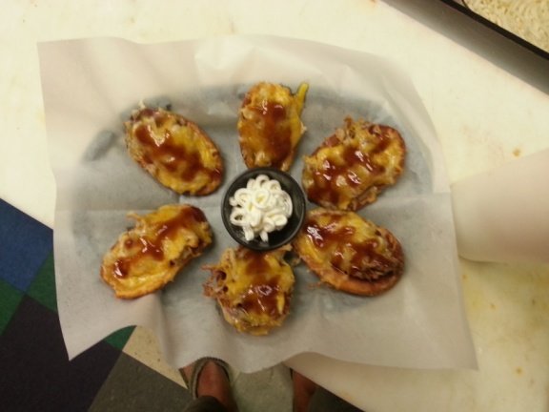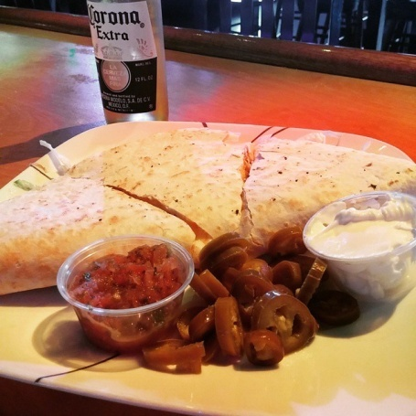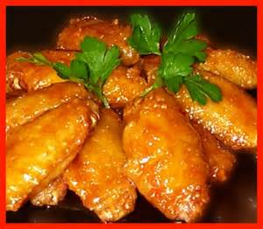

**Egg Rolls:** 4 fried egg rolls served with our bourbon teriyaki dipping sauce..........................................$6

**Fried Cauliflower**: battered and fried Spicy Cauliflower served with a ranch dipping sauce...........$6

**Mozzarella Sticks:**  six mozzarella sticks breaded and served with marinara..........................................$7

**Pig skins:** Five Potato skins filled with Bbq pork topped with cheese and a side of sour cream.....$9

**Fried Mushrooms:** Hand-breaded mushrooms, deep fried and served with ranch..............................$7

**Pretzel Bites:** Bite sized soft pretzels served with cheesy buffalo dip.........................................................$8

**Yard Line Wings:** 10 Wings with your choice of: Mild, Medium, Hot, Fire, Bbq, Hot Bbq, *Bourbon Teriyaki*, Sweet Chili, *Asian Torrie, whambam,*or Yard Sauce **Signature Rubs**: *Sweet Jerk*, Spicy Garlic, Chili Lime,............................$10 ...................................................$10

**Yard Line Wings:** 10 Wings with your choice of: Mild, Medium, Hot, Fire, Bbq, Hot Bbq, *Bourbon Teriyaki*, Sweet Chili, *Asian Torrie, whambam,*or Yard Sauce **Signature Rubs**: *Sweet Jerk*, Spicy Garlic, Chili Lime, .....................................$10

**Smothered Chicken Fingers:** Breaded chicken breast smothered in your choice of Mild, Medium, Hot, Bbq, Honey Mustard, Asian Torrie, Bourbon Teriyaki Sweet Chili. served with a side of ranch or blue cheese.........................................................................................................................................................................$10

**Loaded Nachos:** Tortillas topped with cheese, sausage, lettuce, tomato, onion, jalapeno and served with a side of sour cream and salsa Add Chx $2 Add Pork $3.......................................................................$10

**3 Cheese Quesadilla:** Grilled flour tortilla filled with our 3 blend cheese, lettuce, tomato, and onion. Served with a side of salsa, sour cream and jalapenos. Add Chx $2 Add Pork $3.....................................$7

**Stacked Waffle Fries**: Waffle fries, Bacon, and cheese topped with a bacon aioli..................................$8

**Tot-chos**: A Baskset of tater tots smothered in white queso and taco meat topped with lettuce, tomato, and onion..............................................................................................................................................................$9

**Fire Cracker Pickles**: Our signature spicy pickles battered and deep fried to perfection....................$7

**Salad**

**Chopped salad**: Chicken, lettuce, tomato, onion, cheese and bacon. Served with your choice of ranch, blue cheese, honey mustard, or Italian dressing.............................................$9 **Taco Salad**: Lettuce, tomato, onion, salsa, sour cream, cheese, taco meat and jalapenos served on a bed of crispy tortilla chips................................$10

**Chili**: Cup/$4 Bowl/$5

**Wraps/Panini**

**All Panini and wraps are served with fries, upgrade to tots, or waffles fries for $1**

**The Italian**: Panini or wrap Salami, pepperoni, ham, provolone served lettuce tomato and Italian dressing.............................$9

**Buffalo Chicken wrap:**  chicken, hot sauce, lettuce, salsa, cheese onion............$7

**Chicken Club**: Panini or wrap, chicken served with bacon, lettuce, mayo, and tomato.............................$9

**The Stromboli**: Ciabatta with ground sausage, onion, marinara, and mozzarella...$8

**The Bar-Tenderloin**: Pork loin breaded in our special herbs and spices, deep fried to a golden crisp................$10

**Roast Beef:** Panini pressed roast beef, Horse radish, cream cheese, banana peppers and Yard sauce....................................$9

**Torpedo**: Panini or wrap hot ham and cheddar cheese served with lettuce and Italian dressing...................$8

**Early Riser:** Panini or wrap sausage, American cheese, egg ..........................................$8

**Grilled Chicken Sandwich**: Grilled chicken, choice of cheese, mayo, lettuce, tomato, and onion............$8

**Burgers**

**All Burgers and served with fries, upgrade to tots, or waffles fries for $1**

**Classic Burger**: Burger topped with your choice of cheese, lettuce, tomato, onion..................................$10

**Bourbon Burger**: Burger topped with bacon, Swiss cheese and our signature bourbon teriyaki sauce..................................$12

**Craig Burger**: Burger with bacon and ranch served between two grilled cheese buns...................................$13

**WTFork Burger**: Burger topped with egg, bacon and cheese served between two Fried PB&J.........................$13

**Blackened Blue Burger:** a blackened burger covered in blue cheese.........................$12

**The Yard Line Burger:** Yard Line Bbq sauce, Jalapenos and cheddar cheese....................................$12

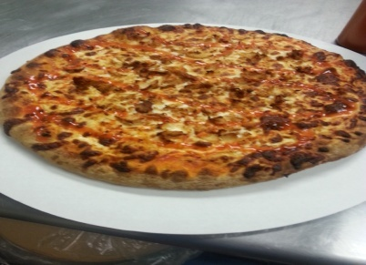

**Pizza**

**Death by Pig:** Oink Oink , a Pizza with bacon, pork, ham, sausage, pepperoni and salami topped with marinara...............................................................................................................................................................$16

**BLT Pizza**: A classic sandwich reinvented as a delicious pizza! Mayo base with bacon, lettuce, tomato, and mozzarella ..........................................................................................................................................$15

**Chicken Bacon Ranch Pizza:** Ranch based pizza topped with bacon and chicken .....................$15

**Buffalo Chicken Pizza**: Chicken our signature wham bam sauce, mozzarella................................$15

**The Carnivore**: A meat eaters Dream topped with bacon, sausage, pepperoni, and Ham ......$15

**The Suprima**: Marinara base topped with pepperoni, sausage, tomato, onion, banana peppers, mushrooms, and mozzarella...................................................................................................................................$15

**BBQ chicken Pizza**: Bbq base topped with chicken, red onions, mozzarella and Bbq sauce....$15

**Build Your Own Pizza**: Make your own pizza just how you like it................................$11+toppings

Meats: $1 Pepperoni, bacon, sausage, chicken, ham, salami, pork, or taco.

Veggies: $.75

Mushroom, onion, tomato, banana pepper, jalapenos, or green olives.

*Waffle fries......$6*

*French fries.....$6*

*Fried PB & J.....$5*

*Side Salad......$4*

*Extra Ranch/ Blue cheese..$.50*

*Tots.............$6*

**Desserts**

**Funnel Fries**: Classic Carnival dessert topped with powdered sugar..............................................................$7

Cheese cake?????

**Limited Menu**

**CHIPS & SALSA**: Our secret recipe salsa served with fresh tortilla chips....................................................$5

**Mac & cheese bites**: Gouda macaroni and cheese lightly battered and deep fried..............................$8

**Pretzel Bites:**  Bite sized soft pretzels served with cheesy buffalo dip..........................................................$8

**Yard Line Wings:** 10 Wings with your choice of: Mild, Medium, Hot, Fire, Bbq, Hot Bbq, *Bourbon Teriyaki*, Sweet Chili, *Asian Torrie,*or Yard Sauce **Signature Rubs**: *Sweet Jerk*, Blackened, Spicy Garlic, Chesapeake bay..............................................................................................................................................................................................................$10

**Smothered Chicken Fingers:** Breaded chicken breast smothered in your choice of Mild, Medium, Hot, Bbq, Honey Mustard, Asian Torrie, Bourbon Teriyaki Sweet Chili. served with a side of ranch or blue cheese..........................................................................................................................................................................$10

**Egg Rolls:** 4 fried egg rolls served with our bourbon teriyaki dipping sauce..........................................$6

**Fried Cauliflower**: battered and fried Cauliflower served with a ranch dipping sauce.............................$6

**Mozzarella Sticks:**  six mozzarella sticks breaded and served with marinara..........................................$7

**Build Your Own Pizza**: Make your own pizza just how you like it..................................$11+$1/topping

**Buffalo Chicken Pizza**: Chicken our signature wham bam sauce, mozzarella.......................................$15

**The Carnivore**: A meat eaters Dream topped with bacon, sausage, pepperoni, and chicken.........$15

**The Suprima**: Marinara base topped with pepperoni, sausage, tomato, onion, peppers, mushrooms, and mozzarella....................................................................................................................................................................$15

**The Bar-Tenderloin**: Pork loin breaded in our special herbs and spices, deep fried to a golden crisp..........................................................................................................................................................................................$10

**Chopped salad**: Chicken, lettuce, tomato, onion, cheese and bacon. Served with your choice of ranch, blue cheese, honey mustard, or Italian dressing.......................................................................................$9

*Waffle fries......$7*

*French fries.....$6*

*Fried PB & J.....$5*

*Side Salad......$4*

*Extra Ranch/ Blue cheese..$.50*

*Tots.............$6*