Onward Sioux Falls
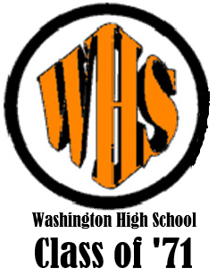
Onward Sioux Falls
You’re the best of all.
All the happy days we’ve spent here
Sioux Rah Rah
We will oft recall.
For your colors black and orange
We will gladly die.
And we will fight, fight, fight
For Sioux Falls High.

Onward Sioux Falls
Onward Sioux Falls
You’re the best of all.
All the happy days we’ve spent here
Sioux Rah Rah
We will oft recall.
For your colors black and orange
We will gladly die.
And we will fight, fight, fight
For Sioux Falls High.

