Shining Starr Learning Academy Supply List
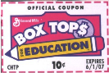
We collect Box Tops We collect Box Tops

Please write your student’s name on all the items below which are used daily:

2 – 1” 3-ring clear view binders (your choice of colors no designs)
1 Sets of 5 dividers
3 Journals (either spiral or composition notebooks whatever your child is more comfortable writing in – any colors - replenish if needed)
1 Clip board
1 Pencil box
1 24 pack of Crayola Crayons
1 24 pack of Crayola colored pencils
1 Headphones or earbuds (whatever your child is more comfortable with)
1 Flash drive
1 pack 24 #2 Pencils
1 pack 4 or more Highlighters - different colors
6 Glue sticks (replenish when needed)
1 flexible 12” ruler (please write your student’s name on it)
1 protractor (grades 3 up)
1 compass (grades 3 up)
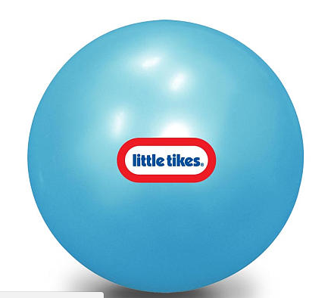
Erasers (either pink or caps or both)

1 - 10” bouncing ball

PLEASE DROP OFF ALL BOXTOPS IN THE BOX IN THE LOBBY

SCHOOL WISH LIST

Wide ruled notebook paper
Copy paper
Graph paper
9 X 12 colored construction paper
12 X18 colored construction paper
White Card Stock
8-1/2 X 11 Laminating Sheets
Page protectors
Dry Erase markers
Washable markers
#2 pencils
Highlighters (pink, blue, yellow, green)
Crayola crayons
Children’s rounded tip scissors
Lysol Wipes
Paper towels
Kleenex
Scott toilet paper
Napkins
Styrofoam plates
Plastic forks
Plastic spoons
16 oz. bottled water
Soccer balls
Basketballs

