Shining Starr Learning Academy Supply List

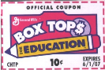

**We collect Box Tops We collect Box Tops**

***Please write your student’s name on all the items below:***

2 – 1” 3-ring clear view binders *(your choice of colors no designs – no black)*

2 Sets of 5 dividers

3 Journals *(either spiral or composition notebooks whatever your child is more comfortable writing in – any colors - replenish if needed)*

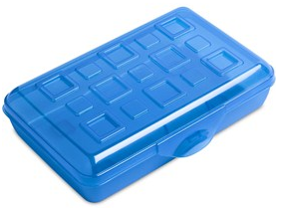1 Clip board – 8-1/2 X 11 only

1 Pencil box any color -

1 Package wide ruled loose leaf paper

1 24 pack of Crayola Crayons

1 24 pack of Crayola colored pencils

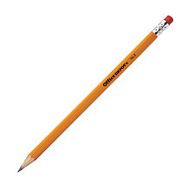1 Headphones or earbuds *(whatever your child is more comfortable with)*

1 Flash drive

1 pack 24 #2 Pencils (no mechanical pencils)

1 pack 4 or more Highlighters - different colors

6 Glue sticks *(replenish when needed)*

1 flexible 12” ruler *(please write your student’s name on it)*

1 protractor *(grades 3 up)*

1 compass *(grades 3 up)*

**Reusable** water bottle for the **whole day** labeled with Name (plastic only-no metal)

Erasers *(either pink or caps or both)*

1 box of tissues

PLEASE DROP OFF ALL **BOXTOPS** IN THE BOX IN THE LOBBY

**SCHOOL DONATION LIST**

Wide ruled notebook paper 9 X 12 colored construction paper

Copy paper Sketch pads

White Card Stock Children’s rounded tip scissors

8-1/2 X 11 Laminating Sheets Sheet protectors

Dry Erase White Board Cleaner 4 color Dry Erase markers

# 2 pencils (no mechanical pencils) Washable markers

Crayola colored pencils Crayola crayons

Lysol Wipes Highlighters (pink, blue, yellow, green)

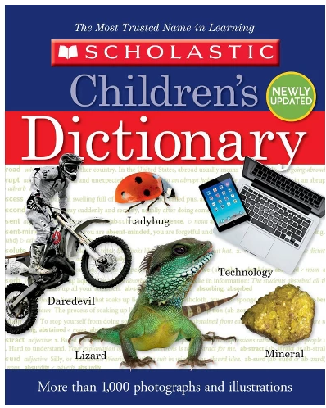Paper towels Scholastic Children’s dictionary

Tissues

Scott toilet paper

Hand soap refills

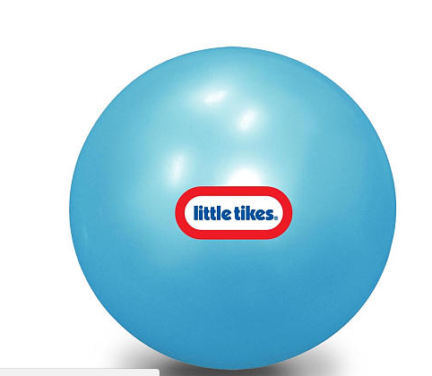Napkins

Styrofoam plates 10” bouncing ball

Plastic forks

Plastic spoons

16 oz. bottled water Nerf Football

Graph paper Soccer balls

12 X18 colored construction paper Basketballs