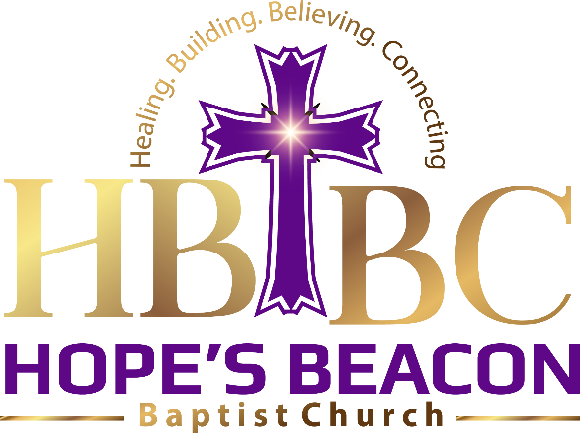

Bringing Hope Home
To better facilitate its mission of restoring and cultivating hope in the neighborhood, the Hope’s Beacon Baptist Church (HBBC) will maintain a sacred space for communal worship, prayer, and civic gatherings with a seating capacity of fifty persons. It will also develop and install the Beacon of Hope Center (BOHC)
The BOHC is a Christian Education ministry of the (HBBC). The BOHC is intended to provide comprehensive support for the development, facilitation and sustainment of community and placed based instruction and guidance in matters of Christian education, discipleship, and enrichment.
As churches shift emphasis and broaden their appeal, to accommodate emerging social views and secular political culture, they readily disavow historical core values, mores, doctrines, and theological perspectives, that once distinguished the Christian Faith and heritage. Alternatively, these churches install ambiguous or spiritually neutral programming and ambivalent religious leadership that pivot to serve the expressed or perceived entertainment interests and requested rituals of its sporadic and fickle subscribers.
Such spiritual vagary and incontinency undermine Christian integrity, confusing and dismaying the faithful and disserving God. Worse it misrepresents the original identity, spiritual lineage, and mission of the church. There is a need for life giving and illuminating, authentic, trustworthy Christian education and orientation that is community and placed based. The HBBC will facilitate Christian discipleship and spiritual maturity through its BOHC.
HBBC asserts that, the presence and hand of the church can and should serve more than the social interest, humanitarian needs, and civic ideals of communities where they are situated. Though these objectives of the church are necessary and very important; its most significant contribution must be the grooming and strengthening of the community’s spiritual life by sharing its riches found in the salvific love of Jesus Christ. Moreover, the church’s footprint must always be demarcated by the blood and finished work of Christ so as to imprint peoples’ lives with the spirit of the loving and living God.
The HBBC recognizes the primacy of intentional spiritual formation of Christian faith that promotes and celebrates eternal hope. Such hope intentionally grooms a well-developed faith that can help us, grow in Christlikeness, establish, and sustain godly relationships, be actively missional, pursue spiritual maturity and sustain community.
The HBBC BOHC will host a sixteen-person capacity Family Learning and Fellowship Theater (FLFT) equipped with state-of-the-art multimedia-based technology for on-site hosting and live streaming of visual and audio Christian education and inspiration curricular. It will access an expansive onsite catalog of the most highly rated and subscribed intergenerational, family friendly and culturally relevant print, electronic and digitalized biblically based Spiritual Formation, Christian Discipleship, Character Development and Social Engagement content. The FLFT will be complemented with a twenty-five-person capacity small neighborhood Café Hope that serve life sustaining messages of Hope and fellowship meals 3 days a week.

Yamaha - YHT-5960 Premium All-in-One Home Theater System with 8K HDMI and Wi-Fi; Samsung QN*5QN800A 85” 8K Smart Neo QLED TV with HDR; 128'' Wide Genuine Leather Home Theater Sofa with Cup Holder X4

