Good News!
Beachfront Community Yoga Continues!
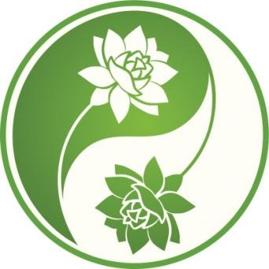

AT RICHMOND TOWN BEACH
Town Beach Road
Saturday July 11th, 18th, and 25th 9:00am - 10:00am
- Led by Certified Yoga Instructor: Linda Mitchell (413-212-2931)
- Bring your own yoga mat and water bottle.
- Donations accepted ($5-$10)
- Refreshments provided by Richmond Pond Association
- FYI: Accessible: portable restroom and benches on the grass
ALL ARE WELCOME!
Linda incorporates a variety of standing, seated and reclining postures/poses. Wherever you are, is where you begin your practice. We hope to see you there!

