**NEWSLETTER AND CURRICULUM January 2021**

Wearing a mask, it is a must!

We are asking all parents who drop off and pick up children to wear a mask when on site. This is a sensible precaution to protect you, your child, our staff and the community.

You may see some of our parents not wearing a face mask as they may be exempt. If we see you without a face mask, we may discretely ask you about this – or let us know in advance.

Pick up and Drop off – How’s it going?

Thank you to everyone for supporting our dropping off and picking up procedures including keeping to times. Drop off in the mornings is working reasonably well. A big thank you to all staff, working tirelessly to ensure the COVID-19 risk assessment and protective measures are observed and maintained constantly.

Keep warm! The scientific advice for schools is to keep fresh air circulating throughout the school. To do this we keep many of our windows open. As the weather is now turning colder, please make sure your child has several layers of clothing on to keep them nice and warm. If they have a thick fleece, jumper or cardigan that keeps them warm, they can bring that with them to school to wear as well as their nursery school jumper.

We have published plenty of advice on our website <https://www.nhs.uk/live-well/healthy-body/is-my-child-too-ill-for-school/>,

GET A TEST if The main symptoms of coronavirus are:

a high temperature – this means you feel hot to touch on your chest or back (you do not need to measure your temperature)

a new, continuous cough – this means coughing a lot for more than an hour, or 3 or more coughing episodes in 24 hours (if you usually have a cough, it may be worse than usual)

a loss or change to your sense of smell or taste – this means you've noticed you cannot smell or taste anything, or things smell or taste different to normal

Most people with coronavirus have at least 1 of these symptoms.

What do I do if I or my child has symptoms?

• Book a test

• Tell school

• Do not leave your house for any reason apart from going for a test (You may receive a fine)

• You can only stop your isolation if you have a negative test

You should try to get a test within 5 days, otherwise whoever has symptoms will have to self-isolate for the full 10 days. All other members of your household will have to isolate for 14 days from the day you started to have symptoms. They can only come out of self-isolation if the person who has symptoms returns a negative result. If you have been contacted by the Government’s Test and Trace system saying that you are a close contact, you must isolate for 14 days from the day you had contact with the close contact. The rest of your household does not have to isolate but should maintain a safe distance (if possible) and enforce good hygiene procedures. You can stop your 14 days isolation only if the other person you had close contact with gets back a negative result.

How to book a drive through or home test Visit the Government website: <https://www.gov.uk/get-coronavirus-test>

If you have problems using the online service, call 119 Lines are open 7am to 11pm. NHS COVID 19 APP We would highly recommend that everyone downloads the new NHS Covid19 App on their phones. This is a key weapon in helping us defeat the virus.

The App has many advantages including:

• Trace: find out when you've been near other app users who have tested positive for coronavirus.

• Alert: lets you know the level of coronavirus risk in your postcode district.

• Check-in: get alerted if you've visited a venue where you may have come into contact with coronavirus, using a simple QR code scanner. No more form filling.

• Symptoms: check if you have coronavirus symptoms and see if you need to order a test.

• Test: helps you order a test if you need to.

• Isolate: keep track of your self-isolation countdown and access relevant advice.

Remember: If it wasn’t for Covid, would your child be in school?

School details:

Easy Peasy Nursery, 12 Arnott Close, Off Titmuss Avenue, Thamesmead, London SE28 8BG Telephone number: 07878554042

Website: [www.fabuloustots.com](http://www.fabuloustots.com) [www.fabuloustots.co.uk](http://www.fabuloustots.co.uk)

Email: [info@fabuloustots.co.uk](mailto:info@fabuloustots.co.uk) 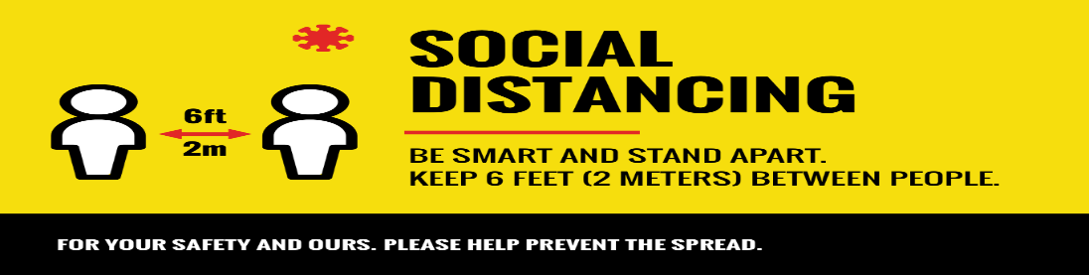

**Curriculum newsletter for Spring Term Two- 2021**

**Curriculum newsletter for Autumn Term One - 2021**

**Curriculum newsletter for Summer Term Three - 2021**

**Curriculum newsletter for Autumn Term One - 2021**

* [Sunflower Autumn term 1 - 2021 curriculum outline newsletter.pdf](https://primarysite-prod-sorted.s3.amazonaws.com/portsdownprimaryschoolandearlyyears/UploadedDocument/0710cca2aef5406ca5ddfbbc1fa36800/autumn-term-1-2020-curriculum-outline-newsletter.pdf)

**Curriculum newsletter for Autumn Term Two - 2021**

* [Sunflower Autumn term 2 - 2021 curriculum outline newsletter. pdf](https://primarysite-prod-sorted.s3.amazonaws.com/portsdownprimaryschoolandearlyyears/UploadedDocument/ee74e2acb3844e9f80b18c62bebe4445/autumn-term-2.pdf)

**Curriculum newsletter for Spring Term One 2021**

* [Sunflower Spring Term 1 - 2021 curriculum outline newsletter.pdf](https://primarysite-prod-sorted.s3.amazonaws.com/portsdownprimaryschoolandearlyyears/UploadedDocument/616e41e130114cdb99205925870f9627/caterpillars-newsletter-spring-term-1-2021.pdf)

**Curriculum newsletter for Autumn Term One - 2021**

* [Sunshine autumn term 1- 2021 curriculum newsletter.pdf](https://primarysite-prod-sorted.s3.amazonaws.com/portsdownprimaryschoolandearlyyears/UploadedDocument/27dc5fc3ad6f47ebaf85f13e6b0cb4e0/butterflies-autumn-term-1-curriculum-newsletter-2020.pdf)

**Curriculum newsletter for Autumn Term Two - 2021**

* [Sunshine autumn term 2- 2021 curriculum newsletter.pdf](https://primarysite-prod-sorted.s3.amazonaws.com/portsdownprimaryschoolandearlyyears/UploadedDocument/d431e8f4a7b54b0992bd41a27b5ba0d0/butterflies-autumn-2-curriculum-newsletter-20.pdf)

**Curriculum newsletters for Spring Term One -2021**

* [Sunshine spring term 1-curriculum newsletter.pdf](https://primarysite-prod-sorted.s3.amazonaws.com/portsdownprimaryschoolandearlyyears/UploadedDocument/85eba35c9a45460296ad96f5986d0fd2/butterflies-spring-term-1-curriculum-newsletter.pdf)

**Further activities to support home learning**

* [Nursery Home Learning - Summer term 1, 20-4-2020.pdf](https://primarysite-prod-sorted.s3.amazonaws.com/portsdownprimaryschoolandearlyyears/UploadedDocument/8f39ef867bab4423a17ed7c395f9f0fc/nursery-home-learning-summer-term-1-20-4-2020.pdf)

**Further ideas for supporting Home Learning**

* [Early_Years_Home_Learning_Collection.pdf](https://primarysite-prod-sorted.s3.amazonaws.com/portsdownprimaryschoolandearlyyears/UploadedDocument/447e3ac5501447f5bb42e4d116906999/early_years_home_learning_collection.pdf)