   **Welcome to** **Sunshine!**

**Sunshine Classroom caters for nursery children aged**

**three to four years**

**SPRING TERM - 2021**

**Welcome to EASY PEASY NURSERY**

It has been lovely to welcome children into Sunshine this spring term and to see them so settled and happy in Nursery.

Below you will find pictures of Sunshine room, and newsletters

showing what we will be doing this term.

If you have any queries about the learning, please do not hesitate

to ask your child's Key Person or email:

* info@easypeasynursery.co.uk

**January 2021, Nursery Newsletter**

[January 2021 Easy Peasy Nursery Newsletter (1).pdf](https://primarysite-prod-sorted.s3.amazonaws.com/portsdownprimaryschoolandearlyyears/UploadedDocument/408ecdc228f749938e493c985130ff59/january-2020-newsletter-1.pdf)

**Sunshine Curriculum Spring term 1 2021**

**Spring Term 2021, Curriculum newsletters**

* [Spring Term 1 - 2021 curriculum outline newsletter.pdf](https://primarysite-prod-sorted.s3.amazonaws.com/portsdownprimaryschoolandearlyyears/UploadedDocument/34277e85365d46bb9463b6d0185f1bcd/caterpillars-newsletter-spring-term-1-2021.pdf)

**Spring Term 2021, Curriculum newsletters**

[Sunshine spring term 1- 2021 curriculum newsletter.pdf](https://primarysite-prod-sorted.s3.amazonaws.com/portsdownprimaryschoolandearlyyears/UploadedDocument/159ad0b439a349359da68f6b6b3ac7e1/butterflies-spring-term-1-curriculum-newsletter.pdf)

**Autumn Term 2021, Curriculum newsletters**

[Sunshine autumn term 1 - 2021 curriculum newsletter.pdf](https://primarysite-prod-sorted.s3.amazonaws.com/portsdownprimaryschoolandearlyyears/UploadedDocument/b4bd8bae0ddd4da080c0d4c870015e68/butterflies-autumn-term-1-curriculum-newsletter-2020.pdf)

[Sunshine autumn term 2 - 2021 curriculum newsletter.pdf](https://primarysite-prod-sorted.s3.amazonaws.com/portsdownprimaryschoolandearlyyears/UploadedDocument/880bd08d728f44d7a619f722231a8e15/butterflies-autumn-2-curriculum-newsletter-20.pdf)

[SPRING 1- Let's pretend - Going on a bear hunt - curriculum newsletter.pdf](https://primarysite-prod-sorted.s3.amazonaws.com/portsdownprimaryschoolandearlyyears/UploadedDocument/8e60fb72308749eabc3f3cfa02418bb2/spring-1-lets-pretend-going-on-a-bear-hunt-curric-newsletter.pdf)

[SPRING 1-LETS PRETEND - WHATEVER NEXT, PEACE AT LAST, CHINESE NEW YEAR.pdf](https://primarysite-prod-sorted.s3.amazonaws.com/portsdownprimaryschoolandearlyyears/UploadedDocument/baa9bc721f354a04ba0188c62c658dc8/spring-1-lets-pretend-whatever-next-peace-at-last-chinese-new-year.pdf)

**If you would like further ideas to support your child to learn, then why not look at:**

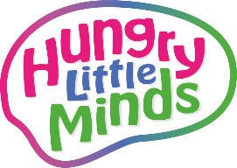Please click on the following link for further information-<https://www.easypeasynursery.co.uk/nursery-curriculum-support-information/>

There are some further links below on our class page for helping your child 's learning at home.

**Digital Resources and ideas to support online learning at home**

The links below have been suggested by the School's Library Service, we hope you will find them useful for Home Learning.

**Usborne Play and Learn at Home**

Usborne is launching Play and Learn at Home, a digital campaign to keep children stimulated during the lockdown, alongside reducing all its e-books to 99p across all platforms until the end of April.

[https://www.thebookseller.com/news/usborne-launches-play-and-learn-home-digital-hub-1198269](https://ascel.us14.list-manage.com/track/click?u=df9af6a3a267145e8657d73bb&id=47b6fa5e32&e=0b8c429f5d)

**BBC Tiny Happy People Updates**

BBC's Tiny Happy People online resources, weekly updates.

[https://www.bbc.co.uk/tiny-happy-people?dm_i=3YNL,146QV,5TQZZ5,3X7MB,1](https://ascel.us14.list-manage.com/track/click?u=df9af6a3a267145e8657d73bb&id=089bcc0d97&e=0b8c429f5d)

**Hungry Little Minds**

Simple, fun activities for kids, from newborn to five years old.

[https://hungrylittleminds.campaign.gov.uk](https://hungrylittleminds.campaign.gov.uk/)

[https://www.easypeasynursery.co.uk/nursery-curriculum-support-information/](https://www.portsdownprimary.co.uk/nursery-curriculum-support-information/)

**Websites to support home learning ideas for Nursery**

* [TWINKL -home learning website information.pdf](https://primarysite-prod-sorted.s3.amazonaws.com/portsdownprimaryschoolandearlyyears/UploadedDocument/534a973a7e4448eea6ee664c53efd117/twinkl-home-learning-website-information.pdf)
* [CBeebies](https://www.bbc.co.uk/cbeebies)Online games to play, activities to make and do and quizzes to take part in.
* [Hands on as we grow](https://handsonaswegrow.com/activities/preschool-activities/)7 Day challenge: Activities to encourage Pre-Schoolers concentration
* [Tiny Happy People](https://www.bbc.co.uk/tiny-happy-people)Help for parents and carers in developing their child's language and communication skills so they get the best start in life
* [Words for life](http://www.wordsforlife.org.uk/)Fun ideas, games and printable activity sheets for your children to enjoy
* [Small Talk](https://small-talk.org.uk/3-5-years/)Ideas for talking, playing and reading with your 3-4 year old child.
* [Net Mums](https://www.netmums.com/activities/100-activities-for-a-rainy-day)Fun activities to do while you are stuck indoors with your children
* [Change 4 life](https://www.nhs.uk/change4life/activities)Ideas for keeping healthy through fun exercises and healthy food recipes.
* [Butterflies number rhyme leaflet.pdf](https://primarysite-prod-sorted.s3.amazonaws.com/portsdownprimaryschoolandearlyyears/UploadedDocument/57ba86300c9e40239768e7fcb512ad84/butterflies-number-rhyme-leaflet.pdf)
* [Number Rap 1](http://www.bbc.co.uk/cbeebies/watch/presenters-number-rap-1)
* [Number Rap 2](http://www.bbc.co.uk/cbeebies/watch/presenters-number-rap-2)
* [The Numtums -Help your child be epic at maths!](http://www.bbc.co.uk/cbeebies/grownups/help-your-child-with-maths)

**Do you have any ideas for this page?**

**Why not let your child's Key Person know?**

**Have you seen the Kids' zone?**

**Play games and visit some cool websites.**

**You can vote for your favourites!**

School Informati**COVID-19 information**

* **We have provided information updates regarding CORONAVIRUS on our Nursery Policy page** <https://www.easypeasynursery.co.uk/nursery-policies/>
* **There are further details on the School Information** tab  <https://www.easypeasynursery.co.uk/covid-19-response/>

**Take a look at our Sunshine room and outdoor**

**GALLERY COMING SOON..**

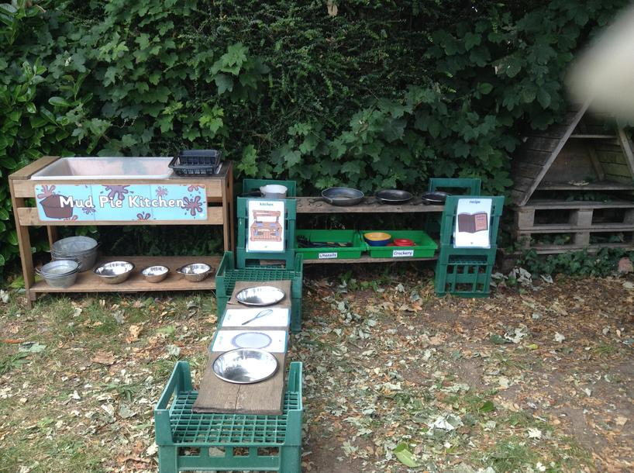

10 / 15

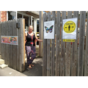

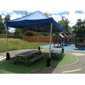

This is our mud kitchen