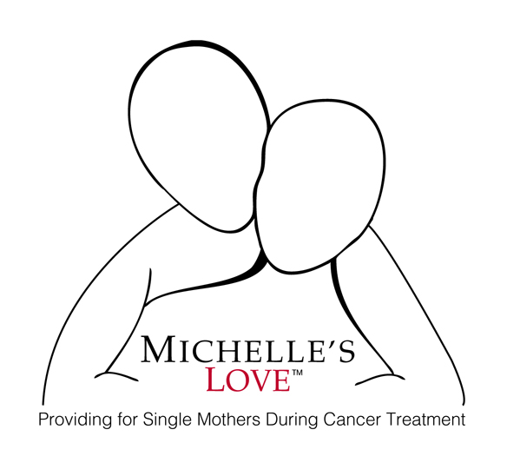

Michelle’s Love
Board of Directors Application

Thank you for your interest in joining our Board.

We are looking for members who have one or more of the following qualities

- Have a wide range of connections to the business, medical, social services and other professional communities
- Self-motivated and ready to network with friends, family, coworkers, and on social media
- Willing and able to donate and raise funds every year
- Can source new volunteers
- Can help us write grants, run booths, and attend networking groups and events to share the story of Michelle’s Love
- Open to being part a of our finance, budget, outreach and development committees.

In the past five years, Michelle’s Love has grown from an organization run by one founder and many giving volunteers into a non profit that is the recipient of significant corporate giving as well as generous, recurring personal gifts. The organization needs a strong, professional board in order to continue fulfilling the vision of supporting single parents undergoing cancer treatment and appropriately guide growth going into the future.

Name: _________________________________________________________________________________________

Contact Number:_____________________________________________________________________________

Address:_______________________________________________________________________________________

Email:_________________________________________________________________________________________

Briefly describe how you found out about Michelle’s Love and why you would like to join our Board:

_________________________________________________________________________________________________

_________________________________________________________________________________________________

_________________________________________________________________________________________________

_________________________________________________________________________________________________

_________________________________________________________________________________________________

_________________________________________________________________________________________________

Do you have any other organization affiliations, if yes what is your role?

_________________________________________________________________________________________________

_________________________________________________________________________________________________

Which of your skills would you like to utilize on our Board:

- Board Development and Governance

- Financial Management, Budgeting or Audit

- Marketing

- Fundraising

- Program Development

- Community Networking

- Volunteer Growth

- Social Media Growth

- Fred Meyer Community Rewards and Amazon Smiles Growth

- Other______________________________________________________________________

How many hours a month do you feel like you could contribute to our board:________

Can you contribute 8 hours in October and February for our Fundraisers:___________

Can you attend at least one of our volunteer opportunities annually:__________________

Can attend at least 3 of our 4 quarterly Board Meetings:________________________________

Amount you feel comfortable donating and or fundraising for annually:_______________

If you are not selected as a member of our Board , or you decide not to join, would you like to be a volunteer to assist our organization in various ways that match your skills and interests:__________

How do you want to help:___________________________________________________________________

_________________________________________________________________________________________________

_________________________________________________________________________________________________

_________________________________________________________________________________________________

_________________________________________________________________________________________________

Sign:______________________________________________________Date:_______________________________

*Michelle’s Love does solicit our database in percentage parties ie: oils, vitamins, beauty products, etc.

Mail application to:

Michelle’s Love
P.O. Box 544
Scappoose, OR 97056

