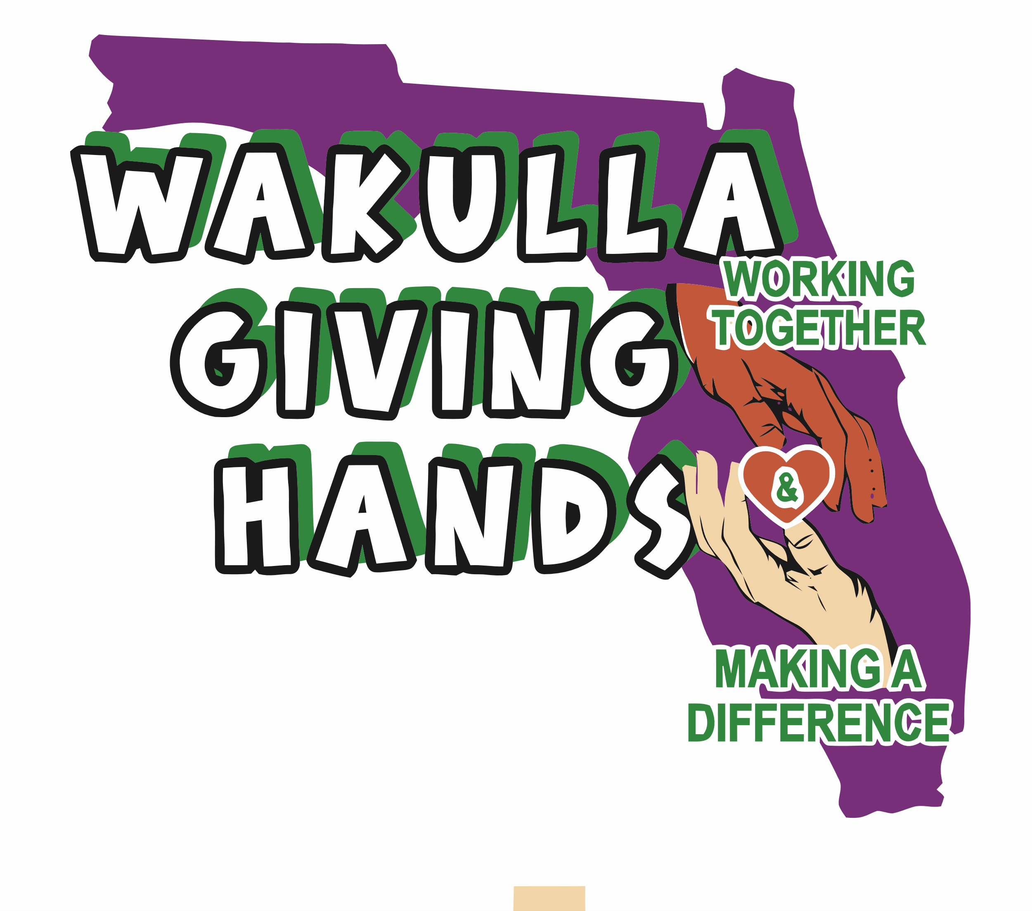

**Wakulla Giving Hands, Inc.**

EIN 93-4513010

FDACS# CH74123

6057 Natural Bridge Road

Tallahassee, FL 32305 (Mailing)

2569 Coastal Highway, Crawfordville, FL 32327 (Physical Location)

**wakullagivinghands@gmail.com**

850-661-0605 Casey Kimbrell – President

850-321-7961 Christell Wood – Treasurer

850-519-1757 Becky Whaley - Secretary

Greetings:

My name is Casey Kimbrell. I am the founder of Wakulla Giving Hands, Inc. We are a local non-profit charitable organization. Our organization aims to provide lifeline services to the homeless, seniors and families. Our mission is to serve in the assistance of food insecurity. Our organization serves Wakulla and Leon County with food, drinks, clothes, toys, personal hygiene products and other needed items.

As a new organization we need donations to make a bigger impact on serving our children, seniors, and families in the community. We are seeking to partner with your business in giving back to our kids, seniors, and families. Our organization provides for everyone in need without judgment or discrimination. We believe our efforts would reach further with your company as one of our official partners. In this role, your business or nonprofit would provide us with what you choose to give us throughout the year of 2025. From services, monetary and gift card donations, fundraising, venues, etc., in turn we would promote your company as one of our official partners.

We are requesting your company or non-profit participate by becoming a partner to help us accomplish the goals of the organization.

Wakulla Giving Hands, Inc is a non-profit under Section 501(c) (3) of the Internal Revenue Code.

With Warm Regards,

Casey Kimbrell, President