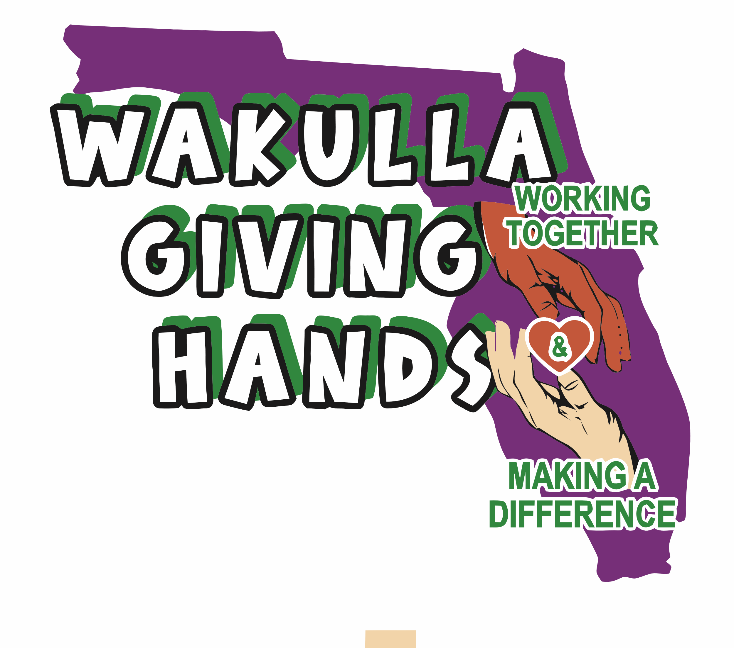

**Wakulla Giving Hands, Inc.**

EIN 93-4513010

FDACS# CH74123

6057 Natural Bridge Road

Tallahassee, FL 32305 (Mailing)

2569 Coastal Highway, Crawfordville, FL 32327 (Physical Location)

**wakullagivinghands@gmail.com**

850-661-0605 Casey Kimbrell – President

850-321-7961 Christell Wood – Treasurer

850-519-1757 Becky Whaley – Secretary

**Sponsorship Agreement 2025**

This Sponsorship Agreement is between Wakulla Giving Hands, Inc and __________________________________________________________________ (The Sponsor).

The Sponsor chose level ___________________ (Bronze, Silver, or Gold), Sponsor paid fee amount _________________ ($250, $500, $1000+) ,

In exchange for the sponsorship fee, the Sponsor will receive the following from Wakulla Giving Hands, Inc _____________________________________________________________________________     (i.e. Facebook Recognition, Banner, Etc. depending on level).

Signing this agreement gives Wakulla Giving Hands, Inc the right to advertise and use Sponsor’s logo file as needed for advertising for the 2025 year. The Sponsor understands that this agreement ends at midnight on December 31, 2025.  Either party may terminate this Agreement upon request.

**Partner Signature:** _________________________ **Date:** _______________________

**Partner Address:** _________________________________________________________

**Phone number:** _____________________________________________________________

**Sponsor’s Small Business Name: __***__________________* **Email:** ______________________

**Board Member Signature:** ____________________________ Date**:** ___________________

Wakulla Giving Hands, Inc

**Address**: ­­­­­­__________6057 Natural Bridge Road Tallahassee, FL 32305________________________

**Telephone No.**: _____850-321-7961 **Email:** [wakullagivinghands@gmail.com](mailto:wakullagivinghands@gmail.com)