**Wakulla Giving Hands, Inc.** 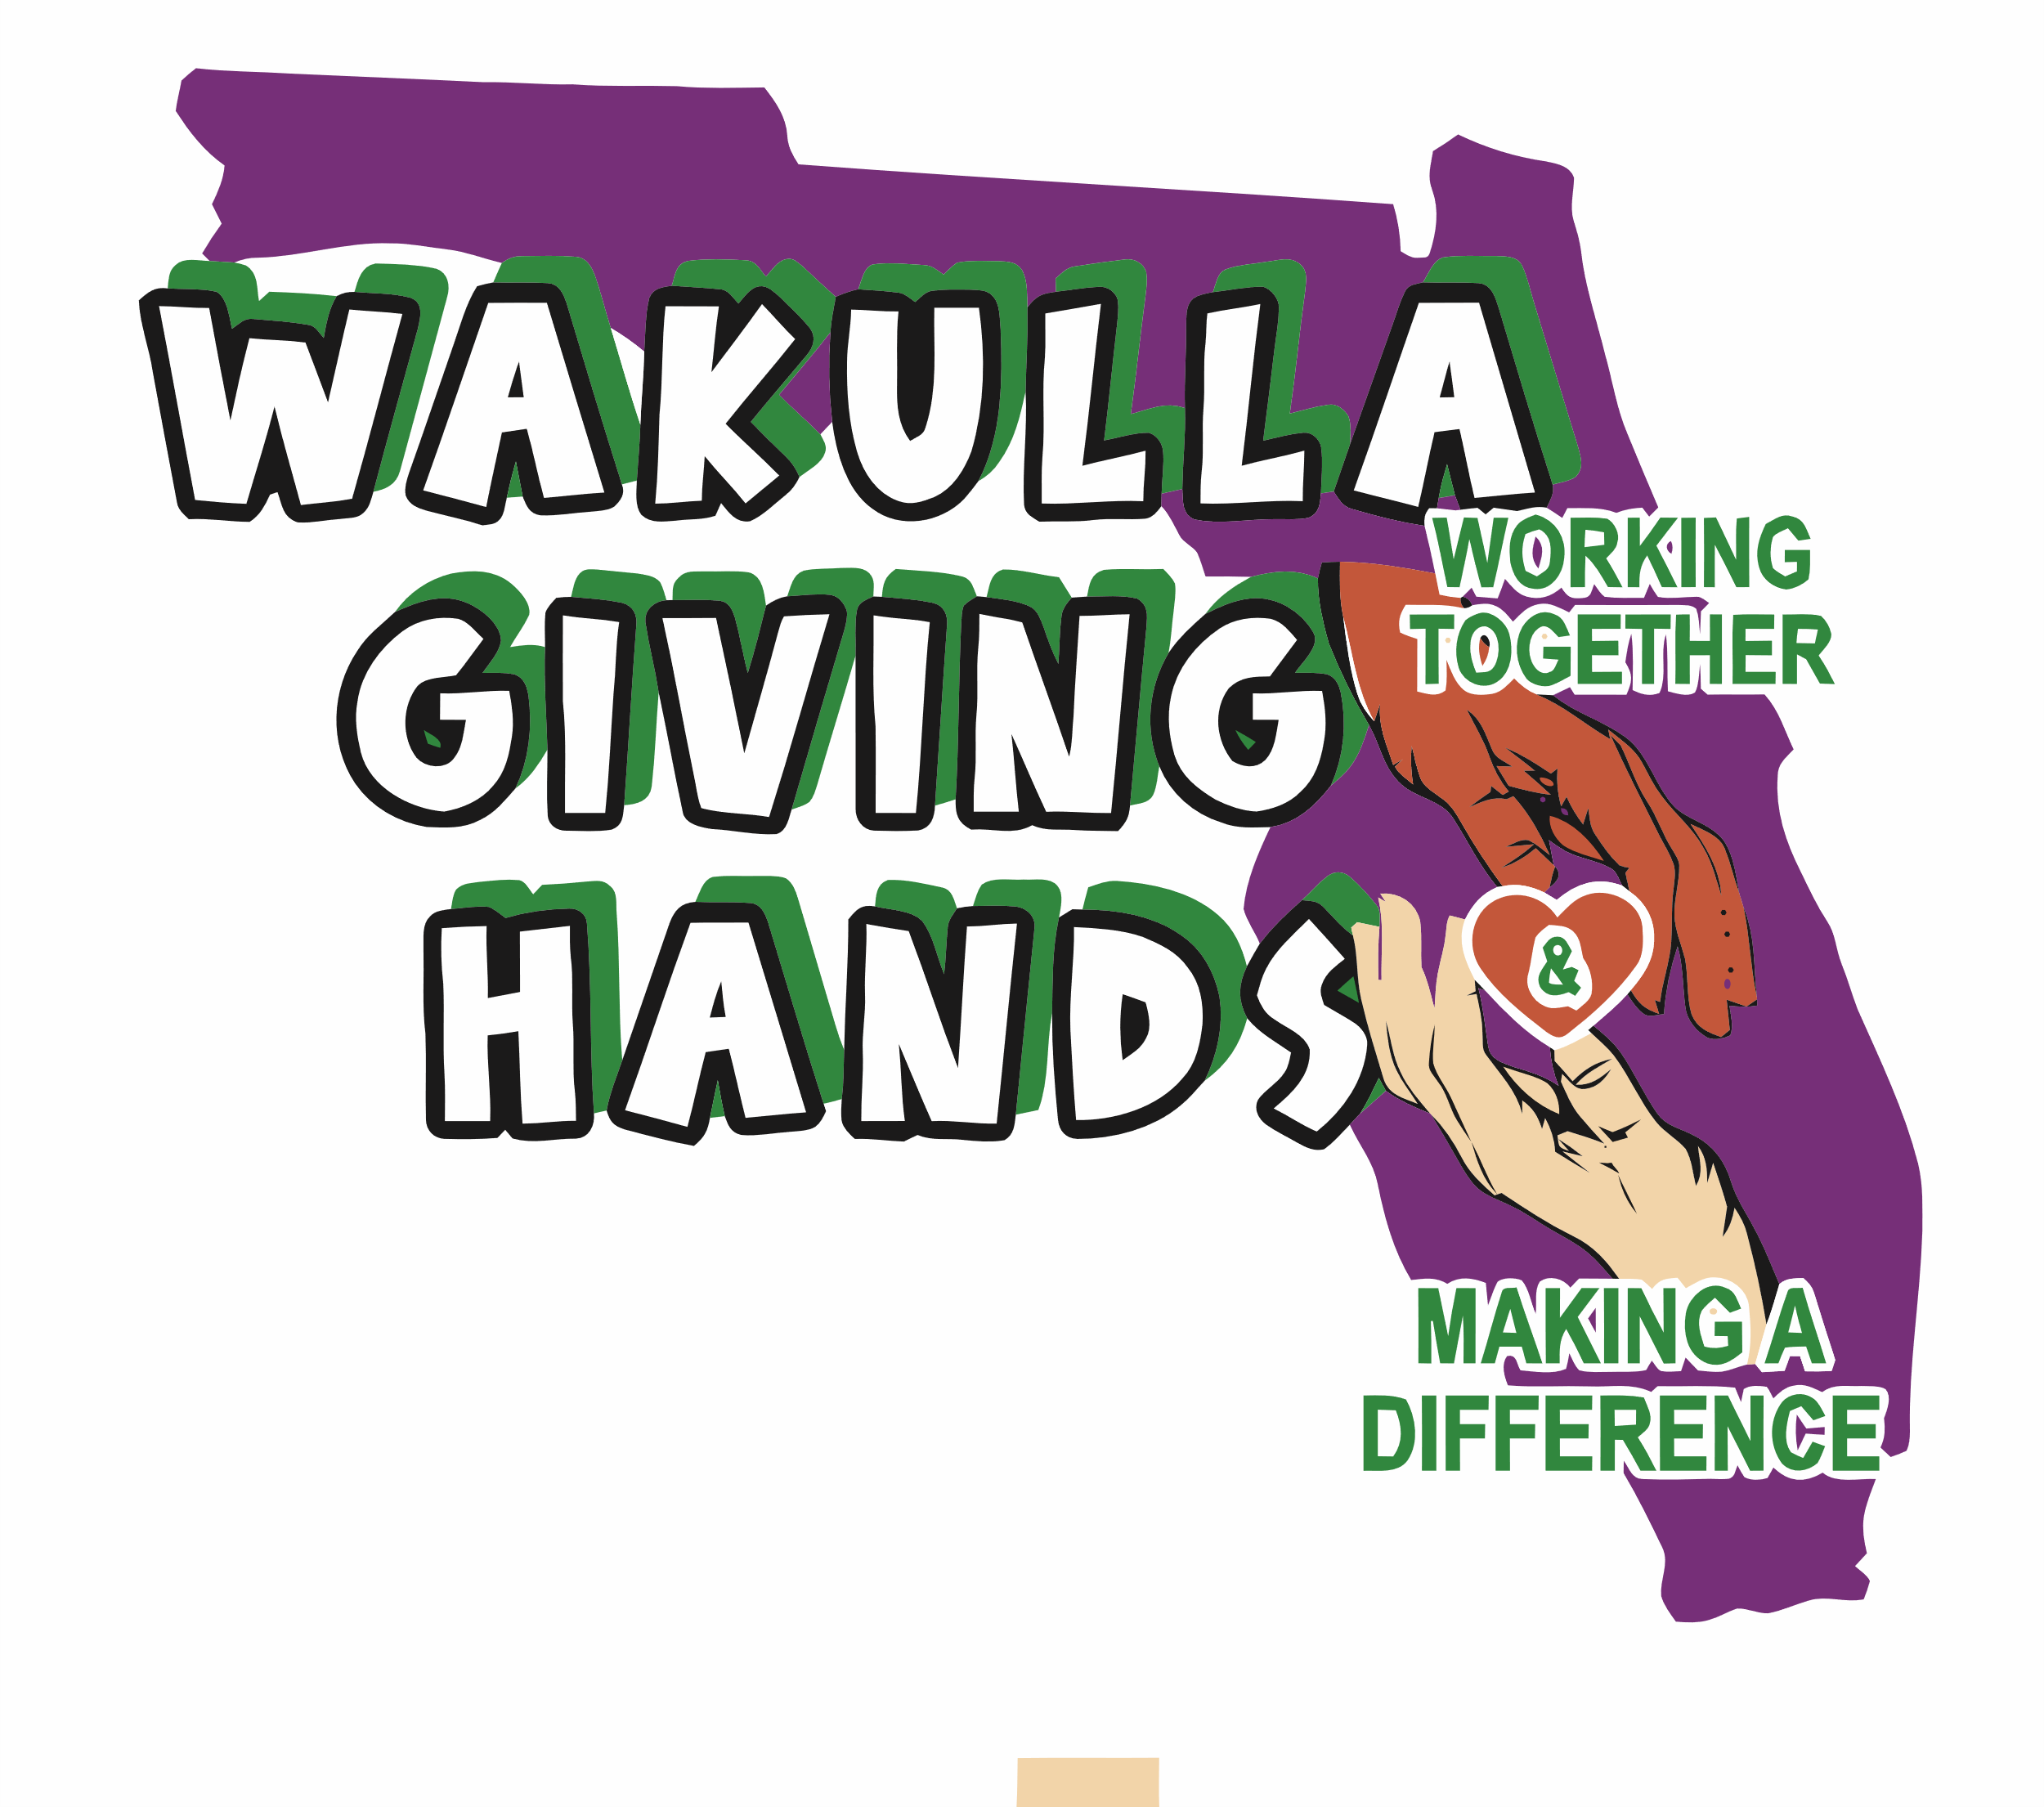

EIN 93-4513010

6057 Natural Bridge Road

Tallahassee, FL 32305 (mailing)

wakullagivinghands@gmail.com

850-661-0605 Casey Kimbrell – President

850-321-7961 Christell Wood – Treasurer

850-519-1757 Becky Whaley – Secretary

Thank you for considering sponsoring the Wakulla Giving Hands, Inc. Here is a little more information to help you pick the level best for your advertising needs and in return being able to help with a worthy cause.

**Bronze $250**

* Facebook recognition
* 5” Logo on banner, displayed at all our events

**Silver $500**

* Facebook recognition
* 5” Logo on banner, displayed at all our events
* Logo on 14 x 12-yard sign

**Gold $1000 or more**

* Facebook recognition
* 8” Logo on banner, displayed at all our events
* Logo on 14 x 12-yard sign
* Logo on t-shirt

**Diamond $2500 or more**

* Facebook recognition
* 9” Logo on banner, displayed at all our events
* Logo on 24 x 18-yard sign
* Logo on t-shirt

**Platinum $5000 or more**

* Facebook recognition
* 10” Logo on banner, displayed at all our events
* Logo on 24 x 18-yard sign
* Logo on t-shirt