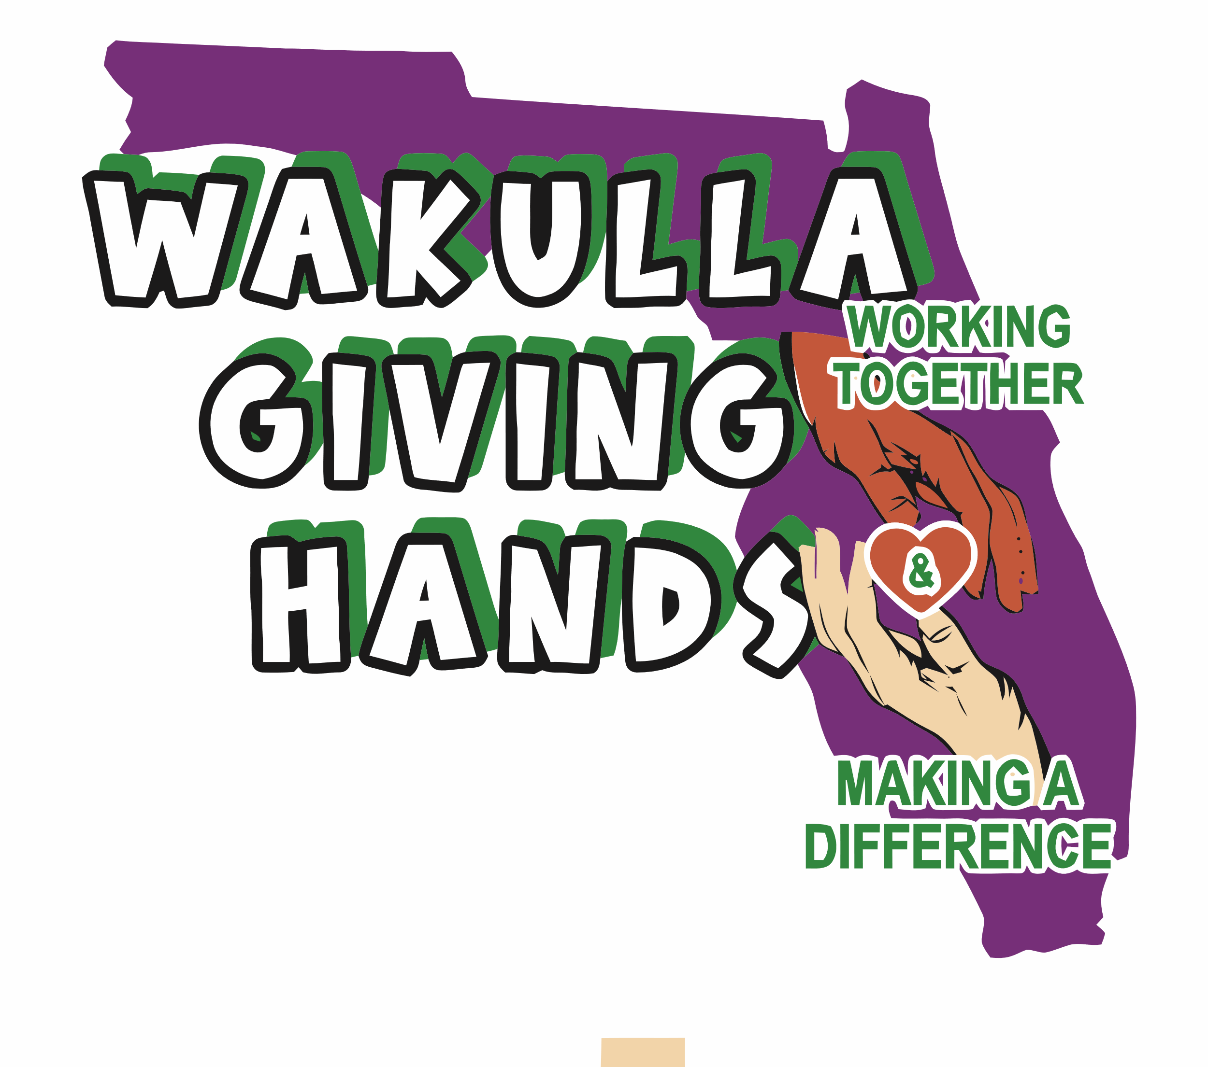

**Wakulla Giving Hands, Inc.**

EIN 93-4513010

FDACS# CH74123

6057 Natural Bridge Road

Tallahassee, FL 32305 (Mailing)

2569 Coastal Highway, Crawfordville, FL 32327 (Physical Location)

**wakullagivinghands@gmail.com**

850-661-0605 Casey Kimbrell – President

850-321-7961 Christell Wood – Treasurer

850-519-1757 Becky Whaley – Secretary

April 1, 2025

Greetings:

I am writing on behalf of Wakulla Giving Hands, Inc. We are a nonprofit organization whose mission is to aid the elderly, children, and less fortunate families in Wakulla and surrounding counties. This consists of but not limited to, aiding in major food insecurities, personal hygiene products, and household cleaning products. We are dedicated to our mission and continually strive to improve our services to better serve our Seniors, children and the less fortunate.

Currently our organization:

1. Feeds approximately 8,000 individuals monthly to include weekly home delivery to approximately seventy homebound seniors and terminally ill individuals.
2. Administers the Summer Break Spot Feeding Program for children on behalf of Second Harvest of the Big Bend.
3. Provides school Angel Closets with hygiene products and clothing when available.
4. Provides the Wakulla High School Culinary Program with needed food and paper goods.
5. Provides water, Gatorade and snacks to local sports organizations and other non-profit organizations upon request.
6. Provides food for halfway homes in North Florida aiding approximately two hundred residents.
7. Emergency response partner for Care Portal to respond to families in crisis with food.
8. Provides two yearly free events providing clothing, household supplies, hygiene products and toys to children and families.
9. Wakulla Giving Hands is a designated disaster responder by Second Harvest of the Big Bend, American Red Cross, Wakulla EOC and COAD.
10. Wakulla Giving Hands has a Backpack Program available to Wakulla County schools that provides a student found by school personnel to need food with a backpack having enough food to feed them during the week.
11. We were voted runner-up for the 2024 People’s Choice Award out of 40 possible nonprofit organizations in The Wakulla Sun nomination process (we began our full-time work with non-paid volunteers in November of 2023); other nonprofits have been in existence for decades but the people have watched our accomplishments and we receive requests for help on a daily basis.

We rely on Sponsorships and fundraisers to make all this possible.

We need you to join us in our fight against food insecurity plaquing our community as well as the entire nation at this time.

Will you join us as a Sponsor at the level you consider best for your organization? The attachment details the level of sponsorship available and describes the promotion of your company at each level.

If you have any questions, I would be happy to provide you with more information about how you can help support our work.

Your Sponsorship will have influence in the lives of countless families. Thank you for your time and consideration.

Sincerely,

Casey Kimbrell

Casey Kimbrell, President

Wakulla Giving Hands, Inc.

[wakullagivinghands@gmail.com](mailto:wakullagivinghands@gmail.com)

Attachment: Sponsorship Levels