UNIT-1
INTRODUCTION TO TEST, MEASUREMENT AND EVALUATION
Meaning of Test, Measurement & Evaluation in Physical Education, and Need & Importance of Test, Measurement & Evaluation in Physical Education, Principles of Evaluation, and Criteria of good test.

INTRODUCTION
The approach to measurement in physical education should be the terms of improved services to boys and girls. If this tenet is acceptable, the selection and use of test should be intimately related to the purposes designed to realize those purposes. Thus, tests would be utilized to and in the educational process. In certain respects, each person is unique, differing in many ways from others in background and capabilities. Physical education should understand each person’s needs in order to give adequate guidance and to adapt programs to meet those needs. Successful measurement then involves defining and evaluating the truly important outcomes of physical education – that is, the abilities, needs, and capacities of individual pupils. The appropriate use of test results should make teaching more effective.

MEANING
- To improve the physical education services to the need of children and society.
- To frame test according to the need of the society.
- To diagonite the individual differences.
- To frame work schedule according to the need of the individual.
- To judge the individual abilities for evaluation.
TEST: Find out the quality of something.
MEASUREMENT: Size or quality found by measuring.
EVALUATION: Decide how much (something) is worth.
Definition:
Test : 1. “A test is a specific tool of measurement and implies a response from the person being measured”.
- Barrow and MC Gee.
2. “Test is a form of questioning or measuring used to assists retention of knowledge and capability to measure ability in some physical endeavours”.
- Johnson & Jack Nelson.
3. “Tests are instrument designed to ascertain the quality of particular courses attributes( consider) possessed by students, teacher and the educational environment”.
- Sheehan.

MEASUREMENT
- “Measurement is an act to the evaluation process in that various tools and techniques are used in the collection of data”.
- Johnson & Jack Nelson.
- “Measurement is a evaluative procedure for collection of data. In other words, measurement is a part of evaluation, it is a quantitative procedure using tools or instruments”.
- Sheehan.
- “A measurement is the score that has been assigned on the basis of a test”.
- D. Allen Phillips and James E. Hornak.

EVALUATION
- “Evaluation is the art of judgement scientifically applied to some trait, quality or characteristic in the universe according to some predetermined standards”.
- Harold M. Barrow.
- “Evaluation may be defined as a process of appraising (judge the value) the effectiveness of the attainment of educational goals”.
- Trayer & Pace.
- “It involves making decisions or judgements about students based on the extent to which instructional objectives are achieved by them”.
- D. Allen Phillips and James E. Hornak.
- It is a continuos process of judging the effectiveness of an individual achievement.
- Unknown.

NATURE OF EVALUATION: (QUALITIES AND CHARACTERISTICS)
- To adjust the programme of physical education to the individual needs.
- To measure progress in the development of the student.
- To assess the effectiveness of teaching.
- To evaluate teaching devices.
- To predict future success of an individual.
- To diagnise the individual differences.
- To establish maximum achievement standards in physical activity.
- To classify student in to homogenous groups on the basis of motor ability, physical capacity to grade the student.
- To provide motivation and to act as a stimulus for the development and interest.
- To provide material for investigation and research.
NEED AND IMPORTANCE OF EVALUATION IN PHYSICAL EDUCATION
Unfortunately, few students clearly understand the objectives or purposes of measurement and evaluation in the typical school setting. Most students feel that the assignment of grades is the only real purpose of evaluation. This thinking is too limited; there are numerous functions that a good program of measurement and evaluation if properly understood and administered can serve.
- PLACEMENT
Before teachers began a unit of study they must assess the skill level of each student. Based on the results of the pre assessment, the teacher may want to classify students and place them into smaller homogeneous groups that will perhaps increase the rate of learning.
- DIAGNOSIS OF LEARNING PROBLEMS
Diagnostic evaluation is quite complex. It involves through testing of a particular characteristic of a student. It generally involves the formulations of a plan for corrective action.
Example: If a student continues to experience failure in the execution of a certain skill after considerable effort by the teacher, a detailed diagnostic testing procedure might be necessary. Evaluation of the tests would lead to solution of the problem and a plan for short and long term correction action.
- PROGRESS DURING INSTRUCTION
It is important for both the student and teacher to keep abreast of the students daily progress during instruction. A special type of evaluation called formative evaluation, which consists largely of self-testing exercises with continuous feed-back, is used to provide this vital information.
- ACHIEVEMENT AFTER INSTRUCTION
Evaluation for achievement at the end of an instructional unit is designed to qualify the extent that the behavioral objectives have been met by each student. This is accomplished by summative evaluation which assigns unit grades or course grades and certifies student competency interms of achievement of the behavioral objectives. Summative evaluation usually involves teacher – made unit tests or various types of standardized tests.
- DETERMINATION OF IMPROVEMENT
There are many forms of evaluation that enable the teacher to determine student improvement such as check lists of objectives, teachers made formative tests, or certain forms of unit tests administered before and after instruction.
- MOTIVATION OF STUDENT THROUGH FEED BACK
Research dealing with feedback has shown that students who are aware of how well they are performing and how much they are improving are likely to be motivated more than student who are not receiving feedback. Also, student learn more rapidly and reach higher levels of performance.
- ASSESSMENT OF TEACHING
Perhaps the best consideration when evaluating a teacher is the performance of his or her students. Learning in the classroom does not take place automatically. Teacher must understand their students as well as their own teaching strengths and weaknesses when they formulate objectives. It is then important for teachers to evaluate their own teaching performances, and it is reasonable to assume that evaluation of individual student performance is a good process of determining teacher effectiveness.
- ASSESSMENT OF A CURRICULUM
Curriculum planning is a complex process involving the input of administrators, teacher, students, and parents. Ongoing measurement programs contribute a great deal to this planning process. New courses might be added or less useful ones deleted from the curriculum based on the performances of students on summative evaluation instruments such as unit tests or standardised tests.
- PREDICTION OF FUTURE SUCCESS
Evaluation can be used to predict a student’s future success in a specific area or skill. There are many similarly of this purpose to that of placement because present status is a particular skill area is used to predict future success in that same area.
- DEVELOPMENT OF NORMS
Norms represents the achievement level of a particular group to which obtained scores can be compared. The development of norms involves administering tests, assigning measures, and then transforming the raw score measures into a new set of scores. The norms or transformed scores are then used by teachers to make important and meaningful judgment about the students taking the test.
- RESEARCH TOOL
Physical education provides many opportunities for conducting valuable basic and applied research. Research is involved in the solving of complex problems. In most instances the problem solving procedure involves the administration of one or more specific tests. Research provides the physical education with evidence for selecting activities, methods of instruction, measuring instrument and measurement techniques.
CRITERIA OF A GOOD TEST: Before constructing a test or even considering selecting one from the many already completed and in print, the instructor must have the tools that will enable him to determine which instrument is best for the particular purpose.
Physical education teacher have to question themselves in the following ways.
- Why give a test?
- What information is needed?
- What use will the result be put?
- Does the test measure the quality for which it is to be used? (validity).
- Can the test be administered accurately? (Reliability, objectivity).
- Can the test scores be interpreted in terms of relative performance? (Norms, objectivity).
- Is the test economical? (cost of instrument, economy and time).

MEANING
Criteria of good test:
- a principle or standard a thing is judged.
- the rule or example by which something is measured or valued.
- a means or standard of judging; a test; a rule, standard.

IMPORTANCE
- To formulate a test, there must be certain criteria which may be used as guide.
- To avoid inaccurate measuring tools, that may lead to dangerous misleading conditions.
- In human organism factors offecting are many in which some are easy to measure and some are very difficult.
- Major decisions and conclusions may not be drawn by using single test.
- In order to make satisfactory selection of the test, the teacher should select available tests in terms of scientific authenticity.

PRINCIPLES OF EVALUATION
- Determining and clarifying what is to be evaluated always has priority in the evaluation process
- Evaluation techniques should be selected according to the purposes to be served
- Comprehensive evaluation requires a variety of evaluation techniques
- Proper use of evaluation techniques requires an awareness of both their limitations and strengths
- Evaluation is a means to an end, not an end itself

GENERAL EVALUATION CRITERIA

SCIENTIFIC AUTHENTICITY ADMINISTRATIVE FEASIBILITY EDUCATIONAL APPLICATION
- Validity - Economy - Test
- Reliability - Feasibility - Knowledge
- Objectivity - Cost - Skill
- Norms - Time - Techniques
- Duplicate form - Facilities - Tactics
- Standardised direction - Fitness component
- Social and psychological factor
- Rules interpretation.
SCIENTIFIC AUTHENTICITY (Scientific approach)
1. VALIDITY: (Well grounded or framed).
Definition: 1. “Validity refers to the degree to which a test measures what it was designed to measure”
- J.K. Nelson.
2. “Validity may be defined as how well a test measures what is claims to measure”
- Charles A. Bucher.
- A test is said to be valid when it measures exactly what it purpose to measure.
- It is meaningless to use a test to measure something for which it is not intended.
Exam: If we wish to know his/her temperature, we use to thermometer that measures heat.
2. RELIABILITY (Consistent, quality)
Definition: “Reliability may be defined as the consistency of measurement on the same individuals or group under the same conditions, and by the same person”
- Charles A. Bucher.
2. “The term reliability refers to the extent to which it gives consistent result on testing and re-testing”
- Frank S. Freeman.
- A reliable test must give the same result when repeated with the same group.
- Consistency (agreement) of the result must be maintained if the test is a reliable one.
- A highly reliable test yields the same or approximately the same scores when administered twice to the same individuals, provided conditions and subjects are essentially the same.
- OBJECTIVITY (Consistency)
Definition: 1. “We can define objectivity as the close agreement between the scores assigned to each subject by two or more judges”
- Baumgarther.
2. “Objectivity is the degree to which the test or technique can be given by different individuals and obtain the same result”
- Charles A. Bucher.
- If the test is scored by two instructors together or independently the results should be similar.
- Objective test is one in which no disagreement occurs among competent persons in scoring any given subject while using the same test.
- NORMS
Definition: 1. “Norms are derived scores that are determined from the raw score obtained by a specific test”
- Margaret.
2. “A norm is a scale that permit conversion from raw score to a score capable of comparisons and interpretations”.
- Harold M. Barrow.
- A norm is a standard to which an obtained score may be compared.
- Norms are representations of some large population for whom the tests are intended.
- DUPLICATE FORM
- It involves two forms of a test, measuring a particular elements.
- Two types of test to measure same component.
Example: 50 mts or 75 mts Run test to measure speed. Two types of model question papers in written examination.
- This type of evaluation normally applicable in written examination test.
- STANDARDIZED DIRECTION
- Uniformity must prevail in the method of scoring, evaluation and administration.
- Test are administered by different people in the different places. Standard administrative procedure will help them in smooth conduct of the test.

II. ADMINISTRATIVE FEASIBILITY
- Test should be simple and straight forward. There must be capable of speedy administration, saving of time, in-expensive and simple in administration.
- A way of spending less money.
- Completion of the test administration in a minimum possible time.
- It includes less cost, availability of equipment and time to administer.

III. EDUCATIONAL APPLICATION
- Test should be framed scientifically and applied to the students.
- Tests are: skill test, fitness test, knowledge test, Technique and Tactical evaluation tests etc.
- It should be frame according to the age, sex, ability and need of the society.
Unit-2
Classification and administration of test
Classification of Tests, Administration of test: Pre, during and post test, Methods of Scoring test.
Classification of tests
- Motor ability tests
- Physical fitness tests
- Physical capacity tests
- Physical efficiency tests
- Physical intelligence tests
- Strength tests
- Proficiency tests
- Achievement tests
- Knowledge tests
- Technique tests
- Decathlon tests
- Skill tests
- Practice tests
- Age norms (names for tests)
- Tests of physiological condition
- Anthropometric tests
- Badge tests

ADMINISTRATIVE PROCEDURE
Definition: “Administration is the process of managing or conducting a programme of activities”. - William L. Hugher.
A successful measurement and evaluation program depends on an adequate preparation of the teacher in the evaluation and selection of tests and in the knowledge and techniques concerning organization, administration, and interpretation of testing programs. Efficient test administration provides maximum accuracy for valid and reliable results and insures that time has been used to the best advantage. In addition, if the collected data are to have significance and value, the teacher must be able to interpret to the appropriate people the meaning of those data.
Efficiency and management in testing are the result of careful step-by-step planning and preparation. There must be an understanding of the techniques to be used and a competence in the actual administrative procedures along with proper utilization of space and time, effective use of leadership, and an adequate follow-up process.
The very nature of testing requires supervision by highly qualified personnel. Test results are only as valid as the basic data have been collected through testing techniques. Tests carelessly administered, or tests administered to a group of students who are not motivated, provide results that may have little significance or value. Student have not been tested until they have given maximum effort.
Test administration procedures and suggestions are listed in three categories, they are.
- Advanced preparation.
- Duties during testing.
- Duties after testing.
- ADVANCED PREPARATION
Testing, like any other educational procedure, requires careful and sometimes precise planning ahead of time. Following is a list of suggested considerations for making preplanning more efficient.
- Selection of the appropriate test.
- Knowledge of the test.
- Equipment and facilities.
- Court and marking, equipment, material etc.
- Preparation of score cards.
- Class Roll sheet, Individual scorer card.
- Preparation of standardized direction.
- Preparation of the testing area.
- Selection of organisation and administration procedures.
- Mass testing, individual testing.
- Scoring.
- By Instructor, By Parties, By trained testers.
- Orientation of students.
- Training of student leaders and scorers.
- DUTIES DURING TESTING
Once the advanced preparations have been made in a through manner, the teacher can move in to the testing period with a great deal of confidence that the procedures will move efficiently. However, some important considerations must still be emphasized during the testing period itself. They are,
- Last-minute check.
- Explanation.
- Demonstration.
- Warm-up and practice.
- Administration.
- Motivation.
- Safety.
- DUTIES AFTER TESTING
At the end of the testing period a number of considerations should be concern to test administrators. Some of these are immediate and some may be performed more at leisure. Therefore, the sooner all of these suggested steps can be implemented, the more effective the test results will become.
- Collecting score cards.
- Converting Raw scorers for interpretation of data.
- Comparing Test results with norms and constructing a profile for evaluation.
- Constructing Norms and standards, if not constructed already.
- Evaluation of Results.
- Using results and formulating follow procedures.

UNIT -3
PHYSICAL FITNESS TESTS
AAHPER youth fitness test, JCR test, Cooper’s 12 minute run/ walk test, Harward Step test, Indiana Motor Fitness Test, Barrow motor ability test.

AAHPERD YOUTH FITNESS TEST
American alliance for health, physical education, recreation and dance.
ESTABLISHED: American Association for Health, physical education and recreation in 1958, U.S.A.
PURPOSE: To measure status and achievement in the physical fitness objective.
AGE GROUP: Boys and Girls between 7 to 17 years of age.
FACILITIES: 400 mt track, stop watch, Basket Ball court, Horizontal Bar.
PROCEDURE: Two tests periods are necessary for the administration of all items. Test consists of the following items.
Test Item Components to measure Sex
1. Pull-ups Arm and shoulder gridle strength B
2. Flexed arm hang Arm and shoulder gridle strength G
3. Sit-ups (Bent knee) Abdominal Muscle Endurance B/G
4. Standing Broad-jump Leg strength B/G
5. Shuttle Run Agility, speed B/G
6. 50 yards Run (46 Mts) Speed B/G
7. 600 yards Run (546 Mts) Endurance B/G
During the first period the pull-ups, sit-ups, standing Broad-Jump and shuttle run, in the second session 50 yards run, 600 yards run or walk or 1-mile or 9-minutes run for 10-12 years of age, or the 1½ mile or 12 minutes run for 13 years and above age will be conducted.

SCORING: Each test item is formulated the scoring procedure for different age group. Norms have been developed by using percentile for the different age groups

TEST DESCRIPTION
1. PULL-UP (For Boys)
PURPOSE: To measure arm and shoulder girdle strength.
FACILITIES: Horizontal Bar approximately. 1½" in diameter is placed at a convenient height. The bar is adjusted to such height that the student can hang free of the floor.

PROCEDURE: The bar is adjusted to such height that the student can hang free of the floor. The student should grasp the bar with his palms facing away from his body (overhand grasp). The student should then raise his body until his chin is over the bar and they lower it again to the starting position with his arms fully extended.

AAHPERD YOUTH FITNESS TEST
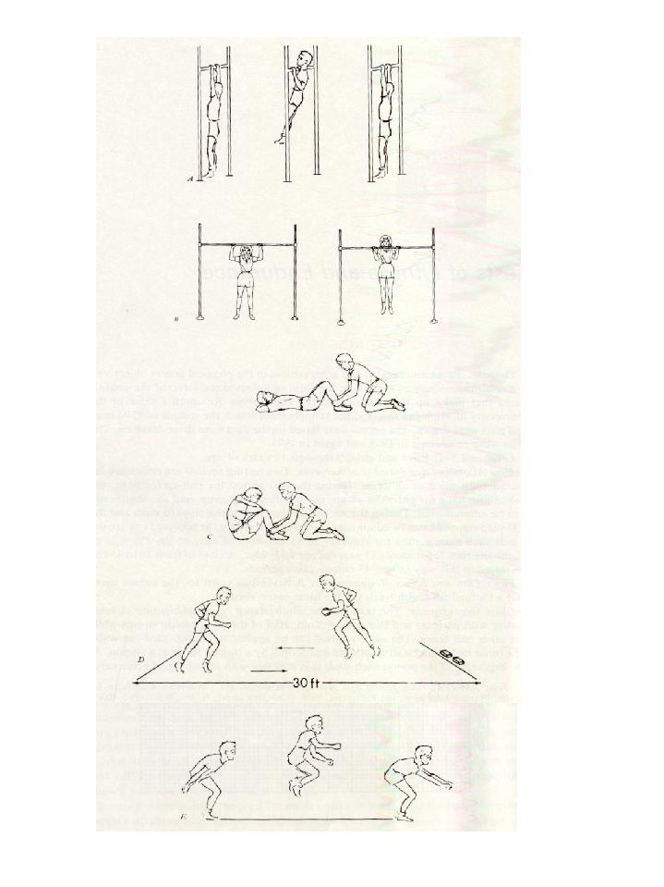
INSTRUCTIONS: Subject should not lift his knees or assist your pull-up by kicking. You must return to the hang position with the arms fully straight. You will not be permitted to swing or snap your way up.
STANDING BROAD JUMP
PUSHUPS
FLEXED ARM HANG
SIT-UPS
SHUTTLE RUN

SCORING: One point is scored each time the student completes a pull-up. Part scores do not count and only one trail is permitted.

TESTERS: One trained tester can administer the item to count the scores, and record the results.
2. FLEXED – ARM HANG (For Girls)
PURPOSE: To measure arm and shoulder strength.
FACILITIES: Same as in pull-up test.
PROCEDURE: Student should grasp the bar with a over hand grasp. She then raises her body off the floor with the help of assistants to a position where the chin above the bar. The elbows should be flexed and the chest should be close to the bar and go for ‘hang’ position as long as possible. The stop watch is started as soon as the subject assumes the starting position and is stopped when the students drop from the position.
INSTRUCTION: It is violation if your chin to touches the bar or fall below the bar.
SCORING: The score is the elapsed time to the nearest second that the subject maintained the proper hanging position.
TESTERS: Same as in put-up test.
3. SIT-UP (Bent knee sit-up):
PURPOSE: To measure abdominal strength and endurance.
FACILITIES: Plain floor.
PROCEDURE: The student lies flat on the back with knee bent and feet on the floor with the heels not more than one foot from the buttocks. The fingers are interlocked and placed behind the neck with the elbows touching the floor. The feet are hold securely by a partner. The students then curls up to a sitting position and touches the elbows to the knees. This exercise is repeated as many times as possible in the time requirement.
INSTRUCTIONS: Your fingers must remain interlocked and in contact with the back of your neck at all times. When you return to the starting position, your elbow must be flat on the floor or mat.
SCORING: One point is scored for each correct sit up. The score is the maximum number of sit-ups completed in 60 seconds.
TESTERS: Same as in pull-up test.
4. SHUTTLE-RUN:
PURPOSE: To measure speed and agility.
FACILITIES: Two lines parallel to each other are placed on the floor 30 feet apart. Two blocks of wood, 2 /4 inches and a stop watch.
PROCEDURE: The student stands at one of the lines with the 2 blocks at the other line. On the signal to start, the student runs to the blocks, taken on, and returns to the starting line, and places the blocks behind that line, then return to the second block which is carried across the starting line on the way back. Two trails are permitted.
INSTRUCTIONS: On the signal to “Go” run as fast as you can to the next line and pick up a block. You should return the block over the second line where you place it on the floor. Do not throw it.
SCORING: The score is the elapsed time recorded in seconds from the best of 2 trails.
5. STANDING LONG-JUMP
PURPOSE: To measure power.
FACILITIES: Plain floor or outdoor jumping pit and measuring tape.
PROCEDURE: The student stands behind a takeoff line with his feet in a shoulder width distance. Before jumping, the student dips at the knees and swings the arms backward. He then jumps forward by simultaneously extending the knees and swinging the arms forward. Three trails are permitted.
INSTRUCTIONS: Subject must takeoff from both feet simultaneously and land on both feet. Not to fall backward after the landing.
SCORING: The score is the distance between the takeoff line and the nearest point where any part of the subject body touches the floor. It is measured in feet and inches to the nearest inch. Only the best trail is recorded.
TESTERS: One trained tester, judge and record scores.
6. 50 – YARDS RUN:
PURPOSE: To measure speed.
FACILITIES: A standard 50-yards distance with starting and finishing lanes. Two stop watches.
PROCEDURE: After a short warm-up the student takes a position behind the starting line. Best results are obtained when more than one student run at the same time for completion. The starter uses the command “Ready Go”. The student run across the finishing line. One trail is permitted.
INSTRUCTIONS: On the command “Ready Go” subject has to run as fast as possible towards the finish line.
SCORING: The score is elapsed time to the nearest second between the starting signal and the instant the student crosses the finish line.
TESTERS: One starter, one or more timers for record.
7. 600 – YARDS RUN OR WALK
PURPOSE: To measure endurance.
FACILITIES: A standard track, stop watch.
PROCEDURE: Students may run individually or in groups, complete 600-yards on the track and finish at the finishing line.
INSTRUCTION: Complete 600-yards running and maintain the pace up to the end.
SCORING: The score is the elapsed time in minutes and seconds.
TESTERS: Trained tester, starter, one or more timers and recorder.

JCR MOTOR FITNESS TEST:
Jumping, chinning and running Test.
ESTABLISHED: Bernath E Phillips, 1947.
PURPOSE: To find out the fundamental motor performance.
AGE GROUP: College men, high school children.
PROCEDURE: Test consist of 3 items.
- Jumping (vertical jump) to measure leg power.
- Chinning (pull-up) to measure Arm and shoulder gridle strength
- Running (100 yards shuttle Run) to measure speed and agility.

TEST DESCRIPTION
- JUMPING (VERTICAL JUMP): Same as in Indiana Motor Fitness Test.
- CHINNING (PULL-UPS): Same as in AAHPERD youth fitness Test.
- RUNNING (SHUTTLE RUN):
PURPOSE: To measure basic elements of speed and agility.
FACILITIES: Plain floor, mark two parallel lines at the distance of 10 yards, stop watch and scorer.
PROCEDURE: The student stands with feet behind the starting line. On the signal “Ready Go” subject runs as fast as possible between the 10 yards lines 5 times covering 100 yards. Scorer should count each trip as the runner completes it.
INSTRUCTION: At the time of starting, stand behind the starting line. For signal ‘Ready Go’ run 5 times as fast as possible between 10 yards lines to cover 100 yards..
SCORING: The score is the elapsed time to the nearest second that it takes the student to run 5 times covering 100 yards.
TESTERS: One trained person, scores and time keeper.
COOPER TEST (12 MINUTES RUN/WALK)
Established: Kenneth H. Cooper in 1977.
PURPOSE: To measure cardio-respiratory endurance capacity.

AGE GROUP: High school Boys, Girls and College Men.

FACILITIES: An outdoor 400 mts. Standard track. Place1 feet height flags at every
40 mts on the track. Testing personels, stop watch, and score cards..

PROCEDURE: At a time 10 students will be running at a signal ‘set Go’. Lap scores is instructed to count the number of laps that are run within the allotted time 12 minutes. When 11 minutes have elapsed, the instructions call out the time left to run. At the end of 12 minutes, the instruction blows a long whistle and the runner/lap scorer note the flags have just passed in the last lap..

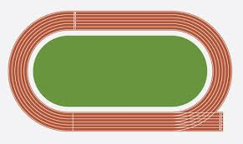

COOPER TEST 400 MTS TRACK MEASUREMENT

SCORING: The lap scorer records the subject number of completed laps has run + number of flags passed on the last lap at long whistle.
Example: If a student completed 4 laps + 5 flags, it measures the running distance as follows.
- 400 mts x 4 laps + 40 mts x 5 flag.
- 1600 mts x 200 mts = 1800 mts.
- Covered distance in 12 minutes = 1800 mts.

NORMS: Norms are fixed for High school Boys, Girls and College Men.

HARVARD STEP TEST
Established: Brouha in 1943.
Purpose: To measure cardio-respiratory endurance capacity and adaptation and its recovery from the hard work.
Age Group: College Men, modified tests are constructed for college women, boys and girls.
Facilities: 20 ft. Bench or plat form, stopwatch, testers and score cards .

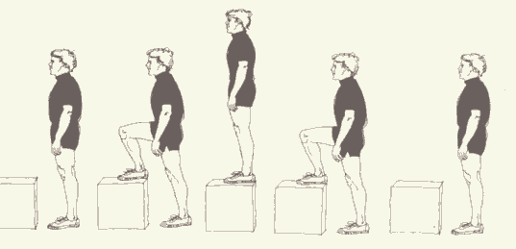
PROCEDURE: Subject steps up and down 30 times a minute on the bench. Each time the subject should step all the way up on the bench with the body erect. The stepping process performed in four counts as follows, 1234 or up, up, down, down. Subject may lead with either foot and can change after four counts is completed. Stepping exercise continues for exactly 5 minutes, unless subject is forced to stop sooner because of exhaustion. As soon as he stops exercising, subject relax and pulse rate are counted after one minute rest. The pulse rate is counted in 1-½, 2 to 2½ and 3 to 3½ minutes, i.e. 30 seconds in each time.

HARVARD STEP TESTSCORING
Physical efficiency Index (PEI) is computed utilizing the following formula.
PEI = | Duration of exercise in seconds x 100
PEI = | 2 x sum of pulse counted in recovery
Example: If a subject completed his exercise 5 minutes i.e. 5 x 60 seconds, it measures 300 seconds. His recovery period, pulse count were 75 for 1-½, 50 for 2-2½ and 35 for 3-3½ minutes i.e. the sum of 160.
Substituting the formula = | 300 x 100 | = | 3000 | = | 94
Substituting the formula = | 2 x 160 | = | 320 | = | 94
- NORMS:

Physical condition PEI
Excellent Above 90
Good 80-90
High Average 65-79
Low Average 55-64
Poor Below 55

INDIANA MOTOR FITNESS TEST
ESTABLISHED: C.C. Franklin and N.G. Lehsten in 1943 and reestablished in 1944 and 1948.
PURPOSE: To measure basic Motor fitness ability.
AGE GROUP: College men, High school Boys and Girls and elementary school children.
TEST ITEMS: The test items for elementary and high school boys and girls are 1. Straddle chin, Floor push ups Vertical jump, and Squat trust in twenty seconds. For college men, the items are Pull-ups or straddle chin, Floor push-ups, and vertical jump or standing broad jump.

TEST DESCRIPTION
- STRADDLE CHIN
PURPOSE: To measure shoulder strength.
FACILITIES: Plain Floor.
PROCEDURE: With individuals paired by approximate height, the subject being tested lies on back grasping hands (finger hold) of partner, who is in stidle-stand position with body erect, the subject ‘chins’ as many times as possible, raising the body each time with back straight and in time with legs until it meets firm resistance from inside partner thigh.
SCORING: One point scored each time the student completes “chin”up.
TESTERS: One trained tester and scores.
- FLOOR PUSH-UP
PURPOSE: To measure arm strength endurance.
FACILITIES: Plain Floor.
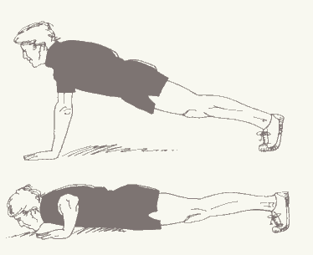
PROCEDURE: The student takes a front leaning rest position with body supported on hands and balls of feet, the arms are straight and at right angles to the body. He then dips or lowers the body so that the chest touches or nearly touches the floor, then pushes back to the starting position by straightening the arms, and repeats the procedure as many times as possible.

PUSHUPS
INSTRUCTIONS: In performing floor push-ups, only the chest should touch the floor; the arms must be straight with each pushup; the body must be held straight throughout.
SCORING: Scoring consists of the number of correct pushups.
- VERTICAL JUMP (Sargent jump)
ESTABLISH: Dr. Dudley A. Sargent, 1921-USA.
PURPOSE: To measure leg power.
FACILITIES: A jump board about two feet wide and five feet long, marked with horizontal lines one centimeter or one inch apart is fixed to the wall, and chalk powder.
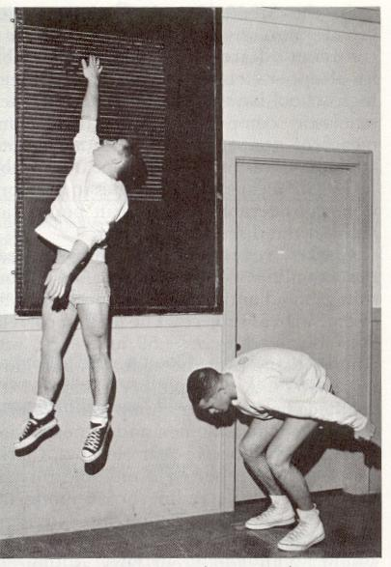
PROCEDURE: It consists of a vertical leap into the air. In this jump, the individual swings his arms downward and backward, taking a crouch position with knees bent approximately to a right angle. The distance between standing height and the top of the head at the height of the jump is recorded. Three trails are permitted, and the best of three trails are consider for evaluation.
INSTRUCTIONS: The specific arm movements in executing the jump are extremely important.
SCORING: The distance between the two marks i.e. standing height and maximum jumping height is recorded. Power evaluation can made by using the following formula.
Work = | Body weight (lbs) x Distance jumped (inc)
 | 12
- SQUAT TRUST (FOUR COUNT BURPEE TEST)
PURPOSE: To measure agility and speed.
FACILITIES: Plain Floor and a stop watch.
PROCEDURE: Subject starts the exercise in a standing position
Position .1: Subject goes to a full squat position placing both hands on the floor about shoulder width apart in front of his feet.
Position. 2: Trusts both legs backward to a front leaning rest position with the body resting on both hands and toes and approximately straight from shoulders to feet.
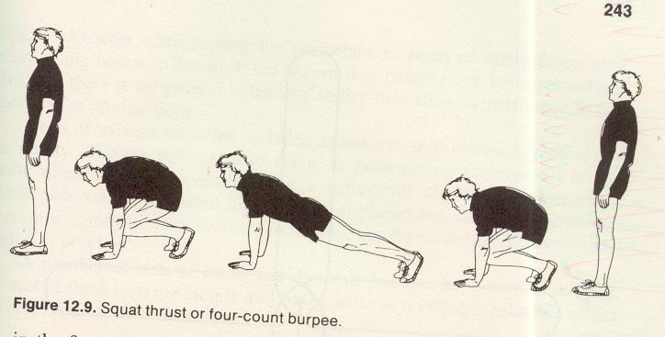
Position. 3: Returns to the full squat position.
SQUAT TRUST
Position. 4: Then the subject stands erect.
INSTRUCTION: Subject must reach the full squat position before your legs are trust backward. Your back should be kept straight in this front leaning rest position. You must come to an upright position with the body in a straight line at the hips. You cannot rest between any of these movements.
SCORING: The score is the number of complete repetitions correctly executed in 20 seconds.
5. PULL-UPS: Same as in AAHPERD fitness test.
6. STANDING BROAD JUMP: Same as in AAHPERD Fitness test.

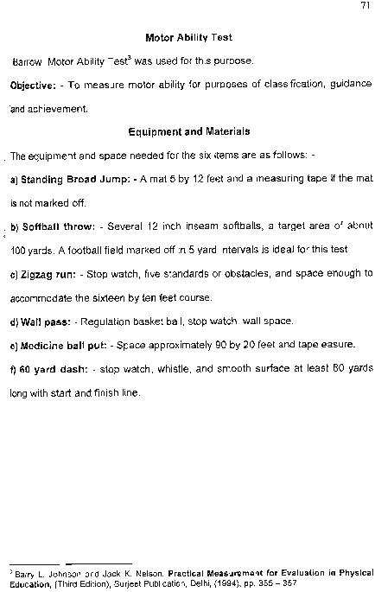

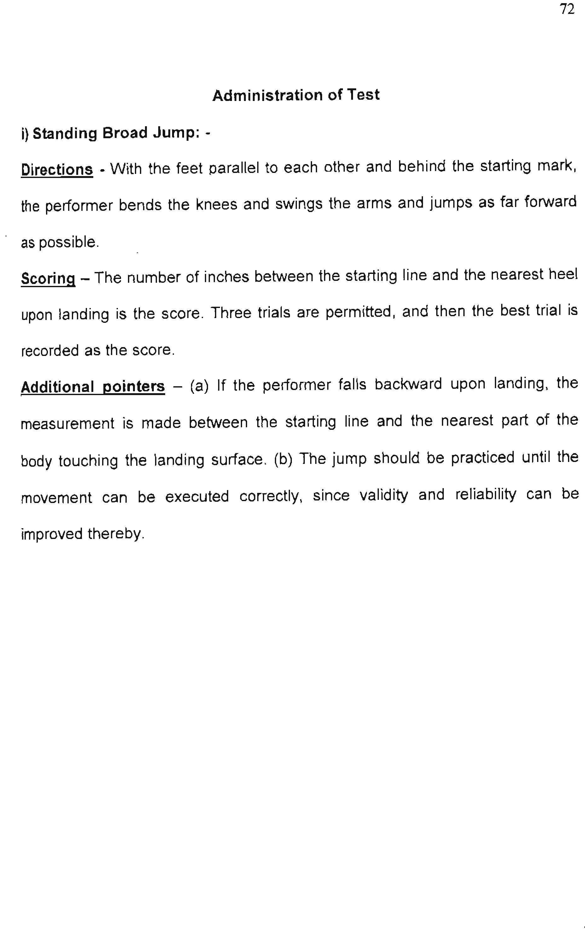

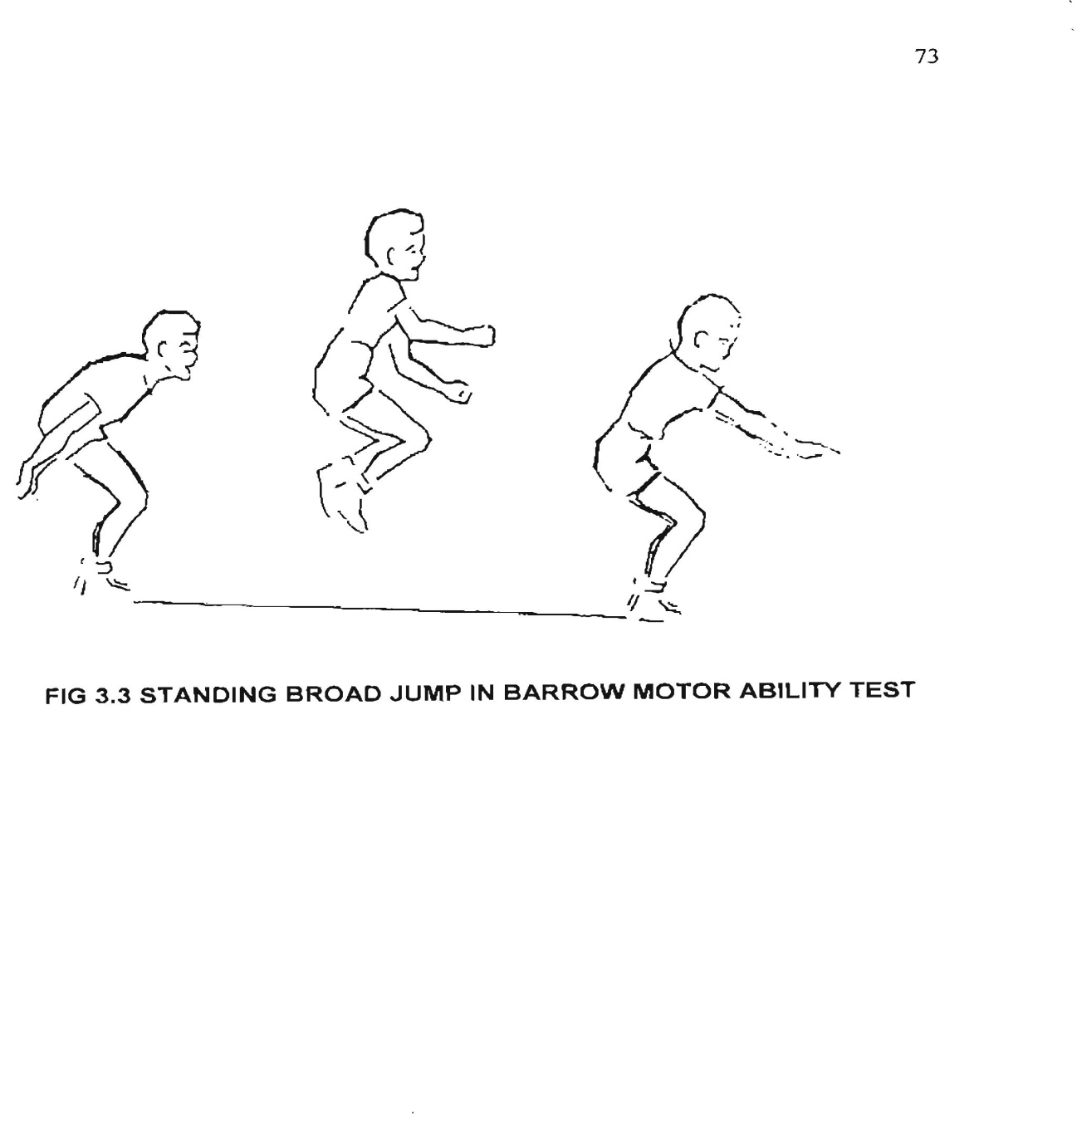

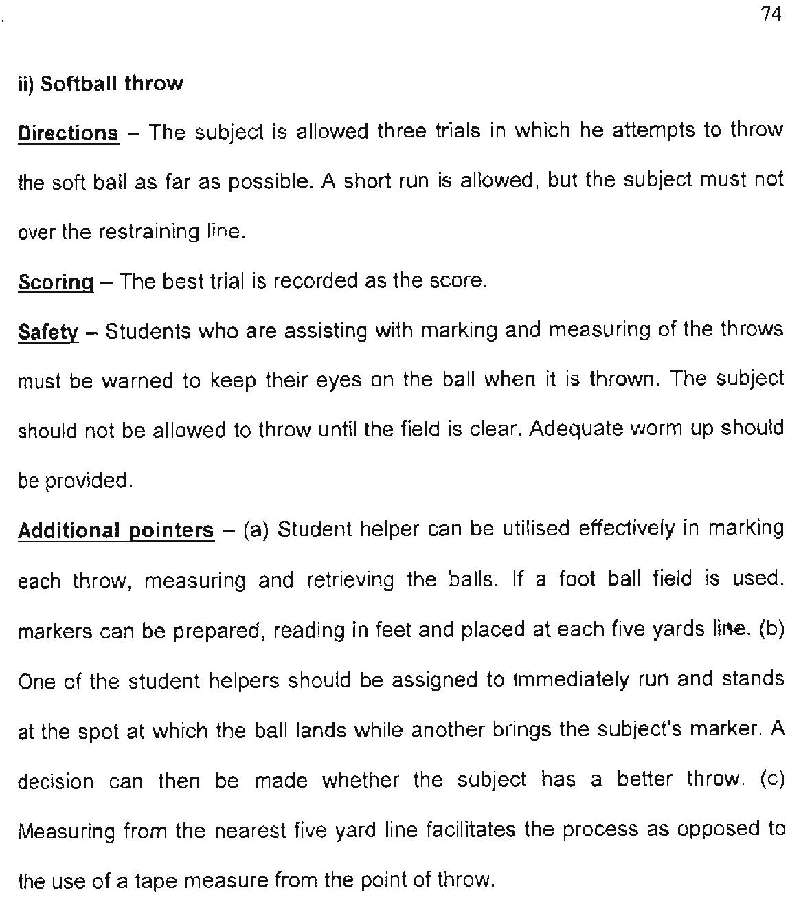

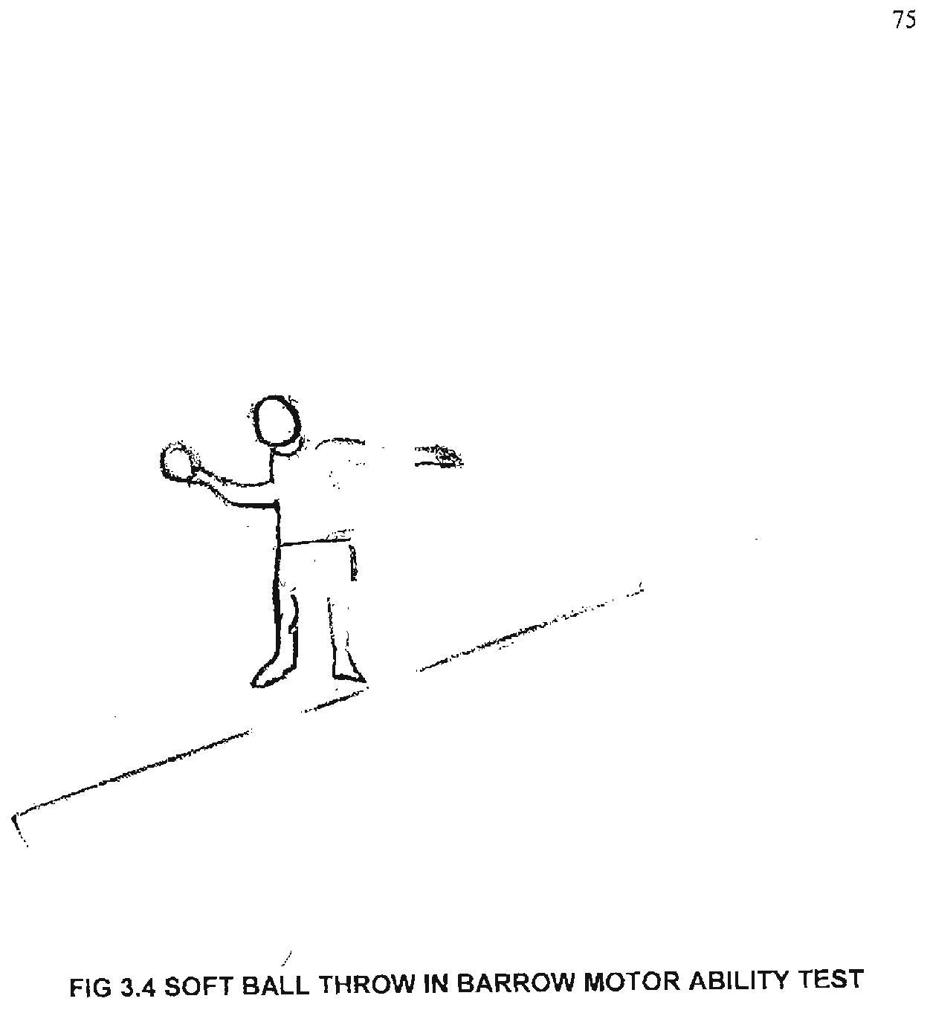

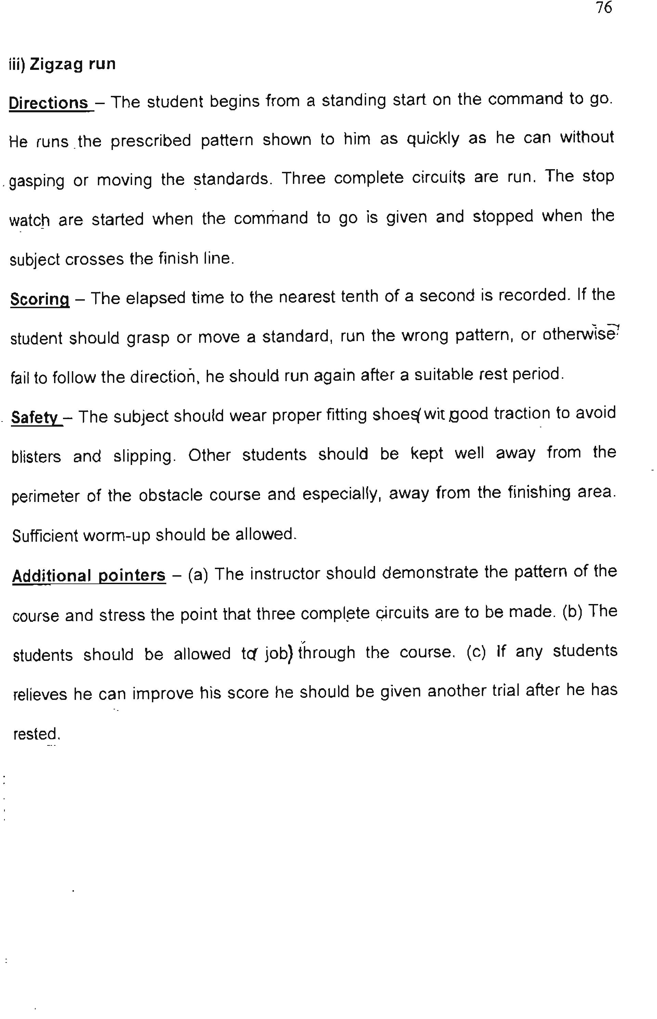
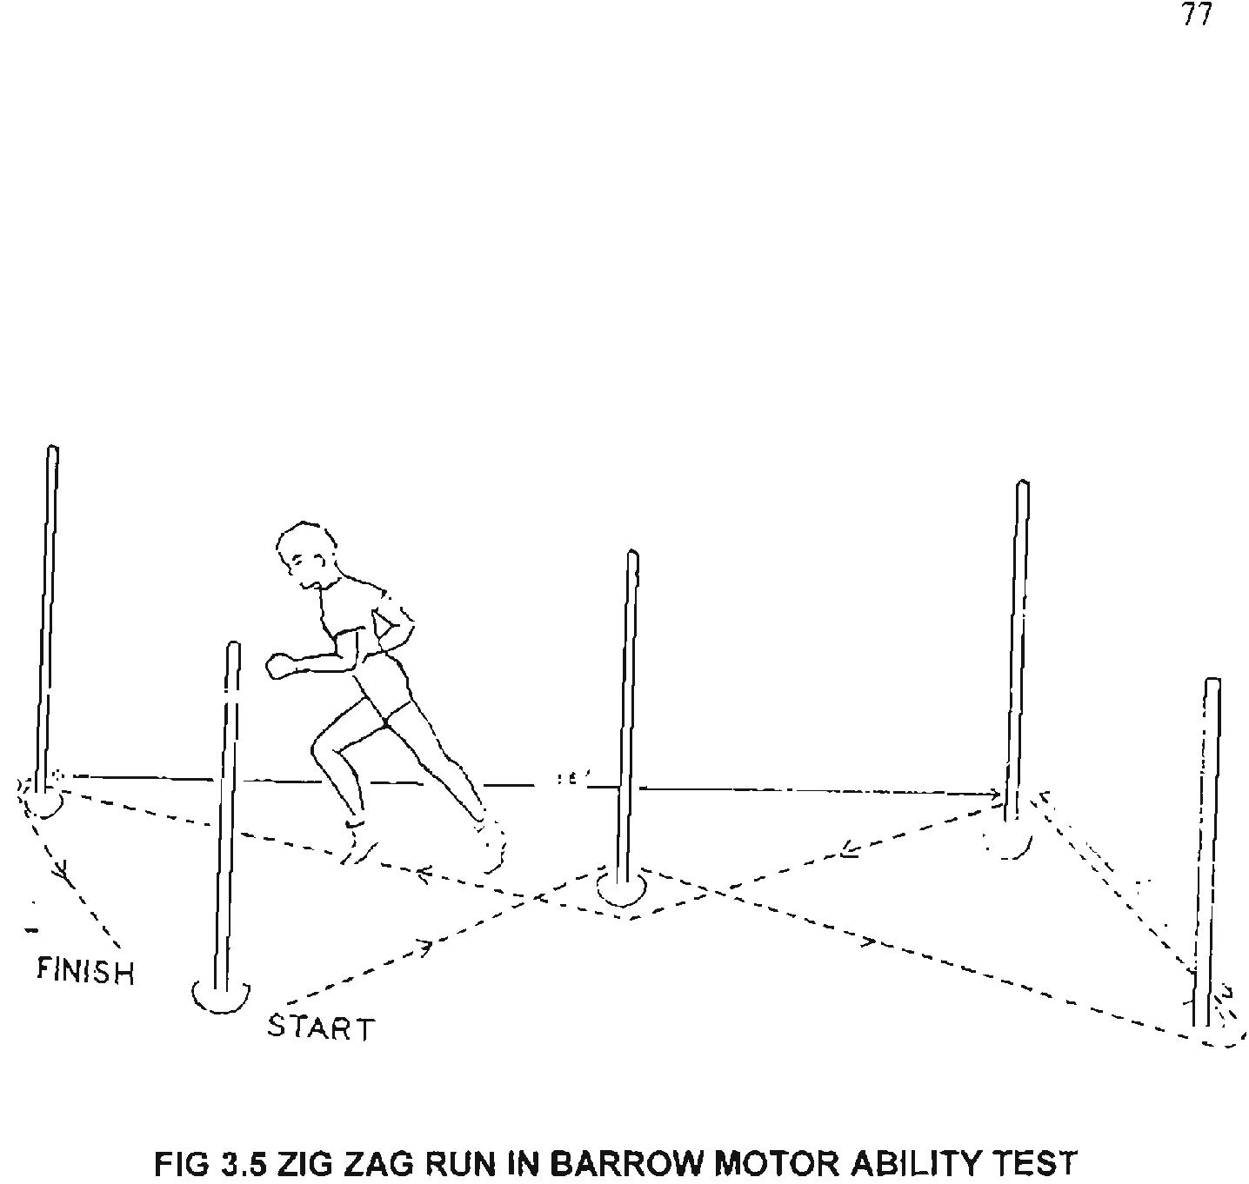

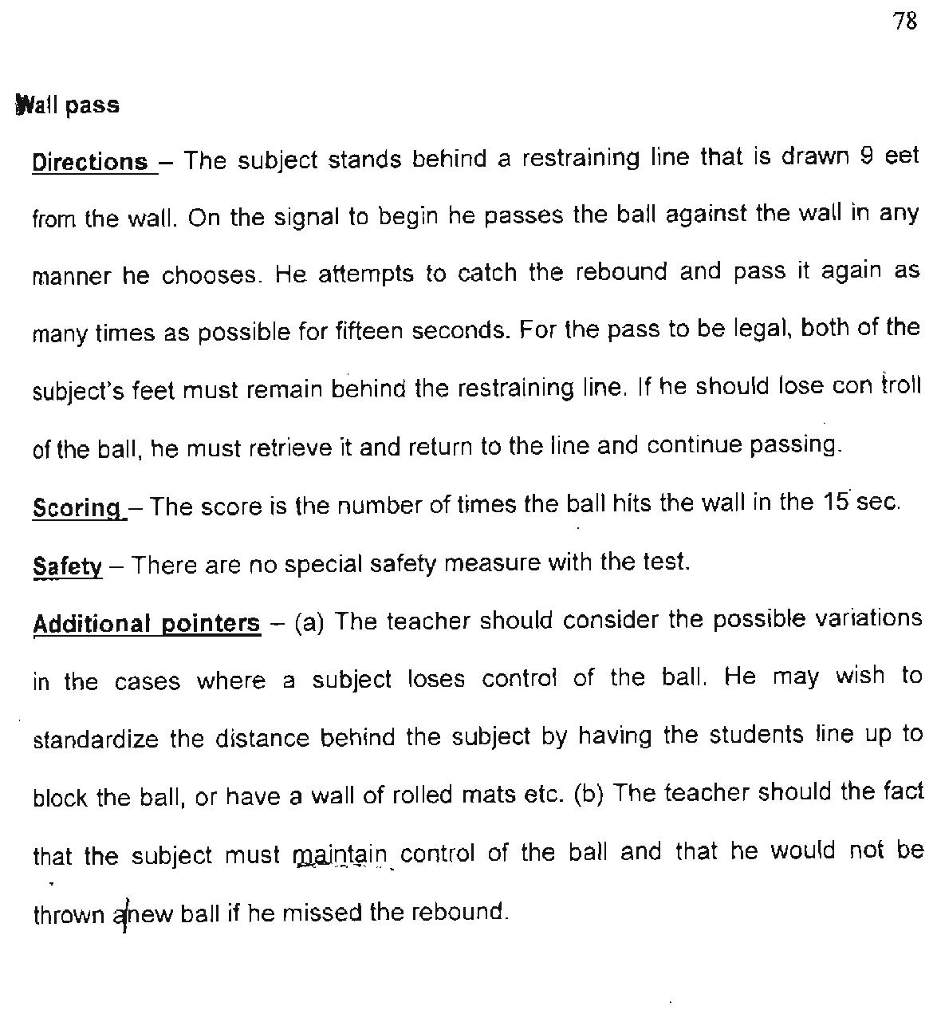

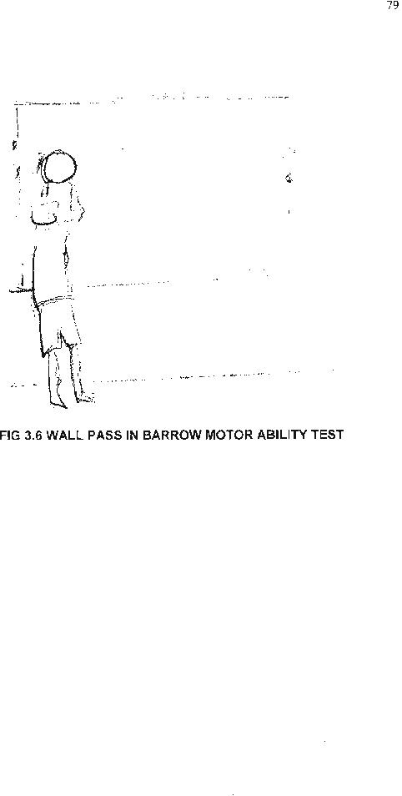

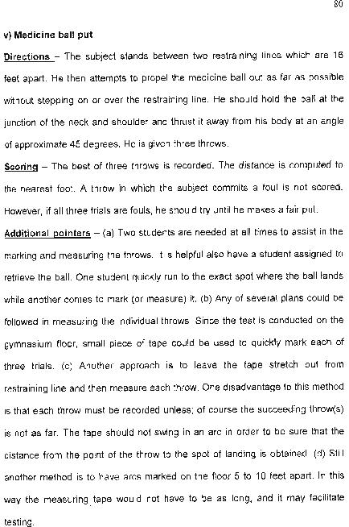

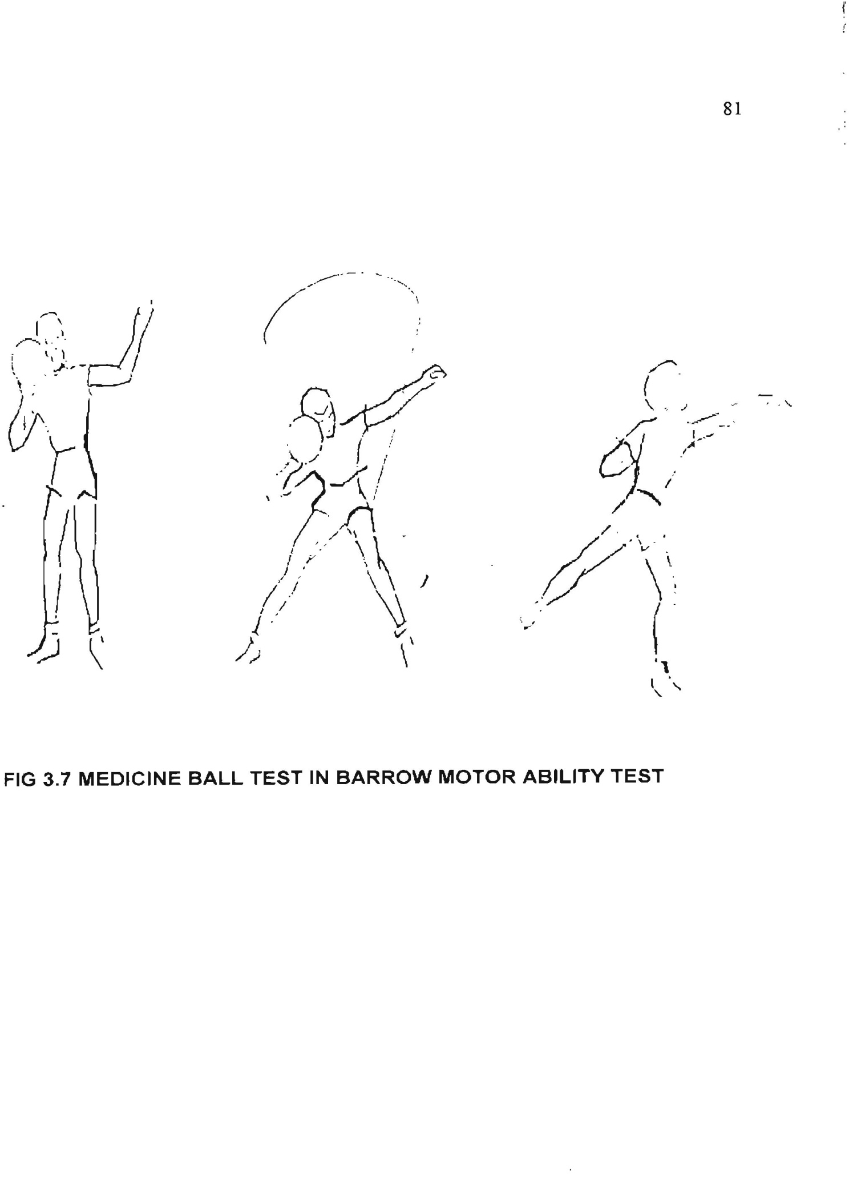

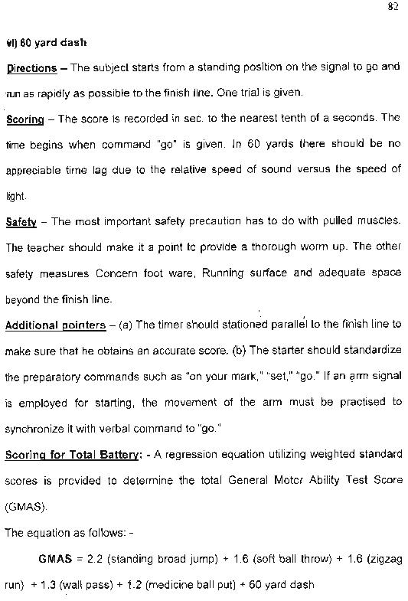

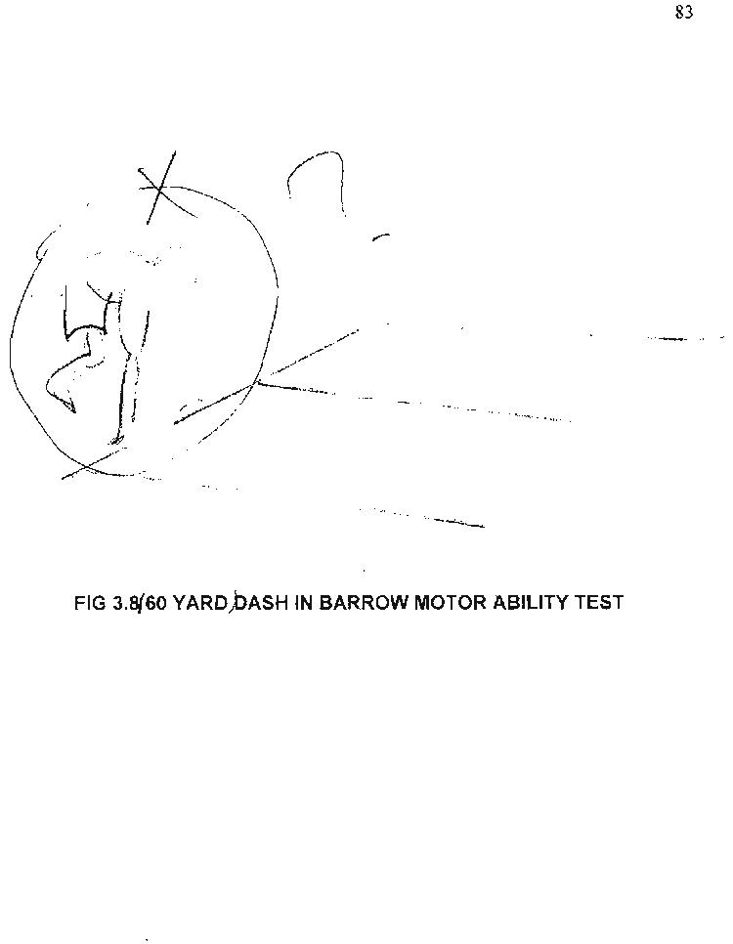

Unit-4
SPORTS SKILL TESTS
Lockhart and McPherson badminton test, Johnson basketball test, McDonald soccer test, Russell - Lange Volleyball test, Schmithals French Field Hockey test

Badminton Skills Test

Lockhart-McPherson Badminton Test

The Lockhart-McPherson Badminton Test is designed to simulate a game situation. The test can be done inside or out, as long as you have an open area, solid wall, and relatively high ceilings. Fist, a line should be made with tape on the wall 5 feet off the ground and parallel to it. This is to simulate the net. Another line should be made on the ground parallel with the wall and 6.5 feet from it. This is the starting line. Another line must be made 3 feet from the base of the wall and parallel to it, called the restraining line. The student being tested begins by serving the shuttle against the wall from behind the starting line. Once the shuttle hits the wall and bounces back, the student continues returning the shuttle against the wall from anywhere behind the restraining line. The object is to see how many times they can hit the shuttle in 30 seconds. If the shuttle hits the ground, they may pick it up and put it back into play from behind the starting line, continuing their count from where they left off. If the student violates the net line or restraining line, they may continue on with their test, but any hits occurring during the violation may not be counted. The test is administered 3 times by each student, and the scores are added together.

Lockhart-McPherson Record Form

Student Test 1 Test 2 Test 3 Total
___________
___________
___________
___________
___________
___________
Johnson basket ball test:
It is probably the oldest but the most commonly used test, constructed in the year 1934 by Johnson during his research work. Two batteries test were proposed initially but usually used only one battery to measure the following: Basic basketball skill test items
(i) Field goal speed test
(ii)Basketball throw for accuracy
(iii)Basketball dribble test
(Equipment, measurement and procedure has to be mentioned accurately for each item

FOOTBALL (SOCCER) SKILL TEST

MC DONALD VOLLEYING SOCCER TEST
ESTABLISHED: Lloyd G. McDonald, 1951.
PURPOSE: To measure kicking skill ability.
AGE GROUP: College Men.
FACILITY: Back Board 30 feet wide and 11 ½ feet height, three soccer balls, stopwatch, score cards.
PROCEDURE: A restraining line is drawn 9 feet from the back board and parallel to it. Three soccer balls are used, one is placed on the restraming line, the other two are located 9 feet behind this line in the centre of the area. The test consists of kicking the soccer ball against the back board as many times as possible in thirty seconds. Any type kicks may be used; both ground balls and fly balls that hit the backboard. To count, however, all balls must be kicked from the ground with the supporting leg behind the restraining line. Rebounds maybe retrieved in any manner, including use of the hands. If a ball is out of control, the subject may play one of the spare balls, but must bring the ball by use of hands or feet to a position at the restraining line before kicking against the backboard.
SCORING: Number of legal kicks in 30 seconds period will be counted for evaluation. The best of four trails is recorded.

VOLLEY BALL SKILL TEST

. RUSSEL – LANGE VOLLEYBALL TEST
ESTABLISHED: Naomi Russel and Eligabeth Lange, 1937.
PURPOSE: To measure volleyball serving and volleying ability.
AGE GROUP: Girls in grades seven, eight and nine.
ITEMS: Test consist of two items.
1. Serving Test 2. Volleying Test
- SERVING TEST
FACILITIES: Volley Ball court, Volleyballs, Score cards.

PROCEDURE: The subject serves ten times in a legal manner into a target on the court across the net. Let server are repeated. Each service is scored according to the value of the target area in which the ball lands. A ball landing on a line separating two areas is given the heighest value. A ball landing on a side or the end line scores the value of the area adjacent. Trails in which foot faults occur score zero.
SCORING: 10 service trails are given. Each service is scored according to the target where ball lands.

HOCKEY SKILL TEST

SCHMITHALS – FRENCH ACHIEVEMENT TEST IN FIELD HOCKEY
ESTABLISHED: Schmithals M and E French , 1940.
PURPOSE: To measure combination of fundamental abilities in the hockey, they are Goal shooting, Dribble, Dodge, Circular tackle, Drive for distance, and Push pass.
AGE GROUP: Secondary school girls and college women.
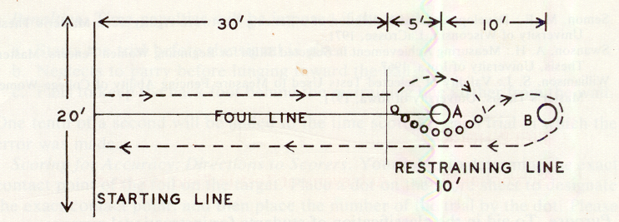
FACILITIES: Hockey sticks, balls, 2 obstacles, stopwatch, score cards.
PROCEDURE: The player begins by standing behind the starting line to her left of the foul line. She is holds a hockey stick and a ball on the starting line any where to the left of the foul live. She dribbles upto the restraining line, keeping the ball to the left of the foul line, send the ball to the right of the obstacles while she goes to the left, regains control of the ball, and dribbles it around the second obstacle going to the right. She then drives the ball back towards the starting line and may follow it up to set it again if more distance is needed.
SCORING: Time will taken from the signal ‘Go’ until the ball cross the starting line. Six trails are recorded and then averaged for the final score.

