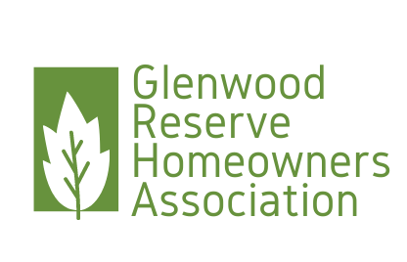

Glenwood Reserve HOA Board Meeting  
PO Box 2004 DeLeon Springs FL 32130

Date: August 10, 2023

Present: Chrissy Nichols, President, Anne Rothenberg, Vice President, Maritza Connelly, Secretary, Shirlanne Bazemore, Treasurer

Start time: 0902

Open Issues:

Financial Update: Shirlanne provided an update to our financial update.

Fire wells/ Volunteers: Brass locks were installed as they are resistant to rust. There is a key at each fire well and extra keys are with the secretary. The fire department suggested we receive training on how to reset the circuit breaker. There was some discussion about recruiting volunteers to check those on a periodic time table. It was decided that since we have such a hard time gaining volunteers, we would best be served getting the training along with our spouses and setting up timetable for the board to do the checks on the fire wells. We also discussed the wood braces that are t the fire wells and the need for them to be replaced. Chrissy is reaching out to Alex Koller to see if he would be able to do that, if not we will need to hire someone to make those repairs.

Signage at sidewalk entrances: Chrissy has provided Alex Koller with the signs for the entrances off Lemon Street. She will be discussing with him the timetable to get the barriers setup and get the signage installed.

Leasing restrictions: Anne provided some verbiage from her previous HOA regarding restricting short-term leases. Maritza to review and send out preview of the verbiage to be sent to the membership to determine if this will be added to the Covenants and Deed Restrictions.

Chickens: We have sent s request to have the PUD changed. We are anticipating sending this to the membership for ratification as soon as we have all the information.

ARC: The ARC became aware of a deficit in our system as the dealt with 2 violations in the neighborhood. Currently reviewing how to better handle submissions that are not complete and better ways to archive approvals.

Security gate: Due to some recent small crime activity on Glenwood Reserve Dr and the sidewalk from lemon to Dunstable, some members are concerned with safety in the neighborhood. A suggestion to look into installing a gate was put forward by a member. These current events in the perimeter of our neighborhood, in our estimation does not constitute such a drastic security measure. The Board does not feel that this is necessary at this time. It is not the responsibility of the HOA to ensure home and property safety for each member. We encourage our members to use personal security devices on their home if they are concerned about the safety of their property.

Violations: The violation of the paint color on the new build on Dunstable was resolved with the member. The violation with the storage crate on Tyngsbourgh has not been resolved. The member has been made aware by the County that the storage crate must be removed. We will be sending out another letter advising that they will be given until August 20 to remove the crate or they will start incurring violation fees.

Tortoise on Corner   
of Chelmsford and Dunstable: Sent an email to the county to have them install another gopher turtle sign. Sending a notification to the property owner advising the need to protect the turtle on the property and to please advise the mowing company they are not to remove the signs the county has installed.

Adjourned: 0948

Respectfully submitted, Approved

Maritza Connelly, Secretary Date:081023 Chrissy Nichols, President Date: