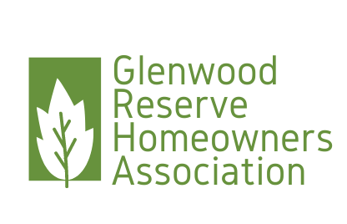

Glenwood Reserve HOA Board Meeting  
PO Box 2004 DeLeon Springs FL 32130

Date: October 12, 2023

Present: Chrissy Nichols, President, Anne Rothenberg, Vice President, Maritza Connelly, Secretary, Shirlanne Bazemore, Treasurer, Mike Horan, member

Start time: 0905

Open Issues:

2023 Financial Update: Shirlanne gave an update on current budget. At our November meeting we will be discussing in depth the 2024 budget.

Rebar Issue: We let Mike and Chuck know that a complaint was made in regards to the rebar they have at the corner of their property. They want a formal complaint letter sent to them before they will address any removal. Mike Horan said the HOA should call the Volusia County code enforcement, we let him know that we only address violations to our Covenants and Deed Restrictions. He is welcome to make a complaint to the Code Enforcement.

Anonymous Complaint: Read the anonymous complaint that the HOA Board received via USPS in regards to the Horan property. Mr. Horan made a threat via text to the president during the meeting, those are attached. Maritza advised that those types of threats need to stop immediately.

Signage issues: Ray Parker sent in a complaint about the open house signs that were put in place during an open house being held in the neighborhood. These are temporary signs, if someone submits a complaint form regarding those temporary signs, we will address it by checking to see if the signs are still in place.

Adjourn: 0934

Respectfully submitted,

Maritza Connelly, Secretary  
Date:

Chrissy Nichols, President  
Date: