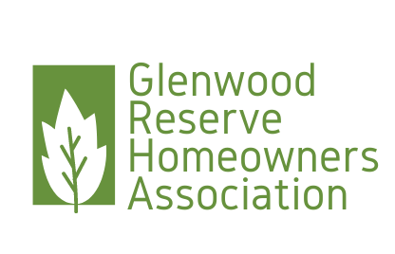

Glenwood Reserve HOA Board Meeting  
PO Box 2004 DeLeon Springs FL 32130

**President’s Report**

January 31, 2024

Dear Glenwood Reserve HOA members,

It’s hard to believe we are already one month into 2024! I truly hope this finds you well so far this year!

Believe it or not, we are closing in on three years as a homeowner led HOA and I feel like we have made great strides these last few years to keep Glenwood Reserve the beautiful neighborhood that it is.

The HOA had another productive year with many accomplishments. Highlights include:

* Finalized the amendments to the Covenants and Deed Restrictions and recorded with Volusia County
* Addressed numerous concerns from Homeowners regarding violations and other issues
* Held a Community Clean-up, Chili Cookoff, Summer Party and had a Holiday movie night, thanks to the Rush Family
* Installed barriers at gate accesses of Lemon Street to prevent motorized vehicles entering the neighborhood
* Installed new signage at the entry of Dunstable and at the Lemon Street Access Points
* Inspected and updated Firewell electrical to ensure availability
* Retained new HOA Attorney and worked with them on next steps with regard to the Secondary Fire Entrance off Lemon Street

On behalf of the Board, I would like to thank you all for your participation in our events and meetings this year to help make these things possible.

I would also like to welcome all the new neighbors who made Glenwood Reserve their home this year. With every new family, construction dwindles, and we anticipate the necessity for temporary yard barriers will no longer be necessary so affected neighbors can gain back their curbside appeal! I know this has been a long time coming for some of you.

Additionally, I would like to mention that we have a lot of awesome events planned for this year and will be publishing dates on the HOA website soon. Our first event is the Community Garage Sale on February 17th. Make sure you get your items together, so we have lots to offer that day, we hope to have a really great turn out!

Lastly, I wanted to say that I have enjoyed serving Glenwood Reserve as your HOA president for the last three years. This year the position is open for those who wish to self-nominate and a form is enclosed to do so. As the incumbent, I do intend to seek re-election for another term and would appreciate your support.

We look forward to seeing you at our Annual Meeting on March 11, 2024.

Thank you,

Chrissy Nichols

Glenwood Reserve HOA

President