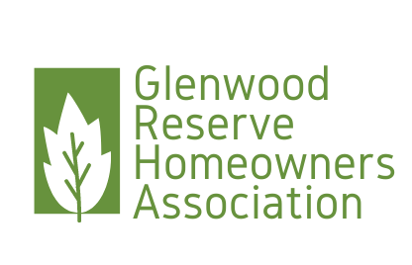

Glenwood Reserve HOA Board Meeting  
PO Box 2004 DeLeon Springs FL 32130

**President’s Report**

February 3, 2025

Dear Glenwood Reserve HOA members,

Believe it or not, we are closing in on four years as a homeowner led HOA and the HOA Board continues to ensure that we work to keep Glenwood Reserve the beautiful neighborhood that it is.

The HOA had a productive year with many accomplishments. Highlights include:

* Explored allowing chickens in the neighborhood which we determined we were not able to pursue due to costs associated with replating the neighborhood from an RPUD.
* Addressed numerous ARC issues from Homeowners and sought legal counsel due to continued violations.
* Held a Community Garage Sale and Community Clean-up.
* Continued regular inspections of the Firewells to ensure availability by having the annual inspection completed and monthly inspections by Shirlanne and Kenny Bazemore. Thank you for your help Shirlanne and Kenny!
* Ensured hurricane debris clean-up was accomplished by the County.
* Navigated HOA Rule changes which impact our declarations and have proposed administrative updates to the declarations for review during our annual meeting.

I would also like to welcome all the new neighbors who made Glenwood Reserve their home this year.

Lastly, I would like to welcome Jessica Flowers, who has been appointed by the Board to fulfill the Vice President role, due to the resignation of Anne Rothenberg. She will remain on the board for the remainder of the Vice President term which expires in March 2026.

On behalf of the Board, I would like to thank you all for your participation in our events and meetings this year. We hope to bring more events to the neighborhood. Please check our website and plan to attend the monthly Board meetings for the latest information.

We look forward to seeing you at our Annual Meeting on March 3, 2025.

Thank you,

Chrissy Nichols

Glenwood Reserve HOA

President