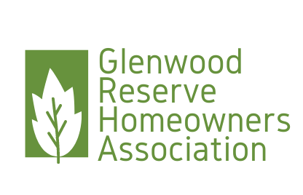

Glenwood Reserve HOA Board Meeting  
PO Box 229219 Deland FL 32722

Date: February 9, 2023

Present: Chrissy Nichols, President, Anne Rothenberg, Vice President, Maritza Connelly, Secretary, Shirlanne Bazemore, Treasurer

Start time: 0831

Open Issues:

Budget Proposals Shirlanne presented the 2022 budget actuals as well as the 2023 budget plan. It was accepted unanimously by the Board. Chrissy was to verify that the 2021 taxes were paid to the State of Florida. Shirlanne suggested  
 that we allow members to drop off their HOA dues to her home. All Board member agreed this would be a good idea to facilitate receiving checks and provide more options to the membership. Maritza will work with   
 Shirlanne to complete all the end of year documents and prepare them for presentation at the Annual HOA Member Meeting.

Insurance Chrissy will verify the insurance information and ensure the proper amount due is set to Shirlanne for payment  
Voting Instruments We are still waiting for the official documentation from the attorney to distribute to the membership a copy of all the changes that were voted in. Chrissy suggested we send out a voting instrument to check if there are  
 enough votes to begin dissolution of HOA. The Board members felt that sending that out at this time is premature. The Board agreed that the new changes to the Covenants and Deed Restrictions be sent to all the   
 members and at the Annual Board Meeting a vote can be taken to determine if we will go this route. Another suggestion was to see if instead of dissolution the members would be amenable to removing all the  
 restrictions in 6.

Annual HOA Meeting The Annual HOA meeting is scheduled for March 20, 2023 at 630 pm. Meeting to be held at LifePoint Community Church on New York Ave. All agenda items need to be submitted for our next Board Meeting

Chili Cook Off Chili Cook Off has been reschedule for March 26, 2023 noon to 4pm 3513 Tyngsbourgh Dr

Records keeping Chrissy wanted to know what is required record keeping for official documents. Anne will check to see what the official records are and how long they must be maintained. This is specifically for records that are pape  
 copies. Since the HOA became an owner run HOA our records are all electronic

Matcovich Shed Mr Matcovich addressed the Board members with his idea for making the shed he is planning on building on his property fit in with the Covenants and Deed Restrictions. The Board agreed that if the front facing façade of  
 the shed matched the home it would be acceptable to allow the sides and rear to be metal. Advised Mr Matcovich to resubmit his plans with the changes to the ARC for approval. We have also alerted Jason and David  
 of discussion we had with Mr Matcovich

Chavez Plan Asked Maritza to circle back with the ARC to see if they could have a meeting in regards to the Chavez plan for build on his lot

Adjourned: 0931

Respectfully submitted, Approved

Maritza Connelly, Secretary Date:021123 Chrissy Nichols, President Date: