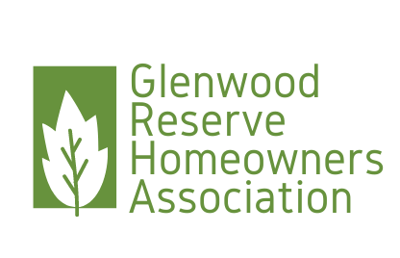

Glenwood Reserve HOA Board Meeting  
PO Box 2004DeLeon Springs FL 32130

April 13, 2023

Present: Chrissy Nichols, President, Anne Rothenberg, Vice President, Maritza Connelly, Secretary

Board meeting was cancelled to allow the Board to meet at the bank to sign the official documents of the ne Covenants and Deed Restrictions and have those documents notarized to be submitted to the county for recording.

Respectfully submitted,

Maritza Connelly,  
Secretary Date: 04082023