Lding 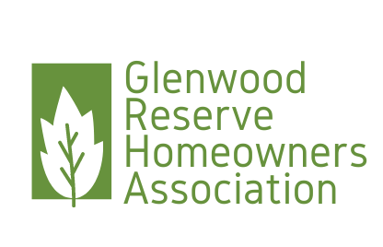

Glenwood Reserve HOA Board Meeting  
PO Box 2004DeLeon Springs FL 32130

Date: November 2, 2023

Present: Chrissy Nichols, President, Anne Rothenberg, Vice President, Maritza Connelly, Secretary, Shirlanne Bazemore, Treasurer, L. Shadonix, Chuck and Mike, Matcovich, Koller’s, Viola, Horan’s, Parker

Start time: 0903

Open Issues:

* **2024 Budget initial report,** Shirlanne gave a summary of what is expected to be the balance in the HOA account for the 2024 budget year. Additional, information will be forthcoming as the year closes out and more discussions are conducted about the needs for the upcoming year.
* **HOA Attorney,** The attorney that we have been using has moved to a new law firm. The hourly charges at the new law firm are higher than we were paying, we reached out to various HOA’s in the area to get recommendations for an attorney. After reaching out to some law firms that specialize in HOA law, we found that the hourly rates ranged between $265-350 per hour. The attorney that we have been using has advised us we could negotiate with her law firm a rate of $300 per hour. It was determined that since this attorney is already familiar with the Covenants and Deed Restrictions of our HOA, she aided us in the rewording of our current Covenants and Deed Restrictions, we would retain her services again as we move forward.
* **Cease and Desist Mike Horan,**  a cease and desist letter was sent to Mike Horan due to harassing and threatening emails that were being sent to the HOA Board and emails that he sent to various county authorities representing himself as someone with authority to do so. Mr. Horan received the letter on 101223, and on the signature line he signed with K M A (kiss my ass).
* **Secondary emergency entrance,** Mr. Horan sent an email to the fire marshal noting that the neighborhood did not have a secondary emergency entrance as per the plat, this has now precipitated the HOA Board to seek advice from the fire marshal on how to remedy. The fire marshal met with Chrissy and advised that yes this is on the plat and should have been done when the neighborhood was being developed, also stated this was not something that they routinely inspect/investigate. We will have our attorney review and determine if this is something that can be sent out to the developers for remediation, if there was a statute of limitations on making the developer responsible. We will work with the attorney to find the least costly resolution to this.
* **Dead tree in swale,** there is a dead tree in the swale behind the Bazemore residence. We have an estimate from a tree removal service for $700 to remove the tree. Several members volunteered to remove the tree themselves. The Board cannot authorize anyone to remove the tree because of the potential for injury. This was a topic of conversation when we had a community cleanup day and to avoid the potential for lawsuits, we cannot authorize any individual to remove the tree.
* **Metal building,** the metal building that is being constructed on Dunstable was approved by the ARC and the Board. Prior to rewriting the Covenants and Deed Restrictions, there was a very narrow view of any outbuildings within our community. The new language allows for a broader interpretation.
* **RV in driveway,** sending out a violation letter to the Koller’s for the RV violation
* **Holiday get together,** the Board will be planning a holiday get together for the neighborhood. The holiday party will also include a cookie exchange. More details to follow.
* **Ray Parker,** asked to speak regarding the open house signs that he believes are in violation of the Volusia County Code. We advised him that there is no violation within our Covenants and Deed Restrictions. We do not enforce County Code violations.
* **Lora Horan,** has requested to be on the December agenda to make a rebuttal to the cease and desist sent to her spouse. We will be adding that to the agenda

Adjourned: 0954

Respectfully submitted,

Maritza Connelly,  
Secretary