**A + B = C (as in Cash!)**

Our **A + B = CASH** program is an equation that everyone loves!

This program is an opportunity for high school and college students to earn $100 **per marking period** by getting all A’s and B’s!

It’s our way of saying “Great Job!” to students for their hard work throughout the school year.

Here’s how it works:

You must be employed for the whole grading period. If you get hired in the middle of a grading period, you’ll be eligible for the next grading period.

You must bring in your report card showing that you earned all A’s and B’s.   
We’ll verify it’s accuracy, and you’ll get a $100 American Express Gift Card.

You are eligible for each grading period that you work in which you bring in a report card showing all A’s and B’s.

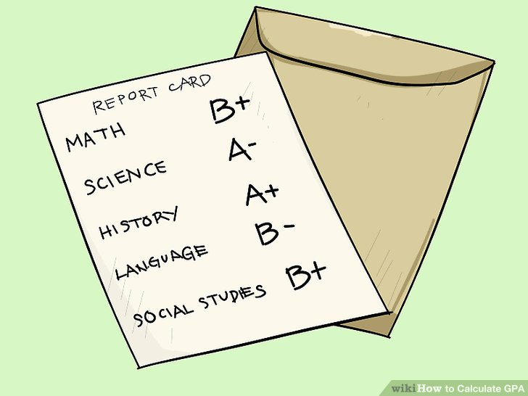

How much will you earn?