December Newsletter
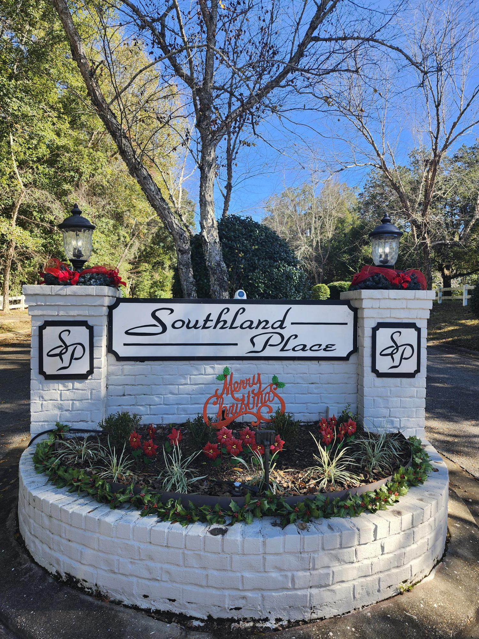

Happy Holidays Southland Place Residents!!

This is our first newsletter. We plan on including it in our webpage every month. To stay informed about our neighborhood check, in around the 21st of the month.

So some good news.
Annual dues in 2026 will remain the same as 2025, $300.00. Payments however, must be made in full by March 31st. If it is easier owners may divide their payments in 2 or 3 payments so long as it is paid in full by March 31st.

Over the course of the last 2 years we have made some substantial improvements and repairs.
- The fences along Southland Place have all been replaced, something that has needed to be done since Hurricane Sally.
- The Gazebo was torn down and a concrete pad installed as a base for future improvements.
- The main drainage pond was mowed and drain channels dug to improve water flow.
- The security cameras are undergoing an upgraded as well as the plants around the pillars have been trimmed and additional plants are being added to the entrance to make our neighborhood more welcoming.
- The broken flag pole was taken down and replaced with a tree.
- The well pump was replaced and the sprinkler system was repaired and updated.

On a less pleasant note:
The lawsuit started under the previous board is still lingering, without resolution.

Moving forward into the new year:
We will be establishing three new programs in the neighborhood. They can be discussed at the Annual meeting or by contacting any board member.
Establishing a Neighborhood Steward program
To encourage residents who are out and about in our neighborhood to be aware of potential issues and problems and alert the board, i.e. If no one has seen an elderly resident for awhile they could check on them. Alert the board to someone who is ill or struggling to see if we can help.

Creating a neighborhood vendor list in the newsletter.
The purpose of the list is to allow residents who own a business or provide services to offer their talents to other residents. The board will only monitor the listings not the actual contacts or services.

Creating a Garden Club to help beautify our subdivision
We want to connect like minded individuals who would be interested in making our subdivision a more attractive place to live. We hope they would provide the vision and labor; the board would supply the materials.

The Annual Association Meeting
Will be on January 8th at Fairhope Unitarian Fellowship 6:30 pm to 7:30pm.
1150 Fairhope Ave, Fairhope, AL 36532

