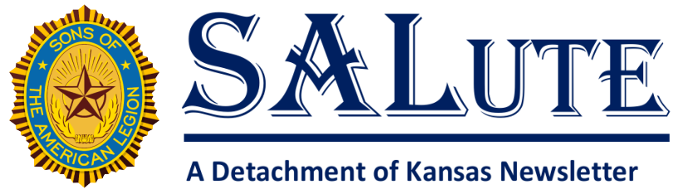
Date: July 2026

Message from the Detachment Commander
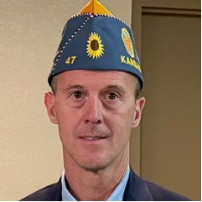
Greetings from the Commander,
From time to time, it is important for us to stop and reflect on who we are, why we joined, and what it means to be members of the Sons of the American Legion. We are more than just an organization that holds meetings and events. We are part of a proud legacy built on service, sacrifice, patriotism, and an unwavering commitment to our veterans, our communities, and our nation.
Many of us joined because of a personal connection to a veteran—a father, mother, grandfather, grandmother, sibling, or friend who answered the call to serve. Their dedication and sacrifice created the foundation upon which this organization stands today. It is our responsibility to honor that legacy, not only by remembering their service but by living out the values they demonstrated through their actions.
Our core values are not just words written in a mission statement. They are the principles that guide everything we do. When we volunteer our time, support veterans and their families, mentor young people, participate in community projects, or simply lend a helping hand to someone in need, we are putting those values into action. Every act of service, no matter how small, contributes to something greater than ourselves.
We live in a time when it can be easy to become distracted by differences or challenges. But what unites us is far stronger than anything that divides us. We share a common purpose. We believe in service before self. We believe in honoring those who wore the uniform of our country. We believe in strengthening our communities and ensuring that future generations understand the importance of citizenship, responsibility, and patriotism.
As members of the Sons of the American Legion, we are the stewards of a mission that has been handed down to us by those who came before. We have been entrusted with carrying that mission forward for those who will come after us. The future of our organization depends on each of us being engaged, involved, and committed to its success. It depends on our willingness to welcome new members, develop future leaders, and ensure that our programs continue to make a positive impact.
I encourage each of us to take pride in what we do and never lose sight of why we do it. Remember the veterans and families we serve. Remember the sacrifices that made our freedoms possible. Remember that every hour volunteered, every project completed, and every life touched reflects the very best of what this organization represents.
Let us recommit ourselves to our core values and to the mission that brings us together. Let us lead by example, support one another, and continue building an organization that future generations will be proud to join. The work we do matters. The legacy we preserve matters. And the mission we carry forward matters.
Together, with dedication, respect, and a shared sense of purpose, we will continue moving the mission forward and ensuring that the ideals of service, patriotism, and honor remain strong for years to come.
Thank you for your commitment, your leadership, and your service to the Sons of the American Legion. It is an honor to stand beside each of you as we continue this important work.
For God and Country,
FROM YOUR COMMANDER
MICHAEL WEBER
det.cmdr.ks@gmail.com
spidercreek220@gmail.com
620-430-0651

Message from the Detachment Vice Commander,
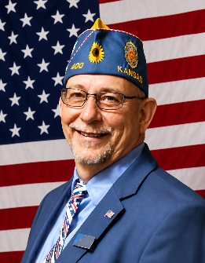
Hello Fellow Sons,

As I sit down to write this article about membership. It brings me thinking less about how is our membership doing. But instead, why do we even have membership? The Sons of the American Legion isn’t just a group—it’s a continuation of the mission started by the American Legion. It’s where we honor the service of our fathers, grandfathers, and all who wore the uniform that made you eligible, by continuing their work right here in our communities.
Membership in the Sons means more than a card. It means standing for patriotism, supporting our veterans and investing in our youth and our future. Every year, we help fund programs, support initiatives like Children and Youth programs, and step up when our communities and veterans need us most.
But here’s the truth—none of that happens without members. That’s why renewal isn’t just important—it’s essential. This is why we are starting a new program to help you retain your members and pick-up a few along the way. We call it "Re-Membership" we will be emailing these out to your District Commanders or contact one of your Detachment officers.
July 1st isn’t just a date. It’s our starting line. It’s when we recommit to the mission, to each other, and to those who served.
This is when we reconnect, re-engage and renew.
Let's all " Re-Membership " this year and make it our strongest yet!

Your,
Detachment of Kansas
Vice Commander
Jeff Kerns

Message from the Detachment Finance Officer

District Commanders and Adjutants,
If you have not yet submitted your paperwork to the Department regarding where to send per capita checks, please do so immediately. While the deadline was July 1st, the Department is still accepting submissions if they are turned in without delay. Please note that you will not receive a check until this paperwork is processed. If you do not have this form, contact me immediately and I will get it to you as soon as possible.
Additionally, the Kansas State Fair is approaching this September. Most districts are assigned a day to staff The American Legion booth from 9:00 AM to 9:00 PM. This is an excellent opportunity for the S.A.L. to increase its visibility. Please contact your District American Legion Commander to ask how you can support this effort.
Best regards,
Michael Saindon
Detachment Finance Officer

Message from the Detachment Adjutant
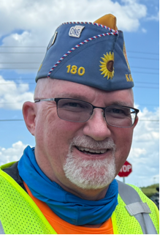
Greetings, Kansas Sons!

Hopefully this finds everyone enjoying their summer, with quality time with family and friends, as well as serving our communities.

American Legion Family Emblems and Brandmarks:

We’re all familiar with the American Legion Family Emblems, and I’m sure you’ve seen the Brandmarks that were adopted a few years ago. If you are tasked with creating flyers, documents or other digital or print materials, how do you know which to use?

Here is a brief discussion of the Emblems and Brandmarks, excerpted from the American Legion Family Branding Guidelines document, also available here.

The following guidelines offer direction in terms of when to use the emblem or one of the brand marks. While most applications will be clearly defined, inevitably some instances may straddle the line between two areas. In those cases, use discretion based on the intended audience. When choosing a brand mark option, default to what is most visually pleasing in that application. For example, the word mark should almost always be used in embroidery.
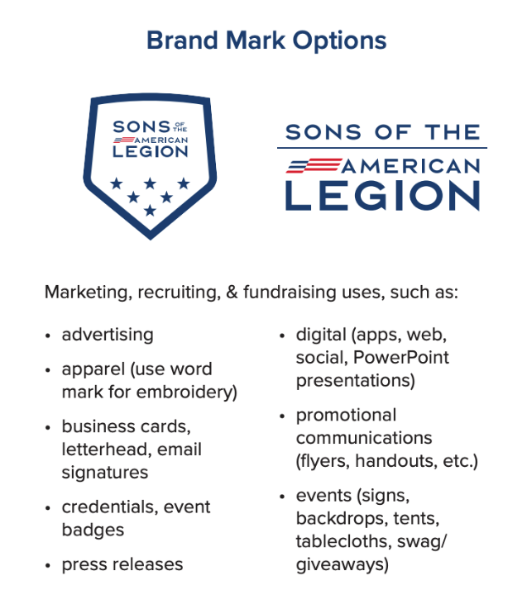
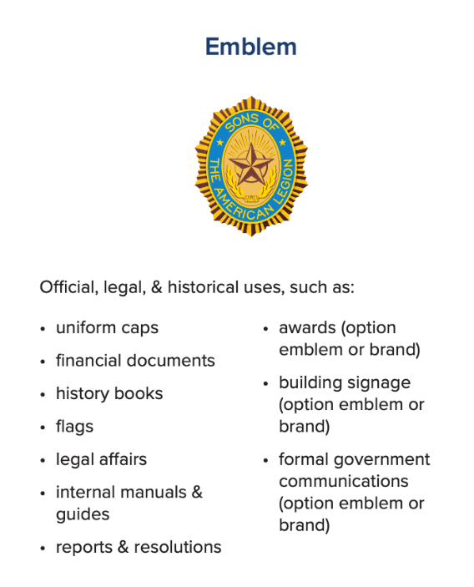
It’s recommended that anyone creating media, printed materials or manufactured items using the emblem or brandmark study the branding guidelines to ensure proper usage. Also, be aware that using any American Legion branding on any manufactured item must be approved by the Department Adjutant and National Adjutant.

All The American Legion emblems are owned by the national organization and licensed for use by posts, departments and other organizations that request, in advance for review to National Headquarters, their use. Yet this license always requires pre-approval from the National Adjutant whenever there is any type of financial exchange.

Grassroots Support:
STAY INFORMED ON LEGISLATIVE PRIORITIES
Want to see the issues Legionnaires are discussing with lawmakers? The 119th Congress, 2nd Session Legislative Priorities materials are available now. View and download them on the Legion website here.

58 billion reasons to support TCAVA

If the Take Care of America’s Veterans Act does not pass, veterans programs stand to lose up to $58 billion, National Commander Wiley writes.

Dear American Legion Family members and friends,
The Take Care of America’s Veterans Act (TCAVA) is really a $58 billion proposition.
If the legislation, which includes more than 60 veterans-related bills, does not get approved by Congress, veterans stand to lose up to $58 billion in programs, benefits and other matters.
Just like when we were in the military, this is a case of “Use it or lose it.”
Let me explain.
The VA has proposed a rule which estimates say will result in somewhere between $19 billion and $58 billion being diverted from veteran benefits to the U.S. Treasury.
The American Legion has objected to this rule change. Despite our best efforts, the VA has not withdrawn this proposed rule.
That means if we don’t act, billions of dollars will go from supporting veterans to funding other causes.
The American Legion is among a coalition of 23 veteran organizations that wrote to the leaders of Congress, advocating to pass TCAVA and keep those tens of billions of dollars for veterans. (Read the letter here.)
Let me be clear. We are not trading veterans benefits.
We are using up to $58 billion to help our brothers and sisters, rather than lose it.
That’s it — use it or lose it.
And that is why The American Legion supports the Take Care of America's Veterans Act. This legislation combines more than 60 bills, most of which The American Legion supports.
It expands suicide prevention.
It improves care for traumatic brain injuries.
It offers relief for combat-injured retirees through the Major Richard Star Act.
It gives real support for the family caregivers who hold our wounded together.
If the Take Care of America's Veterans Act does not pass in its current form, none of these reforms will happen.
That is something The American Legion won’t stand for.
And neither should you.

I recommend reviewing the facts about this legislation, understanding the Legion’s process and encouraging your members of Congress to support TCAVA. Visit this special web page for those resources and more.

Dan K. Wiley
National Commander
The American Legion

The American Legion appreciates all the emails you have sent so far.
Go to the Action Center to quickly email a letter of support to your members of Congress and let’s maintain Kansas’ nationwide lead in contacting our elected representatives.

Upcoming events:
- Kansas American Legion Bowling Tournament – 11-12/25-26 July 2026 – see the flyer on SALKansas.org or KansasLegion.org
- Department of Kansas Homecoming – See Flier attached
- SAL National Convention – 27-29 Aug 2026 – Louisville, Ky
- Kansas American Legion Riders State Rally – 25-26 Sep, 2026 – Post 370, Overland Park
- Eisenhower Pilgrimage – 17 Oct 2026 – Abilene
- Vice-Commander’s/Vice-President’s Homecoming – 17 Oct 2026 - Abilene

Kansas State Fair American Legion Family Booth Schedule:
Friday - 11 September 2026 - 1st District
Saturday 12 September 2026 - 4th District
Sunday - 13 September 2026 - 11th District
Monday - 14 September 2026 - 8th District
Tuesday - 15 September 2026 - 6th District
Wednesday - 16 September 2026 - 10th District
Thursday - 17 September 2026 - 3rd District
Friday - 18 September 2026 - 5th District
Saturday - 19 September 2026 - 9th District
Sunday - 20 September 2026 - 2nd District

Thanks for all you do and remember to Be The One!

Chris Krueger
Detachment Adjutant
