JOHN P. BURNS
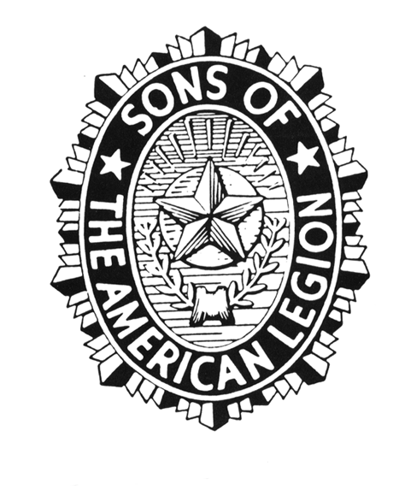

SONS OF THE AMERICAN LEGION SQUADRON #36

5845 E. 22ND ST* TUCSON ARIZONA 85711
Telephone: (520) 747-2700

Thank you for making the decision to join our membership in this great organization.

The mission of the Sons of The American Legion is to support veterans and their families and the policies of our parent organization, The American Legion. Virtually everything that involves the Sons could be grouped under three areas:
- support for veterans and their families,
- promoting patriotism and Americanism and
- promoting programs which benefit the youth of our country.

Here at Squadron 36, one of the ways we accomplish this is by raising funds and donating to causes that support our veterans, their families, and our community. Supporting locally to places like Arizona Fisher House, located here in Tucson on the campus of the VA Hospital. And Books to the Rescue, a charity that places backpacks full of books and toys in law enforcement vehicles to comfort children when officers respond to family calls of domestic violence or other stressful situations. The Community Food Bank is another charity we support. And national programs like The American Legion Child Welfare Foundation, which provides grants to other children’s charities nationwide.

We also participate in numerous events that honor our veterans, both past and present. Ceremonies like Wreaths Across America, placing wreaths at the graves of fallen military. And Memorial Day ceremonies honoring veterans with American flags placed at their graves. The distribution of “GI Josh Dogs”, a family comfort tool in the form of a stuffed animal given to deploying military personnel and their families.

Whatever your reason for joining us, we once again want to thank you for your membership and are grateful for any participation you choose to engage in throughout your time as a member. I urge you to familiarize yourself with our programs and our events. You just might find something you really enjoy, that allows you to give back to our nation’s veterans, their families, or our community. Welcome!

Sincerely

Joe Roberts

Commander Squadron #36
Sons of The American Legion

This is an example of a letter you can “clone” to fit your Squadron and send to a new member.

