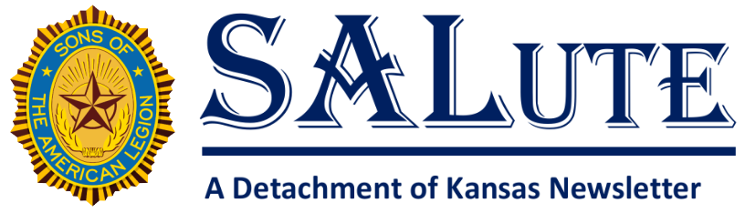
Date: June 2026
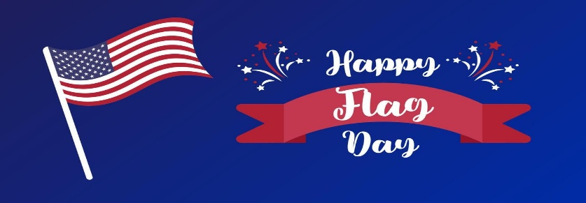
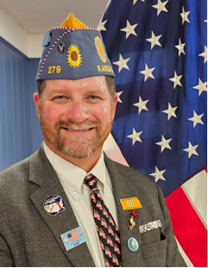
Message from the Past Detachment Commander
HELLO KANSAS SONS OF THE AMERICAN LEGION!!!
I would like to start by thanking all our members for trusting me to be your Commander this past year. There are many memories that I will cherish for the rest of my life. I would like to congratulate your new Commander, Michael Weber! The future of our amazing organization is in great hands. I can’t wait to see the direction we all go!
As this is my last SALute as Detachment Commander I wanted to plant a few seeds by briefly touching on some of the amazing things that the American Legion family does, If there is anything on this list you haven’t heard of don’t be afraid to ask questions. By the way, this list is a fraction of what is done across the nation, I think we would all be surprised by the Legion Family’s impact if every Post, Unit, Squadron and Chapter actually reported everything they do.
Child Well-Being Foundation, Operation Comfort Warrior, National Emergency Fund, Veteran’s and Children’s Foundation, Be The One, Children’s Organ Transplant Association, Boys State/Nation, Girls State/Nation, Cadet Law, Children and youth, Scholarships, Baseball, Youth Sports, Oratorical, raise money for local Veterans Memorials, blood drives, pay for lunches at the local schools, support local food banks, and countless other things.
If you want to know more you can reach out to me or any of the Detachment or District current or former leaders. We are all willing to help!
This past year has been an honor to serve. For God and Country
Jr. PDC Matthew Krupco
mwksal@outlook.com

Message from the Detachment Commander
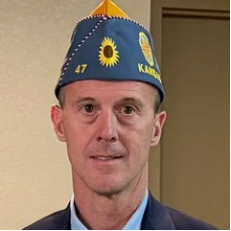
Greetings!
Thank you for the honor and privilege of serving as your newly elected State Commander of the Detachment of Kansas Sons of The American Legion. I am truly humbled by the confidence you have placed in me, and I look forward to working alongside each of you during the coming year. The Sons of The American Legion has a proud tradition of service, patriotism, and support for our veterans, their families, and our communities. Together, we will continue that tradition while building an even stronger organization for the future.
This year, I have selected the Children's Organ Transplant Association (COTA) as my Commander’s Project. Every day, children and their families face tremendous challenges as they await or recover from life-saving organ transplants. Through fundraising and awareness, we can help provide hope and support to these families during some of the most difficult times in their lives. I encourage every Squadron to participate and help make a meaningful impact.
Membership growth will also be a major priority. "Get One for The Legion." Imagine what we could accomplish if every member RENEW OR RECRUIT just one new Son of The American Legion. By inviting a friend, family member, neighbor, or fellow veteran's descendant to join, we can strengthen our organization and ensure our mission continues for generations to come.
As I travel across Kansas, I look forward to meeting many of you, hearing your ideas, and celebrating the outstanding work being done in our Squadrons. The success of our Detachment depends on dedicated members who volunteer their time and talents, and I thank each of you for your commitment. Together, let us work to grow membership, support our veterans and communities, promote our programs, and make a difference in the lives of children and families through our Commander’s Project.
Thank you for your dedication to the Sons of The American Legion.
For God and Country,
FROM YOUR COMMANDER
MICHAEL WEBER
det.cmdr.ks@gmail.com
spidercreek220@gmail.com
620-430-0651

Message from Detachment Vice Commander,
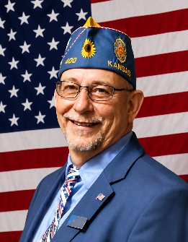
Hello Fellow Sons,

I would like to take a moment to introduce myself as your Detachment Vice Commander. I look forward to the opportunity to meet and speak with members across the Detachment in the coming year. I have both the privilege and the challenge of overseeing membership, and I am excited about the work ahead.

Membership is the lifeblood of our organization, and together we can continue to grow stronger. Let’s get started—July 1 marks the beginning of our renewal season. Now is the time to reconnect, re-engage and renew. I am ready to get to work, and I look forward to working alongside each of you.

Let’s RE-Membership with a mission with activities and our Why.

Your Detachment of Kansas
Vice Commander
Jeff Kerns

Message from the Detachment Adjutant
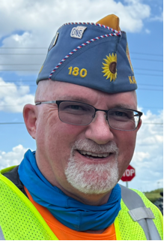
Greetings, Kansas Sons!

At the 2026 SAL Detachment Convention held in Topeka 29-31 May 2026, the following officers were elected:
Detachment Commander: Michael Weber 47 Dodge City
Detachment Vice-Commander: Jeff Kerns 400 Topeka
Detachment Adjutant: Chris Krueger 180 Great Bend
Detachment Finance Officer: Mike Saindon 408 Derby-Haysville
Detachment NEC: Doug Evans 192 Canton
Detachment Alternate NEC: Terry Harris 180 Great Bend
Detachment Masters At Arms: Dan McDowell 136 Mulvane and Mark Wessel 21 Seneca
The following appointed positions were approved at the Post Convention DEC Meeting:
Detachment Judge Advocate: Gerald Hammerschmidt 173 Hays
Detachment Assistant Adjutant: James Snyder 36 Oskaloosa
Detachment Chaplain: Gregg Thompson 136 Mulvane
Detachment Historian: Kyle Krout 47 Dodge City

The following Committee Chairman were appointed by Commander Weber and confirmed at the Post Convention DEC meeting:
Americanism - Gerald Hammerschmidt
Children and Youth - Doug Evans
Community Service - Gregg Thompson
Constitution and Bylaws - Terry Harris
Finance - Michael Saindon
Legislative - James Snyder
Member Training - Jeff Kerns
Membership - Jeff Kerns
Public Relations - Rick Miller
Resolutions - Terry Harris
Scholarships - Mike Saindon
VA&R - Neil Herrs
The Committee Chairmen will select the committee members for confirmation at the Fall Detachment Executive Committee meeting.

Several urgent reminders…

Squadron Data Reports were mailed to all Squadrons at their sponsoring Post’s address on 20 March 2026 and are past due at Department Headquarters. The information provided on this form will be entered at mylegion.org as the contact information for your Squadron. Failure to meet the 24 April deadline may cause your Squadron’s first renewal notice to be mailed with incorrect information. These reports were originally due 9 April but can still be sent in.

Notification of Post/Squadron Commander & Adjutant Form This report was also mailed on 20 March 2026 and is to be completed and returned to Department Headquarters after your Post/Squadron elections, by 1 July, 2026. The information provided on this form will be entered at mylegion.org as contact information for your Squadron.

Consolidated Squadron Reports were due by 1 May, 2026. Consolidated Squadron Reports may be submitted by the Squadron leadership through your mylegion.org account. National will notify the Detachment when a Squadron submits their report online. The hard copy blank reports will be mailed soon. Remember that while no one does everything, everyone does something! All of your Squadron events and expenditures are significant and deserve to be reported! CSRs can still be submitted!

All reports are used at State and National levels to inform our Legislators and Congress what The American Legion accomplishes in our communities each year.

Grassroots Support:
STAY INFORMED: LEGISLATIVE PRIORITIES NOW AVAILABLE
Want to see the issues Legionnaires are discussing with lawmakers? The 119th Congress, 2nd Session Legislative Priorities materials are available now. View and download them on the Legion website here.
CALL TO ACTION
This month, The American Legion is again calling on you because combat-injured veterans face a reduction in their retirement pay for every dollar of disability compensation they receive.
The Major Richard Star Act aims to rectify this by allowing combat-injured veterans to receive both their earned retirement pay and disability compensation without offset. Your action in advancing this crucial legislation is essential and greatly appreciated. Contact your Senators today!

The American Legion appreciates all the emails you have sent so far.
Go to the Action Center to quickly email a letter of support to your members of Congress and let’s maintain Kansas’ nationwide lead in contacting our elected representatives.

Tennessee took first place in the most recent count in contacting our elected representatives in Congress – let’s redouble our efforts!

NEED TO FIND YOUR ELECTED OFFICIALS?https://www.votervoice.net/AmericanLegion/Address
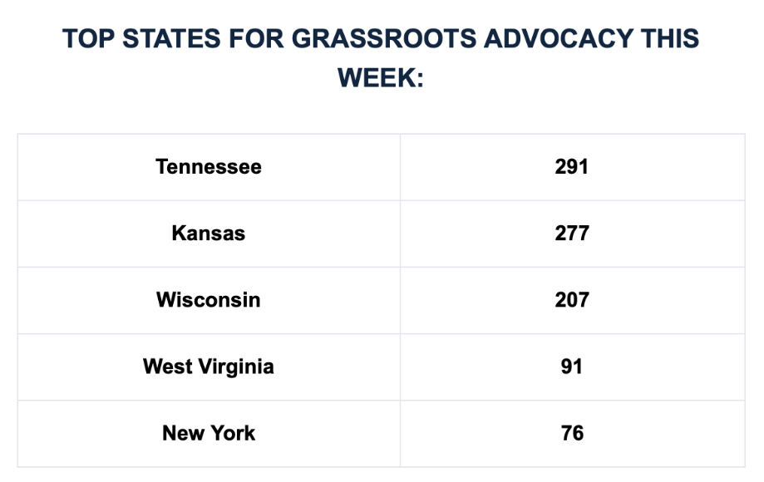

Register more participants in your Department and help amplify the voice of veterans on Capitol Hill. Maybe your state just might earn a spot-on next week’s Letter Board! Register with the link below:
https://www.votervoice.net/AmericanLegion/Register

Upcoming events:
- Kansas American Legion College - 5-7 Jun 2026 - Concordia
- Kansas Legacy Run - 12-14 June 2026 – details on https://Kansasalr.com
- Kansas American Legion Bowling Tournament – 11-12/25-26 July 2026 – see the flyer on SALKansas.org or KansasLegion.org
- SAL National Convention – 27-29 Aug 2026 – Louisville, Ky
- Kansas American Legion Riders State Rally – 25-26 Sep, 2026 – Post 370, Overland Park

Thanks for all you do and remember to Be The One!

Chris Krueger
Detachment Adjutant

NOTES from the SALute staff

We know that Summer is always a busy time for Sons across the state. Please take a moment and consider doing one action and two follow up things.
The action, snap a picture of all those fun activities and community focused activities you are doing.
The follow up things:
- Share them. Facebook, Instagram, and the local newspaper are great places to start. Another is to send them to us along with a small article and let us share them with the Detachment.
- If it is a really good picture consider reading the rules for Snapshots of service at https://www.legion.org/getmedia/95374c6a-4f7c-483e-ab8d-e2f2498cbe9f/sal-snapshots-of-service-rules-award-form-release-forms-revised.pdf . And share them with National.

